Utah Lake Hydrodynamic (EFDC) and Water Quality (WASP) Model Report

IN Support of EPA Project Number 835866-01: Prediction of Nonlinear Climate Variations Impacts on Eutrophication and Ecosystem Processes and Evaluation of Adaptation Measures in Urban and Urbanizing Watersheds

University of Utah   
Department of Civil and Environmental Engineering

Prepared For:

Division of Water Quality

Utah Department of Environmental Quality

195 North 1950 West

Salt Lake City, UT 84116

Prepared By:

Juhn-Yuan Su, M.S., E.I.T. (for the Utah Lake WASP Portion)

Graduate Student, Ph.D.

Civil and Environmental Engineering

University of Utah, Salt Lake City, UT

Nicholas von Stackelberg, P.E. (for the Utah Lake EFDC Portion)

Environmental Engineer

Division of Water Quality

Utah Department of Environmental Quality

Salt Lake City, UT

Advisor: Dr. Michael E. Barber

April 9, 2020 (Revised from the March 18, 2020 Version)

# Table of Contents

Table of Contents i

List of Tables iii

List of Figures iv

Nomenclature v

1. Introduction 1

1.1. Project Background 1

1.2. Model Objectives 1

1.3. Model Background 2

1.4. Constituents for the Utah Lake WASP 3

2. Model Build 5

2.1. Model Structure 5

2.2. Model Inputs 6

2.2.1. Lake Physical Characteristics 6

2.2.2. Meteorology- Data Sources and Approximations 6

2.2.3. Outflow 8

2.2.4. Inflow Quantity 8

2.2.5. Inflow Quality 10

2.2.5.1. Water Temperature and Suspended Solids- EFDC 10

2.2.5.2. Inflow Quality for Other Constituents- WASP 11

2.2.6. Experimental and Literary Parameters for WASP 13

2.2.6.1. Phytoplankton Speciation 13

2.2.6.2. Atmospheric Deposition 15

2.2.6.3. Sediment Diagenesis 16

2.2.7. Solar Radiation Attenuation 19

2.2.8. Wave Characteristics 20

2.2.9. Sediment Transport 20

2.2.9.1. Sediment Characterization and Classes for EFDC 20

2.2.9.2. Sediment Classes, Data Sources, and Approximations for WASP 20

2.2.10. Initial Conditions 22

2.2.10.1. Initial Conditions for the Hydrodynamic (EFDC) Model 22

2.2.10.2. Initial Conditions for the Water Quality (WASP) Model 22

3. Model Sensitivity 24

3.1. Sensitivity Analyses for EFDC 24

3.2. Sensitivity Analyses for WASP 26

4. Model Calibration 31

4.1. Calibration Procedures 31

4.1.1. Calibration Procedures for Hydrodynamic Model (EFDC) 31

4.1.2. Data and Calibration Procedures for Water Quality (WASP) Model 32

4.2. Calibration Performance 34

4.2.1. Calibration Performance of the Hydrodynamic (EFDC) Model 34

4.2.2. Calibration Performance of the Water Quality (WASP) Model 41

4.3. Model Parameterization 44

4.3.1. Model Parameterization for the Hydrodynamic (EFDC) Model 45

4.3.2. Model Parameterization of the Water Quality (WASP) Model 45

5. Model Validation 50

6. Model Uncertainty 50

7. Model User Guidance 50

7.1. EFDC Model 50

7.2. WASP Model 50

References 53

Appendix A: Model Sensitivity Analysis for WASP A-1

A.1. Sensitivity Parameters and Methodology A-1

A.2. Sensitivity Plots A-2

A.2.1. Nutrient Kinetics A-2

A.2.2. Settling Rates A-28

A.2.3. Lighting A-35

Appendix B: Model Calibration for WASP B-1

B.1. Graphical Results (Time-Series) B-1

B.1.1. Dissolved Oxygen (DO) B-1

B.1.2. Ammonia-Nitrogen B-6

B.1.3. Nitrate-Nitrite Nitrogen B-11

B.1.4. Total Phosphate-Phosphorus B-16

B.1.5. Total Phytoplankton Chlorophyll-a B-21

B.1.6. CBOD B-26

B.1.7. Total Solids B-27

B.2. Graphical Results (Scatter Plot) B-32

B.2.1. Dissolved Oxygen (DO) B-32

B.2.2. Ammonia-Nitrogen B-36

B.2.3. Total Phytoplankton Chlorophyll-a B-40

B.3. Graphical Results (Probability Plot) B-45

B.3.1. Dissolved Oxygen (DO) B-45

B.3.2. Ammonia-Nitrogen B-49

B.3.3. Total Phytoplankton Chlorophyll-a B-53

B.4. Statistical Results B-58

B.4.1. Dissolved Oxygen (DO) B-59

B.4.2. Ammonia-Nitrogen B-59

B.4.3. Nitrate-Nitrite Nitrogen B-60

B.4.4. Total Phosphate-Phosphorus B-60

B.4.5. Total Phytoplankton Chlorophyll-a B-61

B.4.6. CBOD B-61

B.4.7. Total Solids B-62

Appendix C: Utah Lake Water Balance C-1

C.1. Water Balance: Components, Data Sources, and Methodology C-1

C.2. Utah Lake Inflow: Components, Data Sources, and Methodology C-1

C.3. Results over Utah Lake Annual Water Balance and Inflows C-2

# List of Tables

Table 2.1. Meteorological Inputs into the Utah Lake Model 6

Table 2.2. Solar Radiation Data Sources 7

Table 2.3. Data Sources for Inflow Quantity into the Utah Lake Model 9

Table 2.4. Inflow Quality Data Sources into Distinct Nodes for the Utah Lake WASP 11

Table 2.5. Constituents Retrieved from the DMRs, AWQMS Sites, and the USGS Sites 12

Table 2.6. Maximum Growth Rates per Phytoplankton/Algal Group Populated into the Utah Lake WASP 14

Table 2.7. Kinetics (Growth, Respiration, Death, and Settling) at 20 Degrees Celsius for Distinct Phytoplankton/Algal Groups into Utah Lake WASP 14

Table 2.8. Referenced and Calculated Stoichiometric Ratios for each Phytoplankton Group 15

Table 2.9. Atmospheric Deposition for Distinct Constituents, Values Employed, and Methods 15

Table 3.1. Input Parameters Applied for Sensitivity Analyses upon the Utah Lake WASP 26

Table 4.1. UDWQ AWQMS Sites along Utah Lake and the Corresponding Node for the WASP Model Calibration Organized based on Station ID 32

Table 4.2. Constituent Mapping along the Utah Lake WASP and the AWQMS Sites 33

Table 4.3. Calibration Statistical Performance Metrics for Water Surface Elevation 34

Table 4.4. Calibration Statistical Performance Metrics for Water Temperature 36

Table 4.5. Model Calibration Parameters for Water Temperature 45

Table 4.6. Data Values, Units, and Sources for the Geographical Coordinates and Light Extinction Parameters for the Utah Lake WASP 46

Table 4.7. Utah Lake WASP Model Input Parameters (Value, Units, Data Source) for the Dissolved Nutrient (NH3-N, NO2-NO3-N, DON, DIP/ortho-P, DOP) Species 46

Table 4.8. Utah Lake WASP Model Input Parameters (Values, Units, Data Sources) for CBOD and DO 47

Table 4.9. Utah Lake WASP Parameters (Values, Units, Data Sources) for Phytoplankton Groups 1 to 4 47

Table 4.10. Utah Lake WASP Model Parameters (Value, Units, Data Sources) for Macro/Benthic Algae (*Stigeoclonium Subsecundum (Chlorophyceae)*) 48

Table 4.11. Utah Lake WASP Input Parameters (Value, Units, Data Sources) for POM and SOD 49

# List of Figures

Figure 2.1. Utah Lake Model Grid with Bathymetry (Elevation in meters relative to Compromise Elevation) 5

Figure 2.2. Calculated Monthly Total Incoming Solar Radiation over Utah Lake for January (Left) and July (Right) 7

Figure 2.3. Annual Evaporation Rate from Utah Lake under Selected Evaporation Models 8

Figure 2.4. Data Sources for Inflow Locations for Water Temperature and Suspended Solids into the Utah Lake Model 10

Figure 2.5. Sites and Added Points from Hogsett et al. (2019) for Approximating Initial POP Sediment Conditions 16

Figure 2.6. IDW Interpolation Technique for Initial POP Sediment Condition (mg P/g sediment) along Utah Lake 17

Figure 2.7. K = 1 Nodes along the Utah Lake WASP with and without Sediment Diagenesis Enabled 18

Figure 2.8. Sediment Characterization Sites along Utah Lake for % Sand and % Silt + Clay 21

Figure 2.9. AWQMS Sites for Approximating Initial Conditions per Node for Selected Constituents throughout Utah Lake 23

Figure 3.1. Probability Plot of Water Temperature at Provo Buoy Station with and without Cloud Cover 24

Figure 3.2. Probability Plot of Water Temperature at Provo Buoy Station with and without Water Surface Reflectance 25

Figure 3.3. Probability Plot of Water Temperature at Provo Buoy Station with Varying Solar Radiation Attenuation Coefficients 25

Figure 4.1. Geographical Locations of the UDWQ AWQMS Sites for the Utah Lake Model Calibration Work 33

Figure 4.2. Time Series Plot of Simulated vs. Observed Water Surface Elevation 35

Figure 4.3. Scatter Plot of Simulated vs. Observed Water Surface Elevation 35

Figure 4.4. Time Series Plot of Simulated and Observed Water Temperature at Utah Lake 2 Miles W of Vineyard 36

Figure 4.5. Scatter Plot of Simulated vs. Observed Water Temperature at Utah Lake 2 Miles W of Vineyard 37

Figure 4.6. Probability Plot of Simulated and Observed Water Temperature at Utah Lake 2 Miles W of Vineyard 37

Figure 4.7. Time Series Plot of Simulated vs. Observed Water Temperature at Utah Lake 1 Mile W of Provo Boat Harbor 38

Figure 4.8. Scatter Plot of Simulated vs. Observed Water Temperature at Utah Lake 1 Mile W of Provo Boat Harbor 38

Figure 4.9. Probability Plot of Simulated vs. Observed Water Temperature at Utah Lake 1 Mile W of Provo Boat Harbor 39

Figure 4.10. Time Series Plot of Simulated vs. Observed Water Temperature at Utah Lake 1 Mile SE of Bird Island 39

Figure 4.11. Scatter Plot of Simulated vs. Observed Water Temperature at Utah Lake 1 Mile SE of Bird Island 40

Figure 4.12. Probability Plot of Simulated vs. Observed Water Temperature at Utah Lake 1 Mile SE of Bird Island 40

Figure 4.13. Monthly Box Plot of Simulated vs. Observed Water Temperature at Utah Lake 1 Mile W of Provo Boat Harbor 41

# Nomenclature

The following acronyms have been employed and implemented throughout this report:

* AWQMS = Ambient Water Quality Monitoring System
* BOD = Biochemical Oxygen Demand
* BOD (5-day) = Biochemical Oxygen Demand, 5-day/Standard Conditions
* BODU = Ultimate Biochemical Oxygen Demand
* CBOD = Carbonaceous Biochemical Oxygen Demand
* CBOD (5-day) = Carbonaceous Biochemical Oxygen Demand, 5-day/Standard Conditions
* CBODU = Ultimate Carbonaceous Biochemical Oxygen Demand
* DIP = Dissolved Inorganic Phosphate-Phosphorus
* DMR = Discharge Monthly Report
* DO = Dissolved Oxygen
* DON = Dissolved Organic Nitrogen
* DOP = Dissolved Organic Phosphate-Phosphorus
* DP = Dissolved Phosphate/Dissolved Phosphate-Phosphorus
* ECHO = Enforcement and Compliance History Online
* HAB = Harmful Algal Bloom
* IDW = Inverse-Distance Weighing
* IPCC = Intergovernmental Panel on Climate Change
* ISS = Inorganic Suspended Solids
* NAD = North American Datum
* NH3-N = Ammonia-Nitrogen
* NO2-NO3-N = Nitrite-Nitrate Nitrogen/Nitrate-Nitrite Nitrogen
* Ortho-P = Orthophosphate
* PHYTO = Phytoplankton Chlorophyll-a
* POC = Particulate Organic Carbon/Detrital Carbon
* POM = Particulate Organic Matter/Total Detritus
* PON = Particulate Organic Nitrogen/Detrital Nitrogen
* POP = Particulate Organic Phosphate/Detrital Phosphate
* RCP = Representative Concentration Pathway
* SLC = Salt Lake County
* TKN = Total Kjeldahl Nitrogen
* TMDL = Total Maximum Daily Load
* TN = Total Nitrogen
* TP = Total Phosphate/Total Phosphate-Phosphorus
* TSS = Total Suspended Solids
* TVS = Total Volatile Solids
* UDWQ = Utah Division of Water Quality
* UDWR = Utah Division of Water Rights
* UTM = Universal Transverse Mercator
* WASP = Water Quality Assessment Simulation Program
* WRDB = Water Resources Database
* WWTP = Wastewater Treatment Plant

# Introduction

The purpose of this report is to document the Utah Lake hydrodynamic and water quality model build and calibration. This section provides the general background of the project for which this model work falls under and describes the relevance of the model (e.g., model objectives). Discussion over the model background (e.g., general theory, previous studies, etc.) concludes this section of the report.

## Project Background

The model calibration work is conducted in part of the University of Utah Project “Prediction of Nonlinear Climate Variations Impacts on Eutrophication and Ecosystem Processes and Evaluation of Adaptation Measures in Urban and Urbanizing Watersheds”, under EPA Project 835866-01. One primary goal of this project involves assessing the performance of the Jordan River watershed under existing and futuristic climate change characteristics followed by land use projections (Barber et al. 2016). The project employs the Jordan River watershed, which involves the shallow lake (Utah Lake) that discharges into the Jordan River, as the case study for analyzing the following questions (Barber et al. 2016).

1. How does drought (seasonal and prolonged), exacerbated by extreme weather and climate change, affect water quality and the availability of surface water and groundwater?
2. How do subsequent drought-related events, such as changes in surface runoff and wildfire, lead to additional changes in water quality and availability?
3. How can changes in water quality driven by other variations in the hydrological cycle related to drought, such as changes in the timing and intensity of spring snowmelt and runoff, affect water quality?
4. What adaptive management strategies and innovative, cost-effective technologies provide communities and ecosystems with protection and resilience against direct and secondary drought-related impacts exacerbated by climate change?
5. How can the proposed management strategies and technologies be demonstrated in different communities to facilitate adoption of sustainable water management?

For addressing the five project questions above, the project implements several models, involving the Distributed Hydrologic Soil-Vegetation Model (DHSVM) for simulating water quantity from mountainous non-urban watersheds, the Stormwater Management Model (SWMM) for simulating water quantity and nutrient loadings from stormwater/urban sub-catchments, the GoldSim model for simulating agricultural outflows and return flows based on wastewater and water demand, the combined in-lake model for simulating water quality through the Water Quality Assessment Simulation Program (WASP) linked with the Environmental Fluid Dynamics Code (EFDC) for simulating hydrodynamics, and the river WASP model for simulating in-stream water quality processes. The results among the distinct models are integrated for deriving and suggesting linkages among existing and futuristic land use and climate change upon both the water quality and quantity performance. Meanwhile, the project integrates the experimental analyses over Utah Lake for evaluating the environmental processes subject to climate change and land use development with assessments over the public perspective upon the water quantity and quality characteristics of the Jordan River watersheds. Such integration is implemented for addressing several project objectives and outcomes highlighted in Barber et al. (2016).

## Model Objectives

Utah Lake involves a shallow, freshwater lake located near Provo, UT and serves as the effluent for several tributaries, involving American Fork, Spanish Fork, and the Provo Rivers. Meanwhile, this system encounters periodic yet significant eutrophication, instigating Harmful Algal Blooms (HABs) that hence impose major concerns over the water quality performance of the freshwater shallow lake. On the other hand, although studies have been attempted for analyzing the performance of the system, no existing models appear to be developed for simulating the hydrodynamics of Utah Lake followed by evaluating the water quality performance. Consequently, this exercise involves the development of a hydrodynamics model through the Environmental Fluid Dynamics Code (EFDC) that is maintained by Tetra Tech, Inc. linked with a separate water quality model through the Water Quality Assessment Simulation Program (WASP) that is maintained by the U.S. EPA. The major objectives for exhibiting a separate hydrodynamics model followed by a water quality model involve the following:

1. Address the need for incorporating sediment transport processes (e.g., erosion, deposition, sediment resuspension) and assess the effects of such processes upon the system hydrodynamics
2. Analyze the water temperature and simulate ice coverage over the shallow freshwater lake
3. Apply the underlying theory (e.g., constituent transport, etc.) for simulating the 3D hydrodynamics of the system
4. Evaluate the water quality performance of the shallow lake system through an assessment of nutrient simulations
5. Assess the phytoplankton performance along the shallow lake system and apply such analysis for evaluating Harmful Algal Blooms (HABs) over the system
6. Assess the effects of existing and futuristic climate change characteristics, followed by land use changes and urbanization, upon the hydrodynamics and water quality performance of the shallow lake system
7. Assess climate change and land use characteristics upon the water quality impairment along Utah Lake, involving the kinetics, eutrophication, and the likelihood of Harmful Algal Blooms over the system

## Model Background

The modeling approach selected to meet the project objectives was to couple the hydrodynamic model Environmental Fluid Dynamics Code (EFDC) to the water quality model Water Quality Assessment Simulation Program (WASP). The modeling approach was vetted by the Utah Division of Water Quality (UDEQ) with a Utah Lake stakeholder group (von Stackelberg 2016) and was included in the grant proposal by the University of Utah (UU).

EFDC is a hydrodynamic model that simulates waterbodies in one, two, or three dimensions (Tetra Tech, Inc 2007). EFDC uses stretched or sigma vertical coordinates and Cartesian or curvilinear, orthogonal horizontal coordinates to represent the physical characteristics of a waterbody. It solves three-dimensional, vertically hydrostatic, free surface, turbulent averaged equations of motion for a variable-density fluid. Dynamically-coupled transport equations for turbulent kinetic energy, turbulent length scale, salinity and temperature are also solved. The EFDC model allows for drying and wetting in shallow areas, which is of particular importance in Utah Lake, by a mass conservation scheme.

The EFDC model has been widely applied to simulate the hydrodynamics of rivers, lakes, estuaries and bays (EPA 2019). EFDC has previously been applied to simulate the hydrodynamics of shallow and eutrophic lake systems similar to Utah Lake. An EFDC hydrodynamic and sediment transport model of Lake Okeechobee in Florida (Jin et al. 2000) was coupled with the WASP Eutrophication module to form the Lake Okeechobee Water Quality Model (LOWQM) (James et al. 1997; James 2012). An EFDC hydrodynamic and sediment transport model was developed of Lake Taihu in China (Wang et al. 2013) that was subsequently coupled to a phosphorus fate and transport model (Huang et al. 2016). An EFDC hydrodynamic and temperature model was coupled to a WASP Eutrophication model for Jordan Lake in North Carolina (Tetra Tech, Inc. 2002).

Meanwhile, the Water Analysis Simulation Program (WASP) Version 8.2 and above (June 2018 version and after), also known as the Water Quality Assessment Simulation Program, is employed for the development and simulation of the Utah Lake WASP. Such version of WASP is selected due to the limitations with the previous version of WASP. For instance, WASP 7 sets a maximum number of grids allowed under the advanced eutrophication routine to 450 (for all nodes), which the Utah Lake grid yielding over 1000 nodes hence surpasses this maximum. At the same time, WASP generally implements segmentation and simulates water quality concentrations as a flexible boxed model; in other words, the user can define the flow segmentation along a set of segments that are applied as boxes in WASP through any method desired. Typically, WASP applies the advanced eutrophication routine for simulating nutrients, allowing the simulation of the following constituents under this module (Wool et al. n.d.).

* **Dissolved Nitrogen Species:** Ammonia-Nitrogen (NH3-N), Inorganic Nitrogen (Nitrate and Nitrite) (NO2-NO3-N), Dissolved Organic Nitrogen (DON)
* **Dissolved Phosphorus Species:** Dissolved Inorganic Phosphate-Phosphorus (DIP), Dissolved Organic Phosphate-Phosphorus (DOP)
* **Oxygen:** Ultimate Carbonaceous Biochemical Oxygen Demand (CBODU; up to 5 Groups), Dissolved Oxygen (DO), Sediment Oxygen Demand (SOD)
* **Phytoplankton:** Chlorophyll-a (up to 5 Groups Maximum)
* **Macroalgae/Benthic Algae:** Chlorophyll-a, Nitrogen, Phosphate Components (up to 3 Groups); can be transported (Macro Algae) or non-transported (Benthic Algae)
* **Particulate Organic Matter (only 1 group allowed for each):** Particulate Organic Matter/Total Detritus (POM), Particulate Organic Carbon/Detrital Carbon (POC), Particulate Organic Nitrogen/Detrital Nitrogen (PON), Particulate Organic Phosphate/Detrital Phosphate (POP)
* **Others:** Water Temperature, Total Suspended Solids (up to 10 Groups), pH, Alkalinity

Meanwhile, WASP simulates nutrient fluxes among the water column and sediment through sediment diagenesis. According to Martin and Wool (2017), the user can specify or have WASP simulate the following nutrient fluxes through the sediment diagenesis routines: benthic ammonia flux, benthic phosphate flux, and sediment oxygen demand (SOD). The nutrient fluxes being inputted by the user manually are only altered based on water temperature-correction coefficients implemented into WASP (e.g., water temperature correction of 1.07 for SOD, etc.). In other words, WASP does not combine the user-specified nutrient fluxes (e.g., prescribed nutrient fluxes, such as prescribed SOD) with those simulated through the sediment diagenesis routines.

Previous versions of WASP (e.g., prior to WASP 8 that is released in August 2016) are employed by previous studies for analyzing the performance of systems of interest. Applications of previous versions of WASP involve assessing the eutrophication characteristics of Lake Okeechobee, FL through WASP 5 (Jin et al. 1998), along employing WASP 6 for supporting TMDL studies along the Neuse River Estuary, NC (Wool et al. 2003). Meanwhile, WASP Version 5 is further implemented for assessing the sorption of heavy metals to suspended solids and the phytoplankton growth limitation toward analyzing water quality concerns along the Saale River in Germany (Lindenschmidt et al. 2007). On the other hand, the version implemented for this exercise, Version 8.3 that is released in December 2018, appears to currently not exhibit significant studies that have applied such version for applications of interest (e.g., evaluating system performance, assessing water quality impairment, etc.).

## Constituents for the Utah Lake WASP

For the Utah Lake WASP, several constituents are simulated as state variables for assessing the water quality performance of the system. The WASP model currently simulates the following constituents over the calibration period of 10 water years, from October 1, 2005 to September 30, 2015, employing water flow and temperature from the hydrodynamic linkage from EFDC.

* **Dissolved Nitrogen Species:** Ammonia-Nitrogen (NH3-N), Inorganic Nitrogen (Nitrate and Nitrite) (NO2-NO3-N), Dissolved Organic Nitrogen (DON)
* **Dissolved Phosphorus Species:** Dissolved Inorganic Phosphate-Phosphorus (DIP), Dissolved Organic Phosphate-Phosphorus (DOP)
* **Oxygen:** Dissolved Oxygen
* **Ultimate Carbonaceous Biochemical Oxygen Demand (CBODU):** Only 1 group simulated
* **Phytoplankton:** Chlorophyll-a (3 Groups)
* **Macroalgae/Benthic Algae:** Chlorophyll-a, Nitrogen, Phosphate Components (1 Group); Non-Transported (Benthic Algae)
* **Particulate Organic Matter (only 1 group allowed for each):** Particulate Organic Matter/Total Detritus (POM), Particulate Organic Carbon/Detrital Carbon (POC), Particulate Organic Nitrogen/Detrital Nitrogen (PON), Particulate Organic Phosphate/Detrital Phosphate (POP)
* **Others:** Water Temperature (read from the hydrodynamic linkage only and not included in the WASP calibration work), Suspended Solids (3 Groups: Sand, Silt, Clay; see Section 2.2.9.2); separate model developed for incorporating pH and alkalinity (but not run due to issues encountered; see Section 7.2)

# Model Build

This section summarizes the structure and population of the model.

## Model Structure

A Cartesian grid with 1000-by-1000 square meters (e.g., 1 km2) cell size was built for Utah Lake (Figure 2.1). Three vertical layers were applied to each grid cell utilizing sigma stretched coordinates (i.e. water depth divided uniformly into three layers). The horizontal grid and vertical layering resulted in 1,356 total model segments. At the same time, although the Utah Lake WASP is linked with EFDC through a hydrodynamic linkage, the model calibration period for the Utah Lake WASP is slightly shorter than the one for the Utah Lake EFDC due to the file size of the hydrodynamic linkage. Hence, while the Utah Lake EFDC simulates from October 1, 2005 to September 30, 2018, the Utah Lake WASP involves a calibration period over 10 water years, from October 1, 2005 to September 30, 2015.

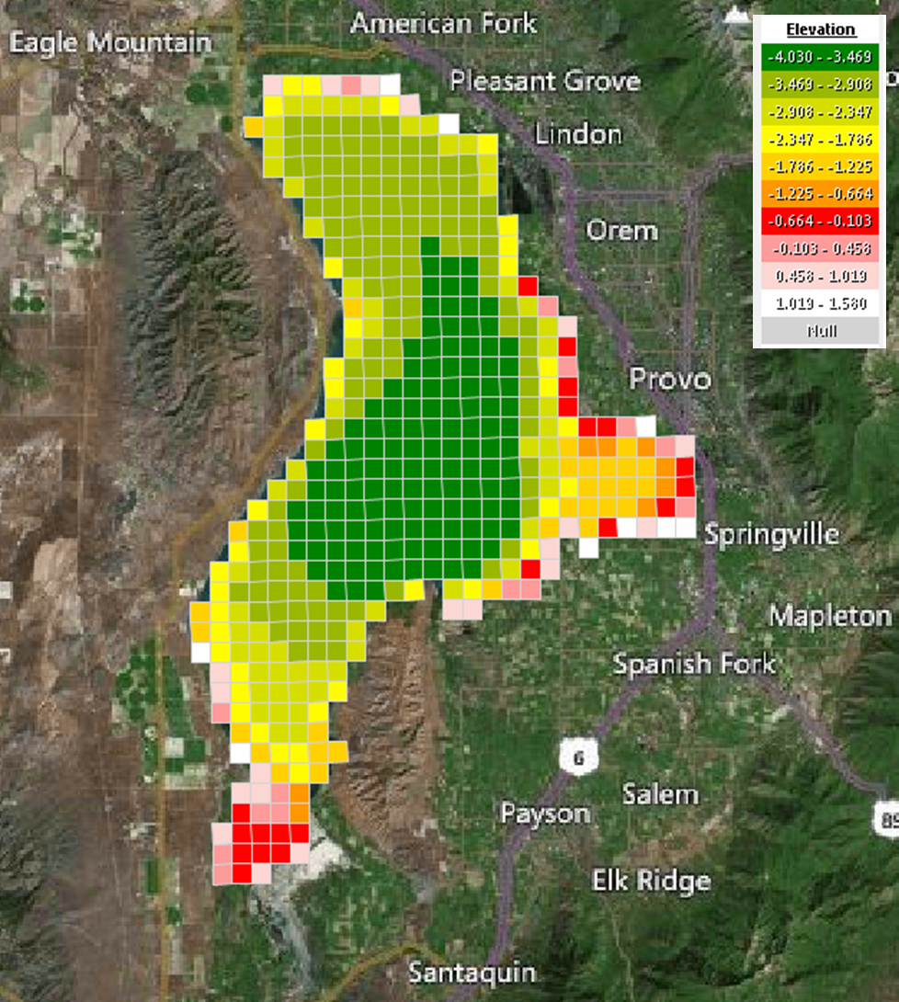

Figure .. Utah Lake Model Grid with Bathymetry (Elevation in meters relative to Compromise Elevation)

## Model Inputs

This section summarizes the model inputs and sources for populating the EFDC and WASP models, involving the meteorological data (Section 2.2.2), outflow data sources needed for EFDC (Section 2.2.3), the inflow quantity/quality (Sections 2.2.4 for inflow quantity and 2.2.5 for inflow quality), approximations for initial conditions (Section 2.2.10), and other approximations for populating other parameters needed for EFDC and WASP.

### Lake Physical Characteristics

The lake bottom elevation for the EFDC grid (and for the Utah Lake WASP) was obtained from two sources:

1. Utah Lake bathymetric contour lines generated from Bureau of Reclamation depth measurements through the surface ice of Utah Lake in 1960 obtained through ESRI ArcGIS Online.
2. 2013-2014 Wasatch Front LIDAR elevation data obtained through Utah AGRC.

The bottom roughness was set to a uniform 0.01. Meanwhile, vegetation resistance was not considered in the model calibration.

### Meteorology- Data Sources and Approximations

An hourly time series of meteorological inputs was primarily sourced from the Provo Municipal Airport station (Table 2.1). The precipitation measured at the Provo BYU station was reduced to reflect that less rain falls on the lake relative to the east bench along the Wasatch Mountains where the station is located. Using ArcGIS, the mean annual precipitation over Utah Lake was calculated using the Utah Lake boundary and PRISM 30-year normal (1981-2010) raster data. The precipitation measured at the Provo BYU station was then multiplied by the ratio of the mean annual precipitation over Utah Lake (353.8 mm) to the mean annual precipitation at Provo BYU station (501.7 mm), 0.705.

Table .. Meteorological Inputs into the Utah Lake Model

|  |  |  |  |  |  |
| --- | --- | --- | --- | --- | --- |
| **Variable** | **Units** | **Station Name**  **(Station ID)** | **Latitude** | **Longitude** | **Source** |
| Air Pressure | millibar | Provo Municipal Airport (KPVU) | 40.21667 | -111.71667 | Utah Climate Center |
| Air Temperature | deg C | Provo Municipal Airport (KPVU) | 40.21667 | -111.71667 | BASINS/MesoWest |
| Cloud Cover | fraction | Provo Municipal Airport (KPVU) | 40.21667 | -111.71667 | BASINS/UCC |
| Evaporation | mm/hr | Priestley-Taylor Formula | 40.21667 | -111.71667 | UDWQ |
| Precipitation | mm/hr | Provo BYU (USC00427064) | 40.2458 | -111.651 | Utah Climate Center |
| Relative Humidity | fraction | Provo Municipal Airport (KPVU) | 40.21667 | -111.71667 | BASINS/MesoWest |
| Solar Radiation | W/m2 | Multiple |  |  | BASINS/MesoWest |
| Wind Direction | degrees | Provo Municipal Airport (KPVU) | 40.21667 | -111.71667 | MesoWest |
| Wind Speed | m/s | Provo Municipal Airport (KPVU) | 40.21667 | -111.71667 | BASINS/MesoWest |

Due to limited data availability in the earlier years of the simulation (2005-2012), the solar radiation time series was sourced from multiple stations (Table 2.2). Due to the topographic shading from adjacent mountains, the solar radiation recorded at each meteorological station is not the same as over the entire lake. The incoming solar radiation also varies spatially and temporally over the surface of the lake (Figure 2.2), as determined by using the Solar Radiation tool in ArcGIS 10.5. The ratio of average annual incoming solar radiation over the entire lake to at the location of each weather station varied: Provo Municipal Airport (0.915), Eyring Science Center (1.079), I-15 at Provo (1.249). However, due to uncertainty associated with the calculated and measured incoming solar radiation data, a correction factor was not applied to the measured data.

Table .. Solar Radiation Data Sources

|  |  |  |  |  |  |  |
| --- | --- | --- | --- | --- | --- | --- |
| **Start Date** | **End Date** | **Station Name** | **Station ID** | **Latitude** | **Longitude** | **Source** |
| 10/1/2005 | 12/31/2009 | Provo Municipal Airport | KPVU | 40.21667 | -111.71667 | BASINS |
| 1/1/2010 | 12/31/2016 | Eyring Science Center | EYSC | 40.2472 | -111.65 | UCC |
| 1/1/2017 | 9/30/2018 | I-15 at Provo | UTPRV | 40.20395 | -111.65530 | MesoWest |

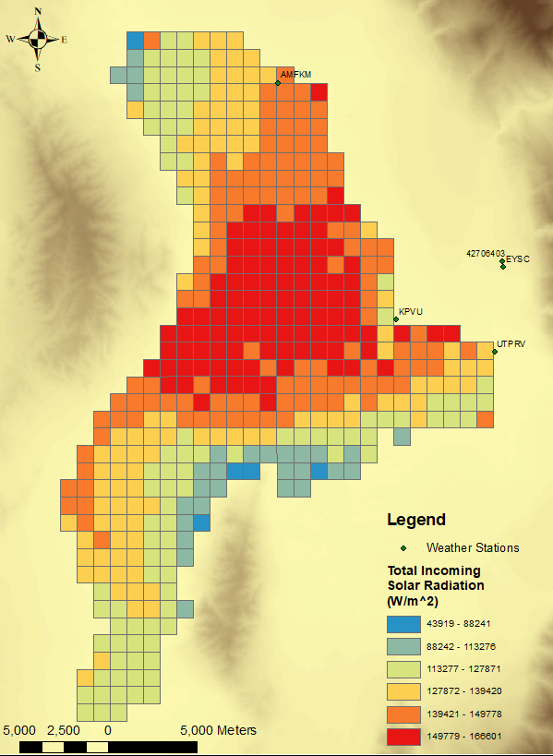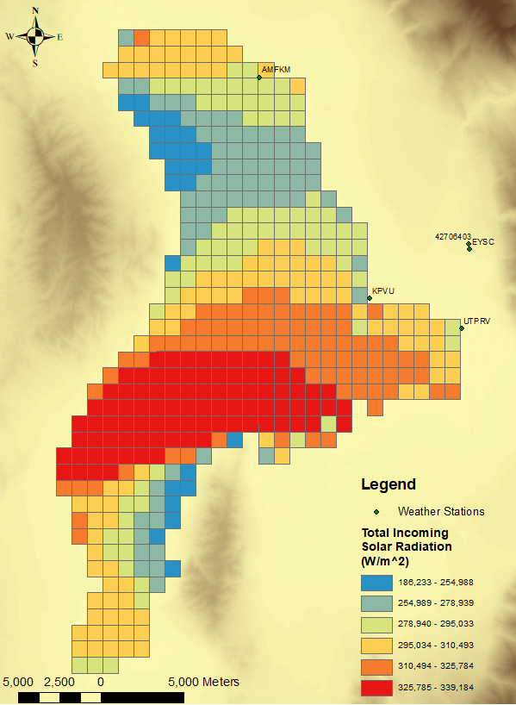

Figure .. Calculated Monthly Total Incoming Solar Radiation over Utah Lake for January (Left) and July (Right)

Several evapotranspiration formulas were evaluated for potential use in the model. The formulas were selected based on their previous application to shallow lakes. The methods rely upon various combinations of the following input data: air temperature (*Ta*), relative humidity (*RH*), wind speed (*u*), solar radiation (*Rs*), and water temperature (*Tw*). The estimated yearly evaporation depth varied significantly depending on the formula (Figure 2.3). The Priestley-Taylor method was selected for the model based on the following reasoning:

* The Priestly-Taylor formula has been recommended as well-suited for shallow lakes in published comparison studies (Stewart and Rouse 1976, Galleo-Elvira et al. 2010).
* The Priestley-Taylor formula falls approximately in the middle of the range of evaporation rates calculated by the various methods (Figure 2.3).
* The Priestley-Taylor formula produces very similar results as the method used in the LKSIM water and ion balance model of Utah Lake, which used the Morton formula reduced by 5% (Merritt 2008).

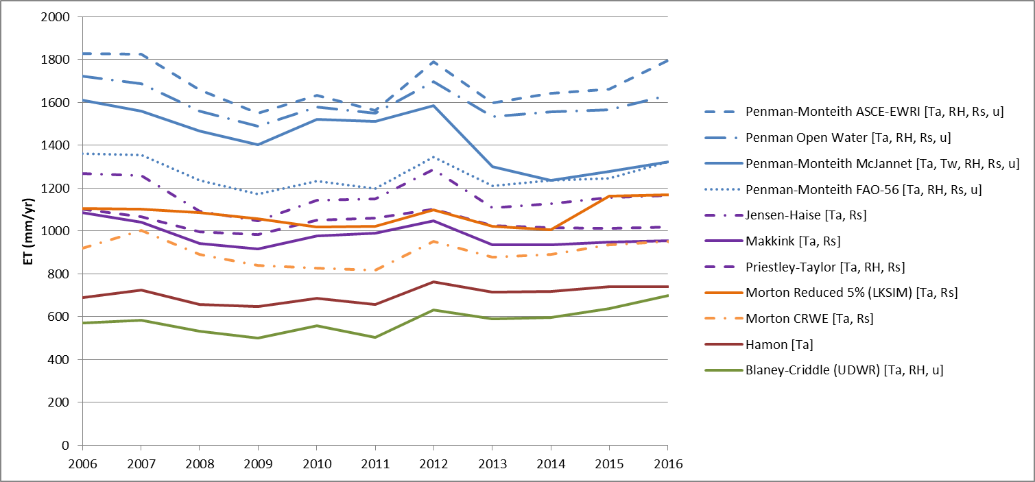

Figure .. Annual Evaporation Rate from Utah Lake under Selected Evaporation Models

### Outflow

Utah Lake has only one outflow location to the Jordan River. The Utah Division of Water Rights publishes outflow records for Utah Lake which were used to develop the outflow time series used in the model.

1. For 9/1/2005-12/31/2008, monthly flow records for “Utah Lake Outflow” were used.
2. For 1/1/2009-9/30/2018, daily flow records for “05 Jordan Narrows (Total)” were used.

Water is pumped from Utah Lake to irrigate agricultural lands adjacent to Goshen Bay and on the west side of the lake. Withdrawal records are not actively published by UDWR and return flows back to the lake are unknown. These withdrawals were considered insignificant to the overall water balance in the lake.

### Inflow Quantity

A total of 12 surface water inflows and 4 groundwater inflows were included in the model (Table 2.3 and Figure 2.4). Only two of the surface inflows were actively gaged during the period of the model: Provo River and Hobble Creek. The flows from the wastewater treatment plants (WWTP) were based on monthly Discharge Monitoring Reports (DMR) submitted to Utah Division of Water Quality (UDWQ). Constant mean annual rates were used for the groundwater inputs, based on estimates published by the USGS. All other surface water, stormwater, and irrigation return flows were ungaged and unknown during the period of the model simulation. To determine the total magnitude of inflows, a monthly water balance was calculated based on the following equation:

$$Q_{I}= ∆S+Q_{O}+ET-P \left(2.1\right)$$

As indicated in Equation 2.1, the water balance in units of volume (e.g., m3) involves the inflow $Q_{I}$ that is computed through the change in storage $∆S$ combined with the outflow $Q_{O}$ with the evapotranspiration $ET$ subtracted by precipitation ($P$). At the same time, the stage-storage-surface area table for the EFDC grid was developed using the Storage Capacity Tool in ArcGIS ArcMap 10.5 Spatial Analyst extension. Meanwhile, lake elevation data was obtained from UDWR under the “Utah Lake Storage Content (Gage Reading)” station name (UDWR 2019). The following data sources and approximations are applied for populating each parameter in Equation 2.1 above.

* The monthly change in storage (*ΔS*) was then calculated by using the lake elevation data to determine the storage content based on the stage-storage table for the EFDC grid.
* The precipitation volume, *P*, and evapotranspiration volume, *ET*, were calculated by multiplying the *P* and *ET* depth by the lake surface area obtained from the stage-surface area table.
* Outflow, *Qo*, was determined as described in Section 2.2.3.

Additional methods and results from the water balance analysis are included in Appendix C: Utah Lake Water Balance. The total ungaged inflow was then calculated by subtracting the observed/estimated inflows from the total inflows. This ungaged inflow was then apportioned to three sources: American Fork River (15.2%), Lindon Drain (11.8%) and Spanish Fork River (73%). The apportionment was based on the average inflows measured during monthly water quality monitoring conducted between 2009 and 2013. The following table documents the inflows applied into the Utah Lake model, the corresponding I and J nodes represented into the model, and the data sources implemented for populating the inflow quantity. Direct discharge to the lake of irrigation canals, drainage ditches, and stormwater pipes not included in Table 2.3 were not explicitly included in the model. Meanwhile, diversion of treated wastewater effluent from Benjamin Slough for irrigation purposes was also not explicitly considered. (Descriptions regarding the outflow components, involving the evapotranspiration losses discussed in Section 2.2.2 and the Utah Lake outflow in Section 2.2.3, are provided in Appendix C.1. Meanwhile, descriptions over the inflow quantity components and calculations are provided in Appendix C.2.)

Table .. Data Sources for Inflow Quantity into the Utah Lake Model

|  |  |  |  |
| --- | --- | --- | --- |
| **Name** | **I Cell** | **J Cell** | **Data Source** |
| Saratoga Springs | 6 | 40 | No data – included for linkage to watershed models |
| Dry Creek North | 7 | 41 | No data – included for linkage to watershed models |
| American Fork River | 14 | 39 | Estimated based on water balance |
| Timpanogos WWTP | 17 | 38 | WWTP DMR |
| Lindon Drain | 17 | 37 | Estimated based on water balance |
| Powell Slough/Orem WWTP | 20 | 30 | WWTP DMR |
| Provo River | 21 | 27 | USGS Gage 10163000 Provo River at Provo, UT |
| Mill Race/Provo & Springville WWTP | 27 | 23 | WWTP DMR |
| Hobble Creek | 26 | 21 | USGS Gage 10153100 Hobble Creek at 1650 W at Springville, UT |
| Dry Creek South/Spanish Fork WWTP | 26 | 20 | WWTP DMR |
| Spanish Fork River | 19 | 19 | Estimated based on water balance |
| Benjamin Slough/Payson & Salem WWTP | 15 | 16 | WWTP DMR |
| Currant Creek | 6 | 3 | No data– included for linkage to watershed models |
| Groundwater-Northern Valley | 13 | 34 | Constant mean annual rate from USGS report  (Cederberg et al. 2009) |
| Groundwater-Southern Valley | 11 | 19 | Constant mean annual rate from USGS report  (Brooks and Stolp 1995; Brooks 2013) |
| Groundwater-Goshen Bay | 6 | 10 |
| Groundwater-Provo Bay | 24 | 21 |

### Inflow Quality

Separate data sources are obtained for populating the inflow quality needed for the Utah Lake hydrodynamic model (EFDC) followed by the nutrients for the water quality model (WASP). Sub-sections document the data sources for populating the pertinent quality data for EFDC and those for WASP.

#### Water Temperature and Suspended Solids- EFDC

The EFDC model also simulates water temperature and sediment transport and therefore requires inputs for each of the inflows. Monthly mean temperatures were calculated at each inflow monitoring site using data from 2005 – 2018. The monthly mean temperature was used as input for each month in the model simulation period. A time series of monthly total suspended solids (TSS) was developed for each inflow based on monitoring data. Each month without a sampling event was filled in with the monthly mean TSS calculated from 2005 - 2018. For 2017 - 2018, the inorganic suspended sediment (ISS) was calculated by subtracting the volatile suspended solids (VSS) from the TSS for each sample. The time series of ISS was developed similar to that for TSS. On the other hand, time series were not developed for the Saratoga Springs, Dry Creek North, and Currant Creek inflow locations. The following figure (Figure 2.4) provides the geographical locations of the data sites employed for populating water temperature and suspended solids along Utah Lake.

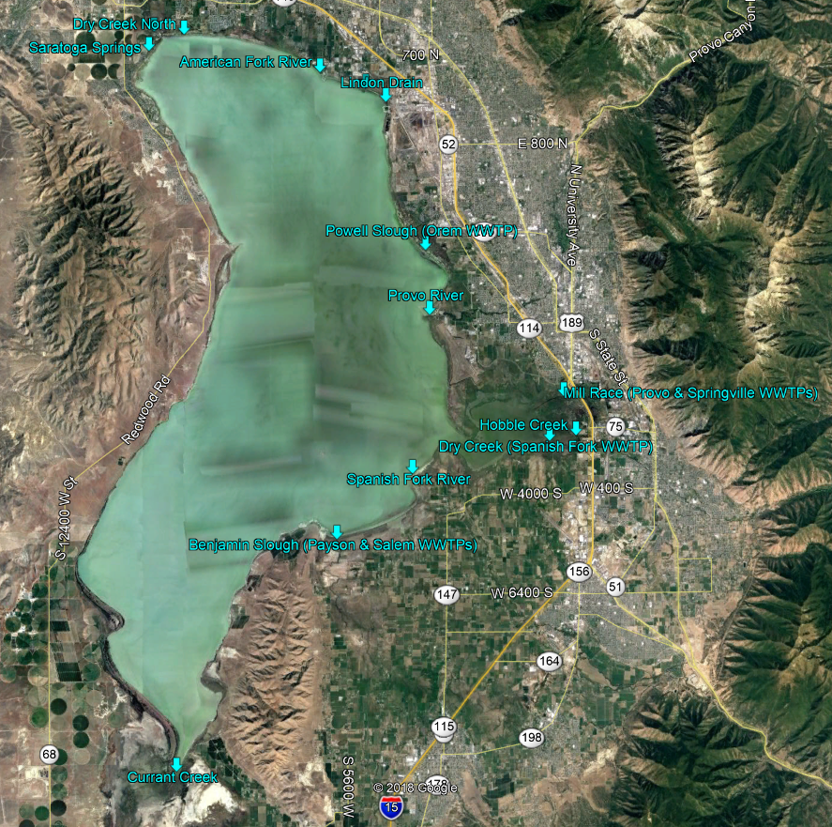

Figure .. Data Sources for Inflow Locations for Water Temperature and Suspended Solids into the Utah Lake Model

#### Inflow Quality for Other Constituents- WASP

For this exercise, the AWQMS database (UDWQ 2019) and the WWTP DMRs via the ECHO database (EPA 2019) were employed for retrieving the inflow quality data for populating several water quality constituents for the Utah Lake WASP. At the same time, the USGS water data are employed for populating any groundwater inflows (water quality) in the Utah Lake WASP. The following table (Table 2.4) lists the inflow, corresponding Utah Lake I and J node, the UDWQ AWQMS/DMR site for populating quality data, and the application of such inflow data into the Utah Lake WASP.

Table .. Inflow Quality Data Sources into Distinct Nodes for the Utah Lake WASP

|  |  |  |  |  |
| --- | --- | --- | --- | --- |
| **Inflow** | **Node I and J** | **Source** | **Site ID (Station Name)** | **Distribution into WASP** |
| Provo River | I=21; J=27 | UDWQ AWQMS | 4996690 (Provo R at U114 Xing) | Even All Layers |
| American Fork River | I=14; J=39 | UDWQ AWQMS | 4994960 (American Fk Ck 2.5 Mi S of Am Fk City) | Even All Layers |
| Spanish Fork River | I=19; J=19 | UDWQ AWQMS | 4995580 (Spanish Fork R Ab Utah L (Lakeshore)) | Even All Layers |
| Hobble Creek | I=26; J=21 | UDWQ AWQMS | 4996100 (Hobble Ck at I-15 Bdg 3 Mi S of Provo) | Even All Layers |
| Dry Creek North | I=7; J=41 | No Data |  | Even All Layers |
| Currant Creek | I=6; J=3 | No Data |  | Even All Layers |
| Lindon Drain | I=17; J=37 | No Data |  | Even All Layers |
| Saratoga Springs | I=6; J=40 | No Data |  | Even All Layers |
| Timpanogos WWTP | I=17; J=38 | AWQMS, DMR | AWQMS: 4995040 (Timpanogos WWTP); DMR: Timpanogos | Even All Layers |
| Dry Creek South/  Spanish Fork WWTP | I=26; J=20 | AWQMS, DMR for Spanish Fork WWTP | AWQMS: 4996020 (Spanish Fork WWTP); DMR: Spanish Fork | Even All Layers |
| Benjamin Slough/  Beer Creek/Payson WWTP, Salem WWTP | I=15; J=16 | AWQMS, DMR for Payson + Salem WWTP | AWQMS: 4995410 (Payson WWTP), 4995440 (Salem WWTP); DMR: Payson, Salem | Even All Layers |
| Mill Race/  Provo WWTP, Springville WWTP | I=27; J=23 | AWQMS, DMR for Provo + Springville WWTP | AWQMS: 4996560 (Provo WWTP), 4996280 (Springville WWTP); DMR: Provo, Springville | Even All Layers |
| Powell Slough/  Orem WWTP | I=20; J=30 | AWQMS, DMR for Orem WWTP | AWQMS: 4995250 (Orem WWTP); DMR: Orem | Even All Layers |
| Groundwater- Northern Valley | I=13; J=34 | No Data |  | Into K = 1 |
| Groundwater- Southern Valley | I=11; J=19 | USGS | 401414111435301 | Into K = 1 |
| Groundwater-  Provo Bay | I=24; J=21 | USGS | 401325111410901 | Into K = 1 |
| Groundwater-  Goshen Bay | I=6; J=10 | USGS | 400325111552501 | Into K = 1 |

Meanwhile, as displayed in Table 2.3, several inflows have applied WWTP DMRs for populating inflow quantity data into the Utah Lake EFDC. Hence, as displayed in Table 2.4, the inflow quality for the corresponding WWTPs, involving the UDWQ AWQMS sites and the WWTP DMRs, is implemented as quality data for the Utah Lake WASP. At the same time, since the Utah Lake WASP calculates a constituent mass load as flow multiplied by concentration (e.g., Load = Flow*Concentration), any inflows indicated as exhibiting no data from Table 2.3 do not have any water quality concentrations populated as well, given that the mass loading will equate to 0 (e.g., Load = Flow*Concentration = 0*Concentration = 0) and that no corresponding site data can be retrieved. The following table (Table 2.5) provides the water quality parameters by species for the inflow data for DMRs, AWQMS sites, and the USGS groundwater sites.

Table .. Constituents Retrieved from the DMRs, AWQMS Sites, and the USGS Sites

|  |  |  |  |
| --- | --- | --- | --- |
| **Species of Interest** | **Constituents from DMRs** | **Constituents from AWQMs** | **Constituents from USGS Sites** |
| Nitrogen | Nitrogen, Ammonia Total (as N); Nitrite + Nitrate Total (as N); Nitrogen, Kjeldahl, Total (as N) | NH3-N, NO2-NO3-N, DON, TKN, DN | 00608 (Ammonia (NH3 + NH4+), Water, Filtered), 00610 (00608 (Ammonia (NH3 + NH4+), Water, Unfiltered), 00631 (Nitrate plus Nitrite, Water, Filtered) |
| Phosphorus | Ortho-P; Phosphate, Total (as P) | DP, TP | 00666 (Phosphorus, Water, Filtered), 00671 (Orthophosphate, Water, Filtered) |
| BOD | BOD (5-day) | BOD (5-day), CBOD (5-day) | N/A |
| Oxygen | DO | DO | 00300 (Dissolved Oxygen, Water, Unfiltered) |
| Solids | Solids, Total Suspended | TSS | N/A |
| Chlorophyll-a | N/A | CHLA | N/A |
| Others | pH | pH, Alkalinity | 00400 (pH, Water, Unfiltered), 00403 (pH, Water, Unfiltered, Laboratory), 39086 (Alkalinity, Water, Filtered) |

Several approximations were made based upon the characteristics observed over the AWQMS sites, along with the WWTP DMRs. Such approximations and approaches have been explained below.

* **DON Concentrations from AWQMS, DMRs, and USGS:** None of the AWQMS sites, DMRs, and the USGS groundwater sites exhibit DON inflow data for the simulation period that can be directly populated into the model. Hence, inflow data for distinct nitrogen species are retrieved for calculating DON through the formulation of either DON = TKN – NH3-N (e.g., TKN = DON + NH3-N) or DON = DN – NH3-N – NO2-NO3-N (e.g., DN = NH3­-N + NO2-NO3-N + DON). Linear interpolation is further applied upon the inflow data of distinct nitrogen species (e.g., NH3-N, NO2-NO3-N) for calculating the DON concentration per time stamp.
* **Total Phosphorus Speciation:** Since WASP requires the user to input inflow quality data for each of DIP and DOP, the AWQMS sites and the WWTP DMRs yielding inorganic and total phosphate cannot be directly populated into the Utah Lake WASP. Therefore, based on the constituents displayed in Table 2.5, DOP is calculated through subtracting the TP concentration by ortho-P (e.g., DOP = TP – orthoP) for WWTP DMR/USGS groundwater site or by DP for AWQMS site.
* **Concentration Data for AWQMS Sites:** The AWQMS sites employed for the Utah Lake model described in Table 2.4 typically appear to not exhibit inflow data covering the entire model calibration period (October 1, 2005 to September 30, 2015). For this exercise, the inflow data corresponding to 10/1/2005 at 12 PM and 10/1/2015 at 12 AM along inflows that only incorporate AWQMS sites are substituted with an averaged value among all the inflows per constituent corresponding to September/October per year (or closest to such months). For instance, if an AWQMS site only exhibits data from 2009-2011, then the inflow concentration at 10/1/2005 and 10/1/2015 are substituted with an averaged value among inflows for 9/2009, 10/2009, 9/2010, 10/2010, 9/2011, and 10/2011.
* **Elemental Mass Balance Conducted for Benjamin Slough and Mill Race:** Some of the Utah Lake inflows employ the inflow quality for 2 WWTPs, involving Benjamin Slough (Payson WWTP, Salem WWTP) and Mill Race (Provo WWTP, Springville WWTP). For this exercise, a spreadsheet model was developed for populating the inflows per WWTP followed by calculating a daily inflow concentration through an elemental mass balance, applying linear interpolation among the WWTP inflow data. Such spreadsheet models were developed for conducting elemental mass balances upon Payson and Salem WWTPs followed by Provo and Springville WWTPs.
* **Application of TSS Data for Simulating Sediment Transport and Populating Inflows:** Ideally, the solids transport is simulated in the Utah Lake WASP, applying inflow quality data for ISS that is calculated by TSS – TVS. On the other hand, none of the AWQMS sites, the DMRs, and the USGS sites exhibit data for TVS for calculating ISS along the model calibration period for the Utah Lake WASP (2005-2015). Therefore, the Utah Lake WASP currently simulates TSS through 3 distinct classes (as described in the following section, Section 2.2.9.2) and employs TSS inflow data.
* **Calculation of Ultimate CBOD/BOD:** WASP requires the user to specify inflow quality for ultimate CBOD, which all the AWQMS sites and DMRs only provide CBOD/BOD after 5 days. Hence, the following formulation is implemented for calculating and populating ultimate CBOD from the provided CBOD/BOD data.

$$L_{0}=\frac{L_{t}}{1-\exp\left(-kt\right)} \left(2.2\right)$$

As indicated in Equation 2.2, the ultimate CBOD $L_{0}$ is computed from the CBOD/BOD concentration at time *t, $L_{t}$* , based on an oxidation rate *k* that is approximated as 0.2 per day. For this exercise, Equation 2.2 is implemented upon all AWQMS sites and DMRs containing CBOD/BOD data for populating ultimate CBOD needed for the Utah Lake WASP.

### Experimental and Literary Parameters for WASP

For this exercise, experimental parameters are provided through collaborations with Dr. Ramesh Goel’s research group for populating particular model inputs for the Utah Lake WASP. At the same time, literary review is further conducted for deriving pertinent parameters describing the underlying processes for WASP, involving phytoplankton/algal speciation, sediment diagenesis processes, etc. This sub-section documents the data sources and approximations implemented for the phytoplankton speciation and the sediment diagenesis processes under the WASP component for Utah Lake.

#### Phytoplankton Speciation

For this exercise, 4 phytoplankton groups and 1 macro/benthic algal group are implemented into the Utah Lake WASP, based on experimental sampling conducted by Dr. Ramesh Goel’s Group. The following phytoplankton and algal groups are simulated through the Utah Lake WASP.

* Diatoms, with emphasis on *Bacillariophyta* (Phytoplankton Group 1)
* Cyanobacteria *Aphanizomenon Gracile* (Phytoplankton Group 2); Group is nitrogen-fixed
* Cyanobacteria *Synechococcus* (Phytoplankton Group 3); Group is NOT nitrogen-fixed
* Green Algae, with *Stigeoclonium Subsecundum (Chlorophyceae)* (Phytoplankton Group 4)
* *Stigeoclonium Subsecundum (Chlorophyceae)* for K = 1 (Benthic Algae; this is indicated as Green Algae and thus simulated as a Benthic/Macro Algae in the Utah Lake WASP)

The Utah Lake WASP requires the user to populate the reaction kinetics per phytoplankton/algal group, involving the maximum growth rate, respiration rate, and the death rate at $20℃$. Meanwhile, stoichiometric ratios are further required per phytoplankton/algal group, involving carbon-to-phosphorus, carbon-to-nitrogen, and carbon-to-chlorophyll-a. Furthermore, the Utah Lake WASP requires the user to implement a maximum growth rate, with a net growth rate computed based on the maximum growth rate multiplied by the corresponding nutrient (NH3-N, NO2-NO3-N, DIP) concentrations with a temperature-correction coefficient followed by being subtracted by the respiration, settling, and death rates. Hence, if the net growth rate appears relatively small (e.g., nearly 0 per day) or negative (e.g., less than 0 per day, indicating net decay), then the phytoplankton group appears rather unresponsive throughout the model simulation period, yielding chlorophyll-a concentrations at nearly 0 $μ$ g/L. At the same time, WASP adjusts a kinetic parameter (e.g., growth rate) as a function of water temperature through the relationship $k_{T}=k_{20℃}θ^{T-20}$, determining the parameter at a water temperature *T*, $k_{T}$, relative to the one measured at $20℃$, $k_{20℃}$, adjusted based a temperature-correction coefficient $θ$. The following table (Table 2.6) provides the maximum growth rate at $20℃$ for the distinct phytoplankton groups, along with the data sources/approximations applied for deriving such values.

Table .. Maximum Growth Rates per Phytoplankton/Algal Group Populated into the Utah Lake WASP

|  |  |  |
| --- | --- | --- |
| **Phytoplankton Group** | **Maximum Growth Rate**  **at $20℃$**  **(per day)** | **Data Source/Approximations** |
| Diatoms (Emphasis on *Bacillariophyta*) | 7 | Flynn et al. (2018) multiplied by 5 |
| Cyanobacteria (Emphasis on *Aphanizomenon Gracile*) | 6.8 | Net growth rate (0.68 per day) provided by Li and Dr. Goel multiplied by 10; Speciation described in Li et al. (2019) |
| Cyanobacteria (Emphasis on *Synechococcus*) | 4.4 | Net growth rate (0.44 per day) provided by Li and Dr. Goel multiplied by 10; Speciation described in Li et al. (2019) |
| Green Algae (*Stigeoclonium Subsecundum (Chlorophyceae)*) | 2 | Net growth rate (0.06 per day) provided by Li and Dr. Goel adjusted to 2 per day as the minimum max growth rate; Speciation described in Li et al. (2019) |

For this exercise, the respiration, death, and settling rates are inputted as model calibration parameters for each phytoplankton group. The following table (Table 2.7) displays the maximum growth rate, respiration rate, the death rate at $20℃$, and the settling rate, applying a default temperature-correction coefficient (1.07) for all phytoplankton/algal groups.

Table .. Kinetics (Growth, Respiration, Death, and Settling) at 20 Degrees Celsius for Distinct Phytoplankton/Algal Groups into Utah Lake WASP

|  |  |  |  |  |
| --- | --- | --- | --- | --- |
| **Phytoplankton/Algal Group** | **Maximum Growth Rate at $20℃$**  **(per day)** | **Respiration Rate at $20℃$**  **(per day)** | **Death Rate at $20℃$**  **(per day)** | **Settling Rate (m/day)** |
| Diatoms (*Bacillariophyta*) | 7 | 0.1 | 0.005 | 0.05 |
| Cyanobacteria (*Aphanizomenon Gracile*) | 6.8 | 0.1 | 0.005 | 0.05 |
| Cyanobacteria (*Synechococcus*) | 4.4 | 0.1 | 0.005 | 0.05 |
| Green Algae (*Stigeoclonium Subsecundum (Chlorophyceae)*) as Phytoplankton Group | 2 | 0.042* | 0.005 | 0.05 |
| *Stigeoclonium Subsecundum*  *(Chlorophyceae)* as Benthic Algae | 2 | 0.042* | 0.005 | N/A |
| * Value employed for Jordan River WASP, as documented in Su (2019) | | | | |

The Utah Lake WASP requires one to specify the stoichiometric ratios per phytoplankton/algal group, involving carbon-to-nitrogen, carbon-to-phosphorus, carbon-to-chlorophyll-a, and carbon-to-detritus (POM). The following table (Table 2.8) provides the carbon-to-nitrogen-to-phosphorus ratios derived, the associated literary citation, and the calculated values per phytoplankton/algal group into the Utah Lake WASP.

Table .. Referenced and Calculated Stoichiometric Ratios for each Phytoplankton Group

|  |  |  |  |  |
| --- | --- | --- | --- | --- |
| **Phytoplankton/**  **Algal Group** | **C:N:P Ratio**  **(or separate C:N, C:P ratios)** | **Reference** | **Calculated Nitrogen-to-Carbon Ratio (mg N/mg C)** | **Calculated Phosphorus-to-Carbon Ratio**  **(mg P/mg C)** |
| Diatom (*Bacillariophyta*) | 6:1 for C:N, 91.75:1 for C:P | Median Values for 12 species from Garcia et al. (2018) | 0.1667 | 0.01103 |
| Cyanobacteria (*Aphanizomenon Gracile*) | 106:20:1 | Bernan (2001) | 0.1887 | 0.009434 |
| Cyanobacteria (*Synechococcus*) | 17.3:5.9:1 | Jover et al. (2014) | 0.3410 | 0.05780 |
| *Stigeoclonium Subsecundum* | 40 g-C:7200 mg-N:1000 mg P | Martin et al. (n.d.) | 0.18 | 0.025 |

For this exercise, default values are implemented upon all other kinetics and parameters per phytoplankton group not included in Table 2.7 and Table 2.8. Meanwhile, uniform fractions (e.g., 33.3% per group) are applied for populating initial conditions per phytoplankton group.

#### Atmospheric Deposition

In addition to the inflow quality data populated into the Utah Lake WASP, atmospheric deposition for selected constituents are implemented into the model. The following table (Table 2.9) summarizes the list of constituents for atmospheric deposition, with the associated reference and method of application for the Utah Lake WASP.

Table .. Atmospheric Deposition for Distinct Constituents, Values Employed, and Methods

|  |  |  |  |  |  |  |
| --- | --- | --- | --- | --- | --- | --- |
| **Water Quality Constituent** | **Model State Variable** | **Method of Implementation into WASP** | **Value** | **Units** | **Reference** | **Notes on Calculated Value Methodology** |
| Ammonia | NH3-N | Steady-State | 0.3477 | mg/m2-day | Brahney (2019) | Wet + Aerosol Deposition |
| Nitrate | NO2-NO3-N | Steady-State | 0.2053 | mg/m2-day | Brahney (2019) | Wet + Aerosol Deposition |
| Organic Nitrogen | DON | Steady-State | 0.7091 | mg/m2-day | Brahney (2019) | Total N – Ammonia – Nitrate Deposition |
| Ortho-phosphate | DIP | Steady-State | 0.009185 | mg/m2-day | Brahney (2019) | Wet Avg + (Water Soluble Fraction*TP) |
| Organic Phosphate | DOP | Steady-State | 0.01205 | mg/m2-day | Brahney (2019) | Organic Fraction*TP |
| Carbon Dioxide | pH, Alkalinity | Every 10 years | N/A | atm | IPCC (2013) | Historical for 2000/01; RCP 8.5 for 2010/01 and 2020/01 |

As indicated in Table 2.9, the atmospheric deposition of nutrients (nitrogen and phosphorus species) is applied into the Utah Lake WASP as steady-state values. In other words, a single value per nutrient is implemented throughout the entire model calibration period (October 1, 2005 to September 30, 2015), employing the results derived by Brahney (2019). At the same time, the atmospheric partial pressure of carbon dioxide is implemented through employing the historical and RCP 8.5 that is indicated as the “business-as-usual” scenario, applying a single value for every 10 years (e.g., 01/2000, 01/2010, 01/2020). (Although pH and alkalinity are not incorporated into the model calibration work for Utah Lake due to issues described in Section 7.2, such documentation over the partial pressure of CO2 is included for describing the data sources needed for simulating such constituents.)

#### Sediment Diagenesis

For simulating sediment diagenesis processes, WASP requires the user to define the initial conditions for the particulate species (e.g., PON, POC, POP), the sediment diagenesis segmentation (e.g., number of nodes with sediment diagenesis), and the fraction distribution among the G classes. Different data sources are retrieved and implemented for populating the model input needed for simulating sediment diagenesis, as explained below.

* **Initial POP Sediment Conditions:** The initial POP sediment conditions are retrieved from Hogsett et al. (2019) that have conducted sampling over the phosphorus speciation of sediments over Utah Lake. For this exercise, initial POP sediment conditions are populated by applying the residual phosphorus speciation from Hogsett et al. (2019), adding additional sites with approximated values for ensuring coverage of the entire Utah Lake, and implementing a spatial interpolation technique for calculating an initial POP condition per Utah Lake node. The following figure (Figure 2.5) displays the sites sampled by Hogsett et al. (2019) and the added sites for incorporating the entire Utah Lake.

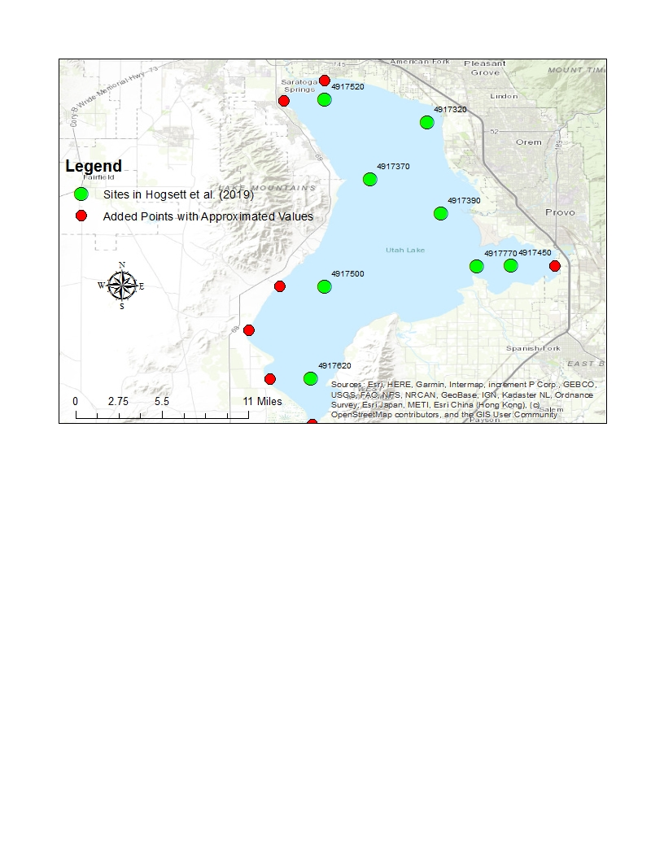

Figure .. Sites and Added Points from Hogsett et al. (2019) for Approximating Initial POP Sediment Conditions

As indicated in Figure 2.5, initial POP conditions equivalent to the neighboring ones retrieved from Hogsett et al. (2019) are implemented upon the added sites. (Each site retrieved from Hogsett et al. (2019) exhibits geographical coordinates equivalent to the corresponding UDWQ AWQMS site ID and applies the residual form for phosphorus speciation under units of mg P/g sediment.) Then, spatial interpolation techniques are applied for calculating the initial POP sediment conditions that covers the entire Utah Lake based on the sites from Hogsett et al. (2019) and the added sites. Based on the spatial interpolation techniques implemented (e.g., natural neighbor, splining, IDW, ordinary kriging, universal kriging, etc.), IDW has been selected for this exercise for approximating the initial POP sediment conditions over the entire Utah Lake. The following figure (Figure 2.6) displays the implementation of the IDW along the sites retrieved from Hogsett et al. (2019) and the added sites for incorporating the entire Utah Lake.

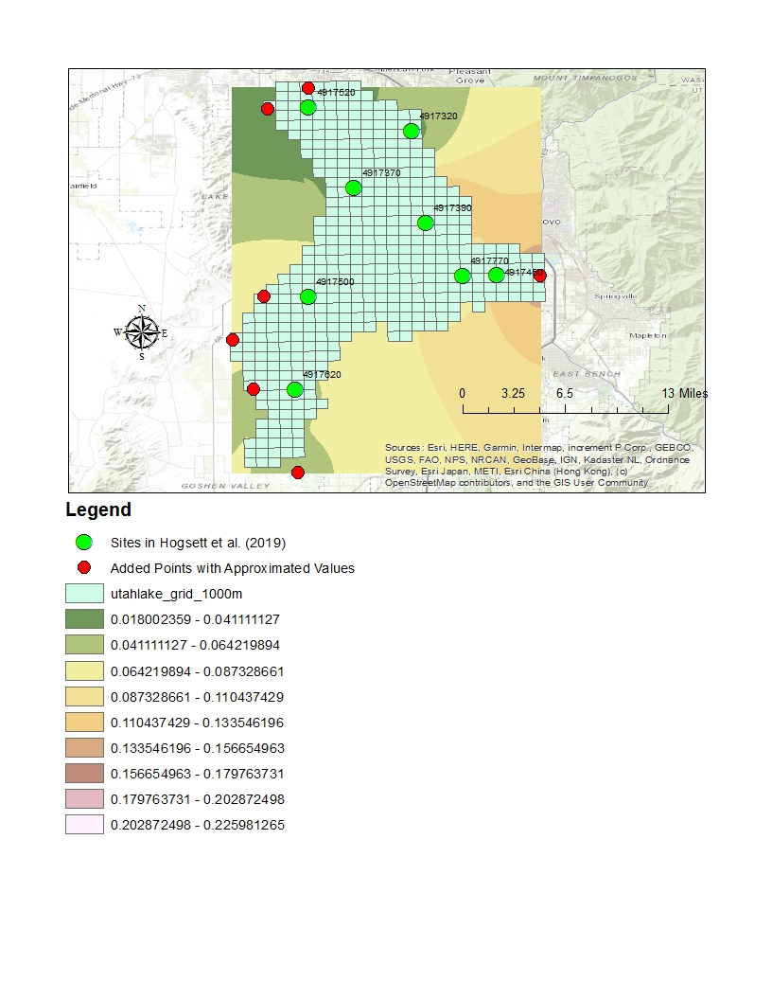

Figure 2.6. IDW Interpolation Technique for Initial POP Sediment Condition (mg P/g sediment) along Utah Lake

Once IDW has been implemented, zonal statistics are applied for calculating an average value for the initial POP sediment condition per node, yielding one value per node. Such average value per node is then populated into the Utah Lake WASP as the initial POP sediment condition for simulating sediment diagenesis.

* **Fraction of POC, PON, and POP into G Classes:** WASP further requires the user to specify the fraction of the particulate species (PON, POC, POP) into separate G classes, involving G1 (labile), G2 (refractory), and G3 (inert), per node for which sediment diagenesis is enabled. Paraska et al. (2014) has provided suggested values for the distinct G classes based on the sediment diagenesis mechanism implemented. On the other hand, Paraska et al. (2014) appears to exhibit highly variable values, ranging from as low as 0-5% to up to 90-99%, for the distinct G fractions, with no suggested single value to employ per G class. At the same time, as the Utah Lake model exhibits wetting and drying mechanisms, higher fractions for the G1 (labile) and G2 (refractory) classes as compared to G3 (inert) are applied for this exercise for avoiding the Utah Lake WASP from requiring significant simulation times (e.g., 20+ hours for simulating over 1 day). Hence, for the Utah Lake WASP, values of 0.4 are implemented for G1 (labile) and G2 (refractory) while a value of 0.2 is applied for G3 (inert) for all nodes.
* **Utah Lake Nodes Subject to Sediment Diagenesis:** Simulating sediment diagenesis routines upon all nodes that are indicated as K = 1 (most bottom) seems to adversely affect the performance of the Utah Lake WASP. For instance, if such sediment diagenesis routines are implemented upon all K = 1 nodes, then the Utah Lake WASP simulates relatively slowly, requiring several hours for the model to run over 1 day (e.g., running from 10/3/2005 to 10/4/2005). Such significant simulation times appear to be due to the wetting and drying mechanisms over the Utah Lake WASP, which simulating sediment diagenesis over the nodes subject to drying appears to instigate lengthy run times. Consequently, not all the K = 1 nodes have the sediment diagenesis routines enabled, which the K = 1 nodes are selected based on their elevation relative to the compromise elevation. In other words, all the K = 1 nodes that are indicated as wet throughout the entire model simulation period are selected for simulating sediment diagenesis while having the Utah Lake WASP run within a reasonable timeframe (e.g., a couple of hours). Based on assessments conducted for determining the number of K = 1 nodes for enabling sediment diagenesis, all the K = 1 nodes that exhibit an elevation below –3.25 meters relative to the compromise elevation simulate sediment diagenesis. Such application yields approximately 189 out of 452 K = 1 grids that potentially exhibit sediment diagenesis routines. On the other hand, the implementation of 189 out of 452 K = 1 grids with sediment diagenesis appears to still have the Utah Lake model run relatively slowly, requiring several hours (e.g., 20+ hours for 1 single day of simulation). Hence, an additional criterion of $I≥10$ is implemented for further reducing the number of K = 1 nodes with sediment diagenesis. Such implementation has the Utah Lake WASP run throughout the model calibration period (October 1, 2005 to September 30, 2015) within a reasonable timeframe (e.g., a couple of hours), yielding a total of 157 out of 452 K = 1 nodes with sediment diagenesis enabled. The following figure (Figure 2.7) displays the K = 1 nodes along the Utah Lake WASP that exhibit separate sediment diagenesis segments and hence simulate sediment diagenesis (e.g., nutrient fluxes, SOD, etc.).

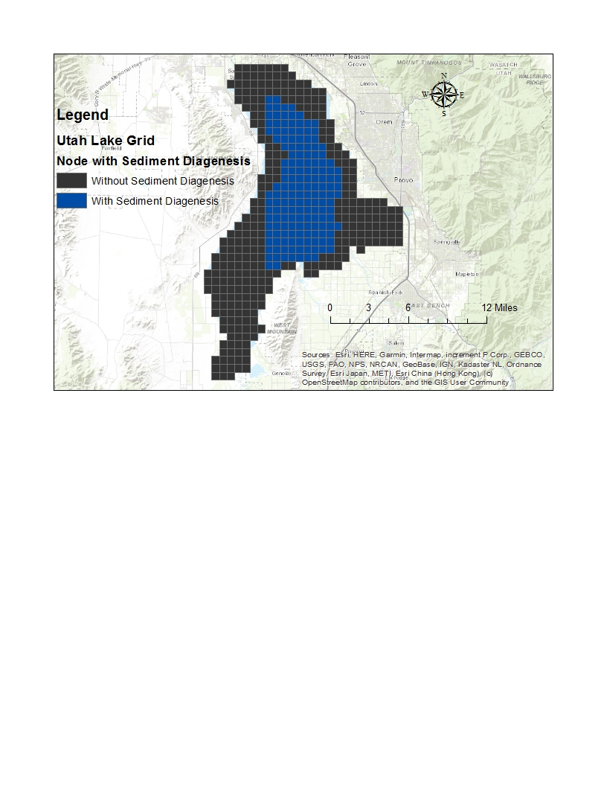

Figure .. K = 1 Nodes along the Utah Lake WASP with and without Sediment Diagenesis Enabled

As indicated in Figure 2.7, only 157 out of the 452 K = 1 grids have the sediment diagenesis routines enabled, which the application of such criteria (e.g., Elevation below -3.25 meters, node I of at least 10) appear to have the Utah Lake WASP run within a relatively reasonable timeframe (e.g., within a few hours for simulating over 10 water years). On the other hand, although such implementation has the Utah Lake WASP appear to run within a relatively reasonable timeframe, such applications indicate that most of the K = 1 nodes do not exhibit nutrient fluxes and SOD. Hence, the Utah Lake WASP intends to employ the following methodology for potentially incorporating nutrient fluxes and SOD throughout all K = 1 nodes.

* The K = 1 Nodes that follow the criteria of Elevation below -3.25 meters and $I≥10$ have sediment diagenesis segments enabled, with one separate sediment diagenesis segment per K = 1 node (e.g., 1-to-1 ratio among sediment diagenesis segment to K = 1 node).
* The K = 1 Nodes that appear to not follow such criteria do not simulate sediment diagenesis and hence have nutrient fluxes and SOD applied as input. For this exercise, data has been retrieved from Hogsett et al. (2019) for populating prescribed nutrient fluxes (ammonia and DIP) and SOD, employing the water column results for ammonia benthic flux, orthophosphate benthic flux, and SOD from the sites involved (same sites represented in Figure 2.5). Similar methodologies as those for approximating initial POP sediment conditions are applied for each of the nutrient fluxes and SOD, adding additional sites (as those from Figure 2.5) for ensuring coverage of the entire Utah Lake, implementing the IDW interpolation technique, and calculating averages for a mean nutrient flux/SOD per K = 1 node. The average nutrient flux and SOD per K = 1 node are populated into the Utah Lake WASP as prescribed nutrient fluxes (ammonia benthic flux, DIP benthic flux) and SOD, with the prescribed SOD being adjusted with a temperature-correction coefficient of 1.07.

In other words, the intent involves simulating sediment diagenesis upon the K = 1 nodes that satisfy the criteria applied (e.g., elevation below -3.25 meters, $I≥10$) while implementing prescribed nutrient fluxes and SOD for other K = 1 nodes. On the other hand, WASP seems to only either simulate sediment diagenesis, with the nutrient fluxes and SOD serving as output, or adjust the nutrient fluxes and SOD based on temperature-correction coefficients. Hence, the nutrient fluxes and SOD values inputted into the Utah Lake WASP appear to be neglected from such simulations.

### Solar Radiation Attenuation

EFDC does not have a parameter for albedo, or water surface reflectance of solar radiation; however, the SOLRCVT parameter can be used to adjust the input solar radiation by a multiplier. The albedo is dependent on sun angle, cloud cover, and waves on the water surface. EFDC has three parameters for light attenuation through the water column: fast scale solar shortwave radiation attenuation coefficient (SWRATNF, *βf*), slow scale solar shortwave radiation attenuation coefficient (SWRATNS, *βs*), and fraction of solar shortwave radiation attenuated fast (FSWRATF, *r*). The following formula is used to calculate solar shortwave radiation (*I)* at a given water depth, *z*:

$$I_{z}=rI_{0}e^{-β_{f}z}+\left(1-r\right)I_{0}e^{-β_{s}z} \left(2.3\right)$$

For shallow water bodies without stratification, FSWRATF is set to 1.0 and SWRATNS is set to 0, which results in the need to specify only one light attenuation coefficient. Based on measured photosynthetically active radiation (PAR) profiles measured during 2019 by UDWQ, the median light attenuation coefficient (*ke*) was determined to be 1.57 /m (Brett 2019).

For solar radiation attenuation, WASP further applies light extinction that involves the background light extinction coefficient, the POM and solids light extinction coefficient, and the dissolved organic carbon (DOC) light extinction coefficients. Meanwhile, WASP8 allows the implementation of an albedo for describing the water surface reflectance for solar radiation, with a default value of 0.06 applied. At the same time, WASP8 further implements the fraction of light for photosynthetically-active radiation (PAR) and the fraction for defining photic zone. For the Utah Lake WASP, default values are implemented for populating the fraction of light for PAR, the fraction of light for photic zone, and albedo. Meanwhile, Stantec Consulting Ltd. (2010) is implemented for populating initial values for light extinction coefficients (e.g., background light extinction, detritus and solids light extinction, DOC light extinction, etc.), applying sensitivity analyses and model calibration for deriving a value for the Utah Lake WASP.

### Wave Characteristics

Wave information was not inputted into the EFDC model. Linkage to a numerical wave model such as Simulating Waves Nearshore (SWAN) has not been implemented as part of this project.

### Sediment Transport

Sediment transport is simulated under both the hydrodynamic (e.g., EFDC) and the water quality (e.g., WASP) components for the Utah Lake model.

#### Sediment Characterization and Classes for EFDC

Sediment was separated into three total classes (1 non-cohesive and 2 cohesive sediment classes):

1. Sand sized class (non-cohesive)
2. Silt/clay sized class (cohesive)
3. Carbonates class (cohesive)

#### Sediment Classes, Data Sources, and Approximations for WASP

For this exercise, since WASP applies both the cohesive and non-cohesive sediment transport processes for simulating solids, the Utah Lake WASP has sediment characterized into the 3 following classes, employing a minimum average particle diameter per class based on the Massachusetts Institute of Technology (Das and Sobhan 2014).

1. Sand-Sized Class: Average Particle Size of 0.06 mm
2. Silt-Sized Class: Average Particle Size of 0.02 mm
3. Clay-Sized Class: Since the Massachusetts Institute of Technology appears to not exhibit a minimum average particle size for clay (Das and Sobhan 2014), an average particle size of 0.01 mm is employed for this sediment class.

For implementing the 3 sediment classes into the Utah Lake WASP, the percentage per sediment class (e.g., % sand, % silt, % clay) is derived based on both the sediment characterization experimental analyses conducted by Dr. Ramesh Goel’s Group and the sediment mineralogy provided by Hogsett et al. (2019). The following procedures have been implemented for deriving percentage per sediment class (% sand, % silt, % clay) along per Utah Lake node.

1. The average particle size followed by percent finer is calculated based on the hydrometer tests conducted by Dr. Ramesh Goel’s Group, applying the underlying theory described by Bas and Sobhan (2014), per sampling site of Utah Lake.
2. The minimum average particle size described by the Massachusetts Institute of Technology (Bas and Sobhan 2014) is applied for determining % sand (D > 0.06 mm) and % silt + clay (D < 0.06 mm) per sampling site of Utah Lake.
3. Since the data calculated from the hydrometer tests are conducted over multiple depths (0-5 cm, 5-15 cm, 15-30 cm from the lake bottom) per sampling site, an average value is calculated for yielding a single value for % sand and % silt + clay per sampling site.
4. Similar methodologies as those for calculating initial POP sediment conditions (as described in Section 2.2.6.3) are applied for approximating % sand and % silt + clay per node, adding additional sites for ensuring coverage of the entire Utah Lake shown in the following figure (Figure 2.8). Each additional site exhibits similar values populated for % sand followed by % silt + clay as the sediment characterization sampled site closest to it.

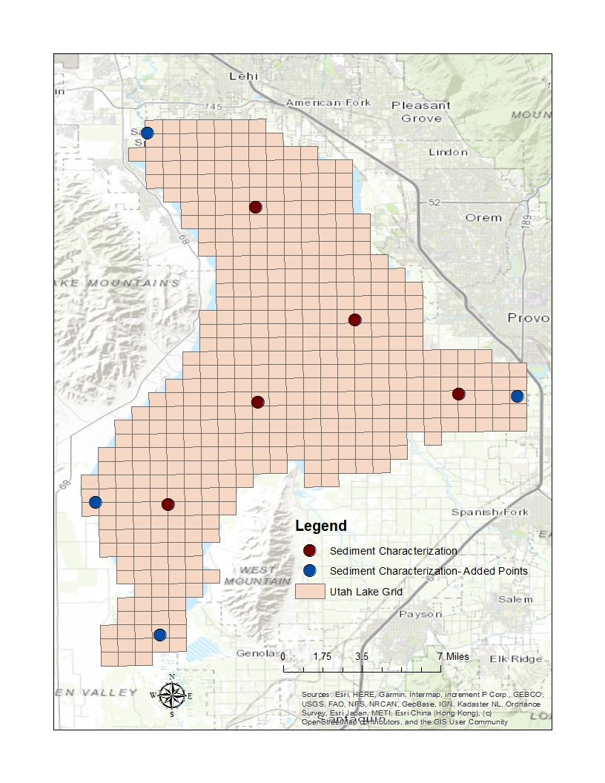

Figure 2.8. Sediment Characterization Sites along Utah Lake for % Sand and % Silt + Clay

1. The IDW interpolation technique is implemented for approximating % sand followed by % silt + clay along Utah Lake, and zonal statistics are then applied for yielding an average % sand and % silt + clay per Utah Lake node.
2. The % clay is then derived among the sites sampled by Hogsett et al. (2019) through summation of the % Illite, % Smectite, % Kaolinite, and % Calcite (e.g., all those identified as part of the clay group). Step 4 is repeated for approximating % clay per Utah Lake node, which the % sand + clay is then subtracted by such result for yielding % silt.

The derived % sand, % silt, and % clay are implemented into the Utah Lake WASP through the TSS inflow data and the TSS initial condition derived per node. For instance, the TSS inflow from the Provo River into the Utah Lake WASP is multiplied by the % sand, % silt, and % clay derived for the node corresponding to the Provo River (e.g., I = 21, J = 27) for yielding the sand, silt, and clay concentrations. (Note that such calculations can be conducted upon populating the inflow concentrations and initial conditions for the distinct sediment classes since similar inflow quantity is implemented for all sediment classes throughout the entire model calibration period.)

### Initial Conditions

For this exercises, initial conditions are implemented for representing water quality and hydrodynamic characteristics of Utah Lake for October 2005. Data sources and approximations are applied for representing initial conditions needed for the hydrodynamic (e.g., EFDC) followed by the initial water quality concentrations for WASP.

#### Initial Conditions for the Hydrodynamic (EFDC) Model

Initial conditions were input for the following variables:

1. Water Temperature: Mean temperature of all sites on the sampling date closest to start of simulation uniformly applied over the lake.
2. Bed Temperature: Assumed value uniformly applied over the lake bottom.
3. Suspended Sediment Concentration: Mean inorganic suspended sediment concentration of all sites on the sampling date closest to start of simulation uniformly applied over the lake.
4. Bed Sediment Concentration: Assumed value uniformly applied over the lake bottom.

#### Initial Conditions for the Water Quality (WASP) Model

Initial conditions are implemented for selected water quality constituents, employing the UDWQ AWQMS sites along Utah Lake.

* Nitrogen Species: NH3-N, NO2-NO3-N, DON
* Phosphorus Species: DIP, DOP
* DO, CBOD
* pH, Alkalinity
* Phytoplankton, Chlorophyll-a (distributed evenly among all 4 groups)
* Macro/Benthic Algae Chlorophyll-a (as Chlorophyll-a, Uncorrected for Pheophytin) for K = 1 only
* Sand, Silt, Clay: Due to the quality of the TVS data among the measured sites (as discussed in Section 2.2.5.2 for inflows), TSS data are employed for approximating initial conditions for sand, silt, and clay concentrations along Utah Lake. The sand, silt, and clay concentrations per Utah Lake node is computed through multiplying the TSS concentration by the % sand, % silt, and % clay, respectively, approximated per node (through methods described in Section 2.2.9.2).

For this exercise, the AWQMS site data that appears closest to October 1, 2005 are directly implemented for populating initial conditions for such constituents described above. Meanwhile, for an AWQMS site that appear to not exhibit data around 10/2005 for a particular constituent, the initial condition is approximated through averaging the September and October data for other years. For instance, a site not exhibiting measured data around 10/1/2005 for CBOD will have its initial condition populated as an averaged CBOD concentration from 09/2006, 10/2006, 09/2007, 10/2007, and up to 10/2015 (the end of the model calibration period). (Note: Such approximations are applied to sites that do not exhibit data for 10/2005 while still exhibiting measured data for September and October of other years, with a maximum of 5 years from 2005. For instance, a site exhibiting data for 2011 and after or 2000 and before is neglected from the approximations for initial conditions.) Similar methodologies as those for approximating initial POP sediment conditions (Section 2.2.6.3) and sediment characterization (Section 2.2.9.2) are implemented for yielding initial conditions per constituent per Utah Lake node. The following figure (Figure 2.9) provides the AWQMS sites (measured and approximated data for 10/1/2005) with the additional sites subject to such spatial interpolation techniques (e.g., IDW) for populating initial conditions for the constituents described above.

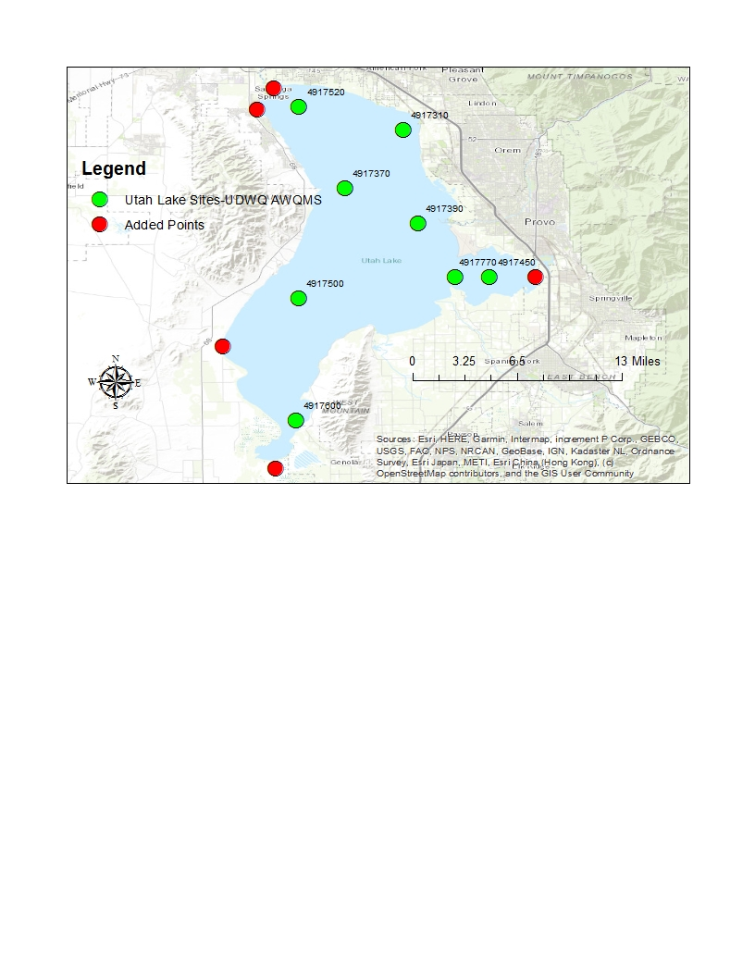

Figure 2.9. AWQMS Sites for Approximating Initial Conditions per Node for Selected Constituents throughout Utah Lake

Then, once the IDW interpolation technique and zonal statistics for yielding average values per constituent per water column are applied, the initial conditions approximated are implemented uniformly along all vertical layers (e.g., K = 1 to K = 3) per water column.

# Model Sensitivity

For this exercise, separate sensitivity analyses are conducted over the EFDC and WASP models for assessing the sensitivity of the hydrodynamics and water quality performance of the Utah Lake models, respectively. Discussions over the input model parameters applied for the sensitivity analyses, the results for such variations per parameter, and the significance of such input parameters upon the model performance are described in this section, with separate sub-sections for each of EFDC and WASP.

## Sensitivity Analyses for EFDC

A sensitivity analysis was conducted on a selection of the EFDC temperature model parameters. The sensitivity analysis was conducted by simulating a range of values for a given model parameter while holding all other model parameters fixed.

* Figure 3.1 compares the water temperature when simulated with and without cloud cover fraction. Including the cloud cover fraction increased the water temperatures across the entire range.
* Figure 3.2 compares the water temperature when simulated with and without water solar radiation surface reflectance (SOLRCVT of 0.92 and 1.0, respectively). Accounting for the water surface reflectance of solar radiation decreased the water temperatures across the entire range.
* Figure 3.3 compares the water temperature under varying solar radiation attenuation coefficients (*ke* of 1.57 and 10.0). The attenuation coefficient had minimal effect on lower water temperatures, with slightly decreased water temperatures at the upper end of the range. The effect of the attenuation coefficient was more pronounced at the lower depth in the water column.

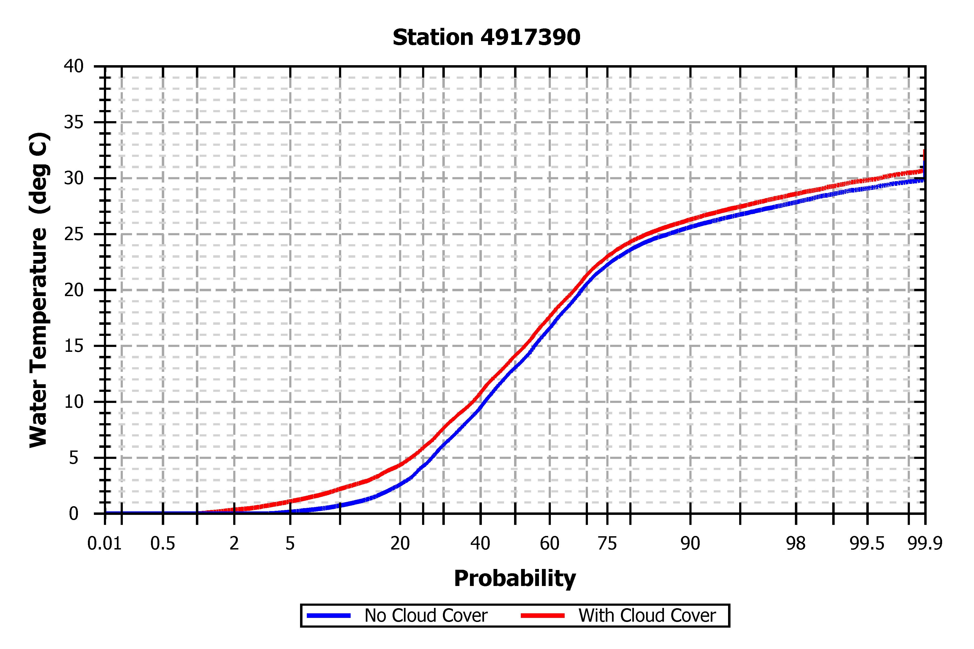

Figure .. Probability Plot of Water Temperature at Provo Buoy Station with and without Cloud Cover

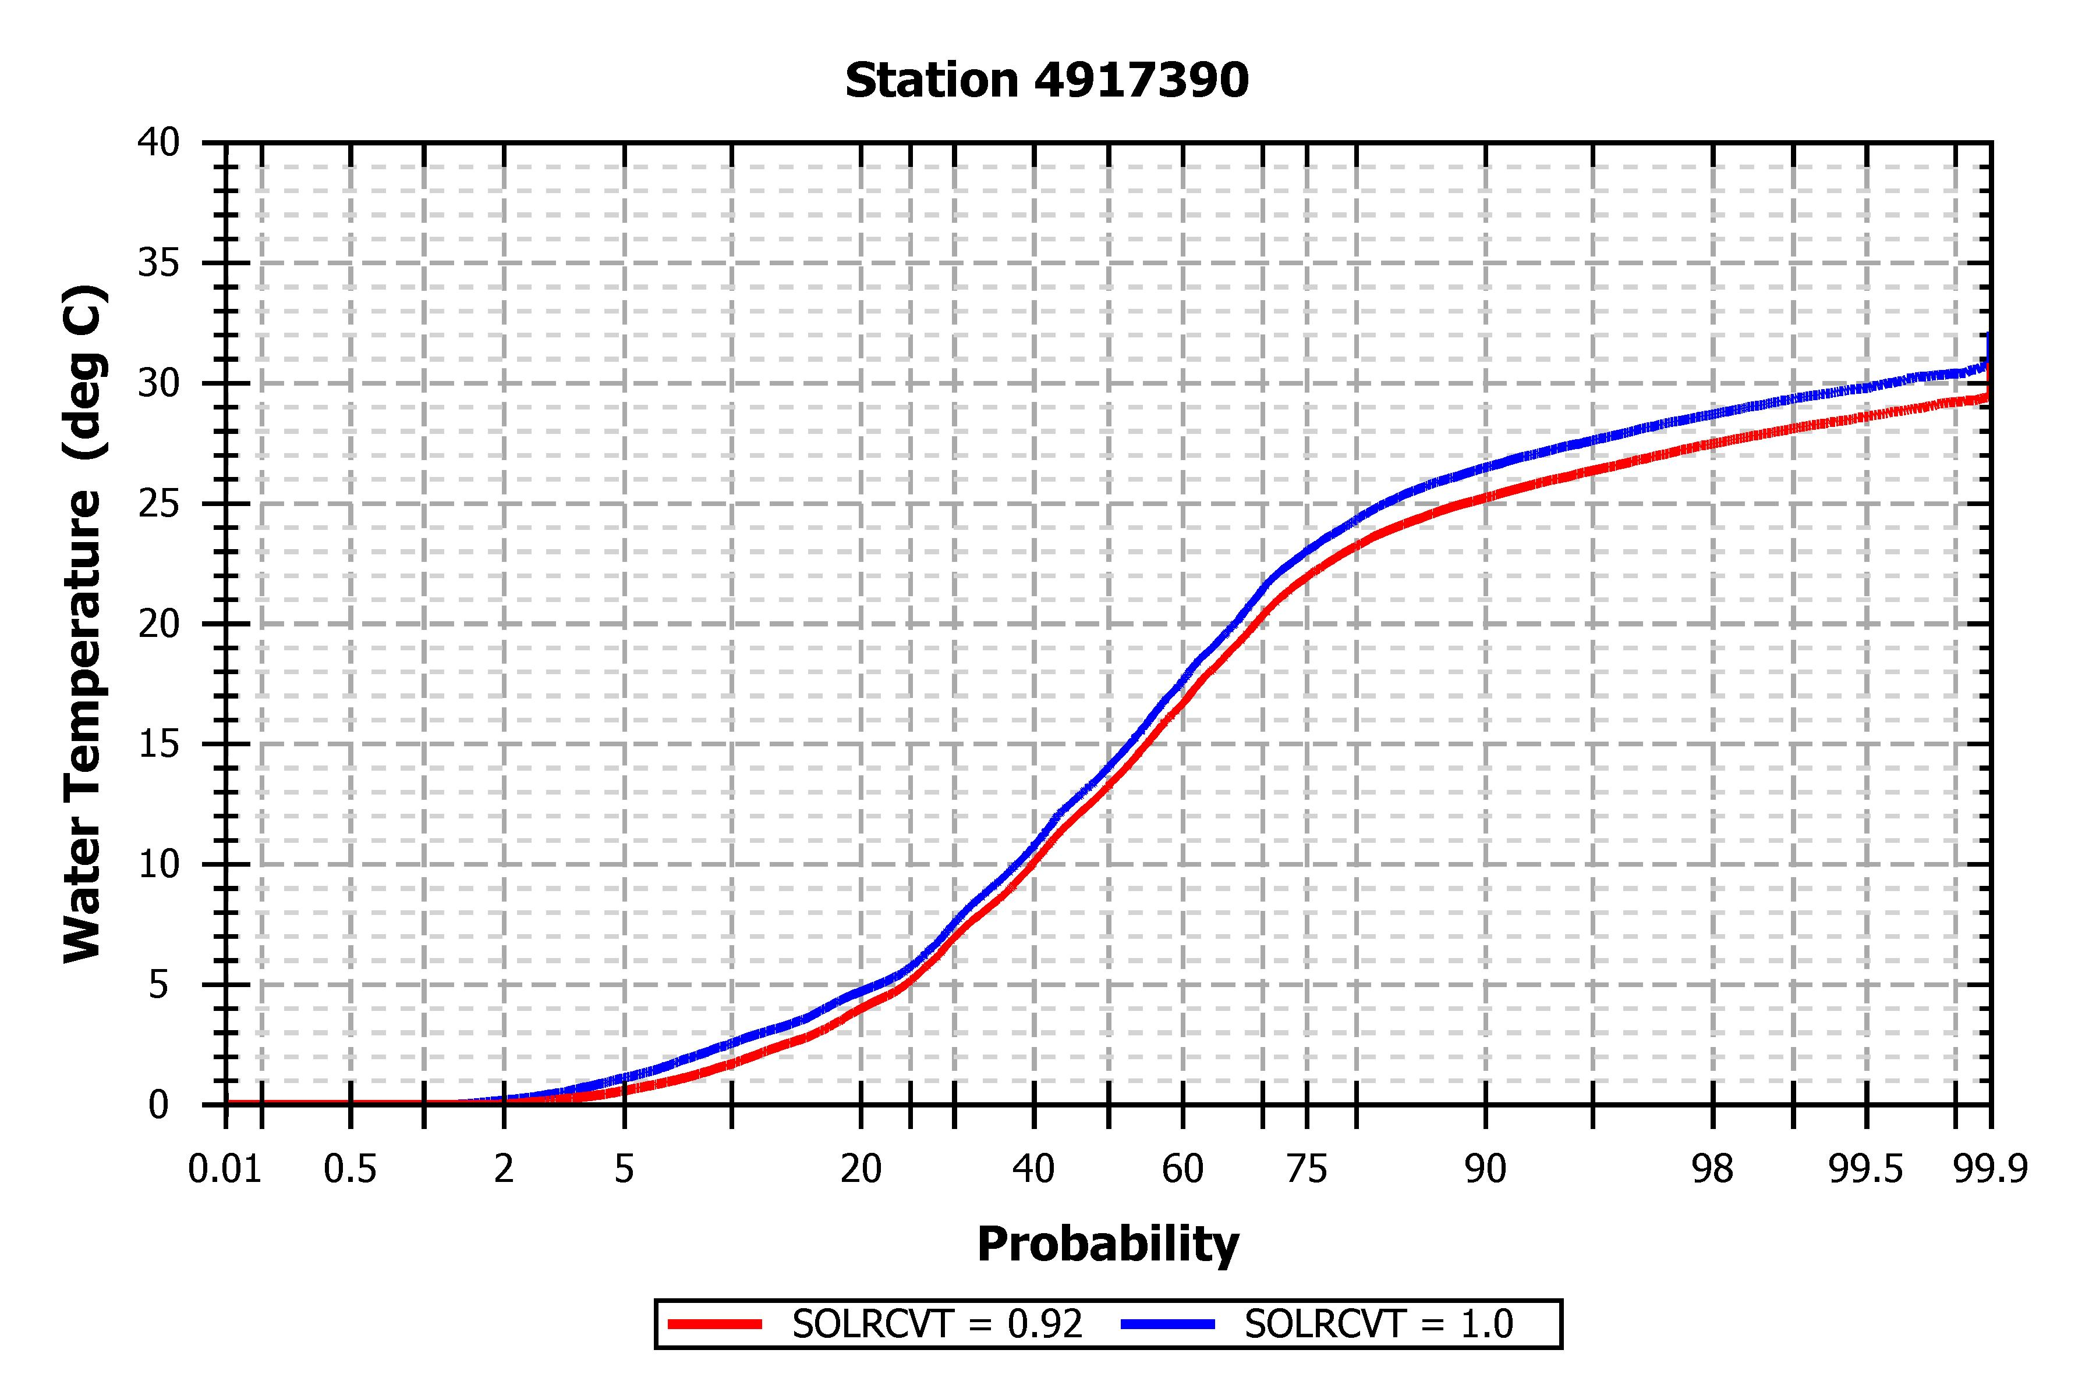

Figure .. Probability Plot of Water Temperature at Provo Buoy Station with and without Water Surface Reflectance

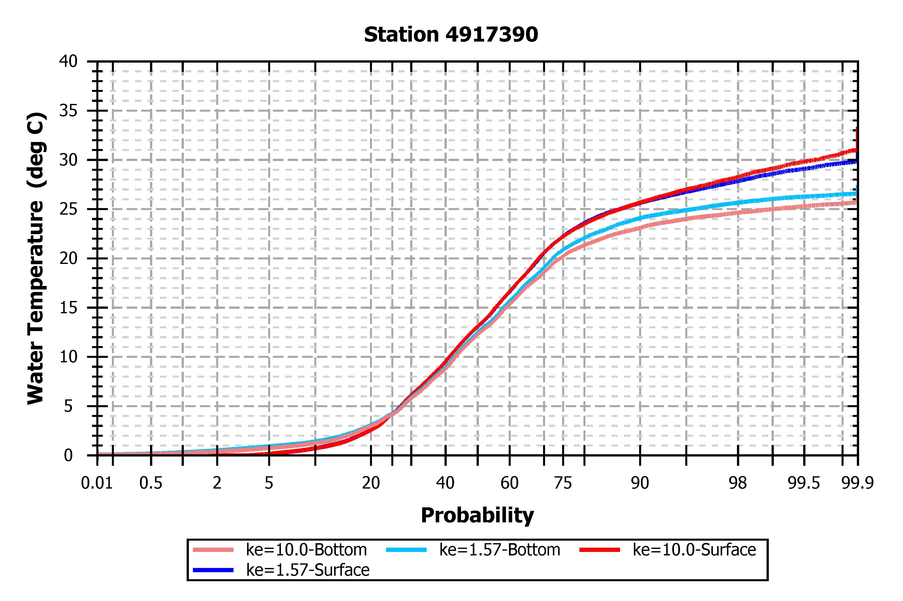

Figure .. Probability Plot of Water Temperature at Provo Buoy Station with Varying Solar Radiation Attenuation Coefficients

## Sensitivity Analyses for WASP

WASP requires the user to input time-series, multipliers, constants, etc. for simulating several processes that affect the performance of several constituents described in Section 1.4. Hence, not all input parameters are selected for conducting sensitivity analyses upon the Utah Lake WASP, which only the nutrient kinetics (e.g., nitrification and denitrification rates, mineralization rate, etc.), phytoplankton kinetics (e.g., maximum growth rate, respiration rate, death rate (non-zooplankton predation)) and settling, algal kinetics, light parameters, and sediment diagenesis inputs for initial particulate conditions are applied for the exercise. The following table (Table 3.1) describes the list of parameters organized by nutrient/process for which sensitivity analyses are conducted upon.

Table .. Input Parameters Applied for Sensitivity Analyses upon the Utah Lake WASP

|  |  |
| --- | --- |
| **Constituent** | **WASP Model Parameters (Units)** |
| Nitrogen  (NH3-N, NO2-NO3-N, DON) | * Nitrification Rate at $20℃$ (per day) * Denitrification Rate at $20℃$ (per day) * Dissolved Organic Nitrogen Mineralization Rate at $20℃$ (per day) |
| Phosphorus (DIP, DOP) | * Orthophosphate Partition Coefficient to Water Column Solids, Silt and Clay (L/kg) * Dissolved Organic Phosphorus Mineralization Rate at $20℃$ (per day) |
| Phytoplankton, Benthic/  Macro Algae | * Phytoplankton Maximum Growth Rate at $20℃$ (per day) * Phytoplankton Respiration Rate at $20℃$ (per day) * Phytoplankton Settling Rate (m/day) * Phytoplankton Death Rate Constant (Non-zooplankton Predation; per day) * Fraction of Segment Covered by Benthic Algae (Fraction; dimensionless) * Macro/Benthic Algae Maximum Growth Rate (per day) * Macro/Benthic Algae O2:C Production (mg O2/mg C) |
| POM and  Sediment Diagenesis | * POM Dissolution Rate at $20℃$ (per day) * POM Settling Rate (m/day) * Initial POC Sediment Condition (mg O2 equivalents/g sediment) * Initial PON Sediment Condition (mg N/g sediment) |
| Lighting | * Background Light Extinction Coefficient (1/m) * Detritus/POM and Solids Light Extinction Coefficient (1/m) * DOC Light Extinction Coefficient (1/m) |

The values applied in the sensitivity analyses per input parameter for the Utah Lake WASP are described in Appendix A.1. Typically, 2 methods for sensitivity analyses are conducted, with the method depending on the model input parameter, and are described as follows.

* **By Percentage/Factor (Applied to all Parameters except for O2:C Production):** Sensitivity analyses are conducted through decreasing the value by 99%, 90%, 75%, and 50% followed by increasing the value by 2 times the amount, 4 times the amount, 10 times the amount, and 100 times the amount. On the other hand, particular values for model input parameters, such as the phytoplankton maximum growth rate, seem to instigate issues with the model performance, which the model appears to require significant simulation times (e.g., several hours, etc.) if such values are specified. Hence, not all input parameters described in Table 3.1 are subject to such variations for the sensitivity analyses conducted, with the actual values applied documented in Appendix A.1. Meanwhile, for the benthic/macro algae coverage, the fraction is increased to a maximum of 100% (e.g., fraction of 1)
* **By Value:** For the algae O2:C production, sensitivity analyses are simply conducted by increasing the value to a particular amount, with negative values allowed for indicating decreasing relationships among benthic/macro algae and DO.

Example plots for the sensitivity analyses conducted for the exercise are provided in Appendix A.2. Based on the sensitivity analyses conducted, the following characteristics are observed regarding the model input parameters.

* **Nutrient Kinetics:** Example plots over the sensitivity analyses conducted upon the input parameters affecting the nutrient kinetics (e.g., nitrification, denitrification, phytoplankton growth, etc.) are provided in Appendix A.2.1.
  + **Nitrification Rate:** The nitrification rate affects primarily the performance of NH3-N and NO2-NO3-N, which increasing this parameter should decrease the NH3-N concentration while increasing the NO2-NO3-N concentration. On the other hand, altering this parameter seems to generally exhibit minor effects upon the concentrations of such constituents.
  + **Denitrification Rate:** The denitrification rate affects primarily the performance of NO2-NO3-N, which increasing this parameter should decrease the NO2-NO3-N concentration. On the other hand, altering this parameter appears to generally exhibit minor effects upon the concentration of this constituent.
  + **DON Mineralization Rate:** The DON mineralization rate affects primarily the performance of DON, which increasing this parameter should decrease the DON concentration. Altering this parameter appears to exhibit variable effects upon the DON concentration depending on the node. For instance, the nodes along Goshen Bay (e.g., nodes with J < 10) appear to have the DON mineralization rate exhibit more significant effects upon the DON concentration. On the other hand, nodes along the Provo Bay (e.g., nodes with I > 20, 19 < J < 24) appear to have the DON mineralization rate exhibit rather minor effects upon the DON concentration, disregarding the significant effects during particular time periods (e.g., summer months of 2007, 2013, etc.).
  + **Orthophosphate Partitioning to Water Column Solids:** The Orthophosphate Partitioning to Water Column Solids affects primarily the performance of DIP (and hence TP), which increasing this parameter should decrease the DIP (and thus TP) concentration. This parameter appears to exhibit significant effects upon the DIP and thus TP concentrations only when this parameter is increased to a relatively high value (e.g., 5 L/kg, 50 L/kg).
  + **DOP Mineralization Rate:** The DOP mineralization rate affects primarily the performance of DOP (and hence TP), which increasing this parameter should decrease the DOP (and thus TP) concentration. Such relationships among the DOP Mineralization Rate and the TP concentration appear observed but only when the DOP mineralization rate is increased beyond 1 per day (e.g., 5 per day, 50 per day).
  + **Phytoplankton Maximum Growth Rate:** The Phytoplankton Maximum Growth Rate affects the performance of phytoplankton growth, which is combined based on the inorganic nutrient concentrations, settling rates, respiration rates, and the death rate for yielding net growth (or net decay). Increasing the phytoplankton maximum growth rate appears to increase the phytoplankton chlorophyll-a concentration but seems to significantly increase the Utah Lake WASP simulation time.
  + **Phytoplankton Respiration Rate:** The Phytoplankton Respiration Rate affects the performance of phytoplankton chlorophyll-a, DON, and DOP. For instance, increasing the phytoplankton respiration rate decreases the phytoplankton chlorophyll-a concentration. Meanwhile, since WASP allows the user to specify fractions of phytoplankton respiration recycled to DON and DOP, increasing the respiration rate appears to increase both DON and DOP. On the other hand, increasing the phytoplankton respiration rate significantly may instigate the phytoplankton to appear to not respond, yielding nearly 0 $μ$ g/L throughout the entire model simulation period. Hence, one appears recommended to not increase the phytoplankton respiration rate to such a significant value so that one can observe response by phytoplankton, particularly during the summer and fall months.
  + **Phytoplankton Death (Non-zooplankton Predation):** The phytoplankton death (from non-zooplankton predation) seems to affect the performance of phytoplankton chlorophyll-a, PON, POP, SOD, and DO. For instance, increasing the phytoplankton death rate (non-zooplankton predation) decreases the phytoplankton chlorophyll-a concentration. At the same time, since WASP allows the user to specify fractions of phytoplankton death recycled to PON and POP, altering the phytoplankton death appears to affect the PON and POP concentrations. Hence, since PON and POP affect the sediment diagenesis simulations, SOD followed by DO may be further affected by the phytoplankton death rate (non-zooplankton predation). Increasing the phytoplankton death appears to decrease the phytoplankton chlorophyll-a concentration, PON, POP, and SOD, particularly at relatively high death rates (e.g., 0.5 per day), with minor effects observed upon DO. One appears to hence be recommended to not increase the phytoplankton death rate significantly (e.g., 0.05 per day, 0.5 per day, etc.) as such relatively high death rates may instigate the lack of phytoplankton response.
  + **Macro/Benthic Algae Fraction Coverage:** Increasing the fraction of each node covered by benthic algae (green algae for the Utah Lake WASP) appears to only increase the benthic algae chlorophyll-a and TN concentrations within the first few water years (e.g., Water Year 2006 to 2009). Then, after Water Year 2010, negligible effects upon the algae chlorophyll-a and TN concentrations appear observed when the fraction covered by benthic algae is increased (even up to 100% coverage). Meanwhile, relatively minor effects upon the TP and DO concentrations appear observed when such fractions are increased (even up to 100%). Note that such sensitivity analyses over this parameter are conducted under the case of applying benthic algal coverage upon all vertical layers (K = 1 to K = 3), which similar characteristics appear expected for algal coverage being applied upon the K = 1 layer only.
  + **Macro/Benthic Algae Maximum Growth Rate:** The Algae Maximum Growth Rate appears to affect both the algae chlorophyll-a and DO concentrations, which increasing this parameter increases the concentrations of both constituents. Hence, one appears recommended to not increase the maximum growth rate to a relatively high value (e.g., 4 per day, 20 per day, etc.) for avoiding high DO concentrations. For instance, as indicated in the example plots provided in Appendix A.2.1, increasing the maximum growth rate to over 4 per day seems to yield algal chlorophyll-a concentrations at nearly 10000 $μ$ g/L followed by DO concentrations above 40 mg/L. Note that such sensitivity analyses over this parameter are conducted under the case of applying benthic algal coverage upon all vertical layers (K = 1 to K = 3), which similar characteristics appear expected for algal coverage being applied upon the K = 1 layer only.
  + **Macro/Benthic Algae O2:C Production:** Specifying positive values for this input parameter increases the DO concentration as the algae chlorophyll-a increases, with DO concentrations up to 30-40 mg/L for an O2:C Production of 2.69 mg O2/mg C. Similarly, inputting negative values for this input parameter decreases the DO concentration when the algae chlorophyll-a increases, with DO concentrations below 5 mg/L for particular water years (e.g., Water Year 2014, 2015) for an O2:C Production of -2.69 mg O2/mg C. Hence, the algae O2:C Production appears to generally exhibit significant effects upon the DO concentration, with input values closer to 0 indicating weaker linkages among algae and DO. Note that such sensitivity analyses over this parameter are conducted under the case of applying benthic algal coverage upon all vertical layers (K = 1 to K = 3), which similar characteristics appear expected for algal coverage being applied upon the K = 1 layer only.
  + **POM Dissolution Rate:** The POM/Detritus Dissolution Rate appears to exhibit effects upon POC, PON, POP, and DO concentrations. Increasing the POM/Detritus Dissolution Rate appears to decrease the POC concentration, with the concentrations appearing “more sensitive” at layers 2 (K = 2; middle layer) and 1 (K = 1; bottom/benthic layer). Similarly, increasing the POM/Detritus Dissolution Rate appears to decrease SOD though the DO concentration appears to decrease also, with the DO concentrations at layers 2 (K = 2) and 1 (K = 1) approaching nearly 0 mg/L. On the other hand, the POM Dissolution Rate appears to exhibit a rather unique relationship with PON and POP, which increasing the POM Dissolution Rate can increase PON and POP during the summer and fall months while decreasing PON and POP during the spring and winter months.
  + **Initial POC Sediment Condition:** Increasing the initial POC sediment condition appears to increase the POC concentration and SOD, thus decreasing the DO concentration. Such characteristics appear observed, particularly for the sub-surface layers (K = 2 and K = 1) and for high initial POC sediment conditions (e.g., at 5 mg O2 equivalents/g sediment, at 50 mg O2 equivalents/g sediment, etc.). On the other hand, near the end of the model simulation (e.g., Water Year 2013 to 2015), altering the initial POC sediment conditions appears to exhibit rather minor to negligible effects upon POC, SOD, and DO.
  + **Initial PON Sediment Condition:** Increasing the initial PON sediment condition appears to increase the PON concentration and SOD, thus decreasing the DO concentration. Such characteristics appear observed, particularly for the sub-surface layers (K = 2 and K = 1) and for high initial PON sediment conditions (e.g., at 5 mg N/g sediment, at 50 mg N/g sediment, etc.). On the other hand, near the end of the model simulation (e.g., Water Year 2013 to 2015), altering the initial PON sediment conditions appears to exhibit rather minor to negligible effects upon PON, SOD, and DO.
* **Settling Rates:** Example plots over the sensitivity analyses conducted upon the input parameters representing the settling rates of distinct constituents, primarily phytoplankton and POM, are provided in Appendix A.2.2.
  + **Detritus/POM Settling Rate:** Increasing the POM settling rate appears to generally decrease the POC, PON, and POP concentrations but increases SOD and DO concentration throughout the model simulation period. On the other hand, the increases upon the DO concentration appear rather minor for the surface water layer (e.g., K = 3) when the POM settling rate increases. In other words, such relationships among the POM settling rate, POC, PON, POP, SOD, and DO appear relatively greater for the sub-surface layers (K = 2, K = 1) as compared to the surface water layer (K = 3).
  + **Phytoplankton Settling Rate:** Increasing the phytoplankton settling rate appears to decrease the phytoplankton chlorophyll-a although such decreases appear rather observable only under high settling rates (e.g., 0.5 m/day, 5 m/day, etc.).
* **Lighting:** Example plots over the sensitivity analyses conducted upon the input parameters that represent lighting (e.g., light extinction coefficients) are provided in Appendix A.2.3.
  + **Background Light Extinction Coefficient:** The Background Light Coefficient appears to affect the concentrations of several constituents, involving phytoplankton and algae chlorophyll-a. Increasing the background light extinction coefficient appears to decrease the total phytoplankton chlorophyll-a while seeming to increase algae chlorophyll-a, TN, and TP. On the other hand, although the background light extinction coefficient appears to affect the algae chlorophyll-a that further impacts DO through the O2:C Production coefficient, increasing the background light extinction coefficient seems to not exhibit any effects upon DO.
  + **POM/Detritus and Solids Light Extinction Coefficient:** The Detritus/POM and Solids Light Extinction Coefficient appears to affect the POC, PON, and POP concentrations. Increasing the POM and Solids Light Extinction Coefficient appears to exhibit rather variable effects upon POC, PON, and POP, seeming to increase the concentration during particular periods of the model simulation while decreasing the concentration during other time periods. Similar characteristics appear observed with SOD, which increasing the light extinction coefficient appear to increase/decrease SOD depending on the time period of interest (e.g., winter vs. summer, etc.). At the same time, a light extinction coefficient of 0.34 per m appears to yield the minimal PON, POP, and SOD values throughout the model simulation period. On the other hand, the POM and Solids Light Extinction Coefficient appears to exhibit rather minor to negligible effects upon TSS, disregarding the layer of interest (e.g., K = 1 vs. K = 2, K = 2 vs. K = 3, etc.). The light extinction coefficient appears to exhibit minor to negligible effects upon DO for the surface water layer (K = 3), with such effects becoming more apparent for K = 2 and K = 1.
  + **DOC Light Extinction Coefficient:** Increasing the DOC Light Extinction Coefficient appears to increase the level of noise upon the CBOD and DO concentrations. Otherwise, increasing the DOC light extinction coefficient seems to exhibit rather minor to relatively negligible effects upon both CBOD and DO.

# Model Calibration

This section summarizes the methods and the results of the calibration of model parameters.

## Calibration Procedures

The model calibration procedures and model performance metrics are summarized in the *Quality Assurance Project Plan for the Utah Lake EFDC/WASP Model Development, Modification, Evaluation, and Application: Utah Lake Water Quality Study* (von Stackelberg and Su 2019). Data sources for representing measured data employed in the model calibration efforts are implemented for each of EFDC and WASP. Sub-sections document the model calibration procedures implemented among EFDC and WASP.

### Calibration Procedures for Hydrodynamic Model (EFDC)

The only output variables with observed data during the calibration period were water surface elevation and temperature. The model calibration performance was evaluated using graphical and statistical tests. The following graphical plots were generated to compare the simulated results to the observed data.

1. Time-series plot: Simulated results and observed data with time as a dependent variable.
2. Scatter plot: Plot of simulated results vs. observed data with least square regression to determine deviation form 1:1 line.
3. Probability plot: compare simulated and observed probabilities.

The following statistical tests (precision and bias) were used during model performance assessment.

* Precision is a measure of the variability in the model results relative to measured values. The following statistics will be calculated to evaluate model precision:

1. Root mean square error (RMSE) is defined as the square root of the mean of the squared difference between observed and simulated values.
$$RSME=\sqrt{\frac{1}{n}\sum_{i=1}^{n}{{(O_{i}-P_{i})}^{2}}} \left(4.1\right)$$

2. Coefficient of determination (R2) varies between 0 and 1 and indicates the proportion of the total variation in observations explained by the model.
$$R^{2}={\left[\frac{\sum_{i=1}^{n}{(O_{i}-\overline{O})(P_{i}-\overline{P})}}{\sum_{i=1}^{n}{\sqrt{{(O_{i}-\overline{O})}^{2}}\sqrt{{(P_{i}-\overline{P})}^{2}}}}\right]}^{2} \left(4.2\right)$$

3. Nash-Sutcliffe coefficient of model efficiency (NSE) ranges from minus infinity to 1.0, with higher values indicating better agreement.

$$NSE=1-\frac{\sum_{i=1}^{n}{{\left(O_{i}-P_{i}\right)}^{2}}}{\sum_{i=1}^{n}{{\left(O_{i}-\overline{O}\right)}^{2}}} \left(4.3\right)$$

As indicated in Equations 4.1 to 4.3, each statistical parameter (RSME, R2, NSE) is calculated based on *Oi* = observation, $\overline{O}$ = mean of observations, *Pi* = model prediction, $\overline{P}$ = mean of predictions, and *n* = number of observed-predicted pairs.

* Bias is the systematic deviation or difference between the predicted and observed values. Bias in this context could result from uncertainty in modeling or from the choice of parameters used in calibration.

1. Percent bias (PBIAS) measures the average tendency of the predicted results to be larger or smaller than observed data.

$$PBIAS=\frac{\sum_{i=1}^{n}{(O_{i}-P_{i})}}{\sum_{i=1}^{n}{O_{i}}}*100 \left(4.4\right)$$

### Data and Calibration Procedures for Water Quality (WASP) Model

For this exercise, UDWQ sites within Utah Lake retrieved from the AWQMS database (UDWQ 2019) are employed as sites with measured data for comparing the simulated results from the Utah Lake WASP. The following table (Table 4.1) lists all the UDWQ sites (site ID, name, geographical coordinates) within Utah Lake and the approximated Utah Lake WASP surface water node (e.g., K = 3) applied for the model calibration work.

Table .. UDWQ AWQMS Sites along Utah Lake and the Corresponding Node for the WASP Model Calibration Organized based on Station ID

|  |  |  |  |  |  |
| --- | --- | --- | --- | --- | --- |
| **Station ID** | **Station Name** | **Latitude** | **Longitude** | **Model Node I** | **Model Node J** |
| 4917310 | Utah Lake 300 Ft Offshore from Geneva Steel | 40.321 | -111.768 | 17 | 36 |
| 4917330 | Utah Lake 0.5 Mi W of Geneva Discharge #15-A | 40.321 | -111.778 | 17 | 36 |
| 4917340 | Utah Lake 5Mi N/NW of Lincoln Beach/ 1 Mi Offshore | 40.210 | -111.852 | 10 | 24 |
| 4917370 | Utah Lake W of Provo Boat Harbor/6 Mi N of Lincoln Beach #08 | 40.232 | -111.805 | 14 | 26 |
| 4917380 | Utah Lake 1 Mi East of Pelican Point | 40.268 | -111.830 | 12 | 30 |
| 4917390 | Utah Lake 0.5 Mi S of American Fork Boat Harbor #14 | 40.334 | -111.802 | 14 | 38 |
| 4917400 | Utah Lake 1 Mi West of Provo Boat Harbor | 40.237 | -111.765 | 18 | 27 |
| 4917410 | Utah Lake 1.5 Mi NW of Provo Boat Harbor #16 | 40.260 | -111.767 | 18 | 29 |
| 4917420 | Utah Lake 1 Mi Ne of Pelican Point #10 | 40.288 | -111.837 | 11 | 33 |
| 4917433 | Utah Lake 1 Mi Se of Pelican Point #09 | 40.251 | -111.835 | 11 | 28 |
| 4917450 | Utah Lake Sp @ Marina | 40.238 | -111.739 | 20 | 27 |
| 4917470 | Utah Lake at Middle of Provo Bay | 40.189 | -111.700 | 24 | 21 |
| 4917500 | Utah Lake at Mixing Zone-WLA | 40.187 | -111.675 | 26 | 21 |
| 4917510 | Utah Lake 3 Mi WNW of Lincoln Beach | 40.170 | -111.872 | 8 | 19 |
| 4917520 | Utah Lake 4 Mi E of Saratoga Springs #11 | 40.349 | -111.840 | 11 | 40 |
| 4917530 | Utah Lake 2 Mi E of Saratoga Springs #12 | 40.342 | -111.871 | 8 | 39 |
| 4917600 | Utah Lake 0.7 Mi East of Pelican Point | 40.268 | -111.837 | 11 | 30 |
| 4917620 | Utah Lake Goshen Bay Southwest End | 40.060 | -111.874 | 8 | 7 |
| 4917700 | Utah Lake Goshen Bay Midway Off Main Point on East Shore | 40.085 | -111.884 | 7 | 10 |
| 4917710 | Utah Lake 2.5 Mi NE of Lincoln Point #02 | 40.168 | -111.760 | 18 | 19 |
| 4917770 | Utah Lake 1 Mi NE of Lincoln Point #03 | 40.158 | -111.791 | 15 | 18 |

The Utah Lake node that appears closest to the AWQMS site is selected for comparing the simulated results against the modeled data. Meanwhile, particular AWQMS sites appear to fall either along the center of 2 Utah Lake model nodes or right at the center of 4 Utah Lake model nodes. Under such circumstances, the node directly southeast of the AWQMS site, such as site 4917310, is selected for comparing the simulated results against the measured data while the node directly east of the AWQMS site is selected for sites along the center of 2 model nodes. The following figure (Figure 4.1) provides the geographical locations of the AWQMS sites described in Table 4.1 along the Utah Lake grid.

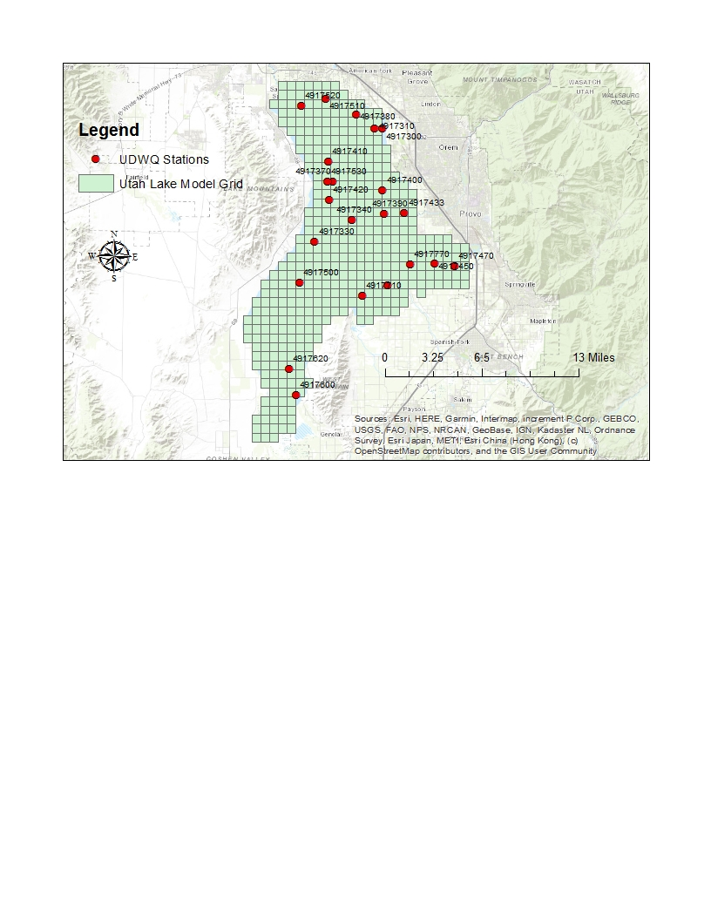

Figure .. Geographical Locations of the UDWQ AWQMS Sites for the Utah Lake Model Calibration Work

The following table (Table 4.2) presents the constituent mapping among the simulated results from the Utah Lake WASP and the measured data from the AWQMS sites. The measured data for the AWQMS UDWQ sites are applied into a separate SDB database file through the Water Resources Database (WRDB), with non-detects approximated as 85% of the Lower Quantification Limit or the Method Detection Level (if the Lower Quantification Limit is not provided). (Note: pH and alkalinity are not included in the model calibration work for the Utah Lake WASP currently due to issues encountered with the model performance. However, such constituents are included into Table 4.2 for future model calibration work as such constituents are included in the SDB database.)

Table .. Constituent Mapping along the Utah Lake WASP and the AWQMS Sites

|  |  |
| --- | --- |
| **Water Quality Constituent from the Utah Lake WASP** | **Corresponding Constituent from the AWQMS UDWQ Sites**  **(and Label/PCode)** |
| pH | pH (pH) |
| Alkalinity | Alkalinity (ALK) |
| Total Solids | Total Suspended Solids (TSS) |
| Dissolved Oxygen | Dissolved Oxygen (DO) |
| Ammonia Nitrogen | Ammonia-Nitrogen (NH3N) |
| Nitrate Nitrogen | Inorganic Nitrogen: Nitrate and Nitrite (NO2NO3N) |
| Total Phosphorus | Total Phosphate-Phosphorus (TP) |
| Total Phytoplankton Chlorophyll-a | Chlorophyll-a and Chlorophyll-a, corrected for Pheophytin (CHLA) |
| Total CBOD | BOD and CBOD, ultimate approximated from standard conditions (5 day) with an oxidation rate of 0.2 per day |

For this exercise, similar calibration performance metrics applied for the Jordan River WASP model calibration work (Su 2019) are implemented for the Utah Lake WASP. In other words, the following graphical and statistical approaches are implemented for assessing the Utah Lake WASP model calibration work.

* **Graphical Approaches:** The time-series of the simulated results per constituent from Utah Lake WASP surface water node are plotted against the measured data for the corresponding constituent for water quality (Table 4.2) of the approximated AWQMS UDWQ site (Table 4.1). Scatter and probability plots are included if the time-series plots appear to not display discrepancies (e.g., underpredicting, overpredicting, etc.) among the simulated results against the measured data and exhibit at least 5 measured data points.
* **Statistical Approaches:** The statistical parameters that are provided through WRDB Graph are employed for assessing the calibration performance of the Utah Lake WASP. The following statistical parameters and the indicated notation by WRDB are reviewed based on the simulated results against the measured data per constituent toward assessing the performance of the Utah Lake WASP.
  + Descriptive Statistics (Mean, Median, 25th Percentile, 75th Percentile)
  + Coefficient of Determination, R2
  + Mean Absolute Error (Mean Abs Err)
  + Root-Mean Square Error (RMS Err)
  + Normalized Root-Mean Square Error (Norm RMS Err)
  + Index of Argument (Index of Argmt)

For this exercise, the model calibration efforts are implemented through minimizing the values for the distinct error parameters (e.g., mean absolute error, RMS error, etc.), maximizing the coefficient of determination, and attempting to yield agreement among the measured data and simulated results for the time-series plots. No other approaches (e.g., autocalibration approaches, Monte Carlo simulations, etc.) are implemented for the Utah Lake WASP model calibration exercise.

## Calibration Performance

This sub-section documents the observed performance of the model calibration for the hydrodynamic (EFDC) and water quality (WASP) components for Utah Lake. Section 4.2.1 documents the model calibration performance (both graphical and statistical) of the EFDC portion against the measured data. Section 4.2.2 provides the general observations for the model calibration performance of the WASP portion against the measured data.

### Calibration Performance of the Hydrodynamic (EFDC) Model

Figure 4.2 depicts the time series plot while Figure 4.3 depicts the scatter plot of the simulated and observed water surface elevation at a grid cell in the middle of the open water portion of the main lake. The statistical performance metrics are summarized in Table 4.3. The water surface elevation was slightly over-predicted for most of the simulation. This is due to the estimation of evaporation from the lake in the water balance calculation, which does not include dry grid cells. In EFDC, dry grid cells that receive precipitation are considered wet until the minimum depth is reached and are subject to evaporation. It was not possible to replicate this model procedure in the water balance calculation.

Table .. Calibration Statistical Performance Metrics for Water Surface Elevation

|  |  |  |  |  |
| --- | --- | --- | --- | --- |
| **Output** | **RMSE** | **R2** | **NSE** | **PBIAS** |
| Water Surface Elevation (m) | 0.059 | 0.995 | 0.991 | 7.4% |

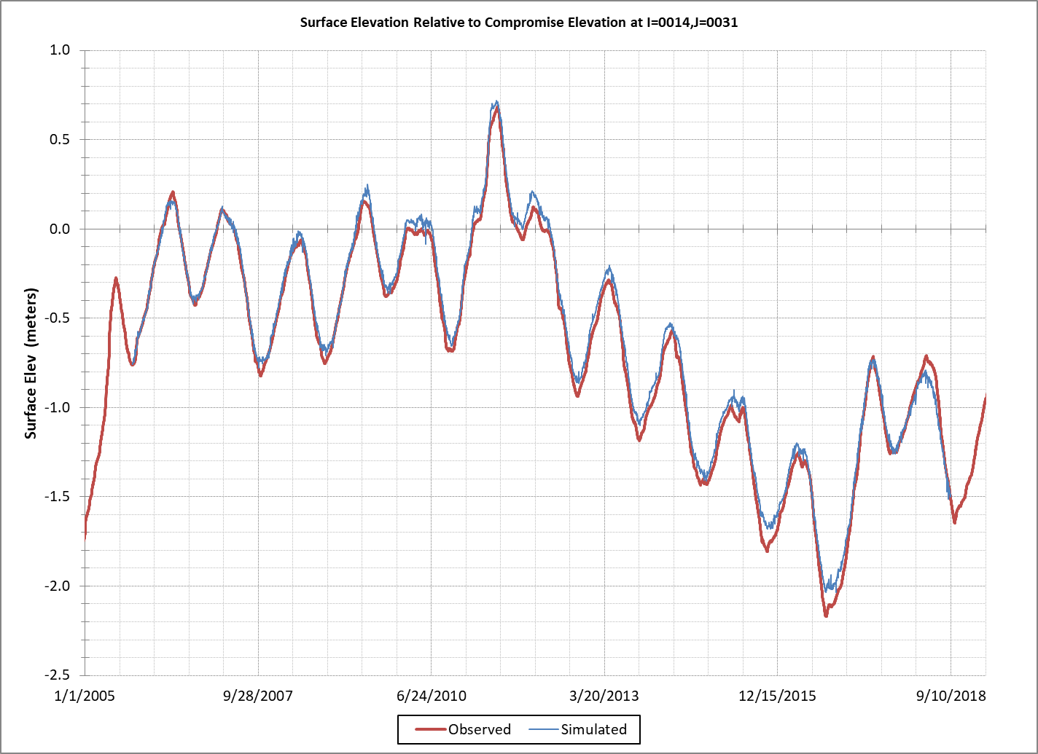

Figure .. Time Series Plot of Simulated vs. Observed Water Surface Elevation

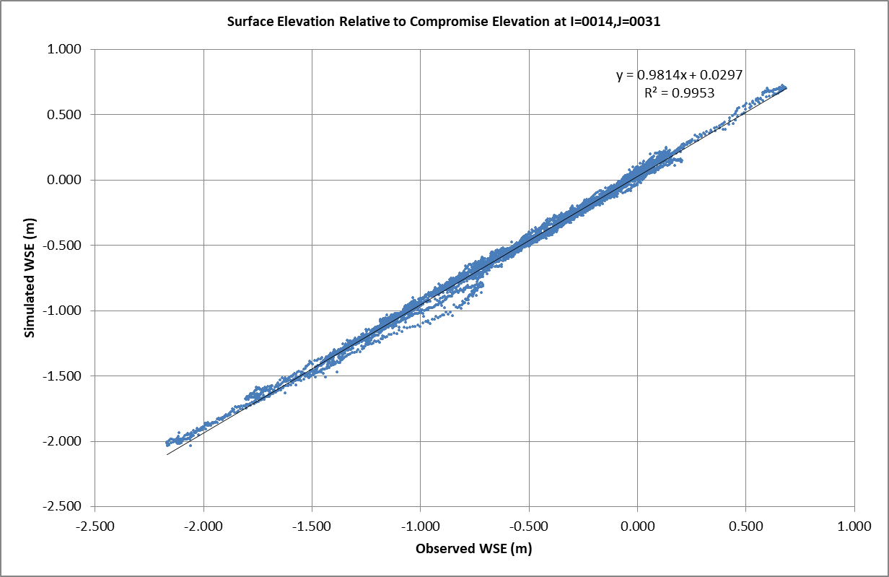

Figure .. Scatter Plot of Simulated vs. Observed Water Surface Elevation

Figure 4.4 to Figure 4.12 depict time series, scatter, and probability plots for the three water buoy stations with continuous temperature data from 2016 – 2018. The statistical performance metrics are summarized in Table 4.4. The negative PBIAS (Table 4.4) indicates that water temperature was slightly over-predicted, except for the higher temperatures, which were slightly under-predicted as shown on the probability plots (Figure 4.6, Figure 4.9, and Figure 4.12). However, the time series plots (Figure 4.4, Figure 4.7, and Figure 4.10) show that prediction error varied throughout the monitoring season and there is indication of seasonal bias with over-prediction occurring August-October (Figure 4.13). The model under prediction of the rate of cooling of the lake in the late summer/fall may be due to seasonal variation in the sun angle and resulting increase in surface water reflectance of solar radiation, but this hypothesis would require additional investigation.

Table .. Calibration Statistical Performance Metrics for Water Temperature

|  |  |  |  |  |  |
| --- | --- | --- | --- | --- | --- |
| **Station ID** | **Station Name** | **RMSE** | **R2** | **NSE** | **PBIAS** |
| 4917365 | Utah Lake 2 Miles W of Vineyard | 1.98 | 0.88 | 0.87 | -1.9% |
| 4917390 | Utah Lake 1 Mile W of Provo Boat Harbor | 1.94 | 0.86 | 0.86 | -1.1% |
| 4717715 | Utah Lake Outside Entrance to Provo Bay | 1.80 | 0.91 | 0.89 | -3.5% |



Figure .. Time Series Plot of Simulated and Observed Water Temperature at Utah Lake 2 Miles W of Vineyard



Figure .. Scatter Plot of Simulated vs. Observed Water Temperature at Utah Lake 2 Miles W of Vineyard

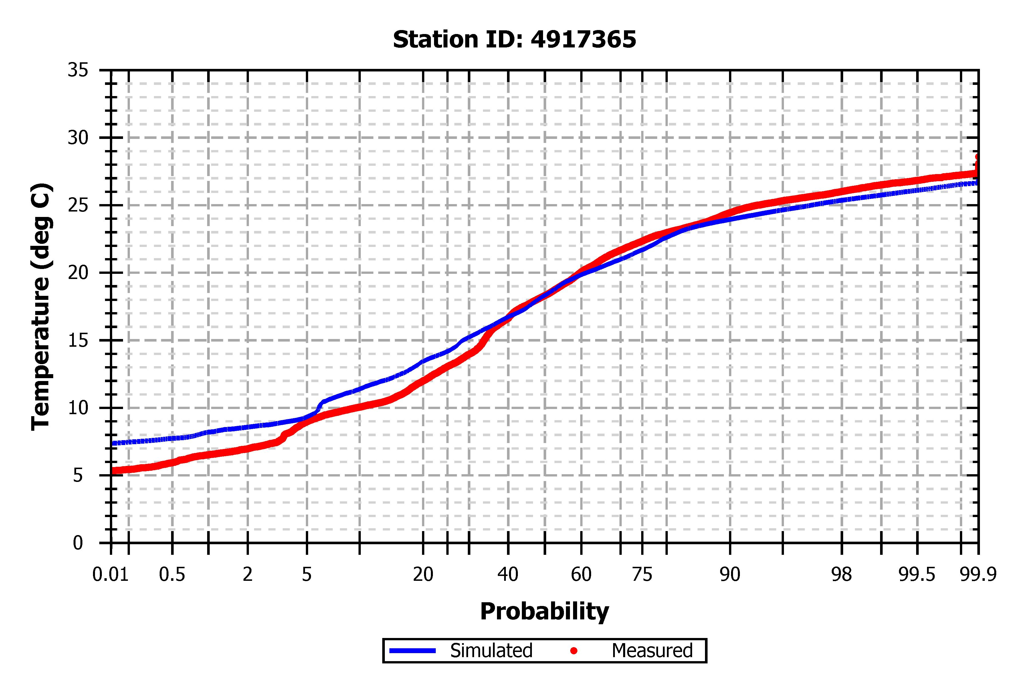

Figure .. Probability Plot of Simulated and Observed Water Temperature at Utah Lake 2 Miles W of Vineyard



Figure .. Time Series Plot of Simulated vs. Observed Water Temperature at Utah Lake 1 Mile W of Provo Boat Harbor



Figure .. Scatter Plot of Simulated vs. Observed Water Temperature at Utah Lake 1 Mile W of Provo Boat Harbor

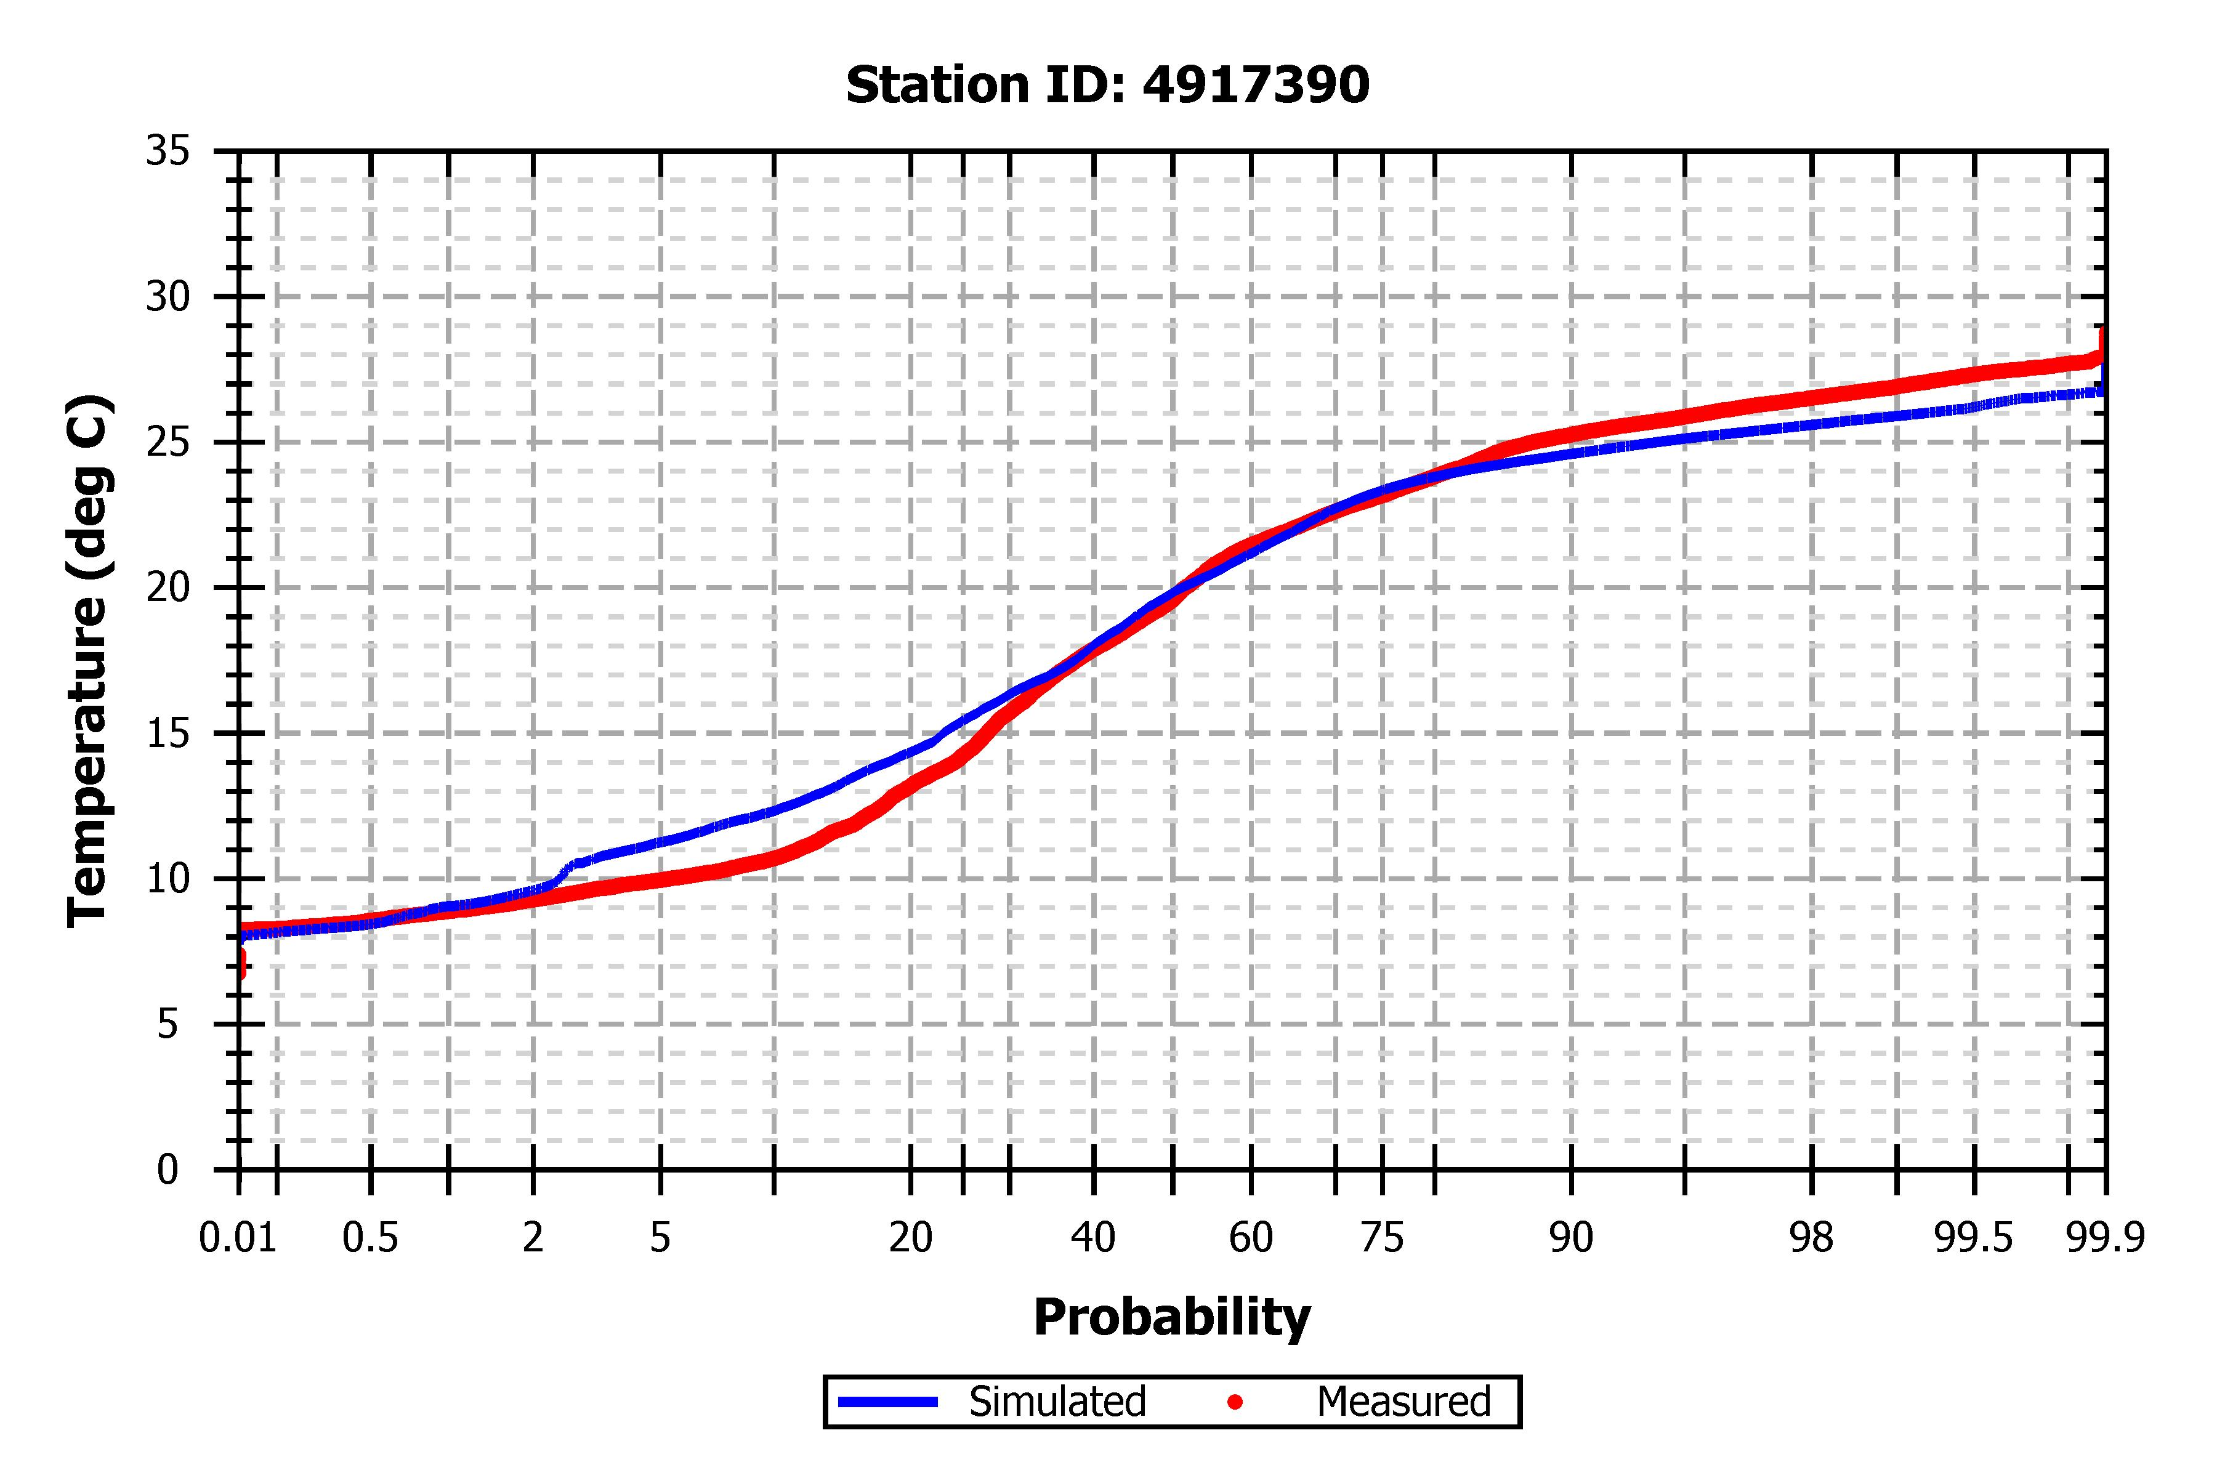

Figure .. Probability Plot of Simulated vs. Observed Water Temperature at Utah Lake 1 Mile W of Provo Boat Harbor



Figure .. Time Series Plot of Simulated vs. Observed Water Temperature at Utah Lake 1 Mile SE of Bird Island



Figure .. Scatter Plot of Simulated vs. Observed Water Temperature at Utah Lake 1 Mile SE of Bird Island

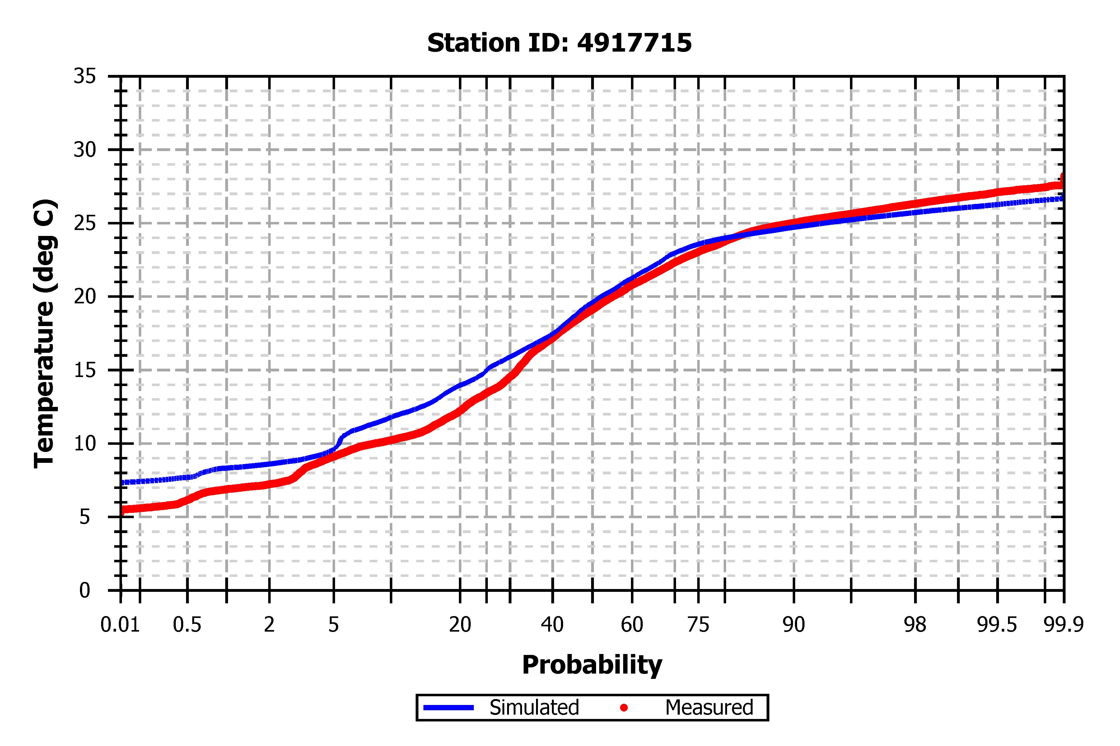

Figure .. Probability Plot of Simulated vs. Observed Water Temperature at Utah Lake 1 Mile SE of Bird Island

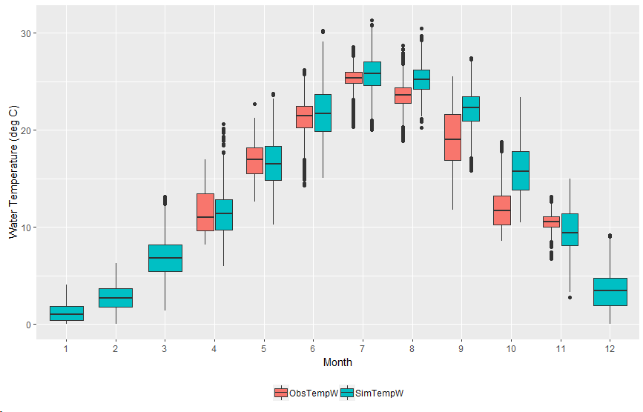

Figure .. Monthly Box Plot of Simulated vs. Observed Water Temperature at Utah Lake 1 Mile W of Provo Boat Harbor

### Calibration Performance of the Water Quality (WASP) Model

The results for the model calibration efforts over the Utah Lake WASP are presented in Appendix B: Model Calibration for WASP. The time-series plots that display simulated results from the Utah Lake WASP and the measured data from the AWQMS sites, based on the segment mapping presented in Table 4.1, are provided in Section B.1, with the plots organized based on AWQMS site ID per constituent. Scatter plots among the simulated results against the measured data for selected constituents are provided in Section B.2 while cumulative probability plots of the simulated results against the measured data are displayed in Section B.3. Meanwhile, tables that display statistical results (mean, median, 25th percentile, 75th percentile, statistical parameters, etc.) for distinct constituents are provided in Section B.4. The following characteristics are implemented for conducting the model calibration efforts over the Utah Lake WASP (both graphical and statistical approaches as described in Section 4.1.2).

* The time-series plots (Section B.1) and tables for statistical results (Section B.4) apply only the AWQMS sites that exhibit data within the WASP model calibration period (October 1, 2005 to September 30, 2015). In other words, such plots/tables per constituent presented do not include all the AWQMS UDWQ sites listed in Table 4.1.
* The constituents for which the time-series plots (Section B.1) appear to not suggest overprediction or underprediction of the simulated results against the measured data are incorporated into scatter (Section B.2) followed by cumulative probability plots (Section B.3). Meanwhile, any Utah Lake I and J node that appears to exhibit less than 5 measured data points throughout the model calibration period (October 1, 2005 to September 30, 2015) is not included in the scatter and probability plots developed.
* The SDB database that involve the measured data for AWQMS UDWQ sites apply measured data at distinct depths (e.g., 0 m for surface water, values other than 0 m for other depths, etc.). The time-series (Section B.1), scatter (Section B.2), and the probability (Section B.3) plots display the measured data for all depths per AWQMS site per constituent. On the other hand, the tables for statistical results (Section B.4) are derived based on the measured data within 1 m of depth.
* Values of “N/A” may appear for the 25th and 75th percentiles for a particular node for a constituent, which such values are generally due to the level of measured data employed per AWQMS site (e.g., inadequate level of measured data from an AWQMS site for calculating the 25th and 75th percentile). Meanwhile, if an AWQMS site appears to exhibit generally lack of data (e.g., only 1-2 measured data) throughout the model simulation period, then the statistical parameters described in Sections 4.1.2 and B.4 are indicated as “0” for the indicated Utah Lake node.

Based on the time-series plots and the tables displayed, the following general characteristics are observed per constituent subject to the Utah Lake WASP model calibration efforts.

* **Dissolved Oxygen:** According to the time-series plots (Section B.1.1), general agreement appears observed among the simulated results from the Utah Lake WASP against the measured data from the UDWQ AWQMS sites over the model calibration period. Some of the Utah Lake WASP nodes (e.g., I = 18, J = 27; I = 24, J = 21) appear to not capture potential outliers observed upon the measured DO data, particularly those below 2 mg/L, and particular nodes (e.g., I = 17, J = 36) seem to yield relatively high DO values (e.g., over 25 mg/L). Such characteristics thus appear observed upon the statistical results for DO, yielding relatively high RMSE values followed by low R2 values. For instance, due to the model appearing to not capture potential outliers as observed upon the measured data, generally low R2 values (e.g., less than 0.5), along with RMSE (e.g., greater than 1-2 mg/L), are yielded among the simulated results against the measured data (Section B.4.1). Such low R2 values appear evident upon the scatter plots for DO (Section B.2.1), suggesting significant variability among the simulated results against the measured data. Meanwhile, the probability plots (Section B.3.1) further suggest the Utah Lake WASP overpredicting the DO concentration as compared to the measured data for particular nodes (e.g., I = 17, J = 36; etc.). Nevertheless, such statistical parameters (e.g., R2, RMSE, etc.) likely can be improved if the temporal resolution of model output is decreased (e.g., from every 6 hours to every 3 hours, etc.). At the same time, such overprediction of DO appears to likely be due to the application of sediment diagenesis over the Utah Lake WASP, which SOD and nutrient fluxes are not simulated throughout all K = 1 nodes along Utah Lake (due to characteristics described in Section 2.2.6.3). The performance of the Utah Lake WASP over DO can potentially be improved through the incorporation of sediment diagenesis followed by the application of prescribed nutrient fluxes and SOD. Hence, with general agreement among the mean, median, and the quartiles (25th and 75th), the Utah Lake WASP appears relatively calibrated against the measured data for DO.
* **Ammonia Nitrogen:** According to the time-series plots (Section B.1.2) and the statistical results (Section B.4.2), the Utah Lake WASP appears to exhibit general agreement among the simulated results against the measured data for NH3-N. On the other hand, a couple of Utah Lake WASP nodes (e.g., I = 8, J = 7; I = 21, J = 21; I = 24, J = 21) suggests the underprediction of NH3-N against the measured data. For instance, the scatter (Section B.2.2) and probability (Section B.3.2) plots for NH3-N suggest the underprediction of the Utah Lake WASP as compared to the measured data for this constituent. At the same time, altering the nitrification rate, particularly decreasing such values (e.g., from 0.2 per day to 0.05 per day, etc.), appears to exhibit rather minor effects upon the NH3-N concentration (e.g., Section A.2.1 over the nitrification rate plots). For instance, adjusting the nitrification rate from 0.2 per day to 0.002 per day appears to increase the NH3-N concentration to slightly above 0.005 mg/L, which is still less than those yielded by the measured data. However, the inflow quality data for distinct sources (with data sources described in Table 2.4) implement relatively high concentrations for NH3-N, with some inflows yielding up to (and potentially at least) 5 mg/L. Hence, for such nodes (e.g., I = 8, J = 7; I = 21, J = 21; I = 24, J = 21), the Utah Lake WASP appears to not incorporate underlying processes that contribute to high NH3-N concentrations as observed upon the measured data, potentially suggesting limitations (e.g., sediment diagenesis upon wet nodes only, not employing prescribed NH3-N fluxes by WASP, etc.) associated with WASP. However, other nodes suggest the general agreement among the Utah Lake WASP simulated results against the measured data for NH3-N.
* **Nitrate-Nitrite Nitrogen:** Similar to the characteristics observed for NH3-N, the Utah Lake WASP appears to generally underpredict NO2-NO3-N. For instance, the time-series plots (Section B.1.3) suggest the measured data as generally above the simulated results, and relatively high values for RMSE and other statistical parameters (Section B.4.3) appear yielded against the measured data. Meanwhile, altering both the nitrification and denitrification rates, particularly with increasing the nitrification and decreasing the denitrification rates, appears to yield rather minor effects upon the NO2-NO3-N concentration (e.g., Section A.2.1 over the nitrification and denitrification rate plots). On the other hand, the inflow data for distinct sources (with data sources described in Table 2.4) implement relatively high concentrations for NO2-NO3-N, with some inflows inputting as high as 15-20 mg/L. Hence, similar to NH3-N, the Utah Lake WASP appears to potentially not incorporate underlying processes (e.g., benthic fluxes, etc.) that contribute to the high NO2-NO3-N concentrations as observed upon the measured data
* **Total Phosphate:** Except for the node I = 26, J = 21, the Utah Lake WASP appears to generally overpredict TP as compared to the measured data. For instance, the time-series plots suggest the simulated results for TP as above the values observed upon the measured data (Section B.1.4). Such characteristics appear observed upon the statistical parameters (Section B.4.4), which the mean and median yielded by the simulated results for TP are generally greater than those by the measured data, along with low R2 values (e.g., less than 0.5) and relatively high RMSE values (e.g., at least 0.4 mg/L). One can attempt increasing both the DOP mineralization rate and the orthophosphate partition coefficient to water column solids. On the other hand, significant effects upon the TP concentration (e.g., decrease by over 0.1 mg/L) appear observed only when relatively high values are populated for the DOP mineralization rate (e.g., 5 per day, 50 per day, etc.) and the orthophosphate partition coefficient (5 L/kg, 50 L/kg), as indicated in the sensitivity plots provided over such parameters (Section A.2.1). Furthermore, one can adjust the input parameters that affect POM, such as the POM Dissolution Rate, POM Settling, and the POM/Solids Light Extinction Coefficient. However, the effects of such adjustments appear rather variable (e.g., increases upon TP during particular water years followed by decreases during other time periods, such as Water Year 2015), as observed in Sections A.2.1 for POM Dissolution Rate, A.2.2 for POM Settling, and A.2.3 for POM and Solids Light Extinction. Hence, similar to both NH3-N and NO2-NO3-N, the Utah Lake WASP appears to generally not incorporate underlying processes (e.g., DIP benthic fluxes throughout Utah Lake) that yield to lower TP concentrations as observed upon the measured data.
* **Total Phytoplankton Chlorophyll-a:** According to the time-series plots (Section B.1.5), the Utah Lake WASP appears to slightly overpredict the phytoplankton chlorophyll-a for some nodes (e.g., I = 17, J = 36; I = 12, J = 30; etc.) while exhibiting general agreement against the measured data (e.g., I = 8, J = 7; I = 24, J = 21; etc.). The over-prediction of the simulated phytoplankton chlorophyll-a results for particular nodes (e.g., I = 17, J = 36; I = 12, J = 30; etc.) appears observed upon the statistical results (Section B.4.5), which the mean and median for the simulated results appear greater than those yielded by the measured data. Such characteristics over the total phytoplankton chlorophyll-a appear observed upon the scatter plots (Section B.2.3) that appear to suggest significant variability upon the simulated results against the measured data. Furthermore, the probability plots (Section B.3.3) suggest the overprediction of total phytoplankton chlorophyll-a for particular nodes (e.g., I = 17, J = 36; etc.) while appearing to underpredict for other nodes (e.g., I = 24, J = 21; etc.). Meanwhile, the Utah Lake WASP appears to generate a response for the nitrogen-fixed cyanobacterial phytoplankton group only (Phytoplankton Group 2) throughout the simulation period, yielding nearly 0 $μ$ g/L for all other groups (Diatoms (Group 1), Non-nitrogen-fixed Cyanobacteria (Group 3), and Green Algae (Group 4)). Investigations appear needed for analyzing the lack of response for other phytoplankton groups included in the Utah Lake WASP. For instance, such characteristics may be due to the underprediction of the nitrogen species (e.g., NH3-N, NO2-NO3-N, etc.) that may thus suggest the dominance of the nitrogen-fixed cyanobacterial phytoplankton group.
* **CBOD:** The measured data quality for the indicated model simulation period (October 1, 2005 to September 30, 2015) from the AWQMS sites along Utah Lake appears relatively poor as compared to other constituents. For instance, only 4 measured data points (as shown in Section B.1.6) are yielded throughout the model calibration timeframe for CBOD (and BOD combined) from 2 AWQMS sites, with 2 measured data points per site, which both sites appear to fall within Provo Bay (I > 20, 17 < J < 26). Hence, no conclusions can be developed based upon the comparisons of the Utah Lake WASP simulated results against the measured data.
* **Total Solids:** Several nodes along Utah Lake subject to the model calibration effort appear to suggest the overprediction of total solids as compared to the measured TSS data. (Note that TSS data are implemented for the model calibration exercise instead of ISS due to the lack of data for TVS observed for the model calibration period needed for calculating ISS, given ISS = TSS – TVS) For instance, the time-series plots yield the simulated results as generally above the measured data for TSS (Section B.1.7), hence yielding relatively low R2 values (e.g., less than 0.5) and high error values (e.g., at least 10 mg/L) (Section B.4.7). Such characteristics can be addressed through adjusting several input parameters that appear to affect total solids, involving the POM/Solids Light Extinction (though appearing to yield rather minor effects as observed in Section A.2.3). For instance, since the Utah Lake WASP simulates sediment transport for yielding settling and resuspension rates for distinct solids classes, the model parameters for simulating sediment transport can be visited for evaluating the effects upon the total solids concentration. Currently, default values (except those for particle diameter) are applied for most of the sediment transport parameters for the Utah Lake WASP model. (Note that WASP incorporates both cohesive and non-cohesive components per sediment class, which one simply adjusts the boundaries for cohesive vs. non-cohesive erosion, cohesive vs. non-cohesive resuspension, and deposition in the Utah Lake WASP.)

## Model Parameterization

This sub-section documents the list of model parameters with associated values applied for pertinent parameters of the hydrodynamic (EFDC) and water quality (WASP) components for the Utah Lake model development.

* Section 4.3.1 describes the parameterization of pertinent constituents, primarily water temperature, for the Utah Lake EFDC model.
* Section 4.3.2 provides the parameterization of pertinent constituents for the Utah Lake WASP model.

### Model Parameterization for the Hydrodynamic (EFDC) Model

Without measured current velocity data with which to calibrate the hydrodynamic model, primarily default values for the model parameters were selected. A bottom roughness of 0.01 was applied to the entire lake and three vegetation classes were applied to the lake (Open Water, Provo Bay, and Goshen Bay). The calibration parameters for water temperature are summarized in Table 4.5.

Table .. Model Calibration Parameters for Water Temperature

|  |  |  |
| --- | --- | --- |
| **Parameter** | **EFDC Code** | **Value** |
| Water surface reflectance (albedo) | SOLRCVT | 0.92 |
| Fast scale solar shortwave radiation attenuation coefficient (1/m) | SWRATNF | 10 |
| Slow scale solar shortwave radiation attenuation coefficient (1/m) | SWRATNS | 0 |
| Fraction of solar shortwave radiation attenuated fast | FSWRATF | 1 |
| Thickness of active bed temperature layer (m) | DABEDT | 5 |
| Initial bed temperature (deg C) |  | 4 |
| Convective heat coefficient | HTBED1 | 0.001 |
| Heat transfer coefficient between bed & bottom water layer (m/s) | HTBED2 | 2E-06 |

### Model Parameterization of the Water Quality (WASP) Model

For this exercise, the following characteristics are implemented for the model parameterization relevant for distinct constituents simulated by the Utah Lake WASP.

* **Flow Hydraulics, Node Characteristics, Precipitation/Evaporation:** Since the Utah Lake WASP employs the hydrodynamic linkage flow routing method, all the associated inputs over inflow quantity (e.g., hydraulic parameters, such as volume of node; etc.) are read from the hydrodynamic linkage yielded by EFDC. Furthermore, the hydrodynamic linkage yielded by the Utah Lake EFDC model simulates all the precipitation and evaporation mechanisms (with the data sources, methodologies, and approximations discussed in Section 2.2.2) for the Utah Lake WASP. Due to the implementation of wetting and drying mechanisms upon the Utah Lake EFDC/WASP models, no values have been specified for populating the minimum and average depths that can be inputted into the Utah Lake WASP under the hydrodynamic linkage routing method.
* **Sediment Transport:** Except for the sediment particle diameter data and sediment classes as described in Section 2.2.9.2, default values are applied for all input parameters for simulating sediment transport (e.g., critical shear stress for erosion, cohesive resuspension, non-cohesive resuspension, etc.) all sediment classes (sand, silt, clay).
* **Sediment Diagenesis:** Except for the initial sediment conditions (POC, PON, POP), the number of K = 1 nodes simulating nutrient fluxes and SOD, and the fraction of POC/PON/POP distribution into classes G1/G2/G3 as described in Section 2.2.6.3, default values are applied to all input parameters for simulating sediment diagenesis (e.g., Solids Concentration (L/kg) in sediment diagenesis Layer 1, Solids Concentration (L/kg) in sediment diagenesis Layer 2, Thickness of Active Sediment Layer (cm), Diffusion Coefficient for Particle Mixing (m2/day), etc.).

Meanwhile, non-default values are implemented for other input parameters that affect the performance of several constituents (e.g., nitrogen species, phosphorus species, etc.) and do not serve as model input parameters as described in Section 2.2. Furthermore, the following tables, Table 4.6 to Table 4.11, include the parameters for which non-default values are applied *and* that are not documented in Section 2.2. The following table (Table 4.6) describes the pertinent WASP parameters, units, and the data sources applied for the geographical coordinates and lighting.

Table .. Data Values, Units, and Sources for the Geographical Coordinates and Light Extinction Parameters for the Utah Lake WASP

|  |  |  |  |
| --- | --- | --- | --- |
| **Lighting/Global**  **WASP Input Parameter** | **Units** | **Value** | **Data Source** |
| Latitude | Degrees | 40.2181824606 | Geographical Coordinates for Provo Municipal Airport |
| Longitude | Degrees | -111.720680451 | Geographical Coordinates for Provo Municipal Airport |
| Background Light Extinction Coefficient | 1/m | 0.2 | Stantec Consulting Ltd (2010) for the Jordan River WASP |
| Detritus and Solids Light Extinction Coefficient | 1/m | 0.034 | Stantec Consulting Ltd (2010) for the Jordan River WASP; Summation of Detritus Light Extinction and Solids Light Extinction |
| DOC Light Extinction | 1/m | 0.34 | Ambrose and Wool (2017) |

The following table (Table 4.7) describes the pertinent WASP parameters, units, the values employed, and the data sources applied for the dissolved nutrient (nitrogen and phosphorus) species, primarily NH3-N, NO2-NO3-N, DON, DIP/ortho-P, and DOP.

Table .. Utah Lake WASP Model Input Parameters (Value, Units, Data Source) for the Dissolved Nutrient (NH3-N, NO2-NO3-N, DON, DIP/ortho-P, DOP) Species

|  |  |  |  |
| --- | --- | --- | --- |
| **Nutrient WASP Input Parameter** | **Units** | **Value** | **Data Source** |
| Nitrification Rate at 20 degrees Celsius | Per day | 0.2 | “Best” Calibrated Value |
| Temperature-Correction for Nitrification | None | 1.07 | Stantec Consulting Ltd (2010) for the Jordan River WASP |
| Half-Saturation for Nitrification | mg-O2/L | 2 | Maximum value recommended by WASP |
| Denitrification Rate at 20 degrees Celsius | Per day | 0.05 | “Best” Calibrated Value |
| Temperature-Correction for Denitrification | None | 1.07 | Stantec Consulting Ltd (2010) for the Jordan River WASP |
| Half-Saturation for Denitrification | mg-O2/L | 2 | Maximum value recommended by WASP |
| Mineralization Rate for DON at 20 deg Celsius | Per day | 0.4 | Stantec Consulting Ltd (2010) for the Jordan River WASP |
| Temperature-Correction for DON Mineralization | None | 1.07 | Stantec Consulting Ltd (2010) for the Jordan River WASP |
| Orthophosphate Partition Coefficient to  Water Column Solids (Silt) | L/kg | 2 | “Best” Calibrated Value |
| Orthophosphate Partition Coefficient to  Water Column Solids (Clay) | L/kg | 2 | “Best” Calibrated Value |
| Mineralization Rate for DOP at 20 degrees Celsius | Per day | 1 | “Best” Calibrated Value |
| Temperature-Correction for DOP Mineralization | None | 1.07 | Stantec Consulting Ltd (2010) for the Jordan River WASP |

The following table (Table 4.8) provides the pertinent WASP parameters, units, the values employed, and the data sources applied for CBOD and DO for which non-default values are implemented.

Table .. Utah Lake WASP Model Input Parameters (Values, Units, Data Sources) for CBOD and DO

|  |  |  |  |
| --- | --- | --- | --- |
| **CBOD/DO WASP Input Parameter** | **Units** | **Value** | **Data Source** |
| CBOD Decay Rate Constant at 20 degrees Celsius (also defined as the CBOD/BOD Oxidation Rate) | Per day | 0.2 | Stantec Consulting Ltd (2010) for the Jordan River WASP |
| Temperature-Correction for CBOD Decay | None | 1.047 | Stantec Consulting Ltd (2010) for the Jordan River WASP |
| Half-Saturation Limit for CBOD | mg-O2/L | 5 | “Best” calibrated value |
| Fraction of Detritus Dissolution to CBOD | None | 1 | “Best” calibrated value |
| Fraction of CBOD Carbon Source for Denitrification | None | 1 | “Best” calibrated value |
| Maximum Allowable Reaeration Rate | Per day | 5 | “Best” calibrated value |
| Temperature-Correction for Reaeration | None | 1.024 | Stantec Consulting Ltd (2010) for the Jordan River WASP |

The following table (Table 4.9) provides the pertinent WASP parameters, units, the values employed, and the data sources applied to phytoplankton for which non-default values are implemented. The values described in Table 4.9 are implemented upon all phytoplankton groups (Group 1 (Diatoms, *Bacillariophyta*), Group 2 (Nitrogen-Fixed Cyanobacteria, *Aphanizomenon Gracile*, Group 3 (Non-nitrogen-fixed Cyanobacteria, *Synechococcus*), Group 4 (Green Algae, *Stigeoclonium Subsecundum (Chlorophyceae)*, as Phytoplankton for K = 3 and K = 2 nodes).

Table .. Utah Lake WASP Parameters (Values, Units, Data Sources) for Phytoplankton Groups 1 to 4

|  |  |  |  |
| --- | --- | --- | --- |
| **Phytoplankton WASP Input Parameter** | **Units** | **Value** | **Data Source** |
| Temperature-Correction for Phytoplankton Growth | None | 1.07 | Stantec Consulting Ltd (2010) |
| Phytoplankton Carbon to Chlorophyll-a Ratio | mg-C/mg-Chla | 40 | Martin et al. (n.d.); based on the ratio 100 g dry weight:40 g-C:7200 mg-N:1000 mg P |
| Temperature-Correction for Phytoplankton Respiration | None | 1.07 | Stantec Consulting Ltd (2010) |
| Optimal Light Saturation as Photosynthetically-Active Radiation | W/m2 | 12.831 | Stantec Consulting Ltd (2010) |
| Half-Saturation for Mineralization Rate | mg-Chla/L | 100 | “Best” calibrated value |
| Half-Saturation Constant for N Uptake | mg-N/L | 0.015 | Stantec Consulting Ltd (2010) |
| Half-Saturation Constant for P Uptake | mg-P/L | 0.002 | Stantec Consulting Ltd (2010) |
| Fraction Phytoplankton Respiration Recycled to Organic N (DON)  per Phytoplankton Group | None | 0.5 | “Best” calibrated value |
| Fraction Phytoplankton Respiration Recycled to Organic P (DOP)  per Phytoplankton Group | None | 0.5 | “Best” calibrated value |
| Fraction Phytoplankton Death Recycled to Detrital N (PON) per Phytoplankton Group | None | 0.5 | “Best” calibrated value |
| Fraction Phytoplankton Death Recycled to Detrital P (POP) per Phytoplankton Group | None | 0.5 | “Best” calibrated value |
| Phytoplankton Detritus/  POM to Carbon Ratio | mg-D (dry weight)/mg-C | 2.5 | Martin et al. (n.d.); based on the ratio 100 g dry weight:40 g-C:7200 mg-N:1000 mg P |

The following table (Table 4.10) provides the input parameters, the values employed, and the data sources for benthic/macro algae (*Stigeoclonium Subsecundum (Chlorophyceae)*) for which non-default values are applied.

Table .. Utah Lake WASP Model Parameters (Value, Units, Data Sources) for Macro/Benthic Algae (*Stigeoclonium Subsecundum (Chlorophyceae)*)

|  |  |  |  |
| --- | --- | --- | --- |
| **Macro/Benthic Algae WASP Input Parameter** | **Units** | **Value** | **Data Source** |
| Macro Algal Growth Model (0 = Zeroth Order; 1 = First Order) | None | 0 | Stantec Consulting Ltd (2010) for Jordan River WASP |
| Fraction of Segment Covered by Benthic Algae (K = 1 Nodes Only) | None | 0.5 | Applied to allow part of K = 1 Nodes with Green Algae as Phytoplankton Group |
| Carrying Capacity for First-Order Model | g-D/m2 | 50 | Stantec Consulting Ltd (2010) for Jordan River WASP |
| Respiration Rate at 20 degrees Celsius | Per day | 0.042 | Stantec Consulting Ltd (2010) for Jordan River WASP |
| Internal Nutrient Excretion Rate Constant | Per day | 0.1 | Stantec Consulting Ltd (2010) for Jordan River WASP |
| Temperature-Correction for Internal Nutrient Excretion | None | 1.05 | Stantec Consulting Ltd (2010) for Jordan River WASP |
| Death Rate at 20 degrees Celsius | Per day | 0.1 | Stantec Consulting Ltd (2010) for Jordan River WASP |
| Half-Saturation Uptake for Extracellular Nitrogen | mg-N/L | 0.163 | Stantec Consulting Ltd (2010) for Jordan River WASP |
| Half-Saturation Uptake for Extracellular Phosphorus | mg-P/L | 0.048 | Stantec Consulting Ltd (2010) for Jordan River WASP |
| Light Constant for Growth | Langley/day | 50 | Stantec Consulting Ltd (2010) for Jordan River WASP |
| Ammonia Preference | mg-N/L | 0.001 | Stantec Consulting Ltd (2010) for Jordan River WASP |
| Minimum Cell Quota of Internal Nitrogen for Growth | mg-N/gD | 30 | Stantec Consulting Ltd (2010) for Jordan River WASP |
| Minimum Cell Quota for Internal Phosphorus for Growth | mg-P/gD | 0.4 | Stantec Consulting Ltd (2010) for Jordan River WASP |
| Maximum Nitrogen Uptake Rate | mg-N/gD-day | 447 | Stantec Consulting Ltd (2010) for Jordan River WASP |
| Maximum Phosphorus Uptake Rate | mg-P/gD-day | 114 | Stantec Consulting Ltd (2010) for Jordan River WASP |
| Half-Saturation Uptake for Intracellular Nitrogen | mg-N/gD | 2.9 | Stantec Consulting Ltd (2010) for Jordan River WASP |
| Half-Saturation Uptake for Intracellular Phosphorus | mg-P/gD | 1.8 | Stantec Consulting Ltd (2010) for Jordan River WASP |
| O2:C Production | mg-O2/mg-C | 0.5 | “Best” calibrated value |
| Fraction of Macro Algae Recycled to Organic N | None | 0.5 | “Best” calibrated value |
| Fraction of Macro Algae Recycled to Organic P | None | 0.5 | “Best” calibrated value |
| Algal Detritus/POM to Carbon Ratio | mg-D (dry weight)/mg-C | 2.5 | Martin et al. (n.d.); based on the ratio 100 g dry weight:40 g-C:7200 mg-N:1000 mg P |
| Phytoplankton Carbon to Chlorophyll-a Ratio | mg-C/mg-Chla | 40 | Martin et al. (n.d.); based on the ratio 100 g dry weight:40 g-C:7200 mg-N:1000 mg P |

The following table (Table 4.11) provides the input parameters, the values employed, and the data sources applied for SOD and POM. (Note that the input parameters pertinent for the sediment diagenesis routines, along with prescribed nutrient fluxes, are described in Section 2.2.6.3.)

Table .. Utah Lake WASP Input Parameters (Value, Units, Data Sources) for POM and SOD

|  |  |  |  |
| --- | --- | --- | --- |
| **POM/SOD WASP Input Parameter** | **Units** | **Value** | **Data Source** |
| POM Dissolution Rate at 20 degrees Celsius | Per day | 0.1 | Stantec Consulting Ltd (2010) for Jordan River WASP |
| Temperature-Correction for POM Dissolution | None | 1.07 | Stantec Consulting Ltd (2010) for Jordan River WASP |
| Temperature-Correction for SOD | None | 1.07 | Stantec Consulting Ltd (2010) for Jordan River WASP |

# Extended Model Analyses: Water Year 2009-2013

The model inflow data sources for populating the inflow quantity and quality data for the Utah Lake model development appear to not cover the entire model calibration period for EFDC (Water Year 2006-2018) and WASP (Water Year 2006-2015). For instance, the AWQMS sites for populating inflow quality data for the Utah Lake WASP, as described in Table 2.4, appear to only cover from around March 2009 to August 2013. Hence, additional model calibration efforts are conducted for this exercise for evaluating the Utah Lake model performance (EFDC and WASP) over a 5-year timeframe, from October 1, 2008 to September 30, 2013. Therefore, this section provides an overview of the model development over this timeframe, describing the hydrodynamic (Section 5.1) and water quality (Section 5.2) performance.

## EFDC Model Development and Performance

Please discuss about the EFDC model development and performance over this time period.

## WASP Model Development and Performance

Please discuss about the WASP model development and performance over this time period.

# Model Validation

A validation of the model utilizing an independent data set has not been performed.

# Model Uncertainty

An analysis of model uncertainty (e.g., Monte Carlo simulations, etc.) has not been conducted upon either of the EFDC or the WASP components of the Utah Lake model.

# Model User Guidance

Please review the general notes for the EFDC component in Section 7.1 and for the WASP component in Section 7.2.

## EFDC Model

The Visual EFDC (Version 2.0) program developed and maintained by Tetra Tech, Inc. was used for pre- and post-processing and to execute the model. An EFDC executable file (Version 2.0WD) that generates a hydrodynamic linkage file for WASP8 that is able to accommodate wetting and drying cells was provided by EPA. The WRDB Graph (Version 6.1) program was used to visualize model output and calculate calibration statistics.

## WASP Model

Please note the following characteristics over running the Utah Lake WASP. Some of the below descriptions are similar to those for the Jordan River WASP and hence are directly retrieved from the Jordan River WASP model calibration report (Su 2019). Meanwhile, similar to EFDC, the WRDB Graph (Version 6.1) program is employed for visualizing model output and calculating calibration statistics.

* **pH and Alkalinity Not Incorporated into Current Utah Lake Model:** Issues regarding the pH and alkalinity simulations over the Utah Lake WASP with hydrodynamic linkage appear to be encountered, which seems to suggest possible bugs within WASP itself. For instance, disregarding what inputs (e.g., atmospheric deposition, inflows, etc.) implemented for pH and alkalinity, WASP will yield initial conditions for pH at 14 and for alkalinity at nearly 1029 mg/L as CaCO3, which “NaN” values then appear upon all constituents for the entire model simulation. Hence, the model calibration efforts currently do NOT incorporate pH and alkalinity due to the issues encountered, which such constituents (pH and alkalinity) are removed from the Utah Lake model. (The developers of WASP have been contacted regarding the issues encountered with pH and alkalinity for the Utah Lake WASP, which such issues may be due to the wetting/drying mechanisms applied into the Utah Lake model.)
* **Time Step of Output:** The time step of output into the BMD2 file is inputted manually in **days** by the user in WASP and affects the simulation time for running the entire model calibration period (October 1, 2005 to September 30, 2015) over Utah Lake, along with the size of the output BMD2 file. The Utah Lake WASP currently outputs results for **every 6 hours**, or **0.25 days**, yielding a BMD2 file size of approximately **19 GB**. The user can refine the time step of output for the model, which increases the size of the output BMD2 file and may significantly increase the simulation time required.
* **WASP Yielding Messages regarding Time Step during Simulation:** During the model simulation, WASP may yield messages regarding the simulation time step employed by the program, such as “WASP requires a time step of [a program-defined amount], which is less”. Such messages may/may not affect the performance of the Utah Lake WASP simulation, which one can either simply note the messages (e.g., not make any adjustments or modifications upon the model accordingly) or adjust the minimum time step. The minimum time step is currently set at **0.0001 days**, or approximately **8.64 seconds**, which the user can specify a minimum value of $1*{10}^{-5}$ days (e.g., 0.864 seconds) for this parameter.
* **Need of a Revised “multi-algae.dll” for Avoiding Mass Check Issues:** Due to the wetting and drying mechanisms incorporated into the Utah Lake hydrodynamic linkage by EFDC, the Mass Check parameter simulated by the Utah Lake WASP that serves as a conservative tracer deviates significantly from 1, yielding values as low as nearly 0 followed by values as high as above 10. Currently, if the version of the “multi-algae.dll” that is installed with WASP (through the directory C:\USEPA-WASP8\wasp\bin) is employed for the Utah Lake WASP simulation, then the model may crash due to mass check exceedances, yielding a message “**Mass Check Exceedances > 10.0; 51**” (or similar messages). Such message indicates that the Utah Lake WASP yields a mass check value of at least 10 for at least 51 times throughout the simulation, which the model then crashes (e.g., gets terminated). If such messages appear, then one should request a revised “**multi-algae.dll**” file that does not apply such criterion for a model run (e.g., Mass Check exceeding 10 within 50 times during the simulation) from the WASP model developers (e.g., U.S. EPA) for avoiding such mass check issues (and the subsequent WASP model crash) from occurring.
* **Model Parameters for Output:** Several output parameters have been selected to have results written as time-series data into the BMD2 file generated per model simulation for all Utah Lake WASP Nodes (e.g., all I, J, and K nodes). Specifically, the following output parameters (grouped based on segment characteristics, water quality constituents, etc.) are currently written into the BMD2 file from a model simulation of Utah Lake WASP, which one can add additional output parameters into the BMD2 file.
  + **Transport:** Mass Check (Should = 1; Dimensionless), Volume (m3), Flow into Segment (m3/s), Flow out of Segment (m3/s), Segment Depth (m), Water Velocity (m/s), Maximum Time Step (days), Calculational Time Step Used (days)
  + **Nitrogen:** NH3-N (mg/L), Ammonia Benthic Flux (mg/m2-day), NO2-NO3-N (mg/L), DON (mg/L), PON (mg/L), TN (mg/L), TKN (mg/L)
  + **Phosphorus:** DIP (mg/L), DIP Benthic Flux (mg/m2-day), DOP (mg/L), POP (mg/L), TP (mg/L)
  + **CBOD:** WWTP CBODU (mg/L), River CBODU (mg/L), Tributary CBODU (mg/L), Storm Drain and Groundwater CBODU (mg/L), Total CBODU (mg/L), POC (mg/L)
  + **Dissolved Oxygen:** DO (mg/L), DO Saturation Concentration (mg/L), Reaeration Rate (per day), SOD (g/m2-day)
  + **Phytoplankton and Macro/Benthic Algae:** Chlorophyll-a for Diatoms represented as *Bacillariophyta* ($μ$ g/L) indicated as Phytoplankton Group 1, Chlorophyll-a for Nitrogen-Fixed Cyanobacteria represented as *Aphanizomenon Gracile* ($μ$ g/L) indicated as Phytoplankton Group 2, Chlorophyll-a for Non-nitrogen-fixed Cyanobacteria represented as *Synechococcus* ($μ$ g/L) indicated as Phytoplankton Group 3, Green Algae represented as *Stigeoclonium Subsecundum* ($μ$ g/L) as Phytoplankton for K = 3 and K = 2 nodes as Phytoplankton Group 4, Total Phytoplankton Chlorophyll-a ($μ$ g/L), Growth and Death Rates (per day) of Each Phytoplankton Group (1 to 4), Macro/Benthic Algae Chlorophyll-a for *Stigeoclonium Subsecundum* ($μ$ g/L)
  + **Solids:** Sand Solids Concentration indicated as Solids 1 (mg/L), Silt Solids Concentration indicated as Solids 2 (mg/L), Clay Solids Concentration indicated as Solids 3 (mg/L), Total Solids Concentration (mg/L)
  + **Light:** Light Top Segment (W/m2)
* **Water Temperature as Output:** Since the Utah Lake WASP incorporates the hydrodynamic linkage yielded by EFDC, the water temperature parameters (e.g., application of a heat model) are not implemented in WASP. Furthermore, the Utah Lake WASP does not simulate water temperature as a separate state variable and simply outputs water temperature yielded by the hydrodynamic linkage. (Including water temperature as a state variable in the Utah Lake WASP with hydrodynamic linkage instigates WASP to crash.) Hence, the user will not be able to alter any of the water temperature parameters and will not be able to have WASP simulate ice coverage over Utah Lake. Ice coverage is currently not implemented as an input into the Utah Lake WASP, which the user can input ice coverage (through a single time function with a single fraction distribution per Utah Lake node that is applied throughout the model calibration period) into the model that only affects reaeration (and hence DO).
* **Sediment Diagenesis Failing to Converge:** Since the Utah Lake WASP employs the **sediment diagenesis routines** for simulating sediment oxygen demand (SOD) and nutrient fluxes, the user will likely encounter issues with the sediment diagenesis routines failing to converge that hence leads to WASP shutting down. The user will need to rerun the model repeatedly until such messages over the sediment diagenesis failing to converge no longer appear.
* **SOD Restart File:** WASP develops a SOD Restart File at the end of each model run that is read by the succeeding runs, which consecutive runs of the Utah Lake model tend to be implemented for the sediment diagenesis routines to approach equilibrium against the nutrient loadings into the water column and along the sediment layers developed by WASP. Hence, if a modification upon the Utah Lake WASP has been implemented, especially upon the inputs relevant for the sediment diagenesis routines, then the user will need to remove the existing/previous SOD Restart File and rerun the Utah Lake WASP for avoiding the rerun from reading in the previous SOD Restart File, which may instigate the sediment diagenesis routines to fail to converge and hence instigate the model to crash.
* **Model Running Slowly:** The Utah Lake WASP may exhibit simulations for which significant values for the distinct constituent concentration are observed (e.g., at least 1010 mg/L for particular constituents, 1010 g/L for phytoplankton chlorophyll-a, etc.), with the model running at a relatively small time step (e.g., within 1 second) around **10/2/2005 0:20:00 (e.g., at 12:20 AM)**. If such characteristics are encountered when running the Utah Lake WASP, then the user should immediately terminate the model run by **exiting out of the program** *rather than* selecting the “Cancel” option in WASP. Then, one should rerun the model, terminating the run if such issues reappear, until the model seems to run smoothly.
* **Linux Version of WASP:** The model currently runs on the Windows Version of WASP and can be opened interchangeably (e.g., no conversions needed) under Linux Machines. On the other hand, the Linux Version of WASP appears to currently exhibit issues with running/executing WIF input files, which may be due to potential bugs within the Linux Version of WASP. The user will only be able to open and edit the input WIF file if the user is accessing the Linux Version of WASP.

# References

Ambrose, R.B., Wool, T.A. (2017). “WASP 8: Nutrient Cycling Processes.” WASP 8.1 Workshop, U.S. Environmental Protection Agency (U.S. EPA), Denver, CO, Sept. 2017.

Barber, M.E., Goel, R., Burian, S.J., Packard, B. (2016). Prediction of Nonlinear Climate Variations Impacts on Eutrophication and Ecosystem Processes and Evaluation of Adaptation Measures in Urban and Urbanizing Watersheds: Quality Assurance Project Plan (QAPP). EPA 835866-01. Department of Civil and Environmental Engineering, University of Utah, Salt Lake City, UT

Bas, B.M., Sobhan, K. (2014). *Principles of Geotechnical Engineering*. Cengage Learning, Stamford, CT.

Bernan, T. (2001). The Role of DON and the Effect of N:P Ratios on Occurrence of Cyanobacterial Blooms: Implications from the Outgrowth of *Aphanizomenon* in Lake Kinneret. *Limnology and Oceanography*, *46*(2): 443-447.

Brahney, J. (2019). Estimating Total and Bioavailable Nutrient Loading to Utah Lake from the Atmosphere. Department of Watershed Sciences, Utah State University, Logan, UT.

Brett, M. (2019). Excel spreadsheet with light attenuation coefficient calculations. Department of Civil and Environmental Engineering, University of Washington, Seattle, WA.

Brooks, L. E., Stolp, B. J. (1995). Hydrology and Simulation of Ground-water Flow in Southern Utah Valley and Goshen Valley, Utah. United States Geological Survey.

Brooks, L. E. (2013). Evaluation of the groundwater flow model for southern Utah and Goshen Valleys, Utah, updated to conditions through 2011, with new projections and groundwater management simulations. United States Geological Survey.

Cederberg, J. R., Gardner, P. M. Thiros, S. A. (2009). Hydrology of Northern Utah Valley, Utah County, Utah, 1975-2005. United States Geological Survey.

Environmental Protection Agency. (2006). Environmental Fluid Dynamics Code Reference List.

Environmental Protection Agency. (2019). Enforcement and Compliance History Online (ECHO) Database. United States Environmental Protection Agency (U.S. EPA), Washington, D.C.

Gallego-Elvira, B., Baille, A., Martın-Gorriz, B., Martınez- Alvarez, V. (2010). Energy balance and evaporation loss of an agricultural reservoir in a semi-arid climate (south-eastern Spain), *Hydrologic Processes*, 24: 758–766.

Garcia, N.S, Sexton, J., Riggins, T., Brown, J., Lomas, M.W., Martiny, A.C. (2018). High Variability in Cellular Stoichiometry of Carbon, Nitrogen, and Phosphorus within Classes of Marine Eukaryotic Phytoplankton under Sufficient Nutrient Conditions. *Frontiers in Microbiology*, *9*: 543-552.

Hogsett, M., Li, H., Goel, R. (2019). The Role of Internal Nutrient Cycling in a Freshwater Shallow Alkaline Lake. *Environmental Engineering Science*, *36*(5): 551-563.

Huang, L., Fang, H., He, G., Jiang, H., Wang, C. (2016). Effects of internal loading on phosphorus distribution in the Taihu Lake driven by wind waves and lake currents. *Environmental Pollution*, *219*: 760–773.

Intergovernmental Panel on Climate Change (IPCC). (2013). *Climate Change 2013: The Physical Science Basis. Contribution of Working Group I to the Fifth Assessment Report of the Intergovernmental Panel on Climate Change*. [Stocker, T.F., D. Qin, G.-K. Plattner, M. Tignor, S.K. Allen, J. Boschung, A. Nauels, Y. Xia, V. Bex and P.M. Midgley (eds.)]. Cambridge University Press, Cambridge, United Kingdom and New York, NY, USA, 1535 pp.

James, R.T. (2012). *The Lake Okeechobee Water Quality Model (LOWQM): Calibration/Validation Update 2012*. South Florida Water Management District.

James, R.T., Martin, J., Wool, T., Wang, P.F. (1997). A sediment resuspension and water quality model of Lake Okeechobee. *Journal of the American Water Resources Association (JAWRA)*, *33*: 661–678.

Jin, K.-R., Hamrick, J. H., Tisdale, T. (2000). Application of three-dimensional hydrodynamic model for Lake Okeechobee. *Journal of Hydraulic Engineering*, *126*: 758–771.

Jin, K.-R., James, R.T., Lung, W.-S., Loucks, D.P., Park, R.A., Tisdale, T.S. (1998). Assessing Lake Okeechobee Eutrophication with Water-Quality Models. *Journal of Water Resources Planning and Management*, *124*(1): 22-30.

Jover, L.F., Effler, T.C., Buchan, A., Wilhelm, S.W., Weitz, J.S. (2014). The Elemental Composition of Virus Particles: Implications for Marine Biogeochemical Cycles. *Nature Review Microbiology*, *12*(7): 519-528.

Li, H., Alsanea, A., Barber, M., Goel, R. (2019). High-Throughput DNA Sequencing Reveals the Dominance of Pico- and other Filamentous Cyanobacteria in an Urban Freshwater Lake. *Science of the Total Environment*, *661*: 465-480.

Lindenschmidt, K.-E., Fleischbein, K., Baborowski, M. (2007). Structural Uncertainty in a River Water Quality Modelling System. *Ecological Modelling*, *204*: 289-300.

Martin, J.L., Ambrose, R.B., Wool, T.A. (n.d.). WASP8 Macro Algae- Model Theory and User’s Guide- Supplement to Water Analysis Simulation Program (WASP). Office of Research and Development, United States Environmental Protection Agency (U.S. EPA), Washington, D.C.

Martin, J.L., Wool, T.A. (2017). WASP Sediment Diagenesis Routines: Model Theory and User’s Guide- Supplement to Water Analysis Simulation Program (WASP). United States Environmental Protection Agency (U.S. EPA), Atlanta, GA.

Merritt, L.B. (2008). LKSIM User’s Manual 2008 Version. Central Utah Water Conservancy District, Orem, UT.

Paraska, D.W., Hipsey, M.R., Salmon, S.U. (2014). Sediment Diagenesis Models: Review of Approaches, Challenges, and Opportunities. *Environmental Modelling and Software*, *61*: 297-325.

Stantec Consulting Ltd. (2010). Jordan River TMDL: 2010 Qual2Kw Model Calibration- Technical Memo. Utah Department of Environmental Quality, Salt Lake City, UT.

Stewart, R. B. and Rouse, W. R. (1976). A simple method for determining the evaporation from shallow lakes and ponds, *Water Resources Research*, *12*: 623–628.

Su, J.-Y. (2019). Jordan River Modeling through the Water Quality Assessment Simulation Program (WASP): Model Report. Department of Civil and Environmental Engineering, University of Utah, Salt Lake City, UT.

Tetra Tech, Inc. (2002). Jordan Lake Nutrient Response Model. Jordan Lake Project Partners.

Tetra Tech, Inc. (2007). *The Environmental Fluid Dynamics Code Theory and Computation - Volume 1: Hydrodynamics and Mass Transport*. United States Environmental Protection Agency (U.S. EPA).

Utah Division of Water Quality. (2019) Ambient Water Quality Monitoring System (AWQMS) Database. Utah Department of Environmental Quality, Salt Lake City, UT.

Utah Division of Water Rights. (2019) Utah Lake Storage Content (Gage Reading). Web page: <https://waterrights.utah.gov/cgi-bin/dvrtview.exe?Modinfo=StationView&STATION_ID=9019>. State of Utah, Department of Natural Resources, Division of Water Rights.

von Stackelberg, N. (2016). *Utah Lake Nutrient Model, Model Selection Report*. Division of Water Quality, Utah Department of Environmental Quality, Salt Lake City, UT

von Stackelberg, N. and J.-Y. Su. (2019). *Quality Assurance Project Plan for the Utah Lake EFDC/WASP Model Development, Modification, Evaluation, and Application: Utah Lake Water Quality Study*. Division of Water Quality, Utah Department of Environmental Quality, Salt Lake City, UT. Department of Civil and Environmental Engineering, University of Utah, Salt Lake City, UT

Wang, C., Shen, C., Wang, P.F., Qian, J., Hou, J., Liu, J.J. (2013). Modeling of sediment and heavy metal transport in Taihu Lake, China. *Journal of Hydrodynamics*, Ser. B 25, 379e387.

Wool, T.A., Ambrose, R.B., Martin, J.L. (n.d.). WASP8 Multiple Algae- Model Theory and User’s Guide- Supplement to Water Analysis Simulation Program (WASP). Office of Research and Development, United States Environmental Protection Agency (U.S. EPA), Washington, D.C.

Wool, T.A., Davie, S.R., Rodriguez, H.N. (2003). Development of Three-Dimensional Hydrodynamic and Water Quality Models to Support Total Maximum Daily Load Decision Process for the Neuse River Estuary, North Carolina. *Journal of Water Resources Planning and Management*, *129*(4): 295-306.

# Appendix A: Model Sensitivity Analysis for WASP

This appendix provides the results and methodologies applied for sensitivity analyses conducted upon the Utah Lake WASP.

## Sensitivity Parameters and Methodology

This sub-section provides the model parameters, units, the values employed in the original/non-calibrated version of the Utah Lake WASP, and the range of values applied for the sensitivity analyses, as described in the following table.

|  |  |  |  |  |
| --- | --- | --- | --- | --- |
| **Model Input Parameter** | **Units** | **Water Quality Constituents Affected** | **Original Non-Calibrated Value** | **Values Employed for Sensitivity** |
| Nitrification Rate at $20℃$ | per day | NH3-N, NO2-NO3-N | 0.2 | 0.002, 0.02, 0.4, 2, 20 |
| Denitrification Rate at $20℃$ | per day | NO2-NO3-N | 0.05 | 0.0005, 0.005, 0.025, 0.1, 0.5, 5 |
| Dissolved Organic Nitrogen Mineralization Rate at $20℃$ | per day | DON | 0.4 | 0.004, 0.04, 0.2, 0.8, 4, 40 |
| Orthophosphate Partition Coefficient to Water Column Solids | L/kg | DIP | 0.5 | 0.005, 0.05, 0.25, 1, 5, 50 |
| Dissolved Organic Phosphate Mineralization Rate at $20℃$ | per day | DOP | 0.5 | 0.005, 0.05, 0.25, 1, 5, 50 |
| Phytoplankton Maximum Growth Rate at $20℃$ | per day | Phytoplankton Chlorophyll-a | As Those Reported in Table 2.7 | 1% of Value, 10% of Value, 50% of Value, 2X of Value |
| Phytoplankton Respiration Rate at $20℃$ | per day | Phytoplankton Chlorophyll-a, DON, DOP | 0.1 | 0.001, 0.01, 0.05, 0.2, 1, 10 |
| Phytoplankton Settling Rate | m/day | Phytoplankton Chlorophyll-a | 0.05 | 0.0005, 0.005, 0.025, 0.1, 0.5, 5 |
| Phytoplankton Death Rate (Non-zooplankton Predation) | per day | Phytoplankton Chlorophyll-a, PON, POP | 0.005 | 0.00005, 0.0005, 0.0025, 0.01, 0.05, 0.5 |
| Fraction of Segment Covered by Benthic/Macro Algae | None | Algae Chlorophyll-a for Growth, Nitrogen and Phosphorus Species | 0.25 for K = 2 and K = 3 nodes, 0.5 of K = 1 nodes | Decrease by 99%, Decrease by 90%, Decrease by 75%, Decrease by 50%, Increase by 50%, All 100% coverage |
| Benthic/Macro Algae Maximum Growth Rate at $20℃$ | per day | Algae Chlorophyll-a | 2 | 0.02, 0.2, 0.5, 1, 4, 8, 20 |
| Benthic/Macro Algae O2:C Production | mg O2/mg C | DO | 0.5 | -2.69, -1.5, -1, -0.5, 0, 1, 1.5, 2.69 |
| Detritus/POM Dissolution Rate at $20℃$ | per day | POM, POC, PON, POP, DO | 0.1 | 0.001, 0.01, 0.05, 0.2, 1, 10 |
| Detritus/POM Settling Rate | m/day | POM, POC, PON, POP, DO | 0.1 | 0.001, 0.01, 0.05, 0.2, 1, 10 |
| Initial PON Sediment Condition | mg N/g sediment | PON, SOD, DO | 0.5 | 0.005, 0.05, 0.25, 1, 5, 50 |
| Initial POC Sediment Condition | mg O2 equivalents/g sediment | POC, SOD, DO | 0.5 | 0.005, 0.05, 0.25, 1, 5, 50 |
| Background Light Extinction Coefficient | 1/m | All constituents | 0.2 | 0.002, 0.02, 0.1, 0.4, 2, 20 |
| Detritus/POM and Solids Light Extinction Coefficient | 1/m | POM, POC, PON, POP, TSS | 0.034 | 0.00034, 0.0034, 0.017, 0.068, 0.34, 3.4 |
| Dissolved Organic Carbon Light Extinction Coefficient | 1/m | CBOD, DO | 0.34 | 0.0034, 0.034, 0.17, 0.68, 3.4, 34 |

## Sensitivity Plots

Please provide resulting plots of the sensitivity analyses conducted over the Utah Lake WASP, potentially including separate sections based on a common characteristic (e.g., nutrient kinetics, etc.).

### Nutrient Kinetics

The following example plots provide the variability of different input parameters that focus on the nutrient kinetics upon the Utah Lake WASP.

* Nitrification Rate at 20 degrees Celsius (per day)
  + Example Plot on Nitrification Rate upon NH3-N

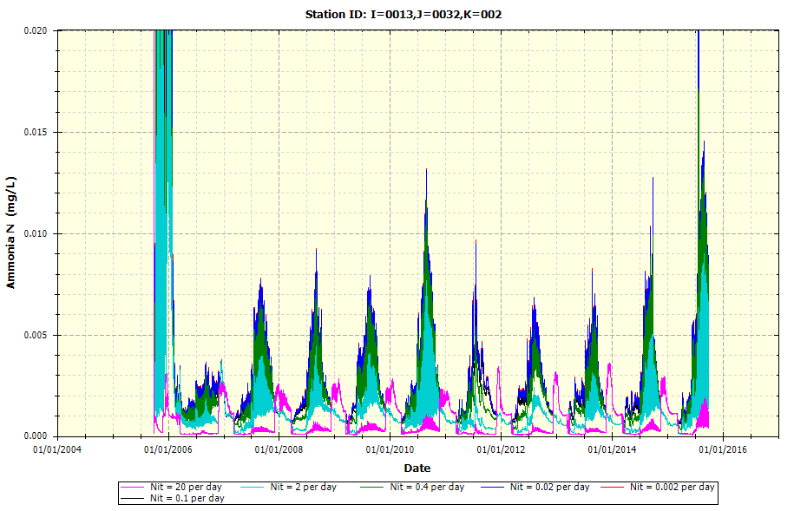

* + Example Plot on Nitrification Rate upon NO2-NO3-N

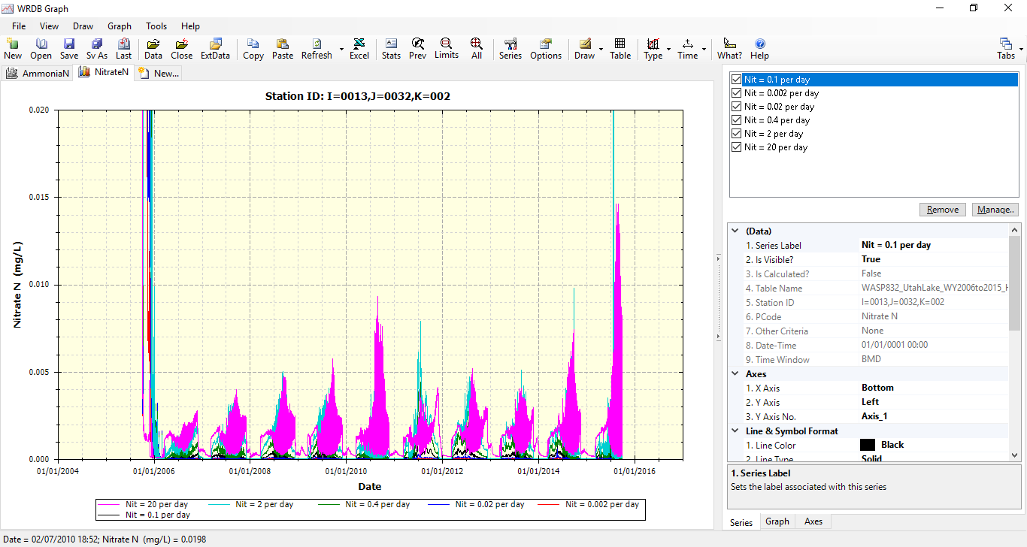

* Denitrification Rate at 20 degrees Celsius (per day) upon NO2-NO3-N

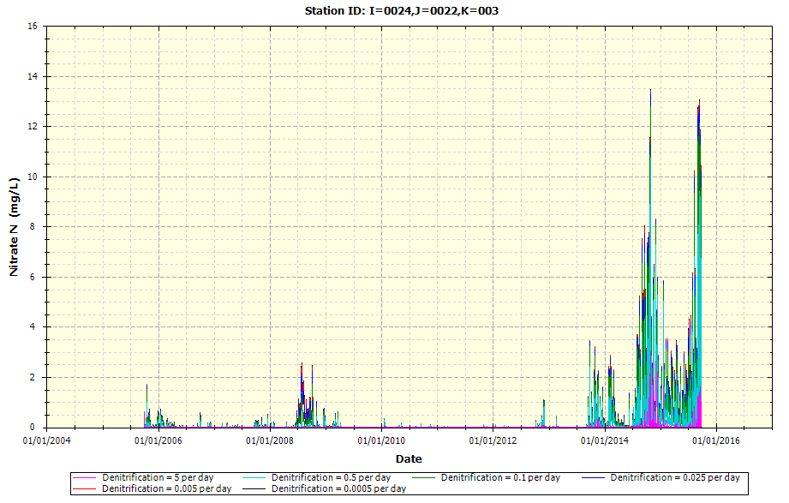

* Dissolved Organic Nitrogen Mineralization Rate at 20 degrees Celsius (per day) upon DON
  + Example Plot on DON Mineralization upon DON at a node nearby Goshen Bay

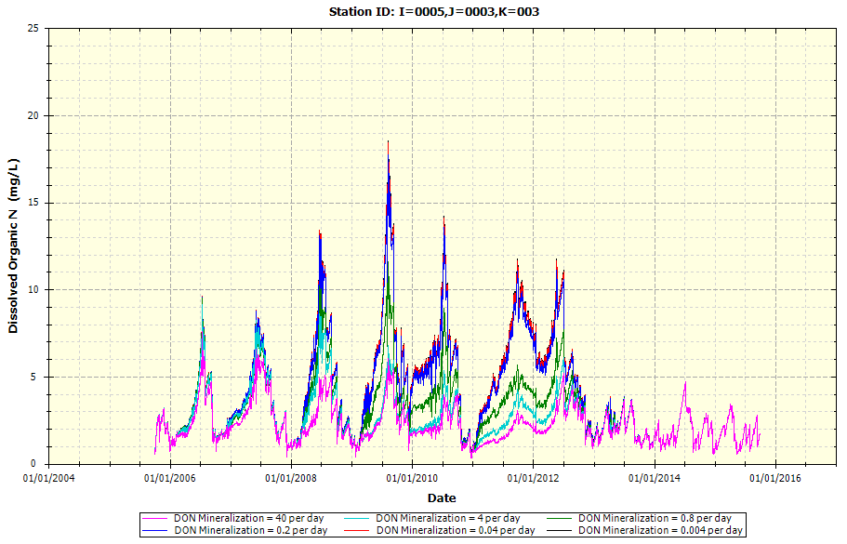

* + Example Plot on DON Mineralization upon DON at a node along Provo Bay

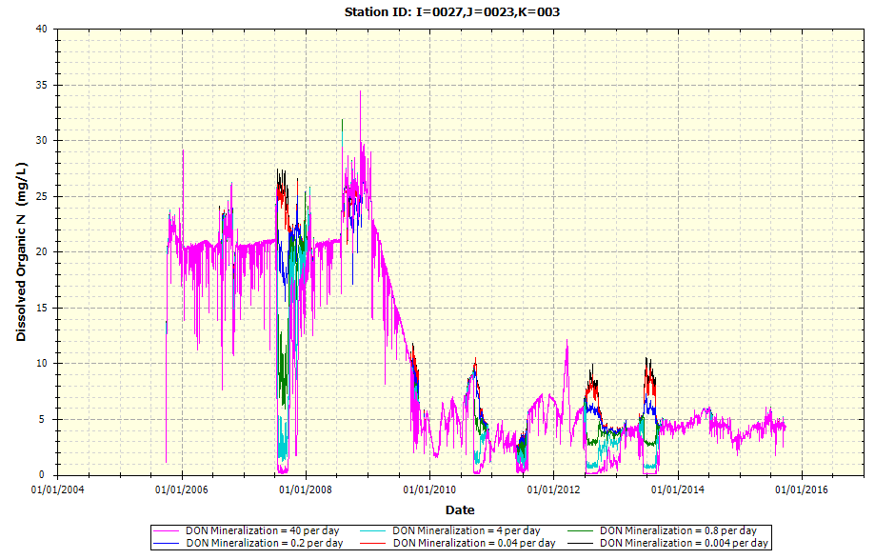

* Orthophosphate Partition Coefficient to Water Column Solids (Silt, Clay) (L/kg)
  + Example Plot on Orthophosphate Partition to Solids upon DIP

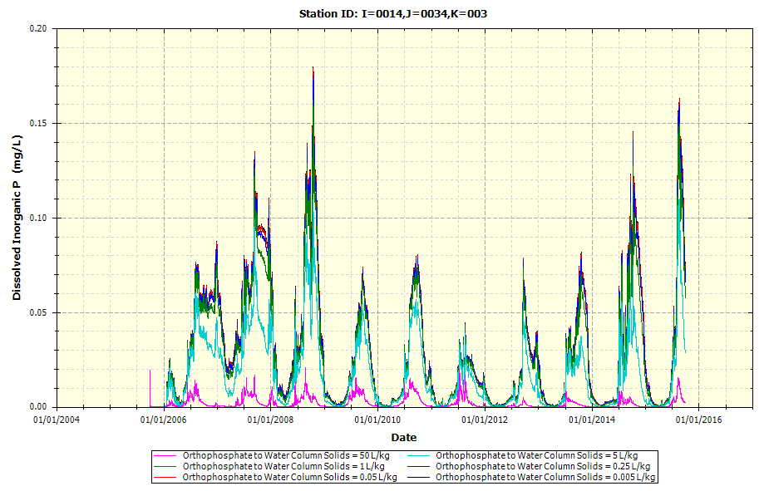

* + Example Plot on Orthophosphate Partition to Solids upon TP

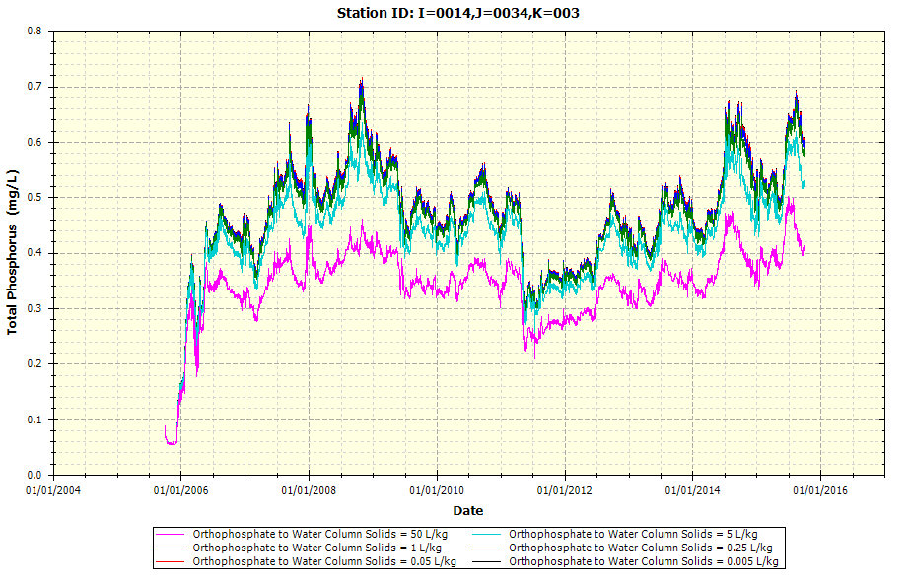

* Dissolved Organic Phosphate Mineralization Rate at 20 degrees Celsius (per day) upon TP

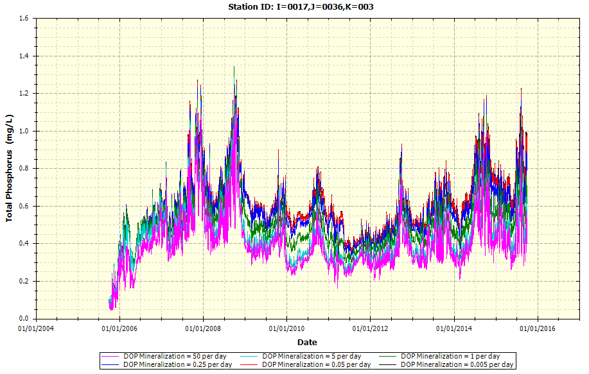

* Phytoplankton Maximum Growth Rate at 20 degrees Celsius (per day) upon Total Phytoplankton Chlorophyll-a

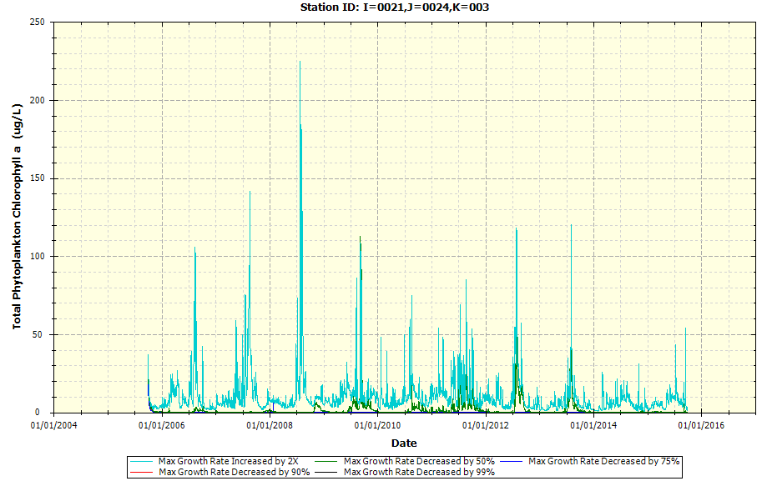

* Phytoplankton Respiration Rate at 20 degrees Celsius (per day)
  + Example Plot on Phytoplankton Respiration upon Total Phytoplankton Chlorophyll-a

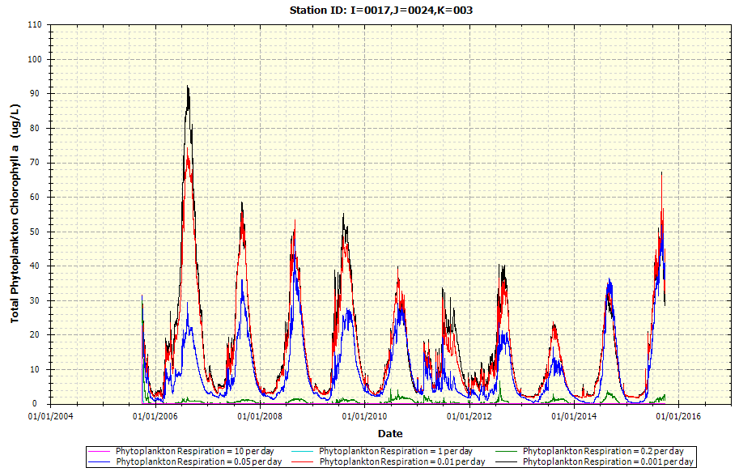

* + Example Plot on Phytoplankton Respiration upon DON

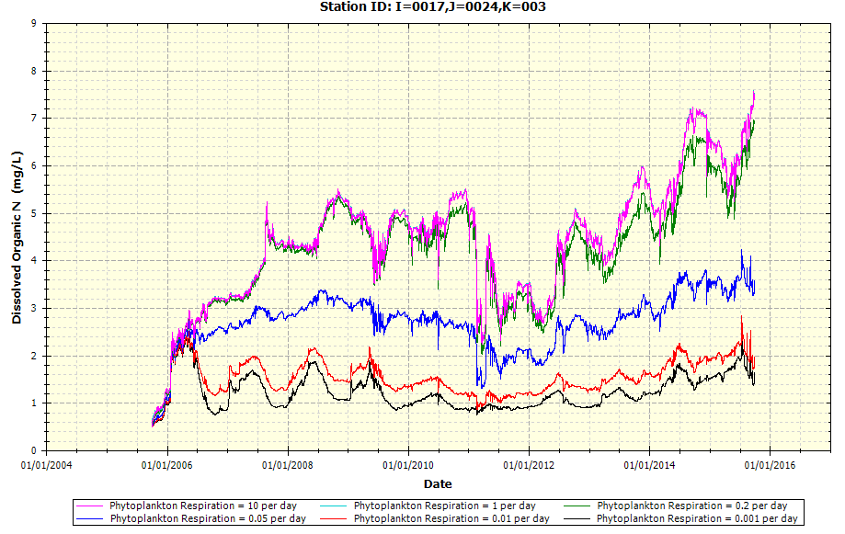

* + Example Plot on Phytoplankton Respiration upon DOP

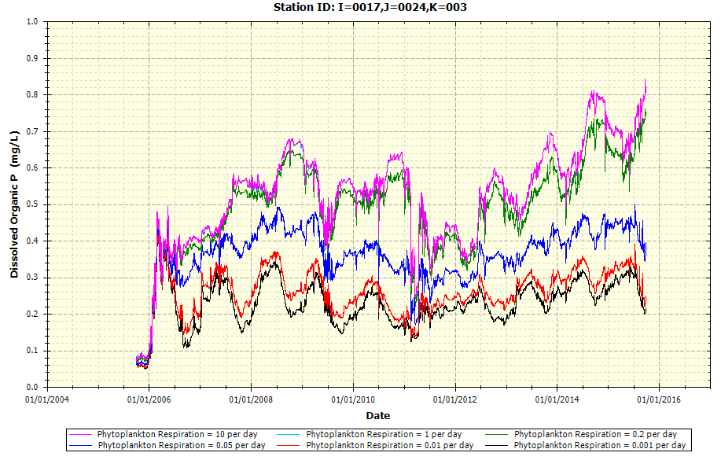

* Phytoplankton Death Rate (Non-zooplankton Predation) (per day)
  + Example Plot on Phytoplankton Death upon Total Phytoplankton Chlorophyll-a

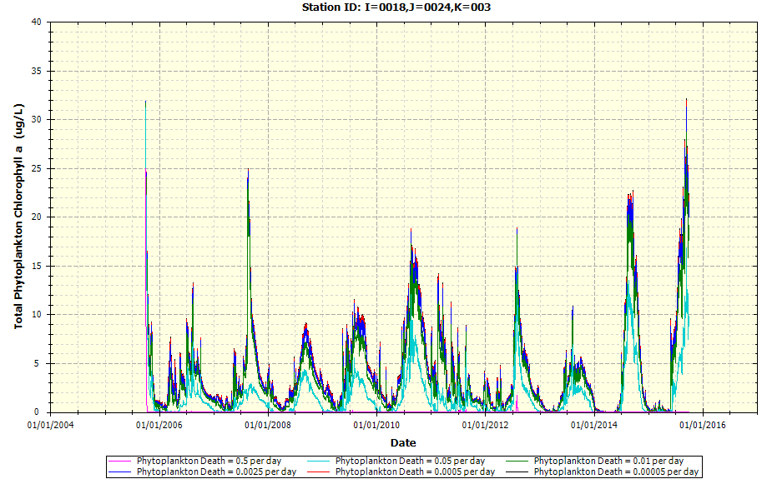

* + Example Plot on Phytoplankton Death upon PON

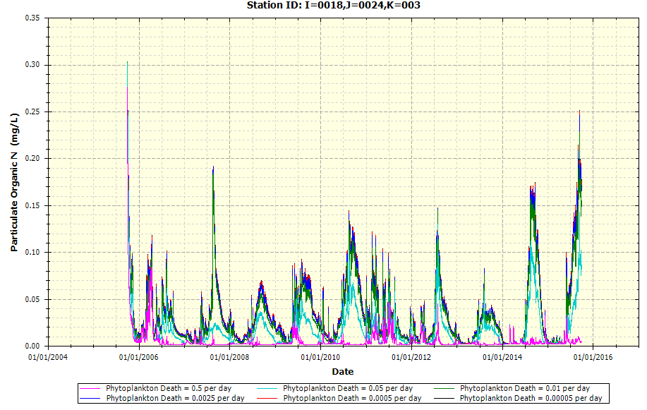

* + Example Plot on Phytoplankton Death upon POP

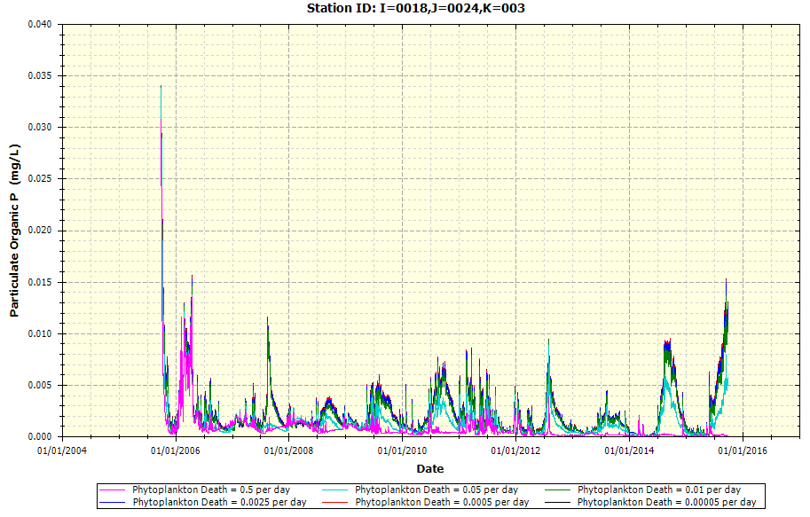

* + Example Plot on Phytoplankton Death upon SOD

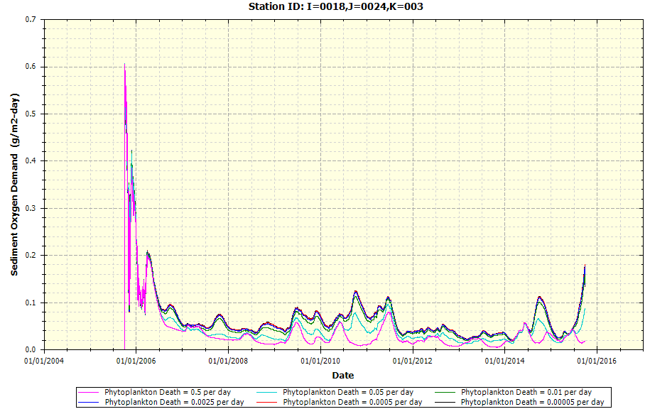

* + Example Plot on Phytoplankton Death upon DO

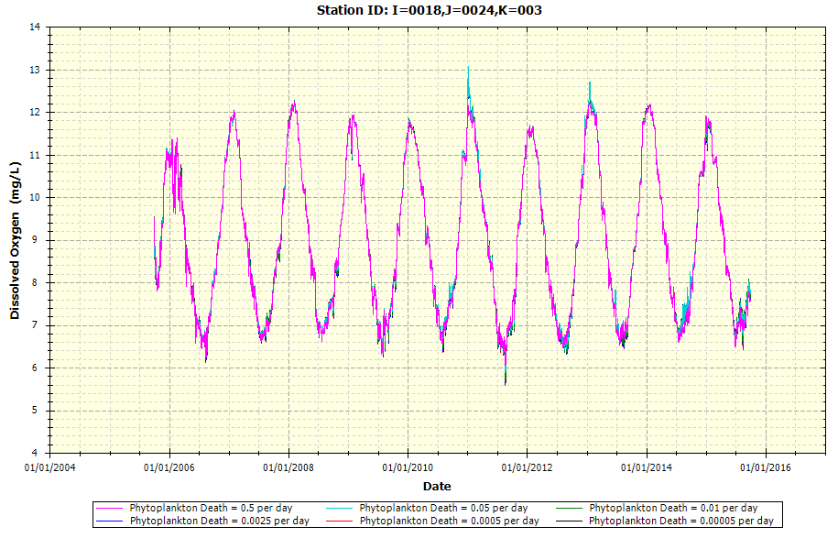

* Macro/Benthic Algae Fraction Coverage
  + Example Plot on Macro/Benthic Algae Coverage upon Algae Chlorophyll-a

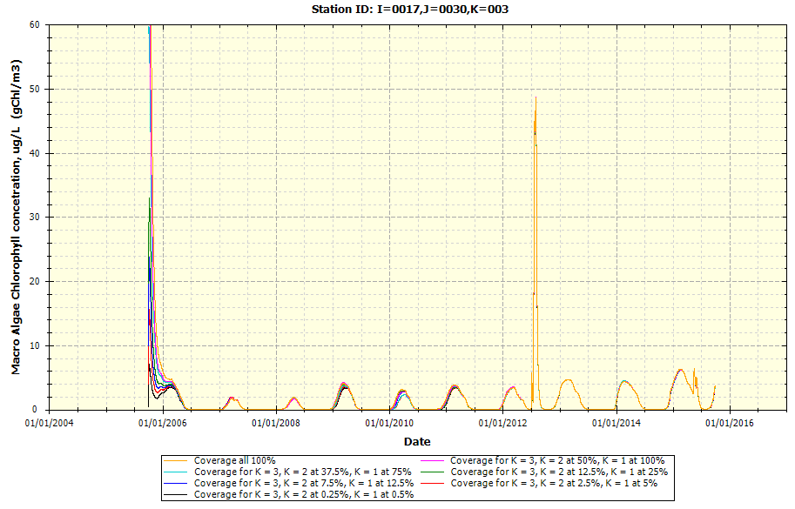

* + Example Plot on Macro/Benthic Algae Coverage upon TN

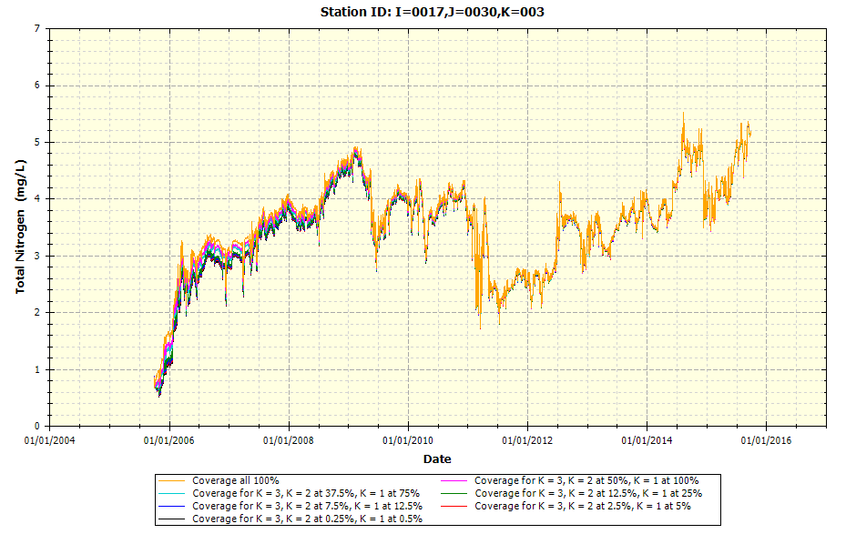

* + Example Plot on Macro/Benthic Algae Coverage upon TP

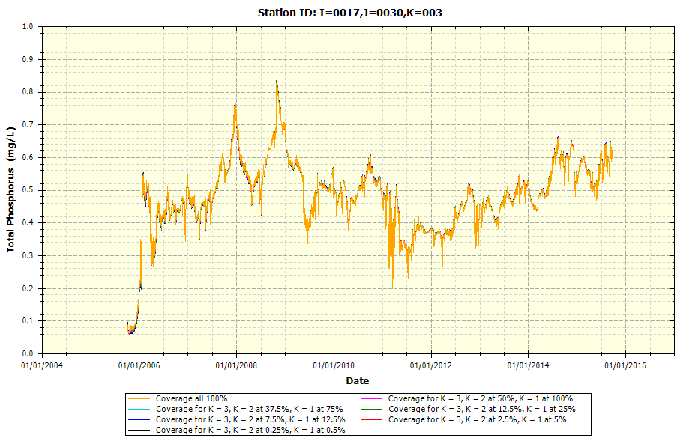

* + Example Plot on Macro/Benthic Algae Coverage upon DO

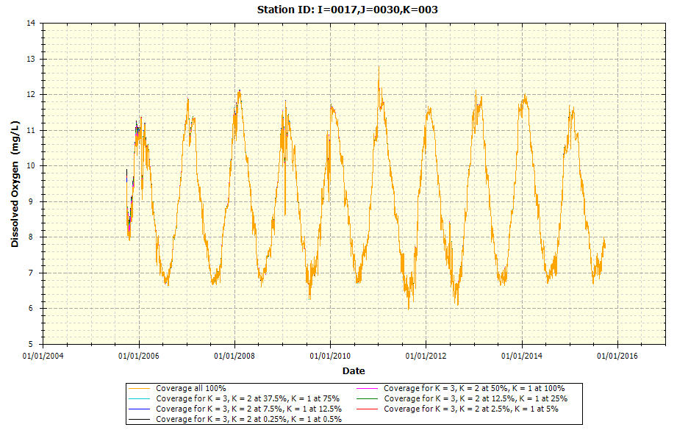

* Macro/Benthic Algae Maximum Growth Rate at 20 degrees Celsius (per day)
  + Example Plot on Algal Maximum Growth Rate upon Algae Chlorophyll-a

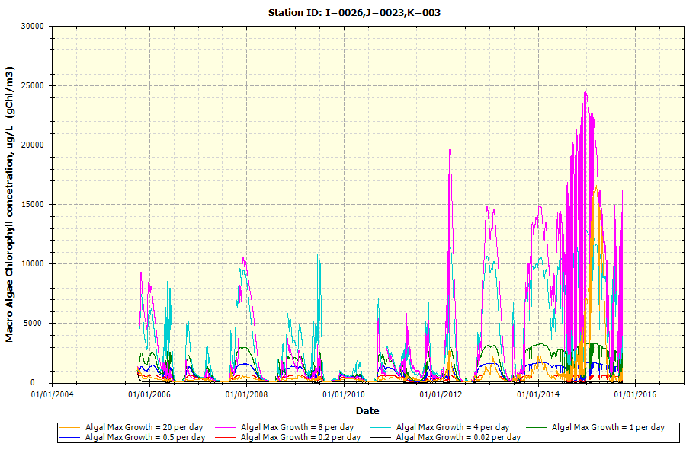

* + Example Plot on Algal Maximum Growth Rate upon DO

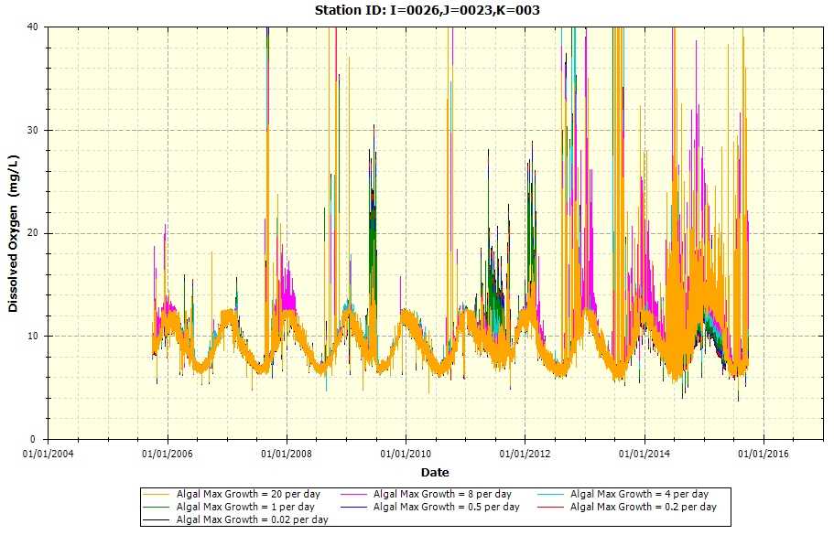

* Macro/Benthic Algae O2:C Production (mg O2/mg C) upon DO

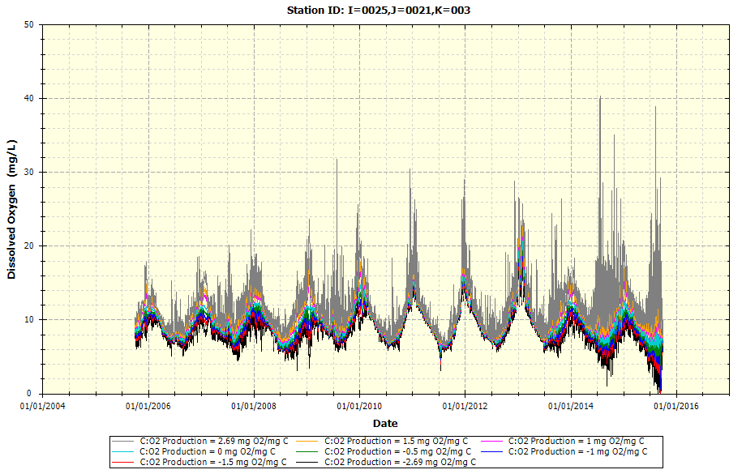

* Detritus/POM Dissolution Rate at 20 degrees Celsius (per day)
  + Example Plot on POM Dissolution upon POC (K = 3 is Surface Water Layer; K = 2 is Middle Layer; K = 1 is Bottom/Benthic Layer)

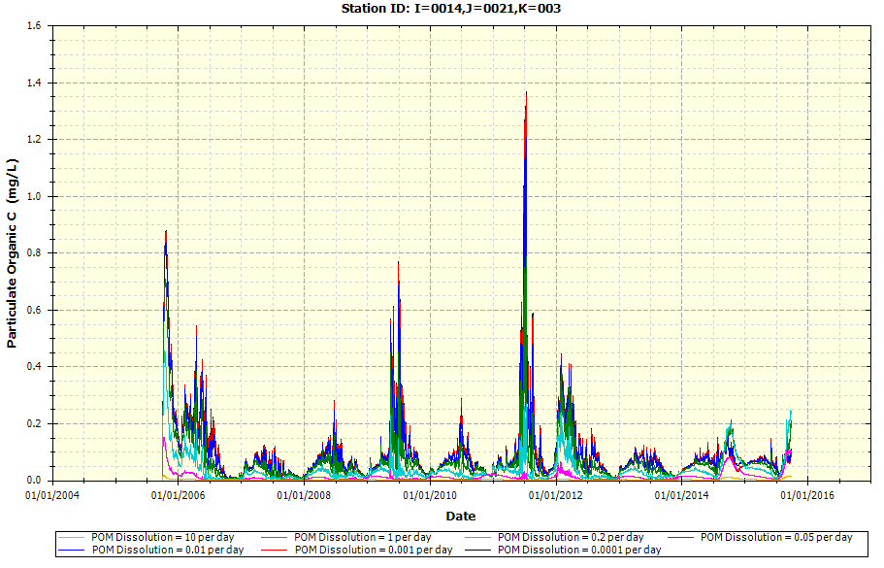

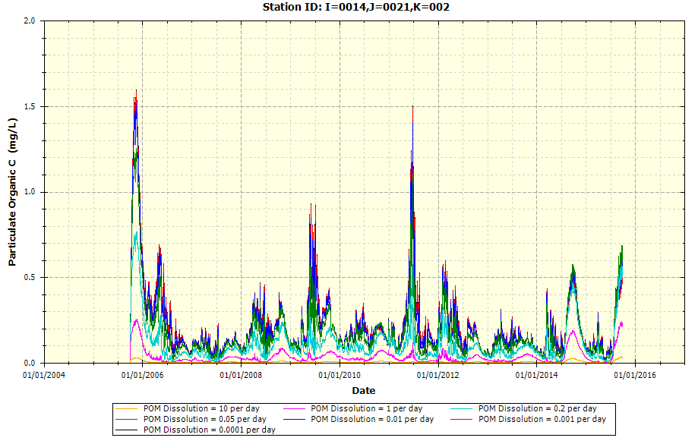 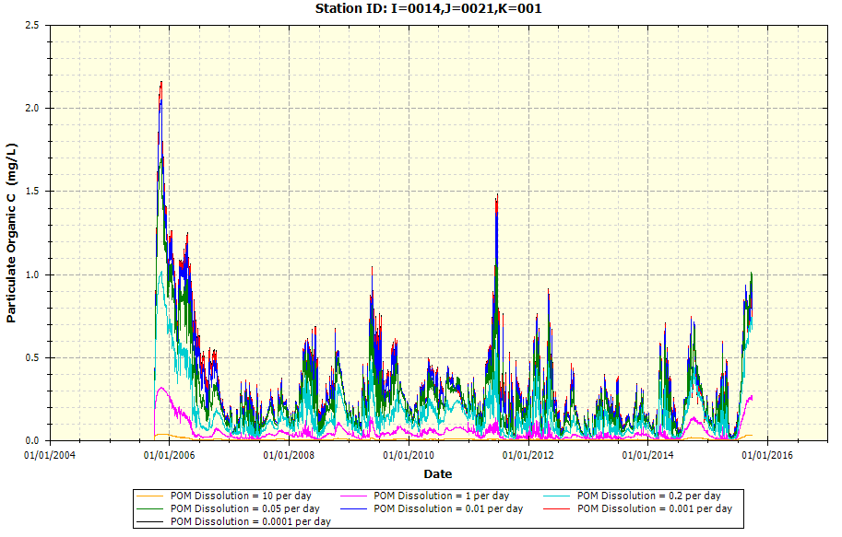

* + Example Plot on POM Dissolution upon PON (K = 3 is Surface Water Layer; K = 2 is Middle Layer; K = 1 is Bottom/Benthic Layer)

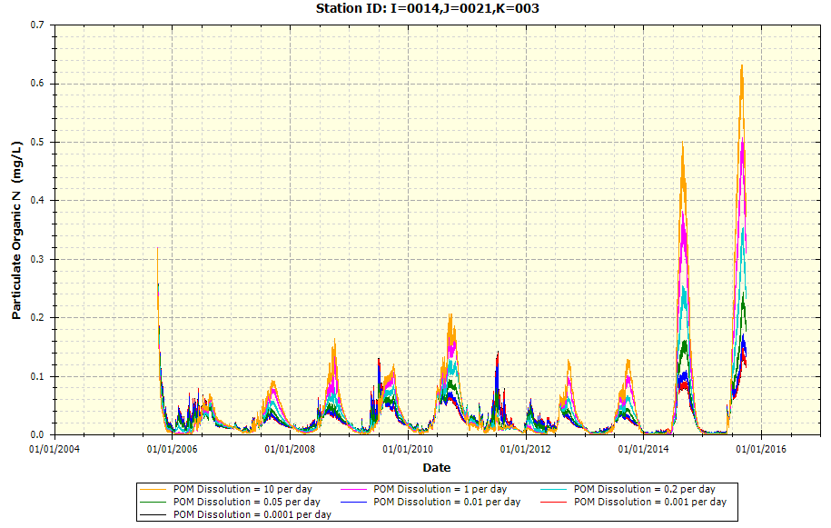

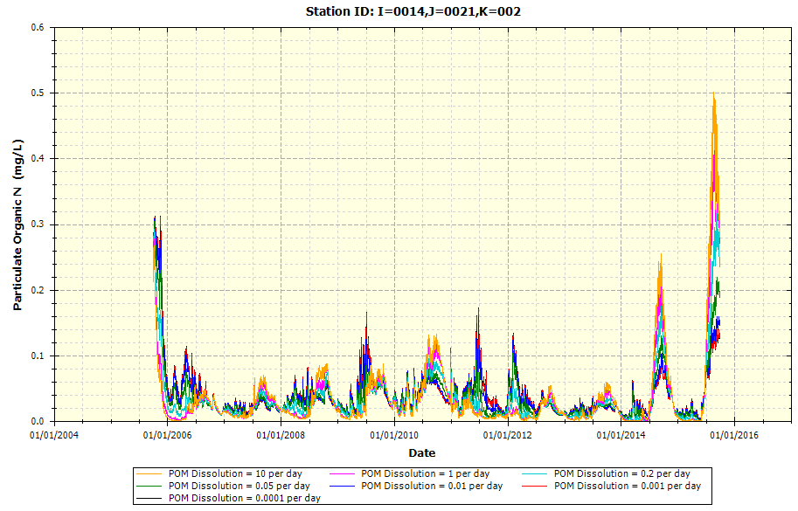

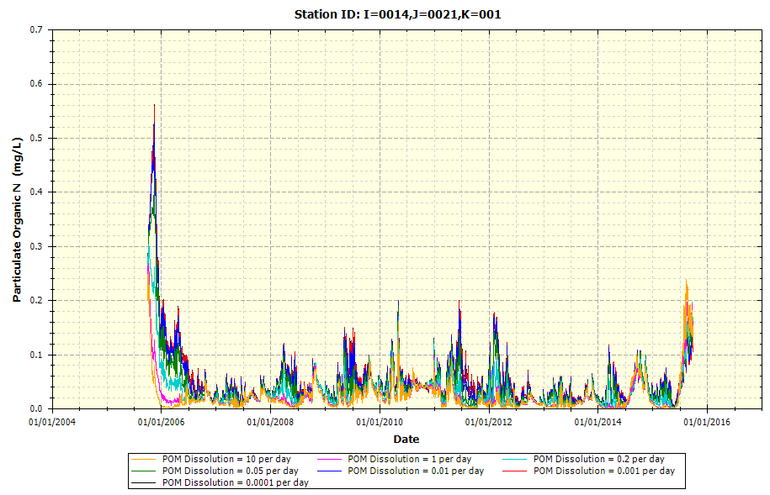

* + Example Plot on POM Dissolution upon POP (K = 3 is Surface Water Layer; K = 2 is Middle Layer; K = 1 is Bottom/Benthic Layer)

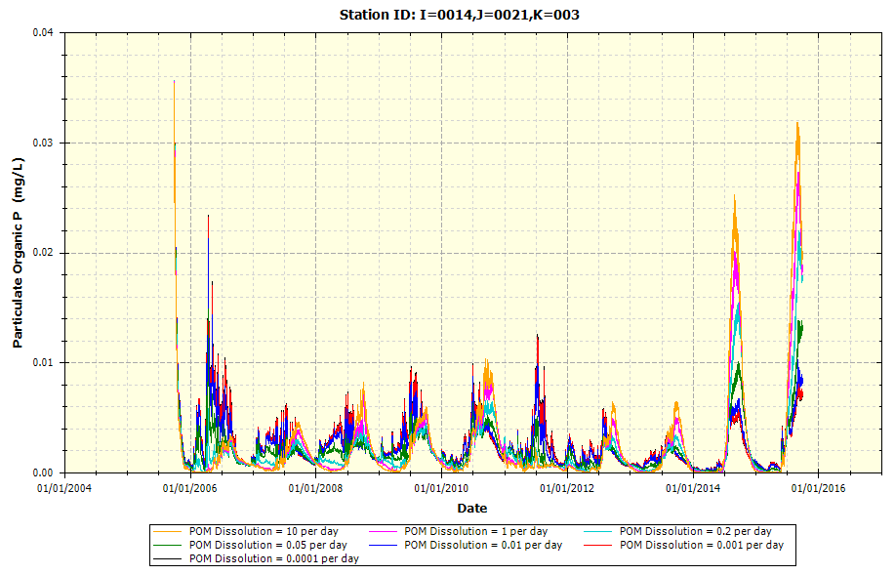

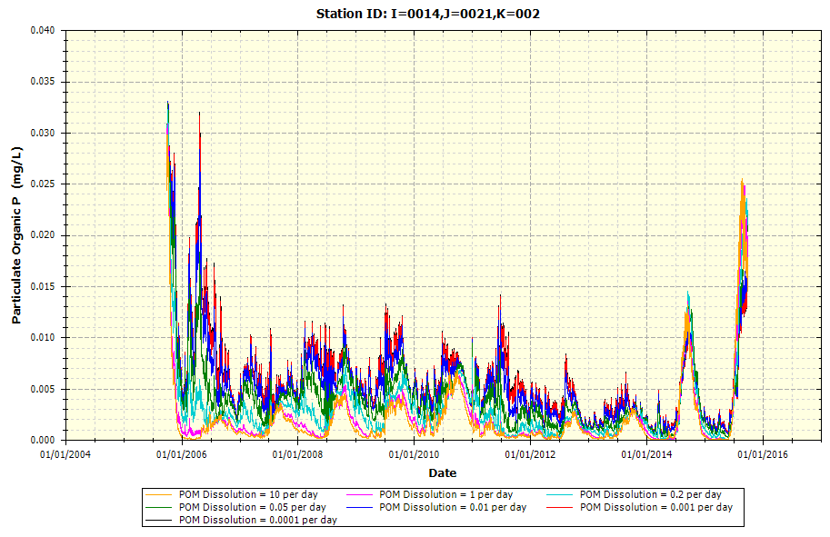

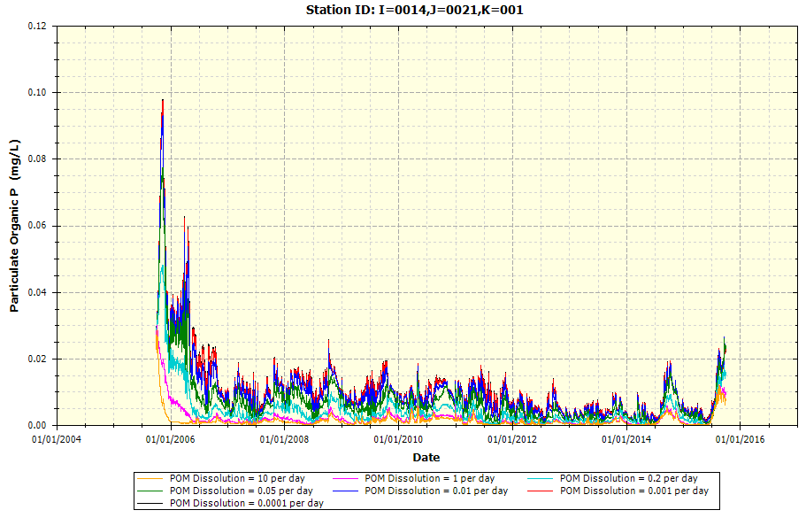

* + Example Plot on POM Dissolution upon SOD (K = 1 Layer)

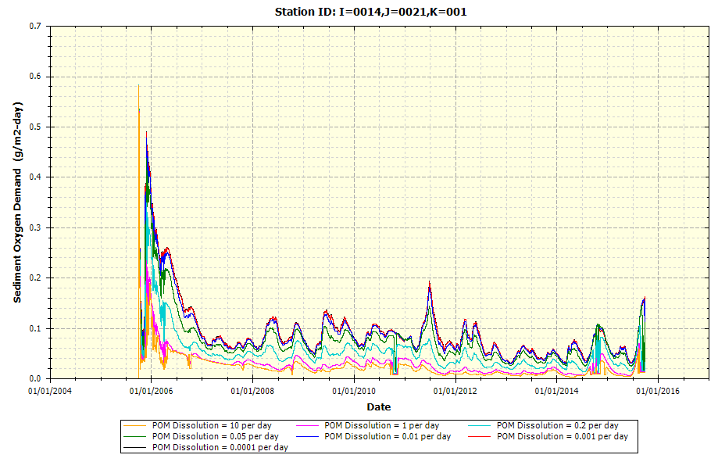

* + Example Plot on POM Dissolution upon DO (K = 3 is Surface Water Layer; K = 2 is Middle Layer; K = 1 is Bottom/Benthic Layer)

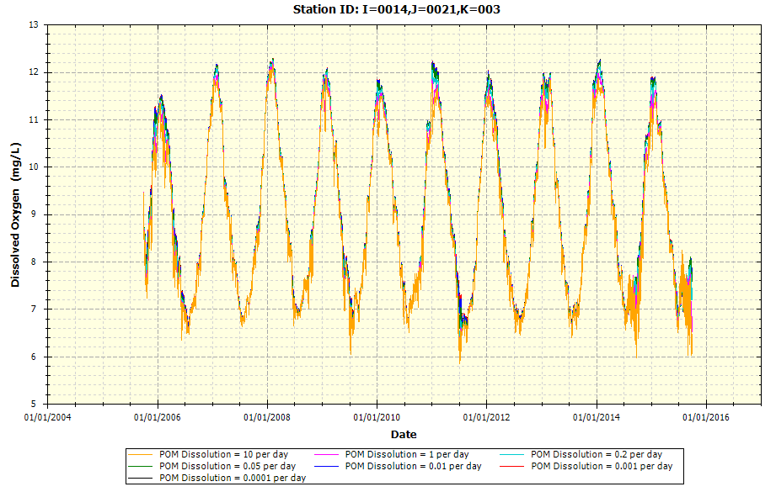

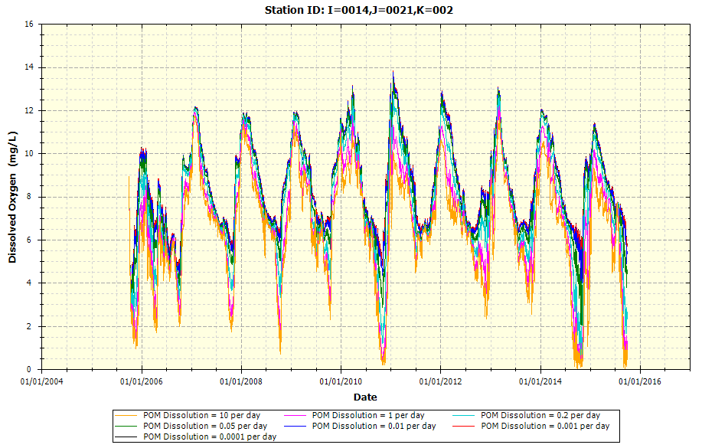

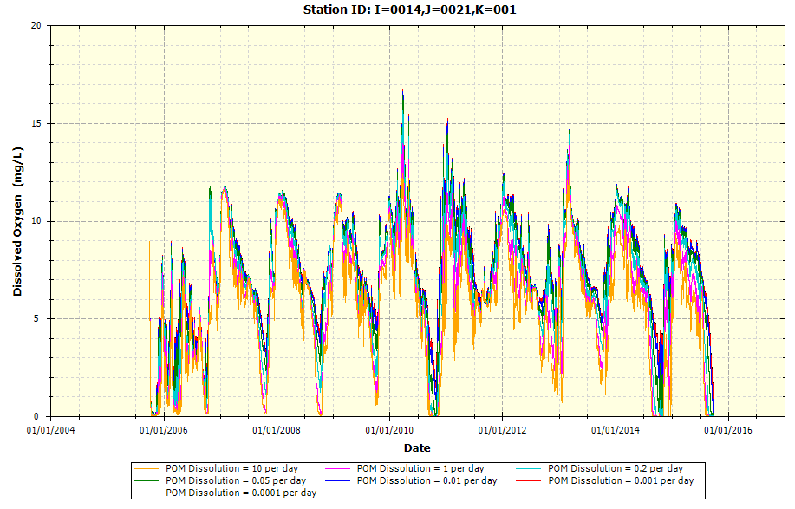

* Initial POC Sediment Condition per Node (mg O2 equivalents/g sediment)
  + Example Plot on Initial POC upon POC (K = 3 is Surface Water Layer; K = 2 is Middle Layer; K = 1 is Bottom/Benthic Layer)

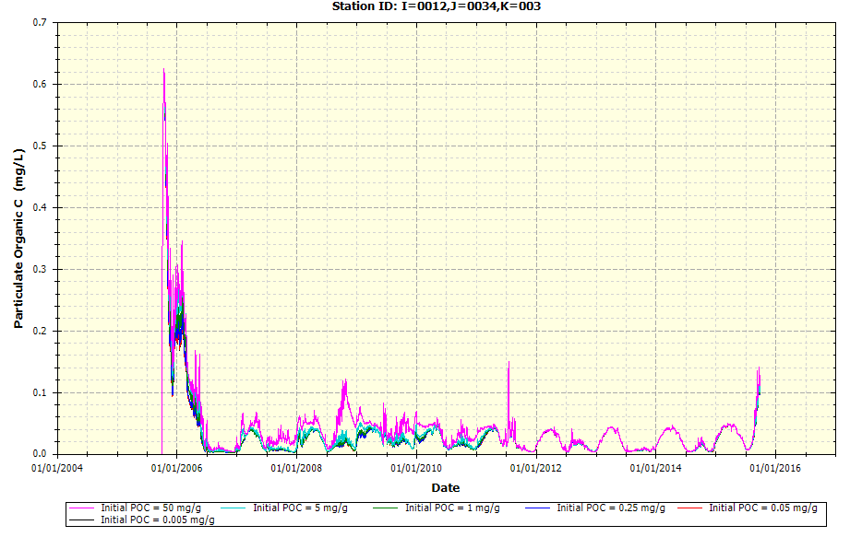

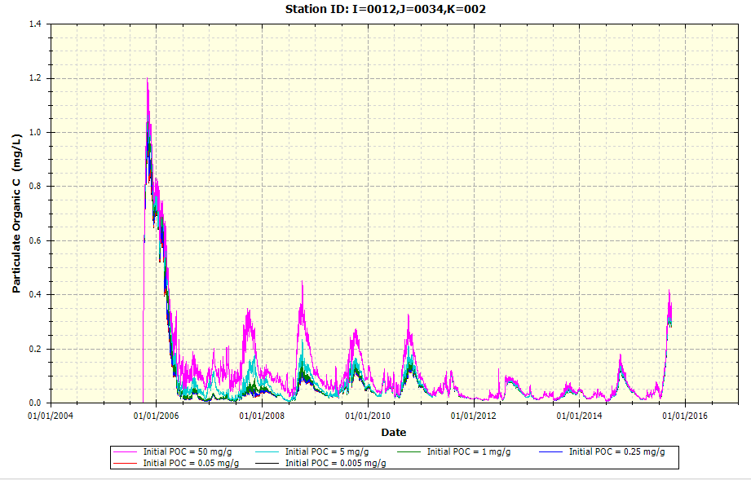

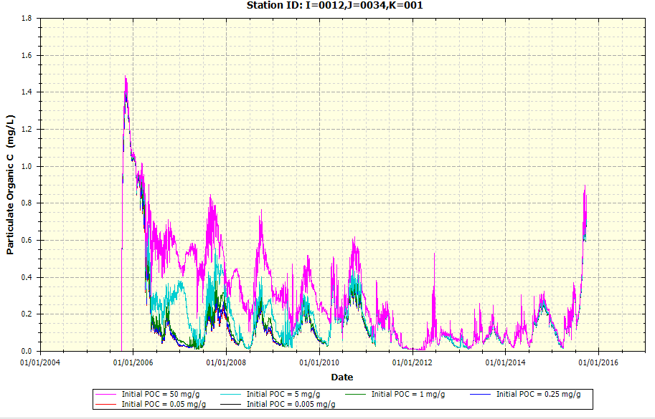

* + Example Plot on Initial POC upon SOD (K = 1 Layer)

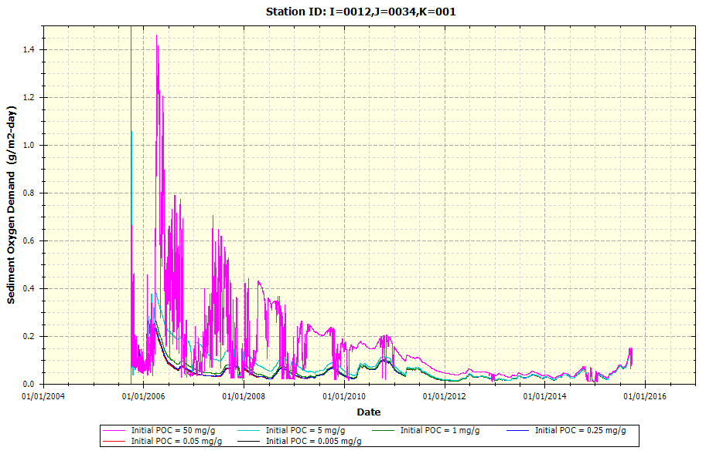

* + Example Plot on Initial POC upon DO (K = 3 is Surface Water Layer; K = 2 is Middle Layer; K = 1 is Bottom/Benthic Layer)

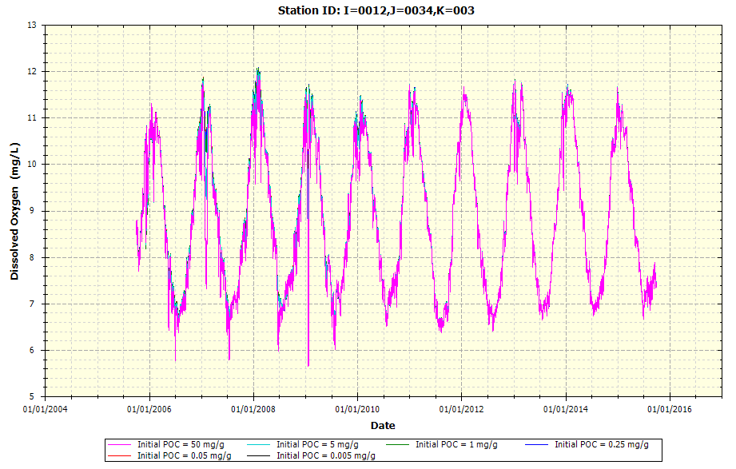

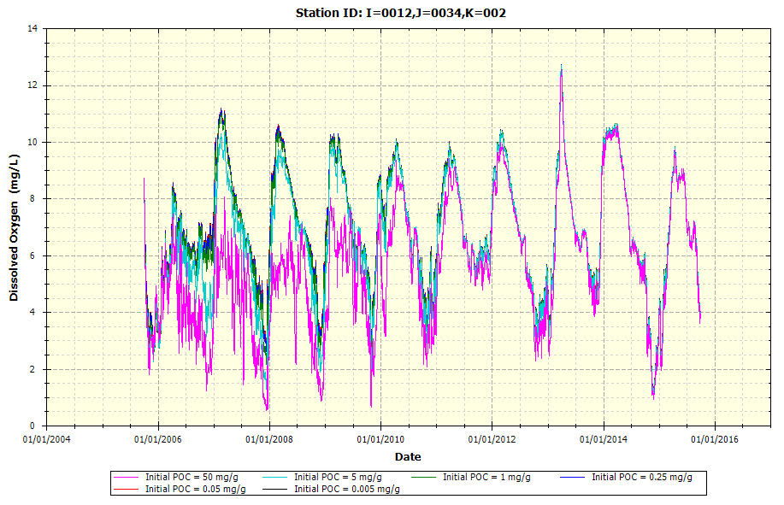

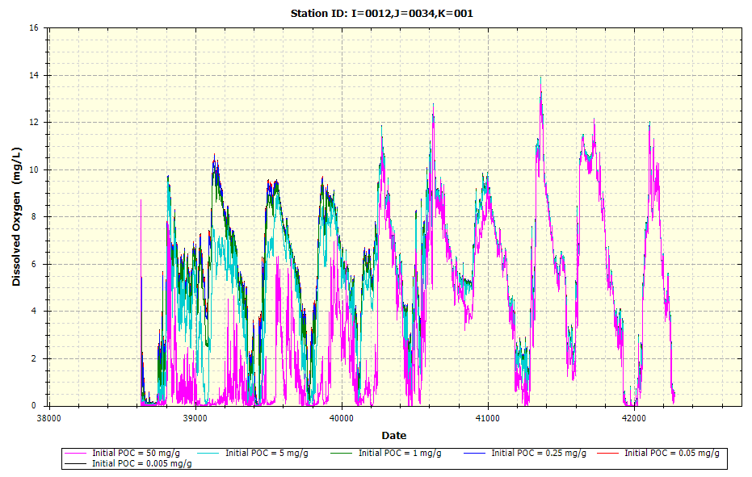

* Initial PON Sediment Condition per Node (mg N/g sediment)
  + Example Plot on Initial PON upon POC (K = 3 is Surface Water Layer; K = 2 is Middle Layer; K = 1 is Bottom/Benthic Layer)

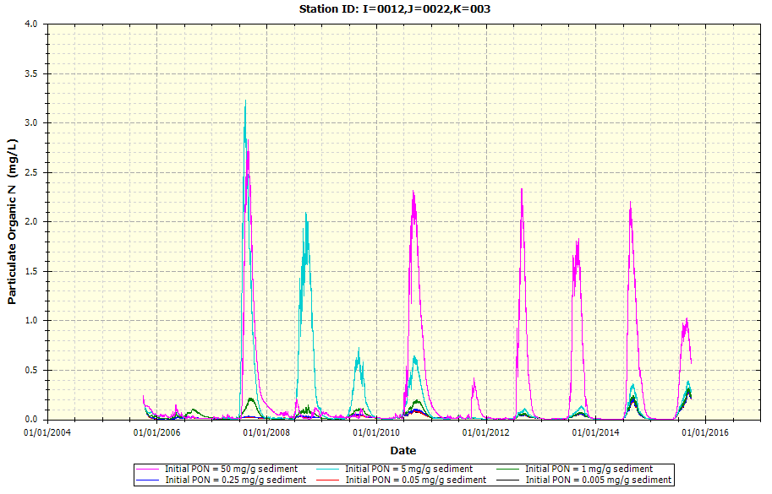

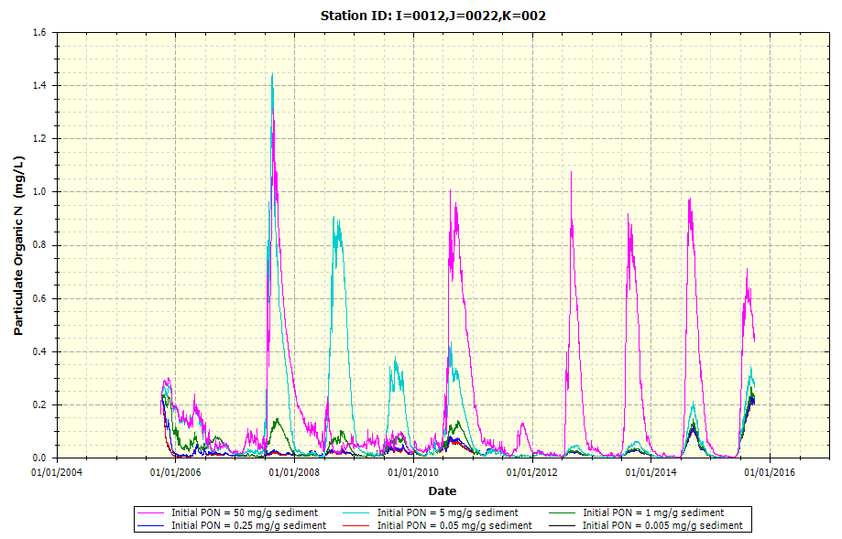

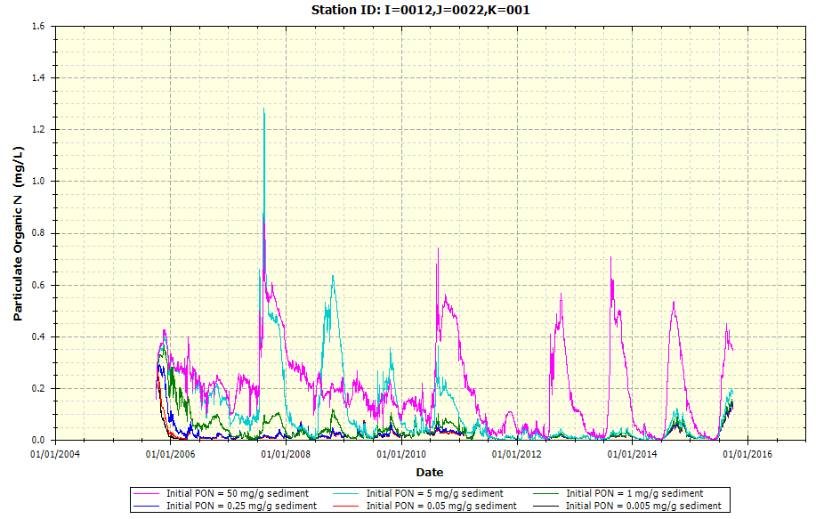

* + Example Plot on Initial PON upon SOD (K = 1 Layer)

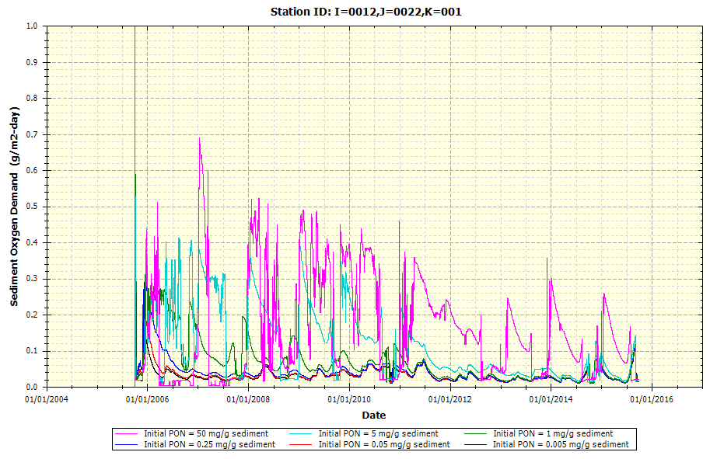

* + Example Plot on Initial PON upon DO (K = 3 is Surface Water Layer; K = 2 is Middle Layer; K = 1 is Bottom/Benthic Layer)

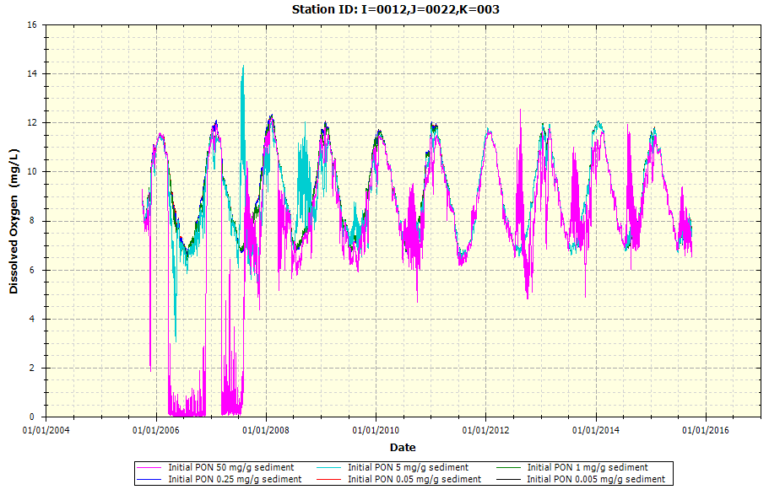

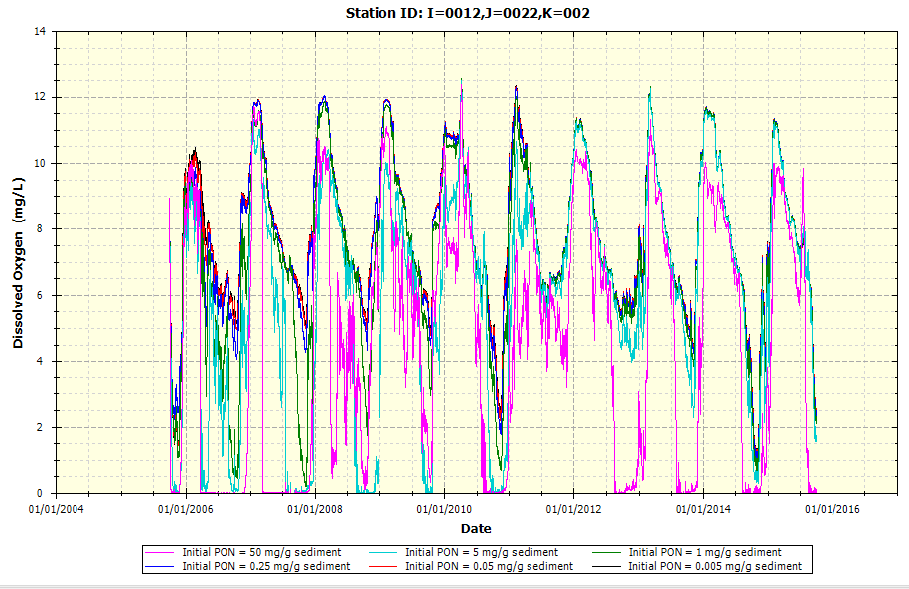

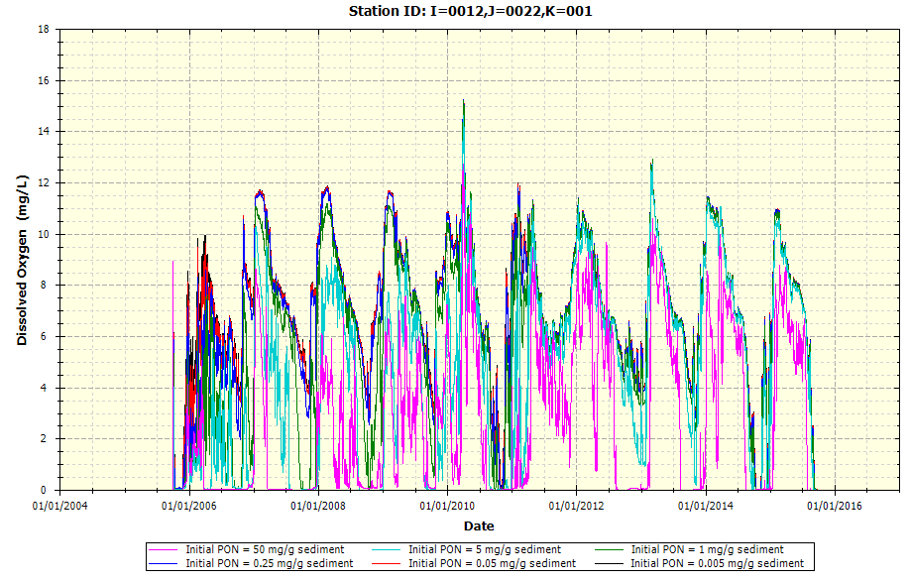

### Settling Rates

The following example plots provide the variability of different input parameters that focus on the settling rates, primarily phytoplankton, upon the Utah Lake WASP.

* POM/Detritus Settling Rate (m/day)
  + Example Plot on Detritus Settling Rate upon POC (K = 3 is Surface Water Layer; K = 2 is Middle Layer; K = 1 is Bottom/Benthic Layer)

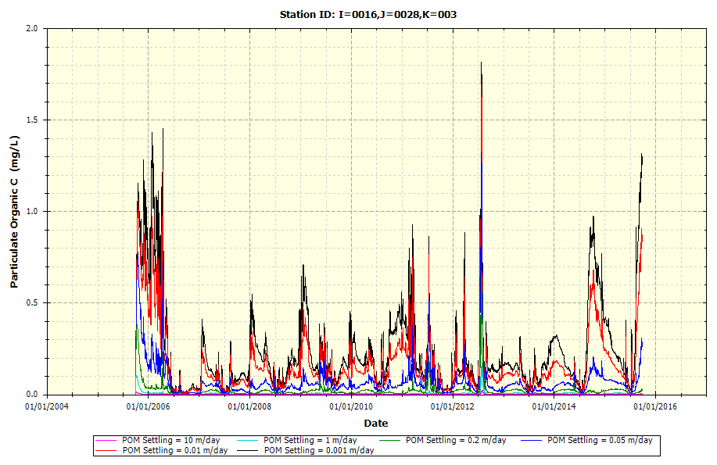

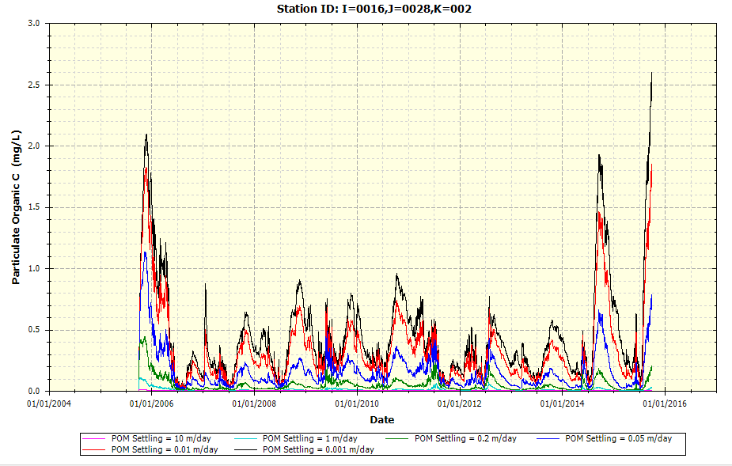

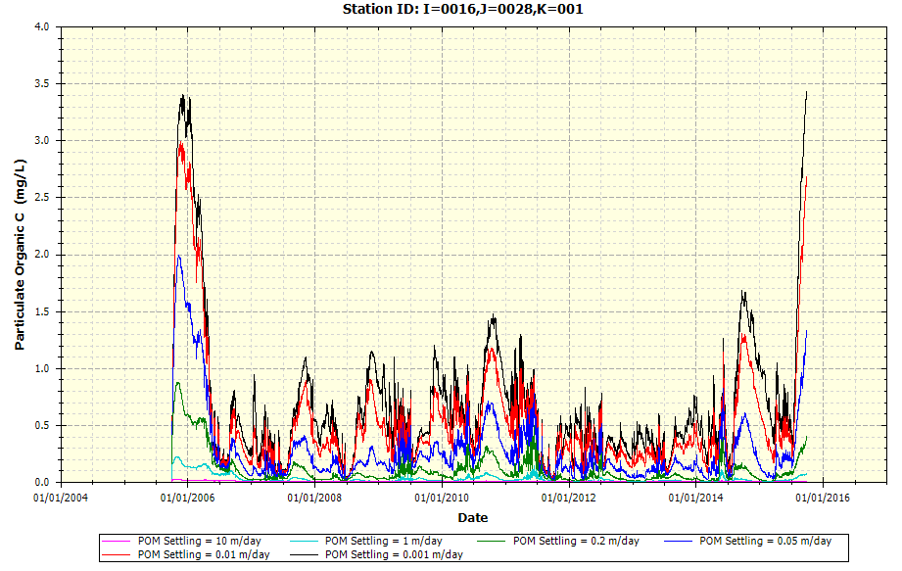

* + Example Plot on Detritus Settling Rate upon PON (K = 3 is Surface Water Layer; K = 2 is Middle Layer; K = 1 is Bottom/Benthic Layer)

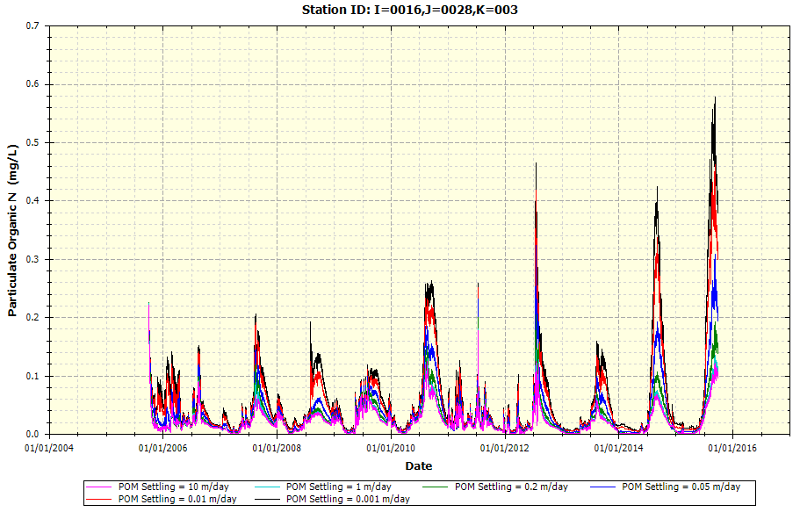

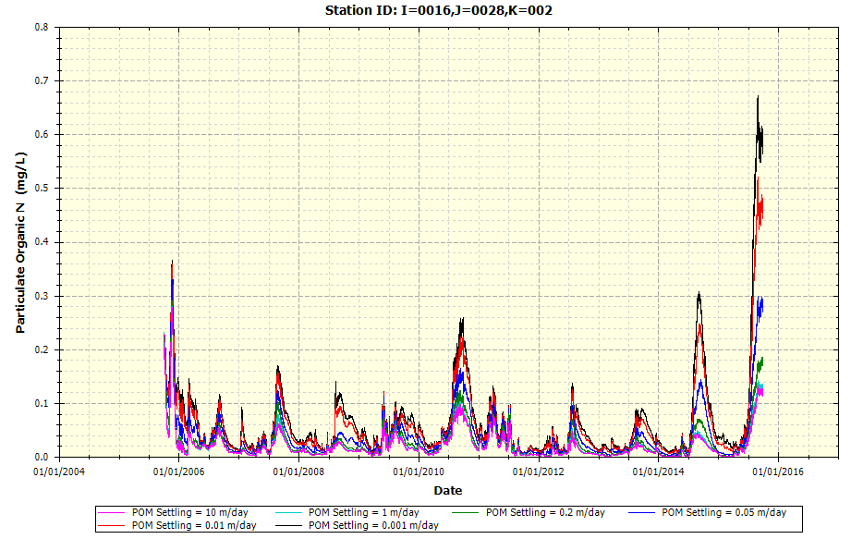

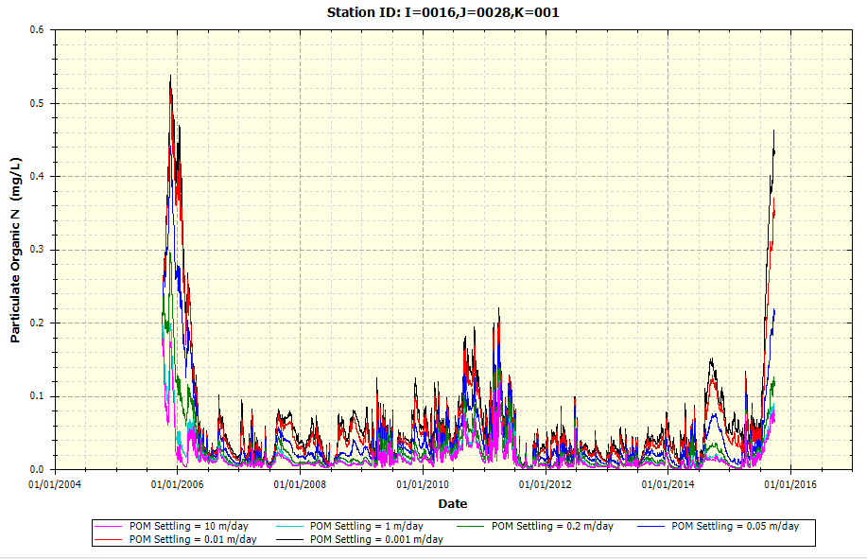

* + Example Plot on Detritus Settling Rate upon POP (K = 3 is Surface Water Layer; K = 2 is Middle Layer; K = 1 is Bottom/Benthic Layer)

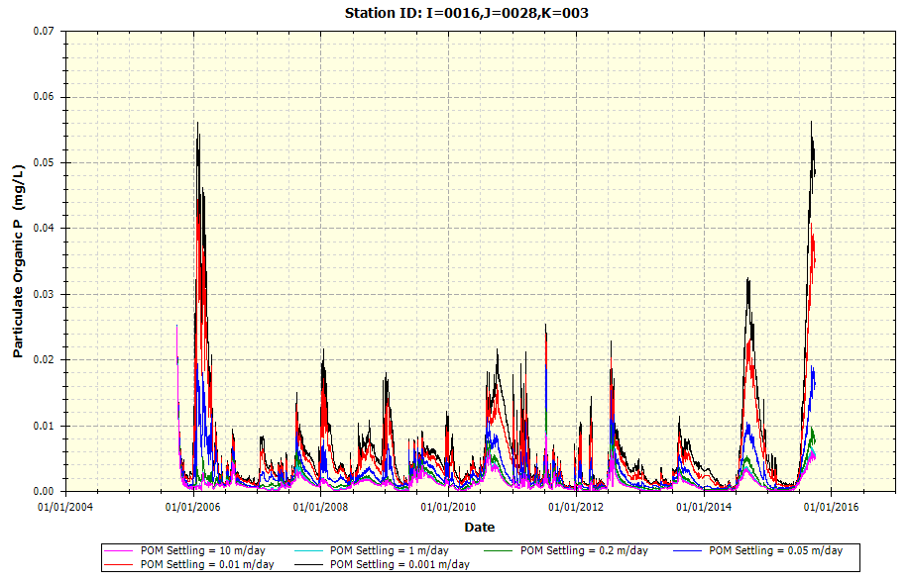

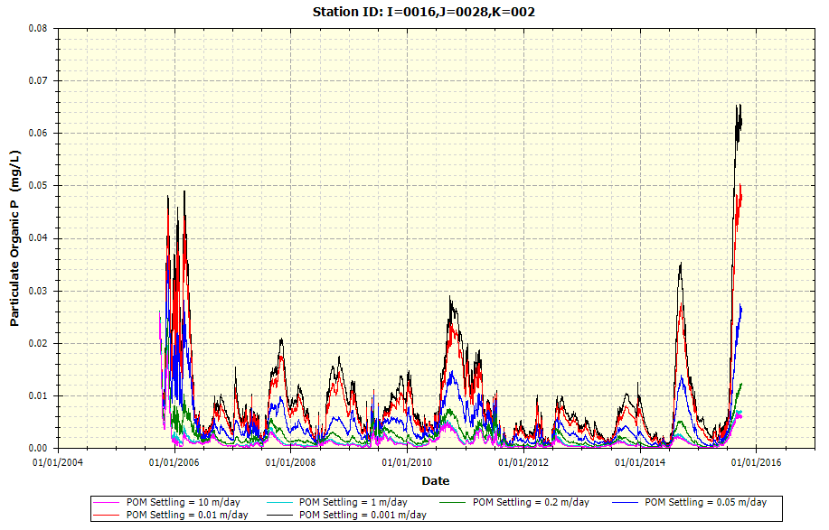

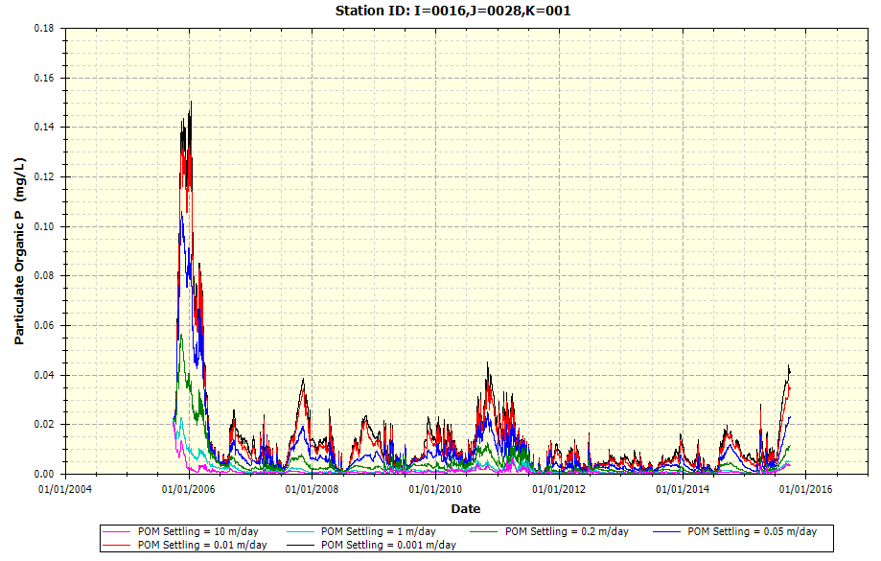

* + Example Plot on Detritus Settling Rate upon SOD (K = 1 Layer)

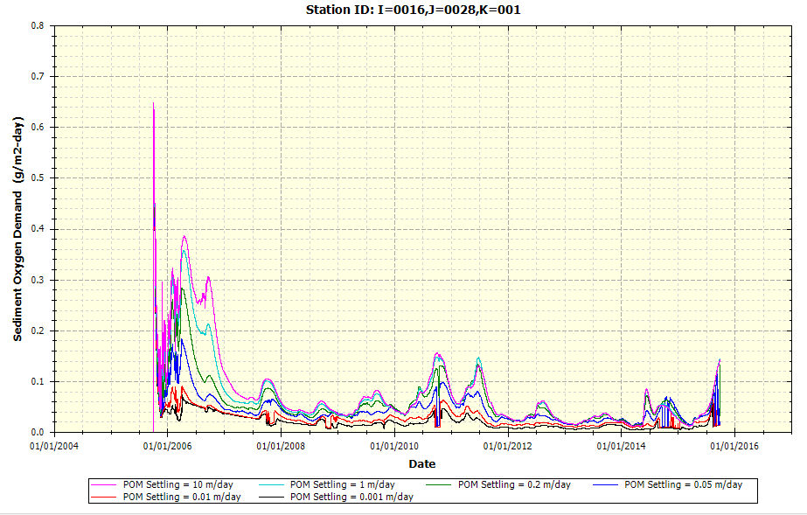

* + Example Plot on Detritus Settling Rate upon DO (K = 3 is Surface Water Layer; K = 2 is Middle Layer; K = 1 is Bottom/Benthic Layer)

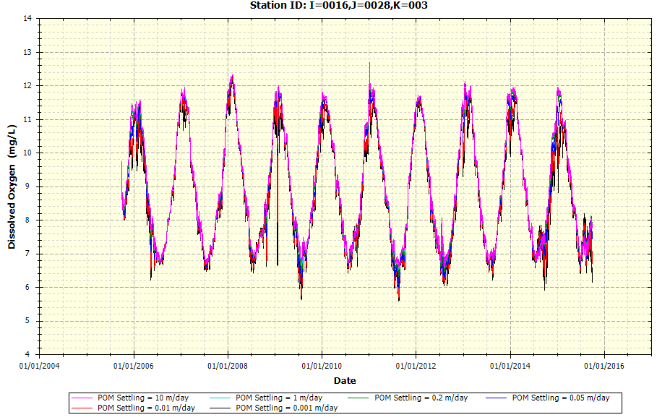

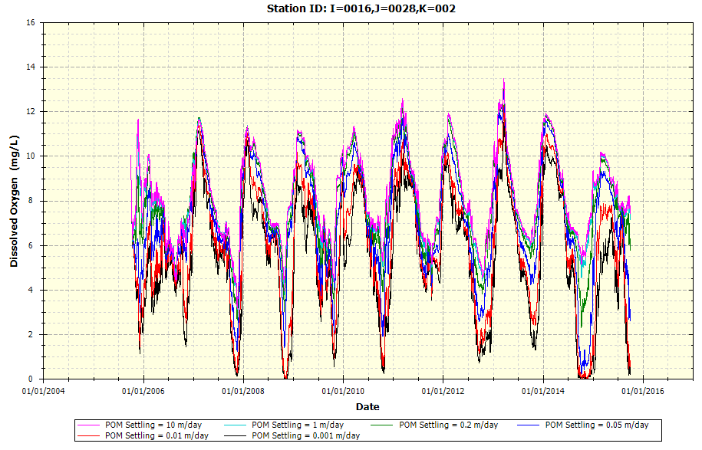

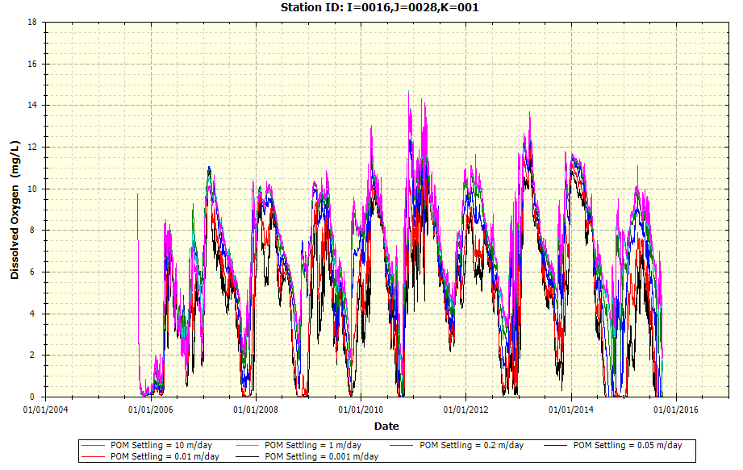

* Phytoplankton Settling Rate (m/day) upon Total Phytoplankton Chlorophyll-a

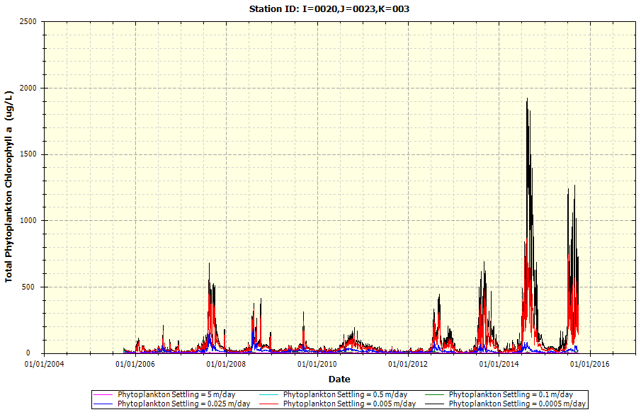

### Lighting

The following example plots provide the variability of different input parameters that focus on light extinction parameters upon the Utah Lake WASP.

* Background Light Extinction Coefficient (1/m)
  + Example Plot on Background Light Extinction upon Phytoplankton Chlorophyll-a

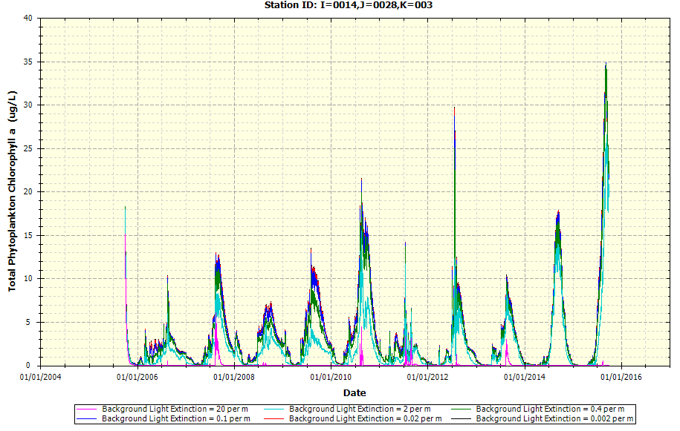

* + Example Plot on Background Light Extinction upon Macro/Benthic Algae Concentration

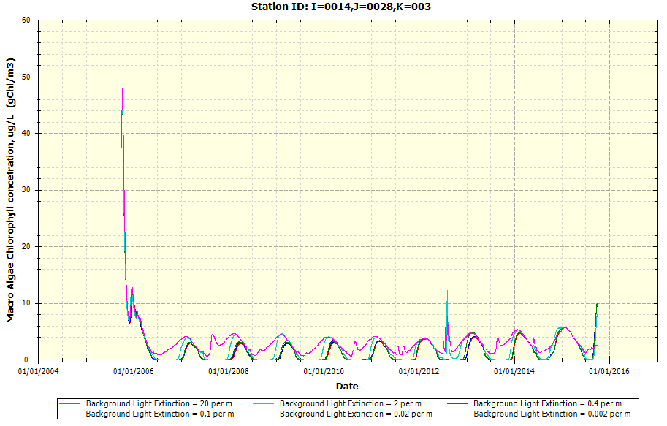

* + Example Plot on Background Light Extinction upon TN

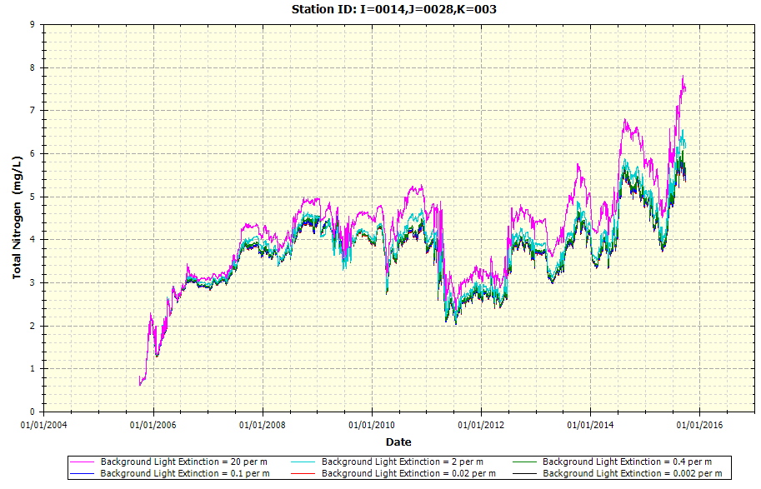

* + Example Plot on Background Light Extinction upon TP

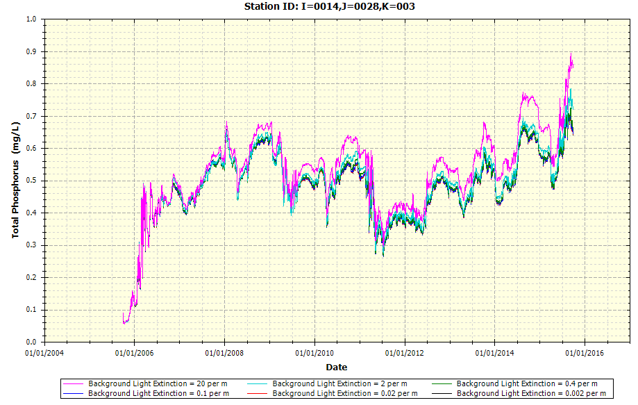

* + Example Plot on Background Light Extinction upon DO

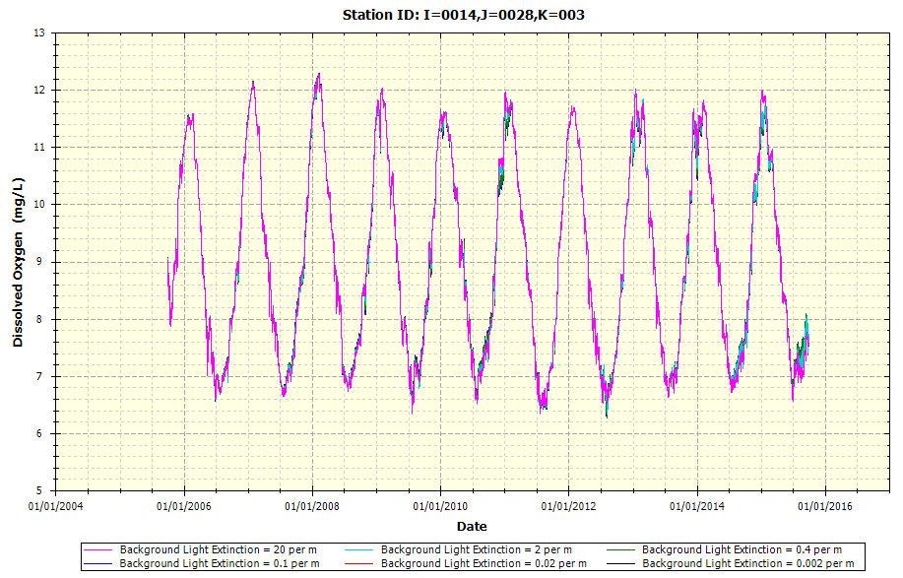

* Detritus and Solids Light Extinction Coefficient (1/m)
  + Example Plot on Detritus and Solids Light Extinction upon POC (K = 3 is Surface Water Layer; K = 2 is Middle Layer; K = 1 is Bottom/Benthic Layer)

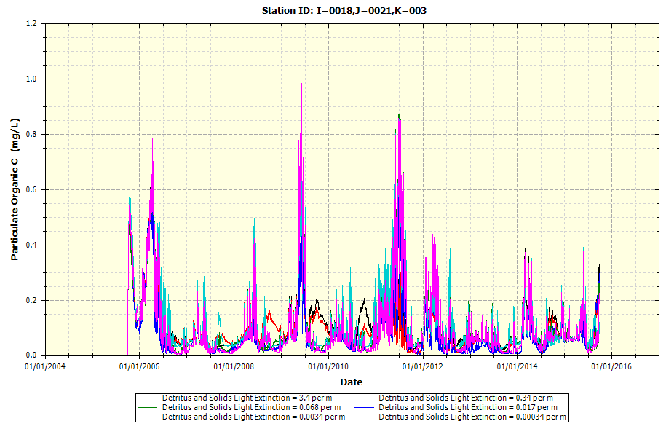

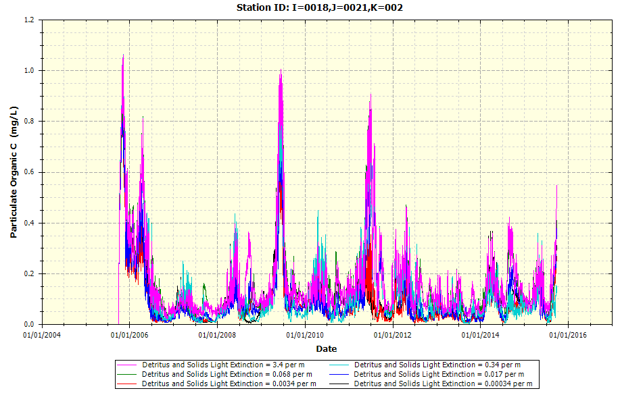

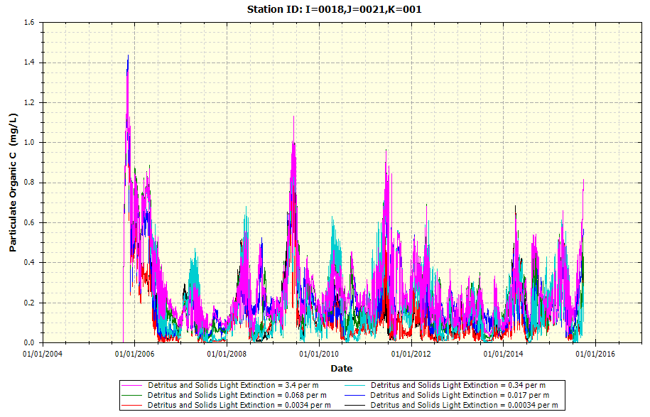

* + Example Plot on Detritus and Solids Light Extinction upon PON (K = 3 is Surface Water Layer; K = 2 is Middle Layer; K = 1 is Bottom/Benthic Layer)

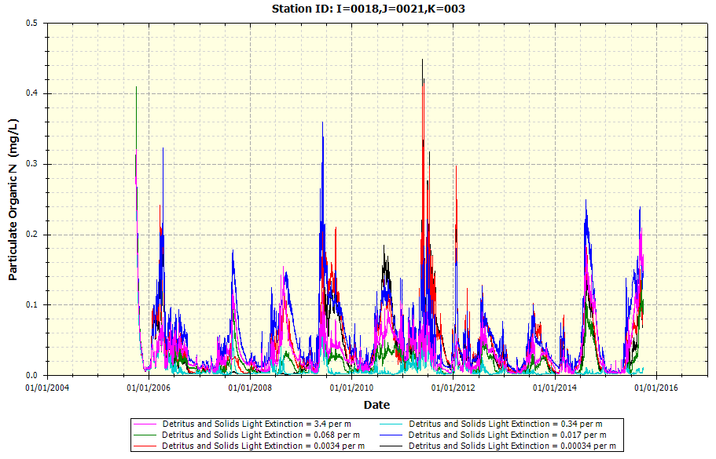

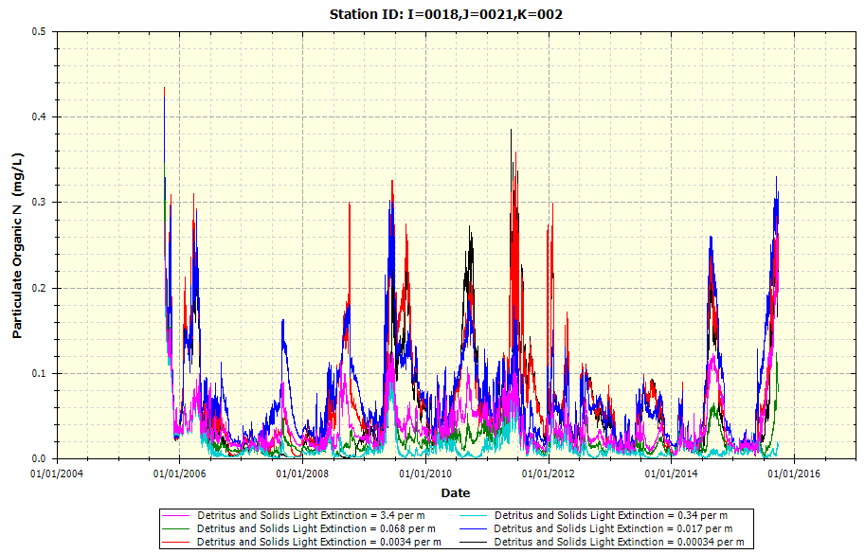

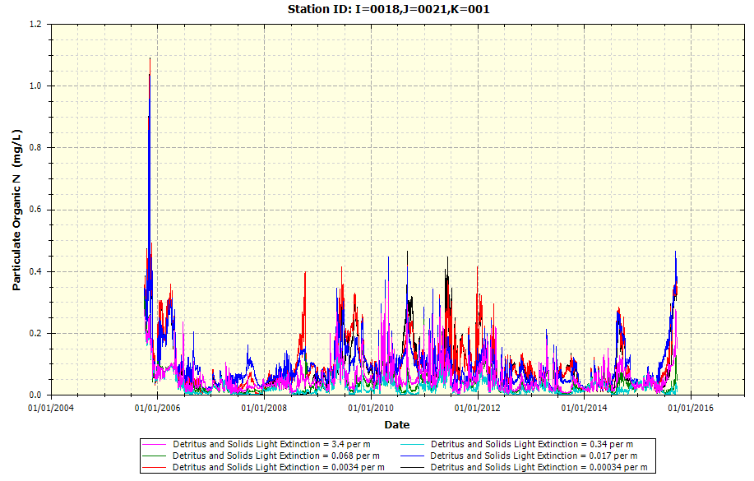

* + Example Plot on Detritus and Solids Light Extinction upon POP (K = 3 is Surface Water Layer; K = 2 is Middle Layer; K = 1 is Bottom/Benthic Layer)

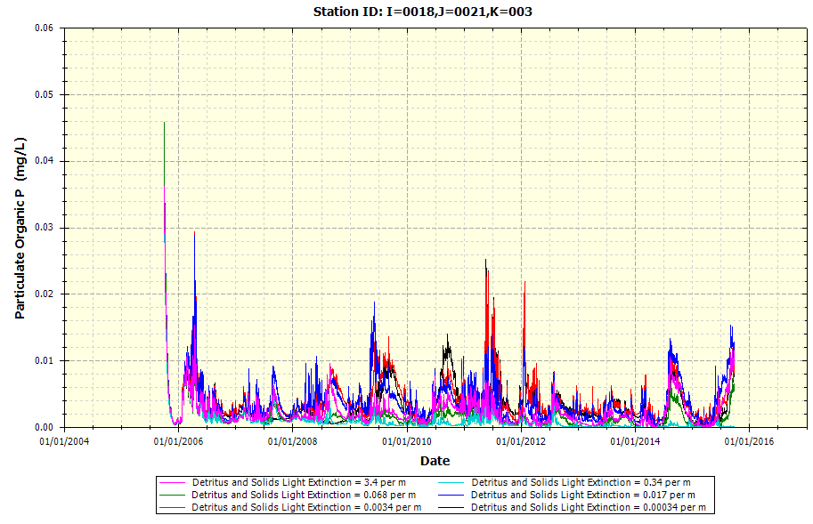

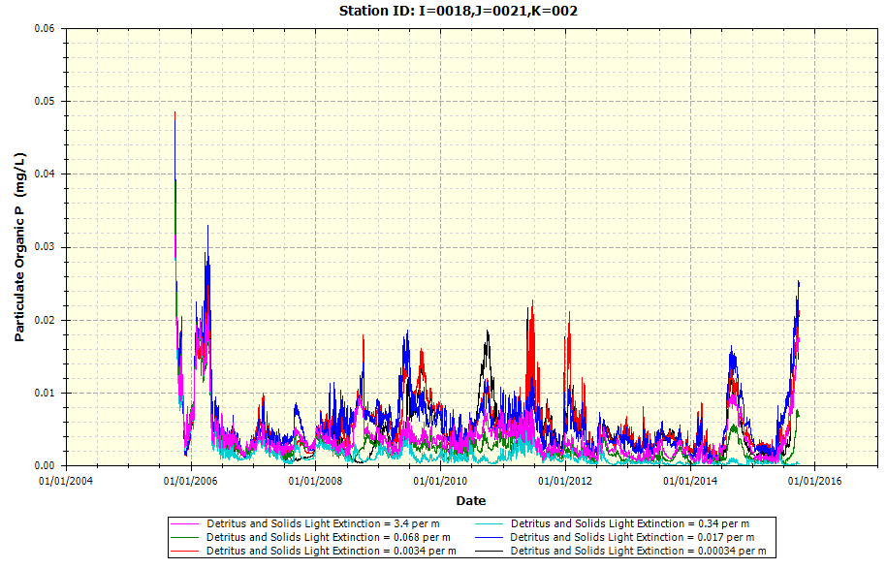

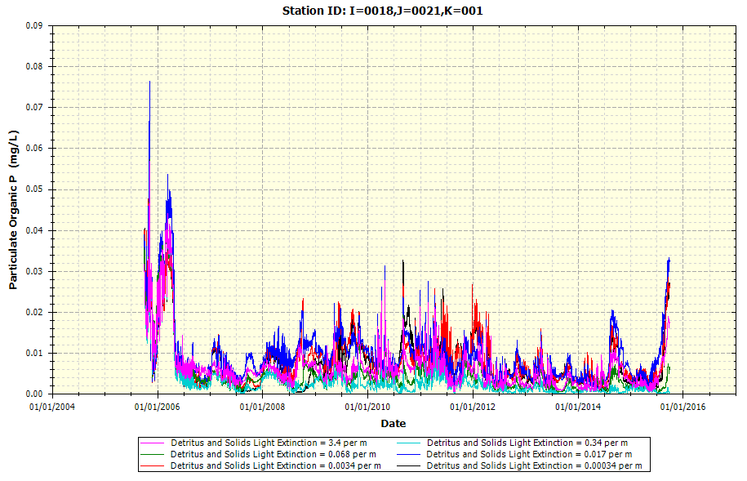

* + Example Plot on Detritus and Solids Light Extinction upon SOD (K = 1 Layer)

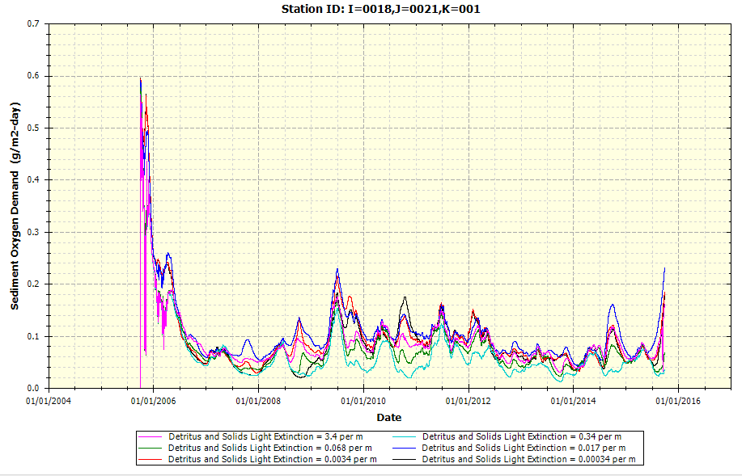

* + Example Plot on Detritus and Solids Light Extinction upon DO (K = 3 is Surface Water Layer; K = 2 is Middle Layer; K = 1 is Bottom/Benthic Layer)

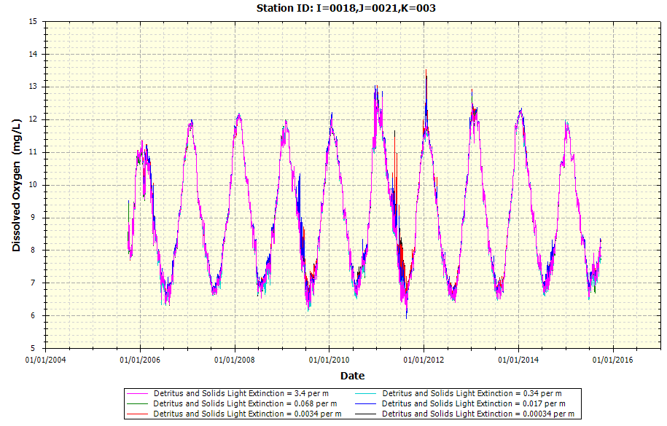

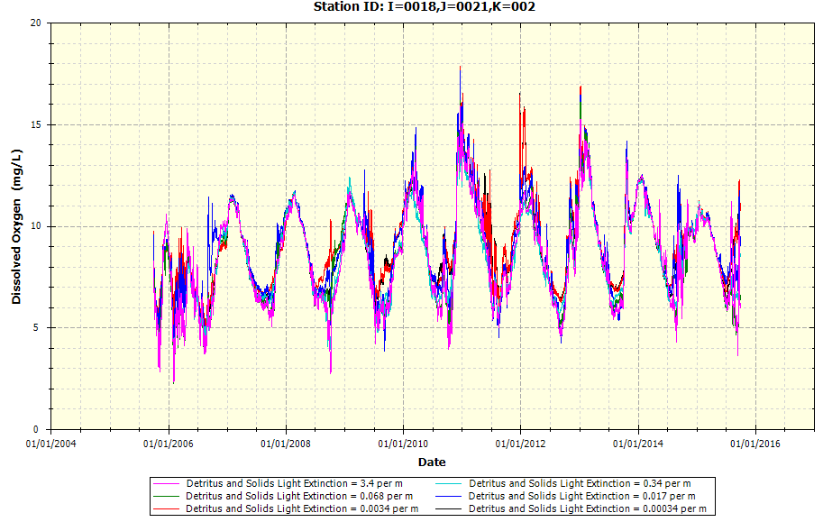

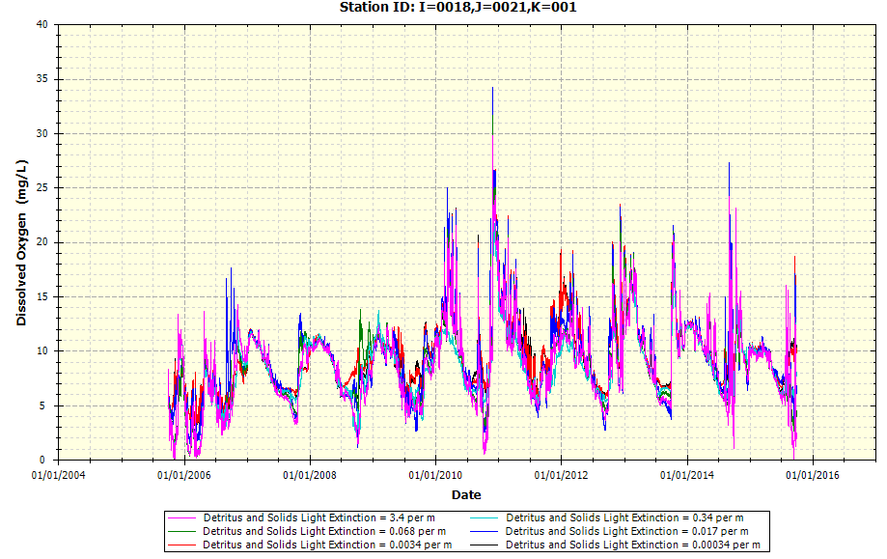

* + Example Plot on Detritus and Solids Light Extinction upon Total Solids (TSS) (K = 3 is Surface Water Layer; K = 2 is Middle Layer; K = 1 is Bottom/Benthic Layer)

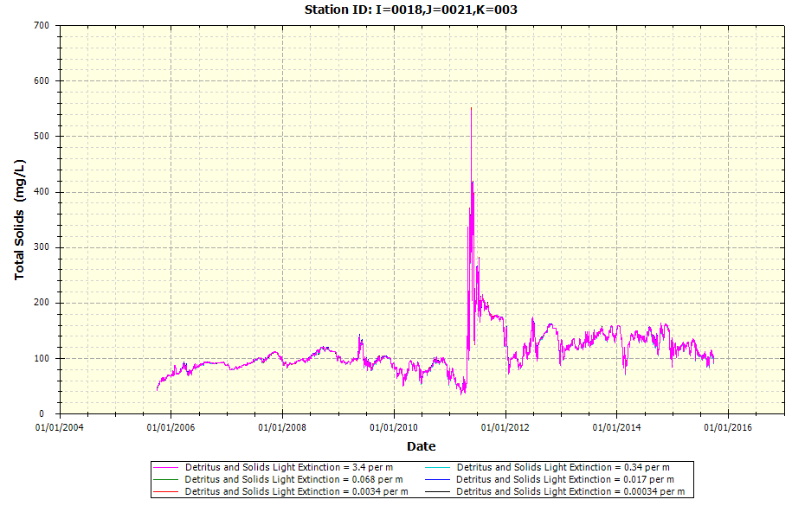

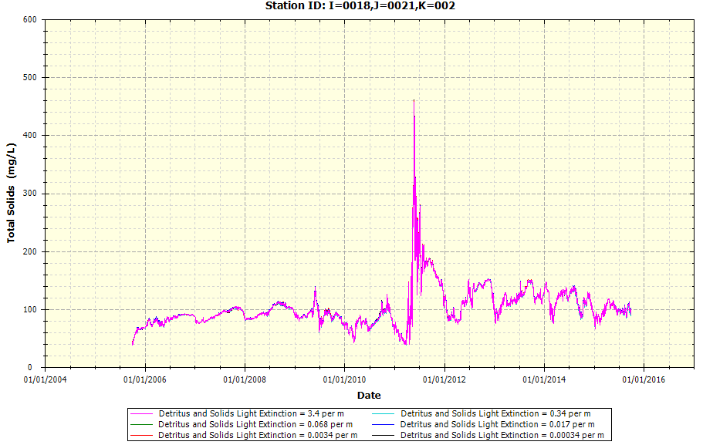

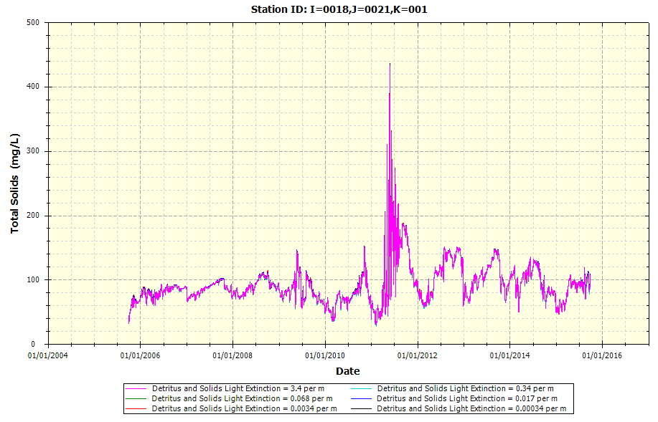

* Dissolved Organic Carbon Light Extinction Coefficient (1/m)
  + Example Plot on DOC Light Extinction upon CBOD

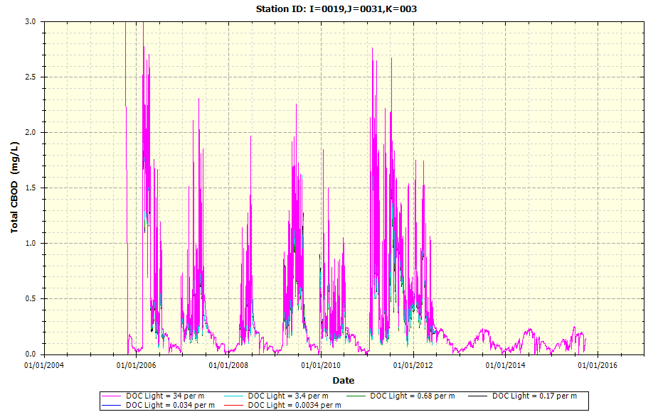

* + Example Plot on DOC Light Extinction upon DO

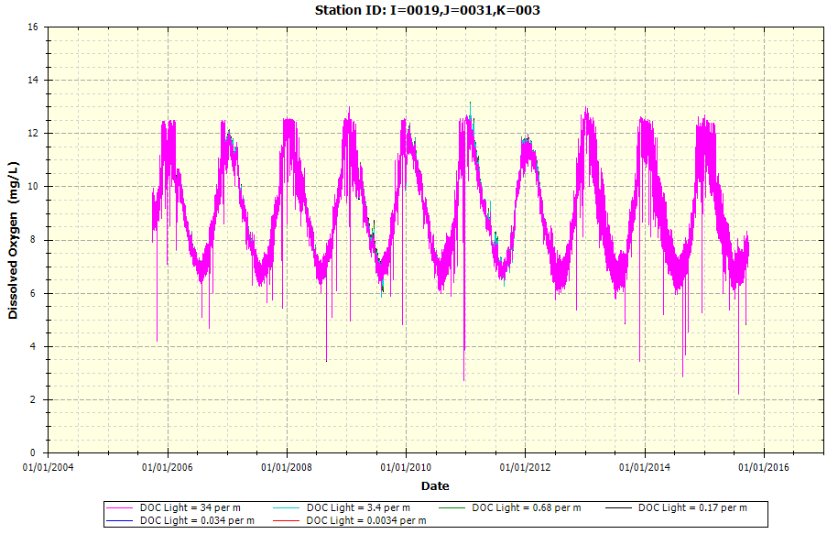

# Appendix B: Model Calibration for WASP

This appendix provides the time-series plots among the results for distinct water quality constituents simulated by the Utah Lake WASP against the measured data employed for the exercise. Meanwhile, this section includes statistical results (R2, RMSE, etc.) for each water quality constituent for which model calibration has been conducted upon. Please refer to the following tables for the following components.

* UDWQ AWQMS site mapping upon the WASP Utah Lake segments
* Constituent Mapping among WASP water quality constituents against UDWQ AWQMS sites measured data parameters

## Graphical Results (Time-Series)

This sub-section provides time-series simulated results against the measured data for each segment (segment indicated in chart title per plot) and is organized into separate sub-sections based on water quality constituent. The time-series for all WASP segments for which the UDWQ AWQMS site exhibits measured data are included in this sub-section per water quality constituent. The corresponding WASP I and J node for which the time-series plot displays is provided in the chart title. The UDWQ AWQMS site ID for the corresponding WASP segment for each plot is provided in the graph legend within each figure.

### Dissolved Oxygen (DO)

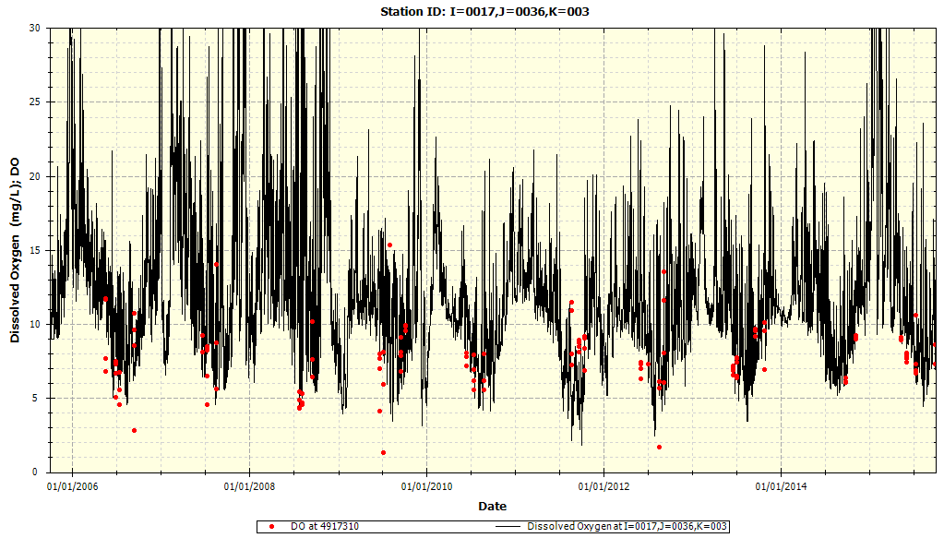

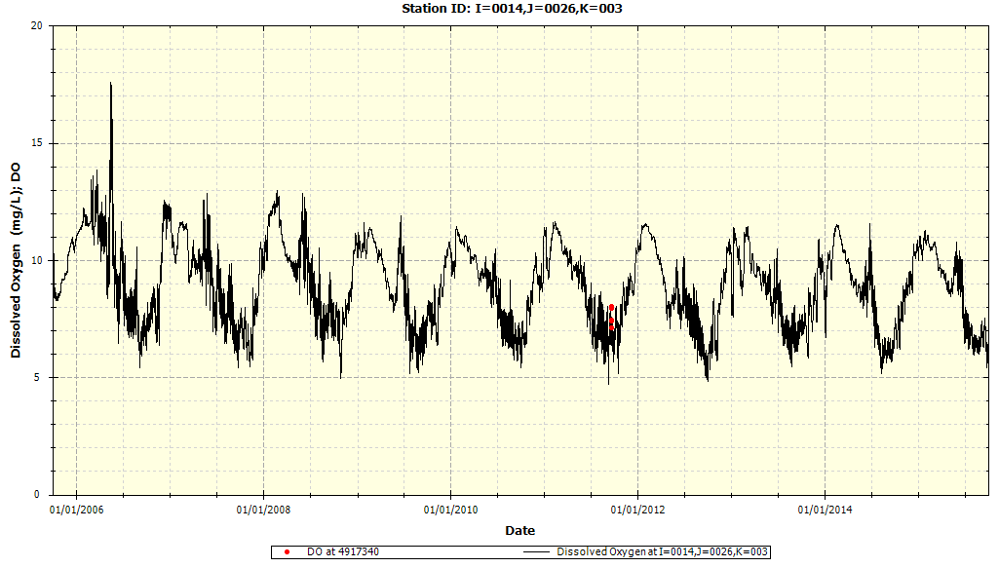

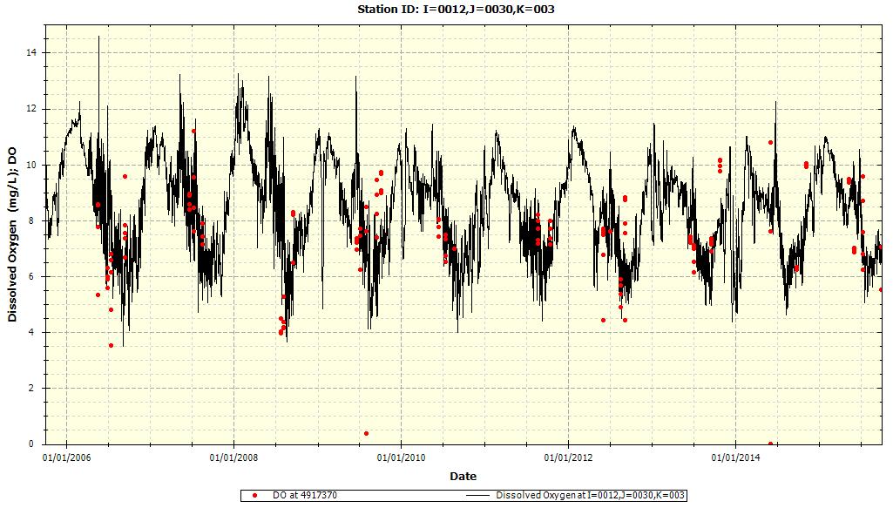

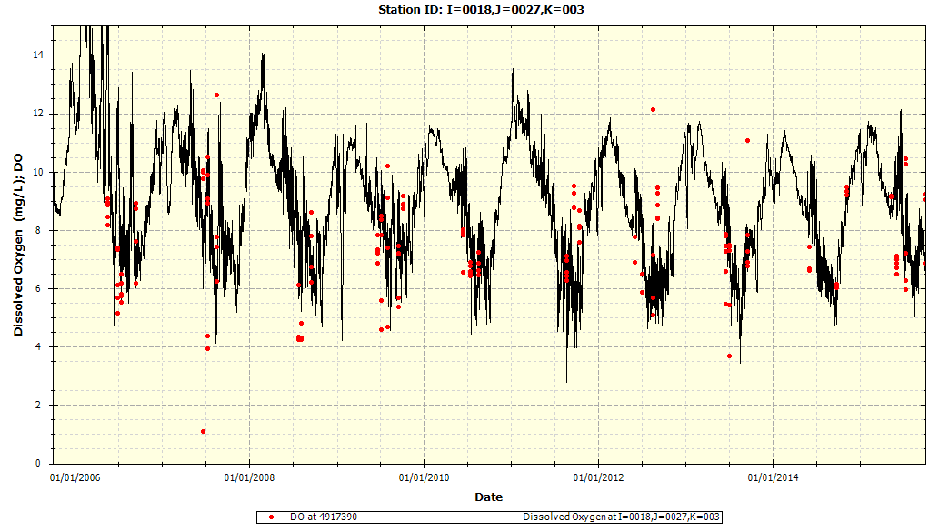

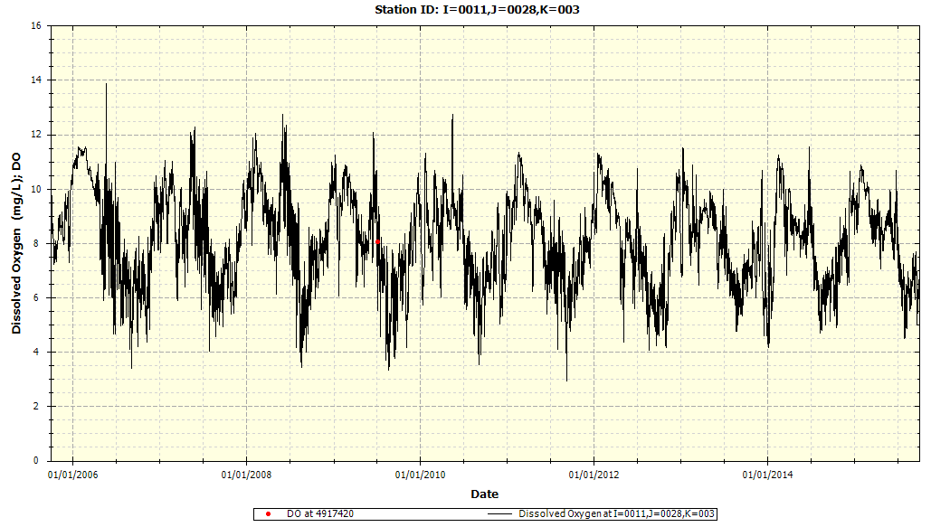

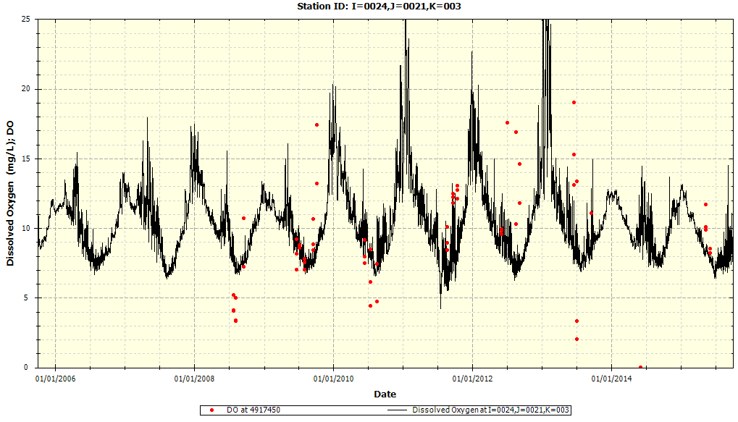

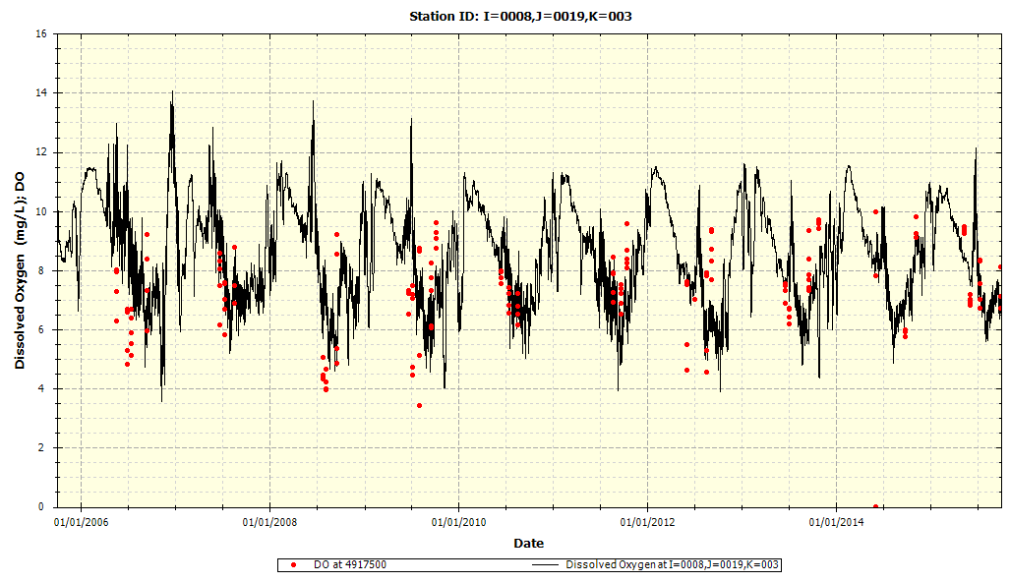

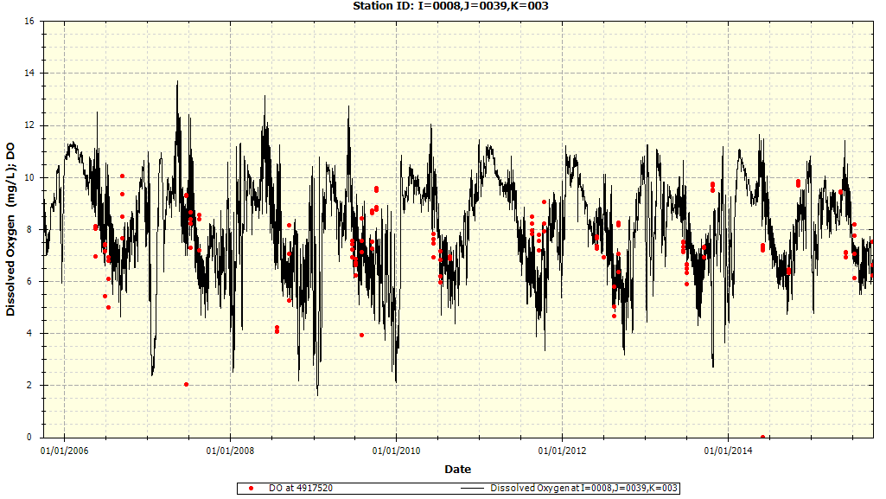

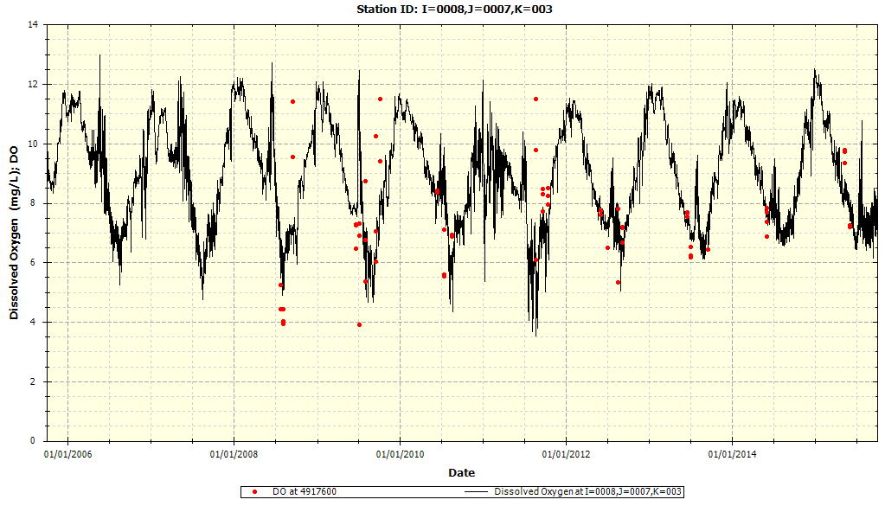

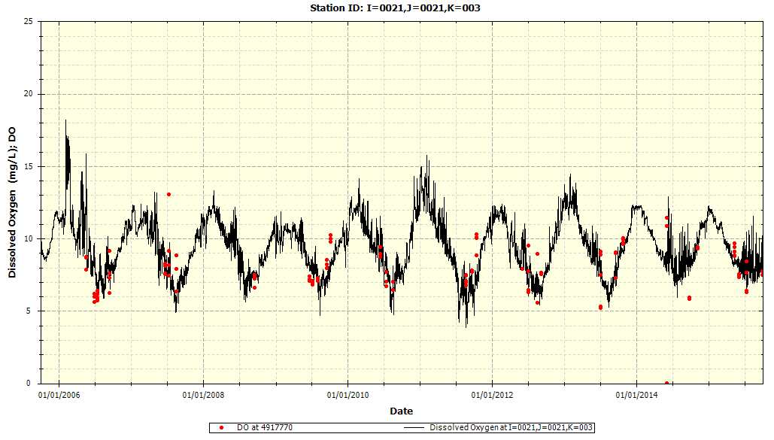

### Ammonia-Nitrogen

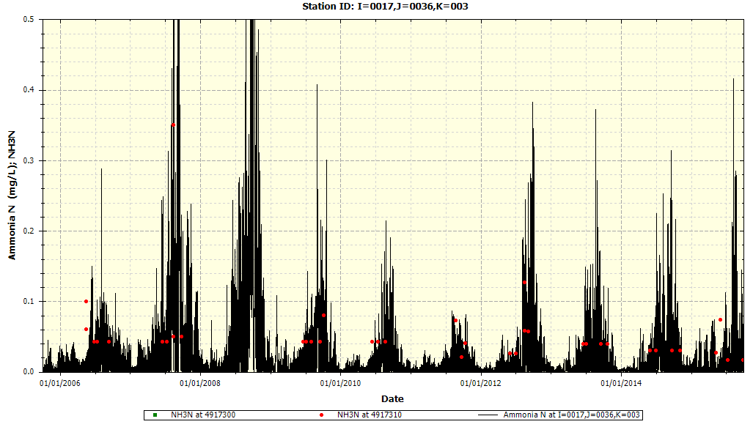

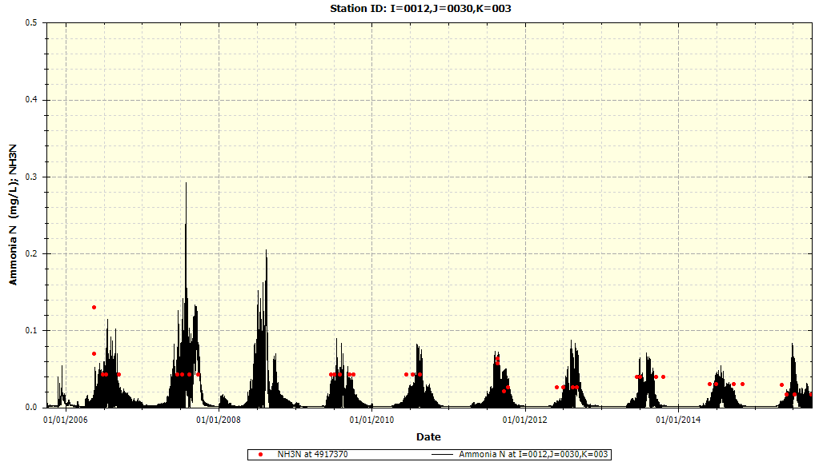

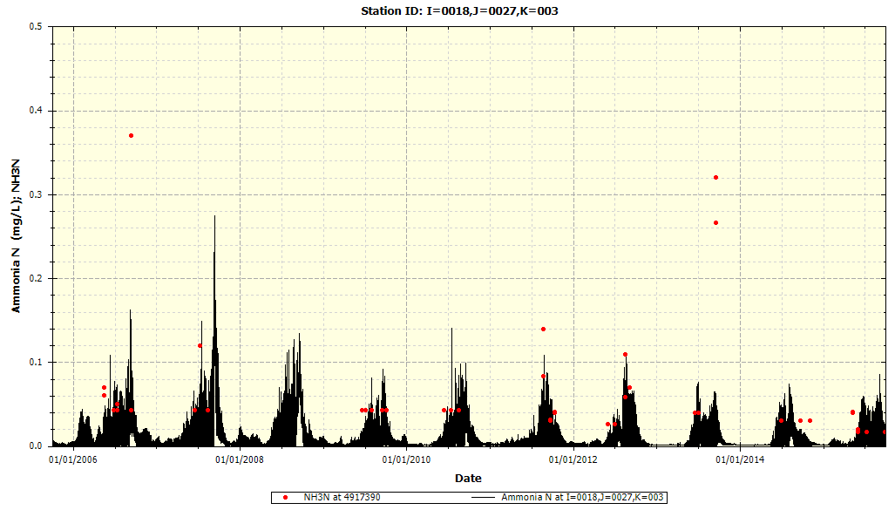

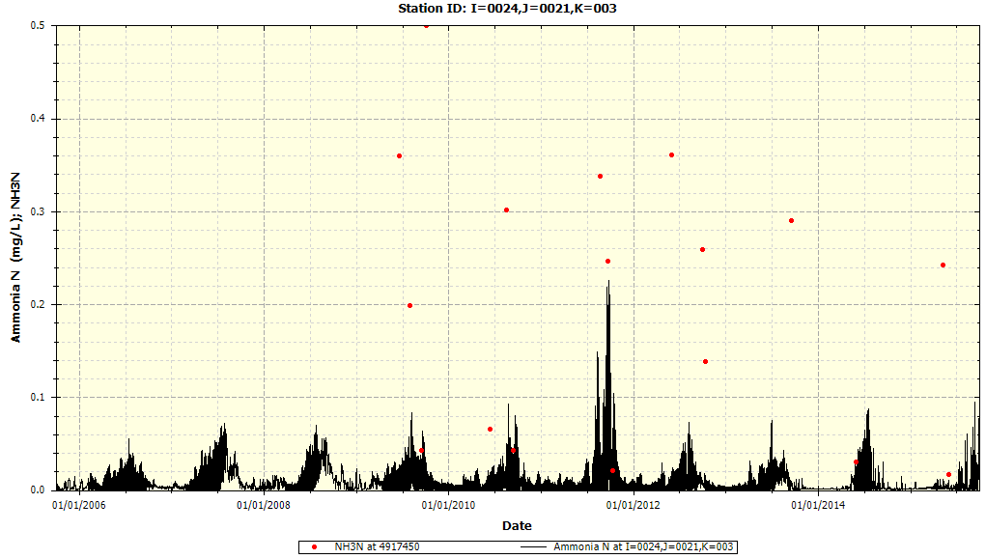

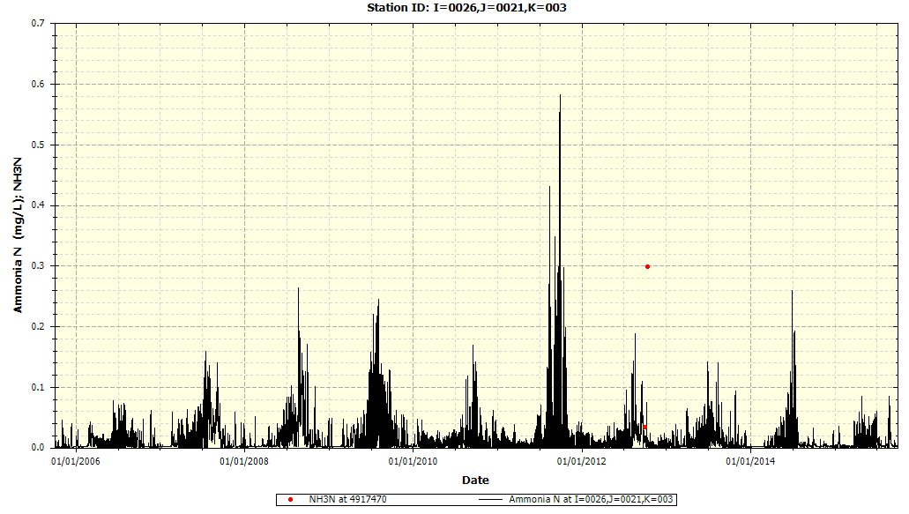

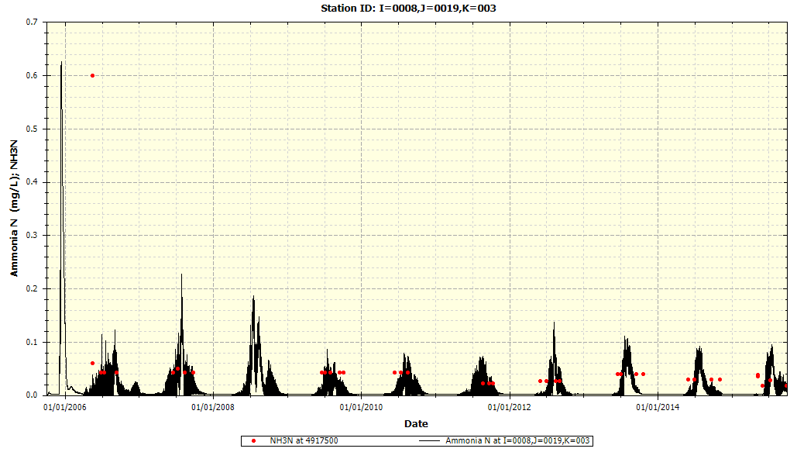

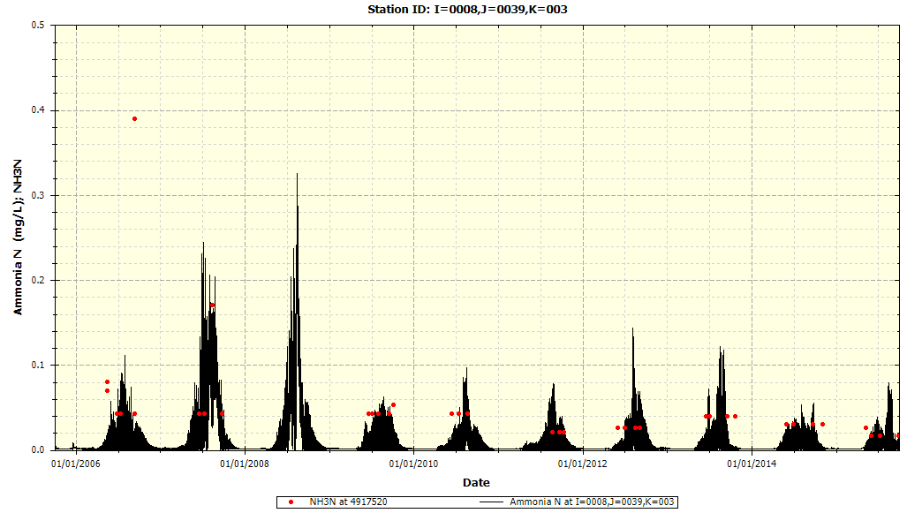

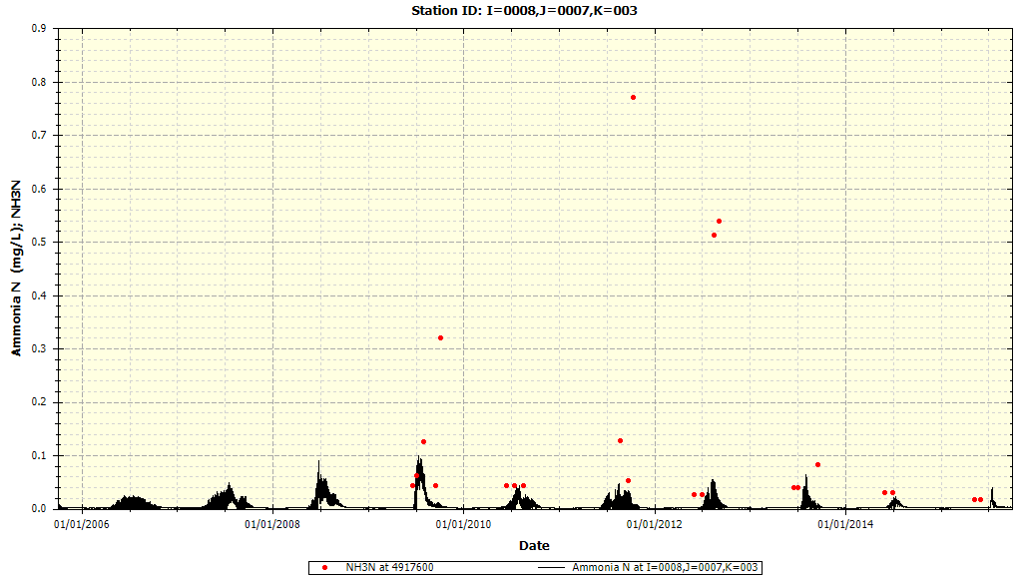

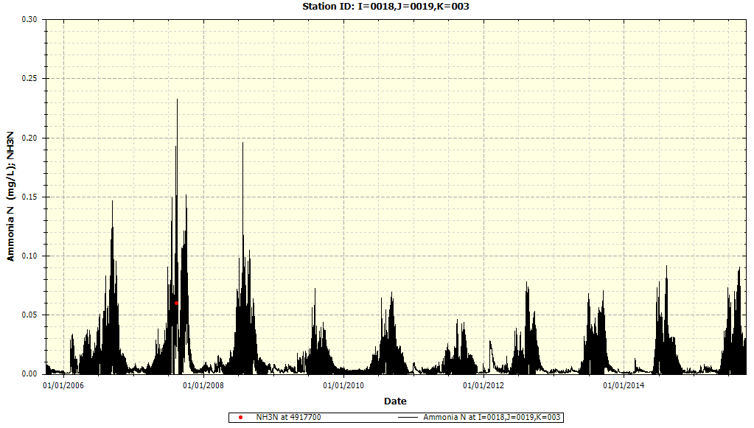

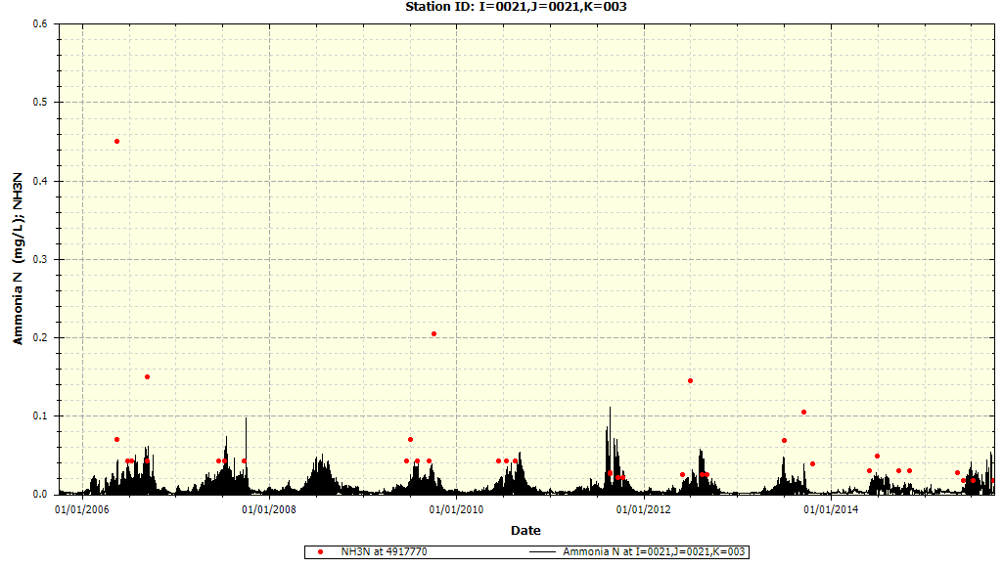

### Nitrate-Nitrite Nitrogen

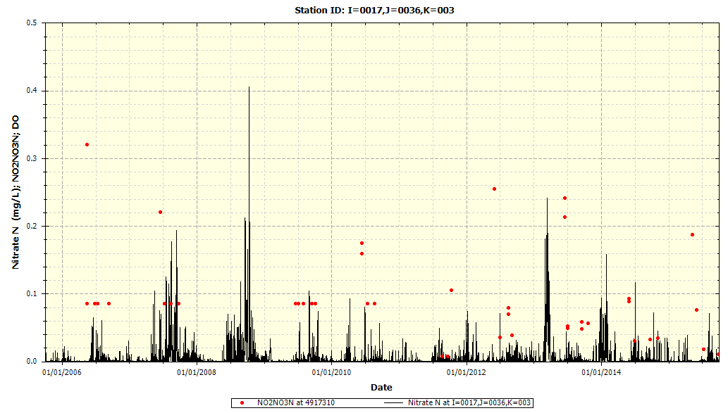

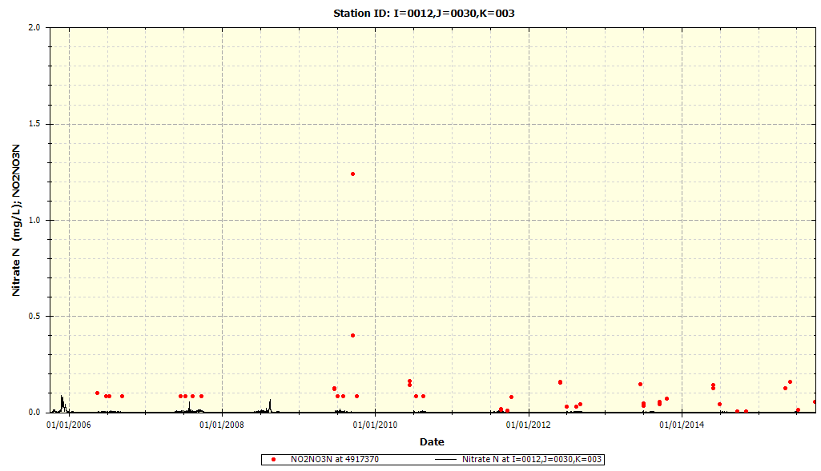

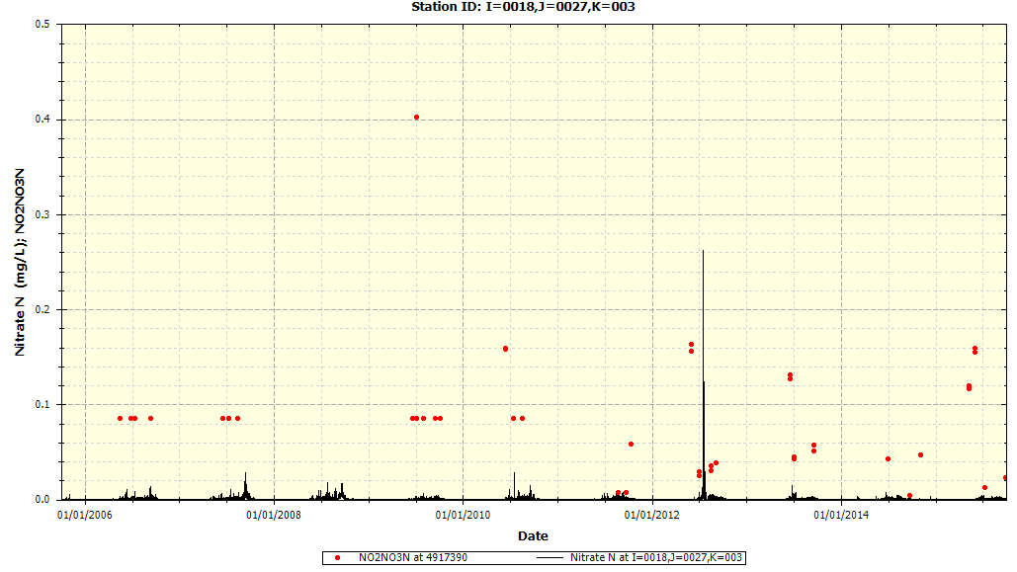

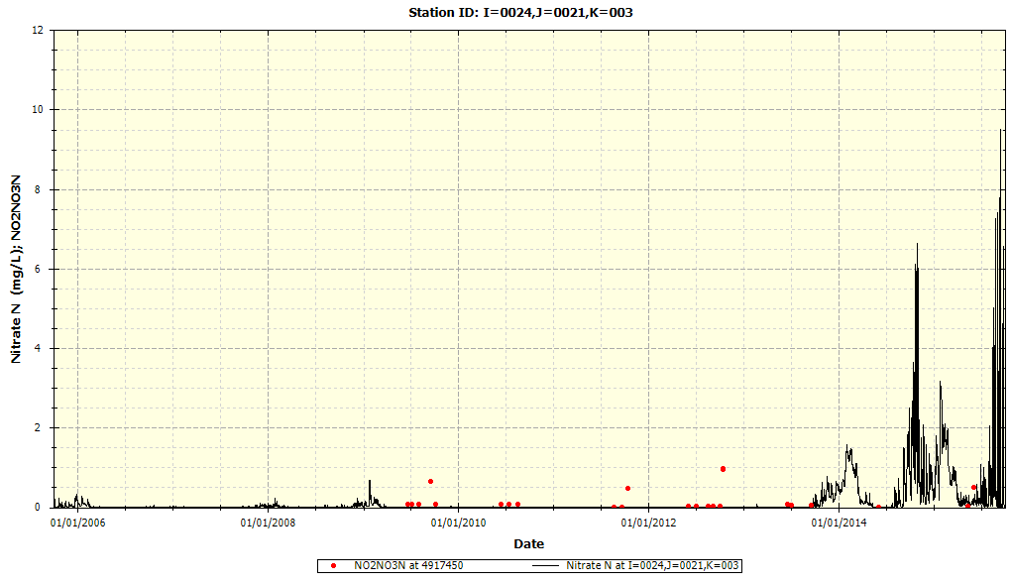

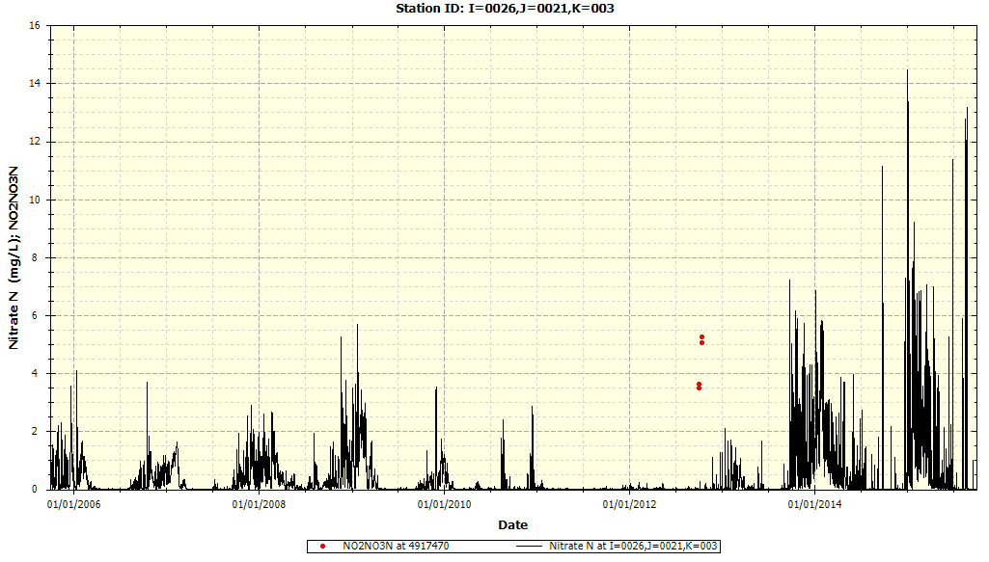

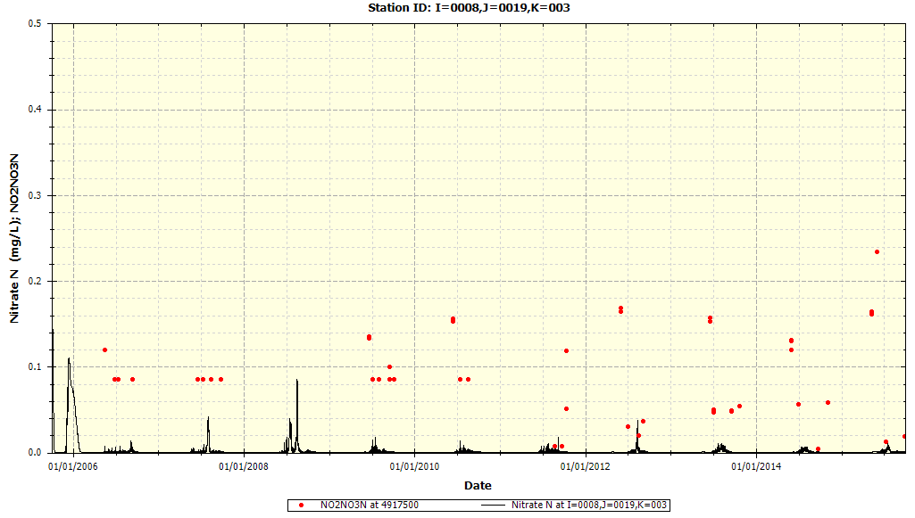

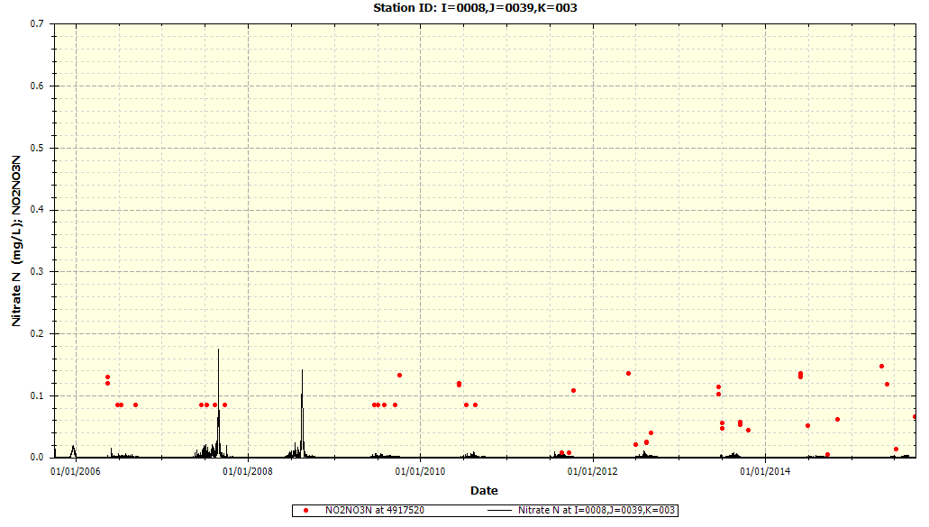

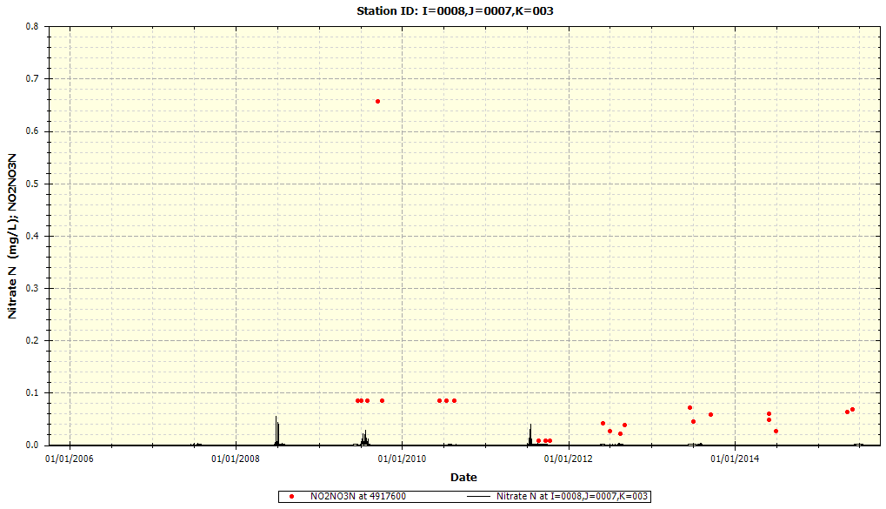

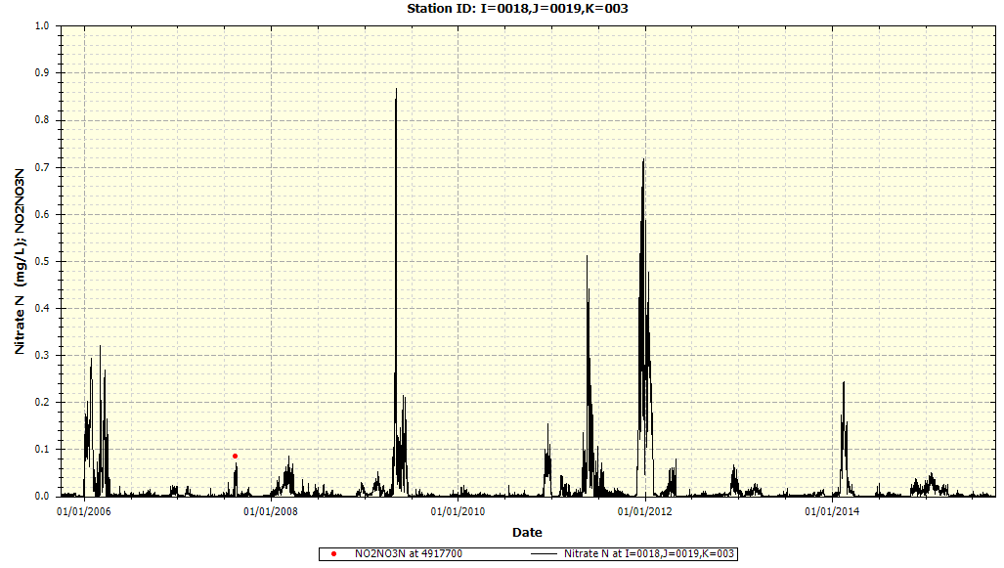

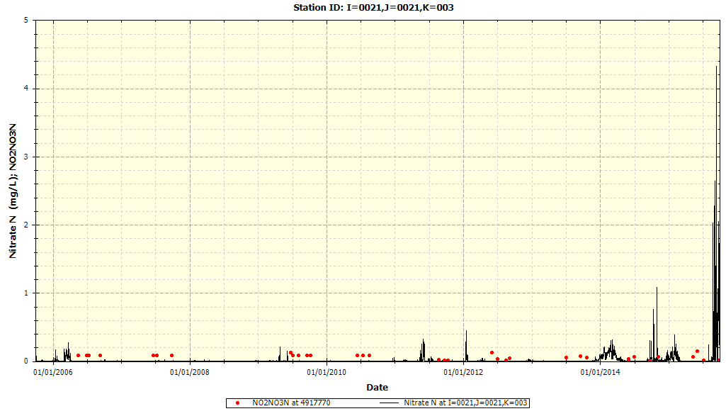

### Total Phosphate-Phosphorus

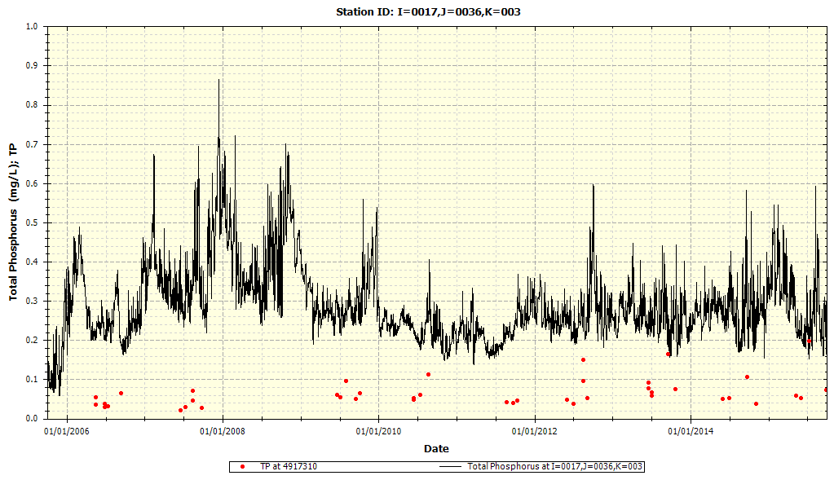

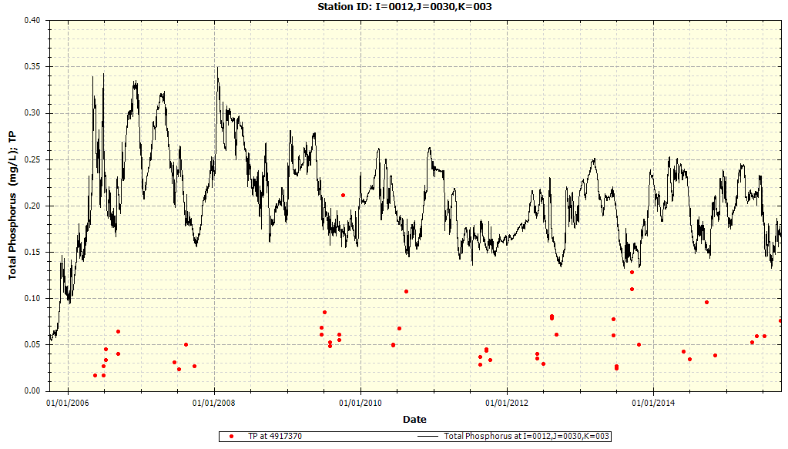

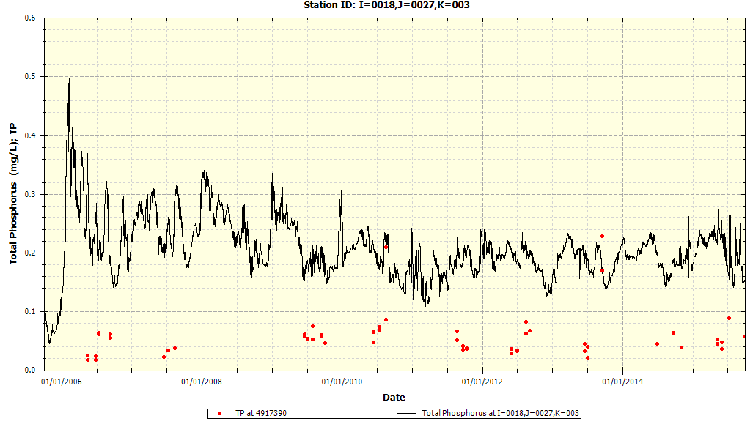

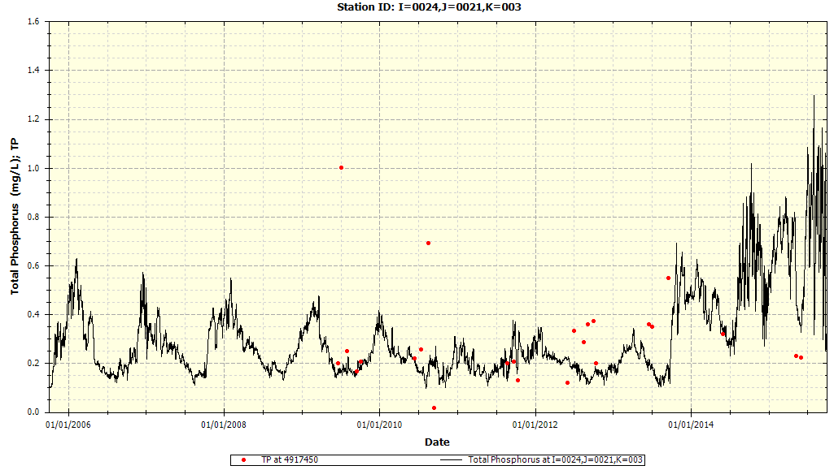

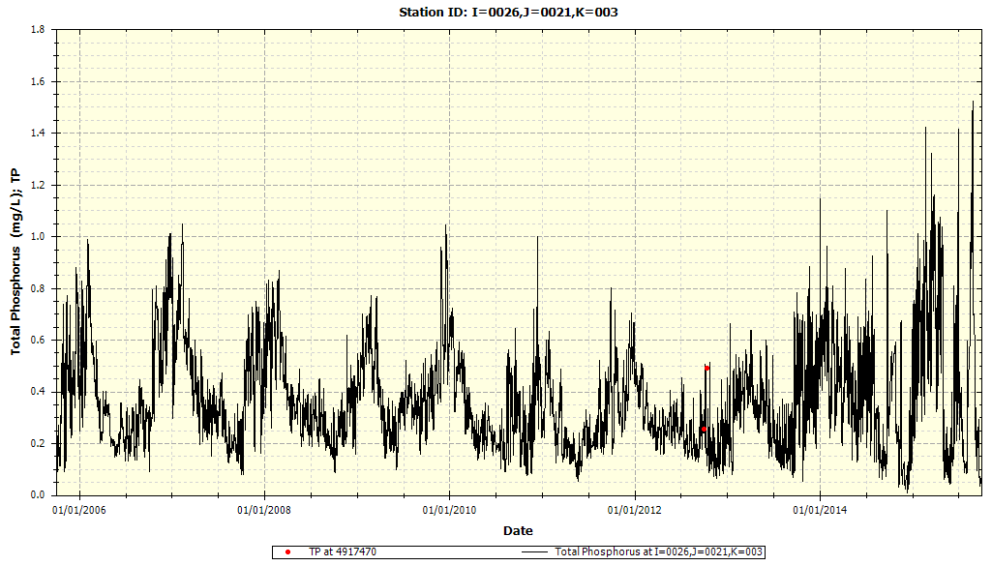

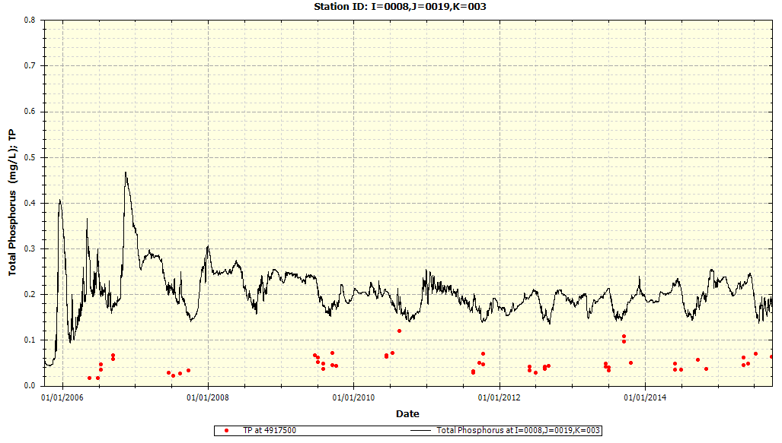

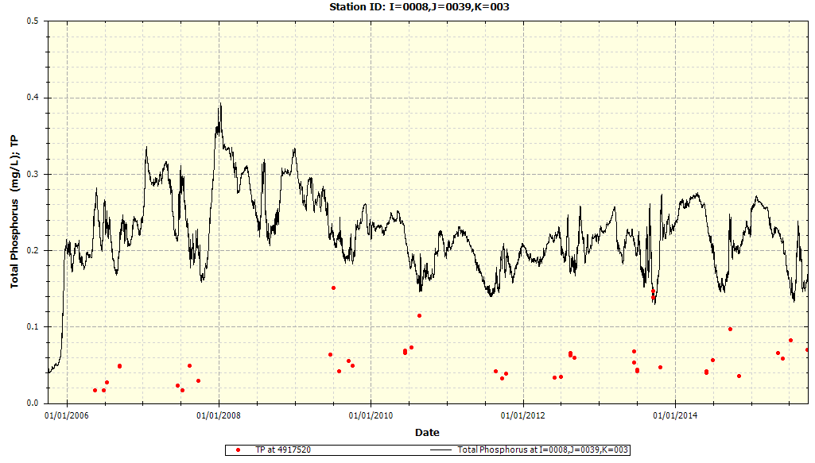

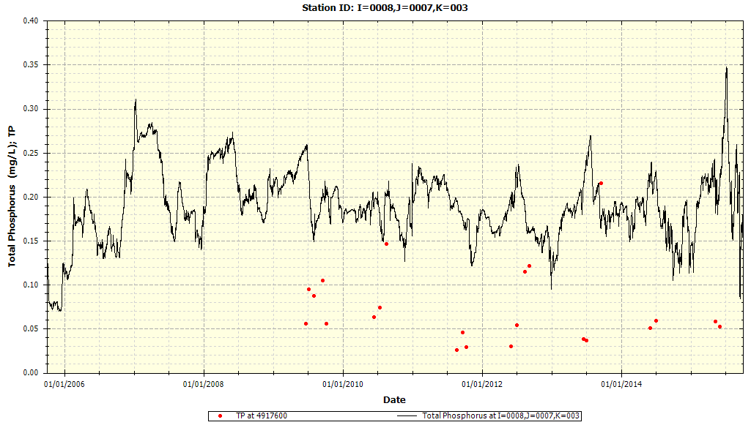

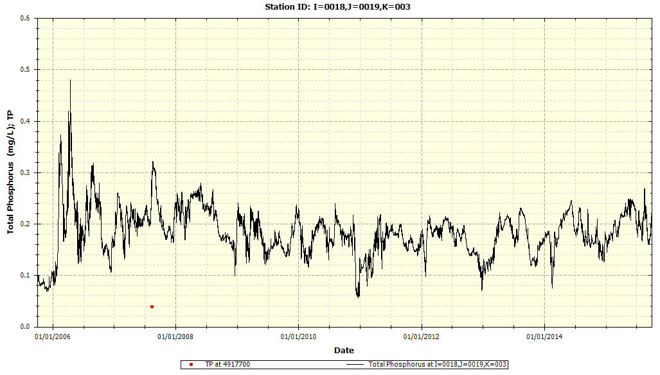

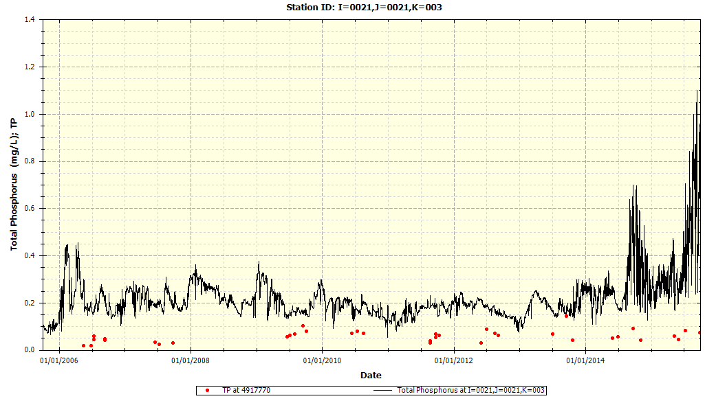

### Total Phytoplankton Chlorophyll-a

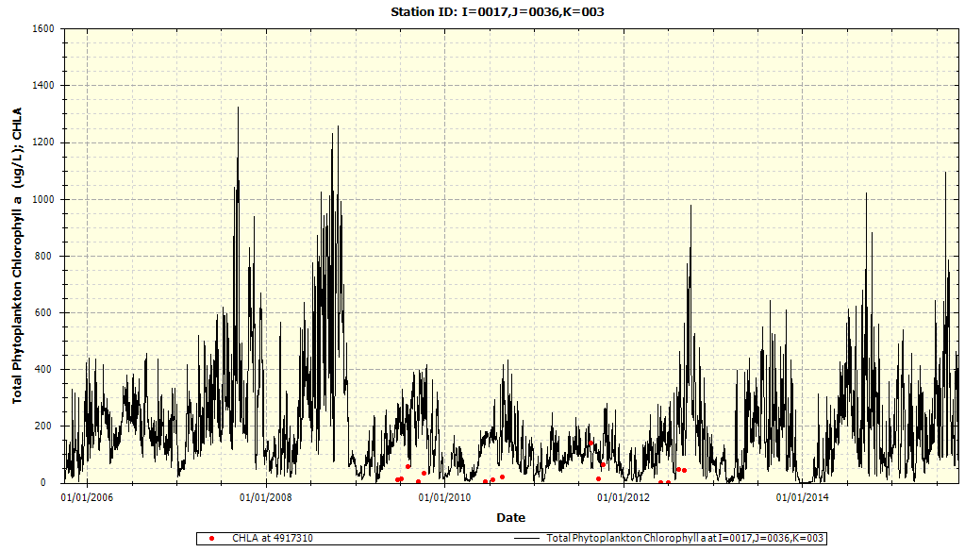

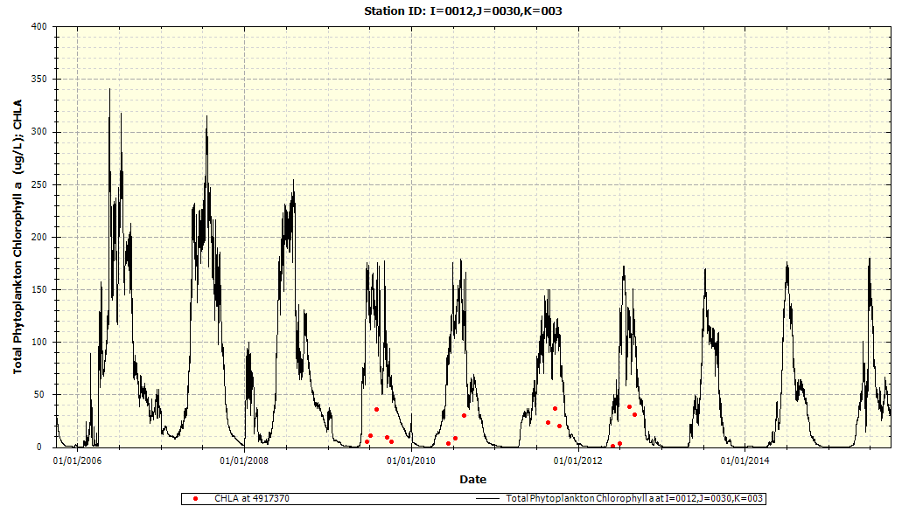

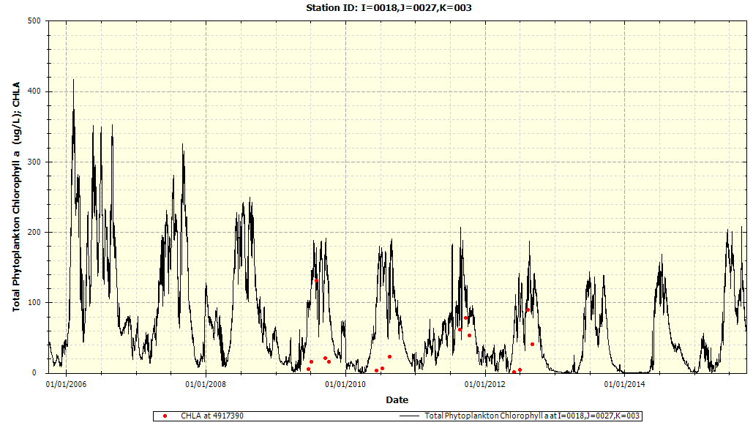

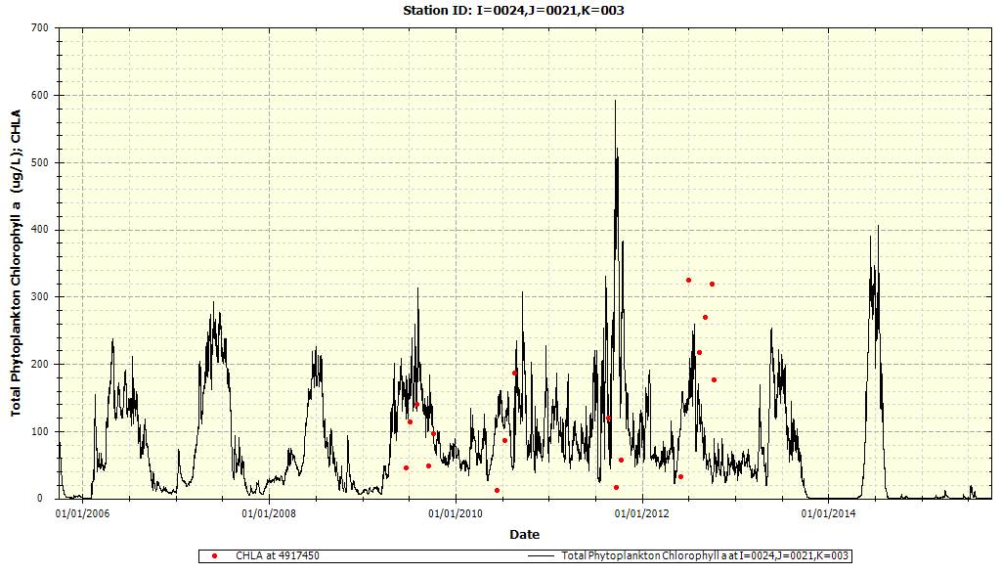

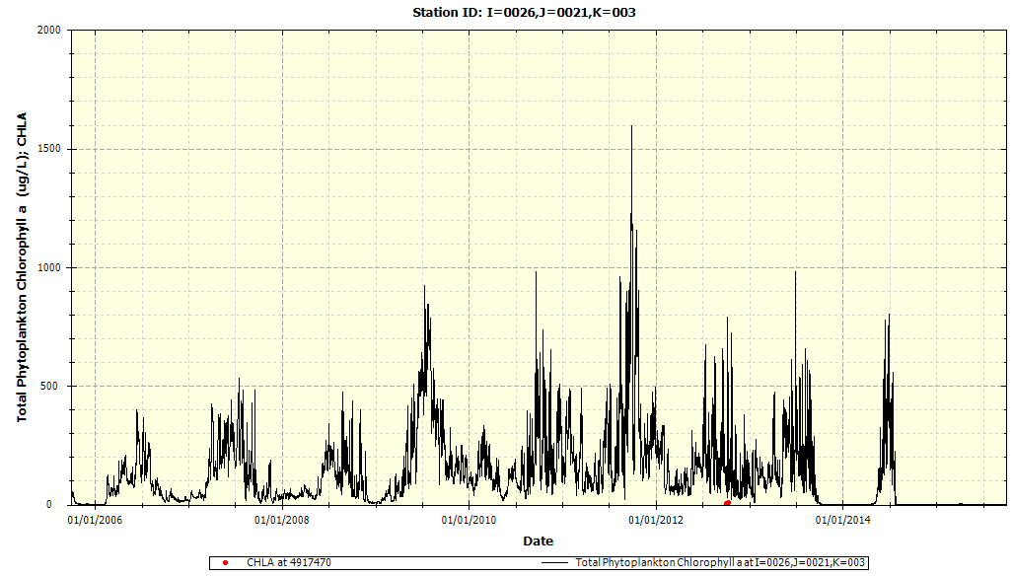

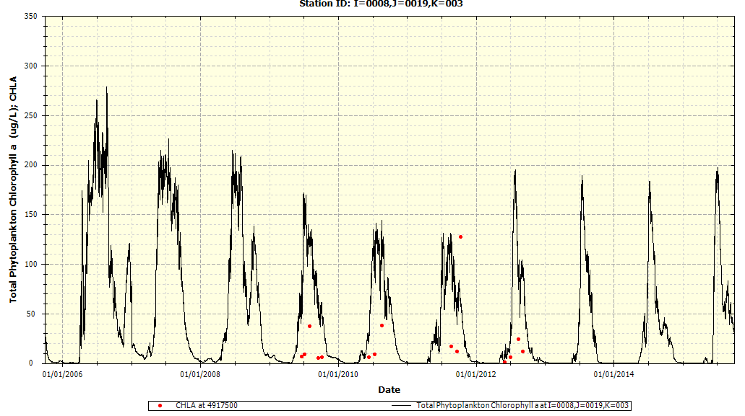

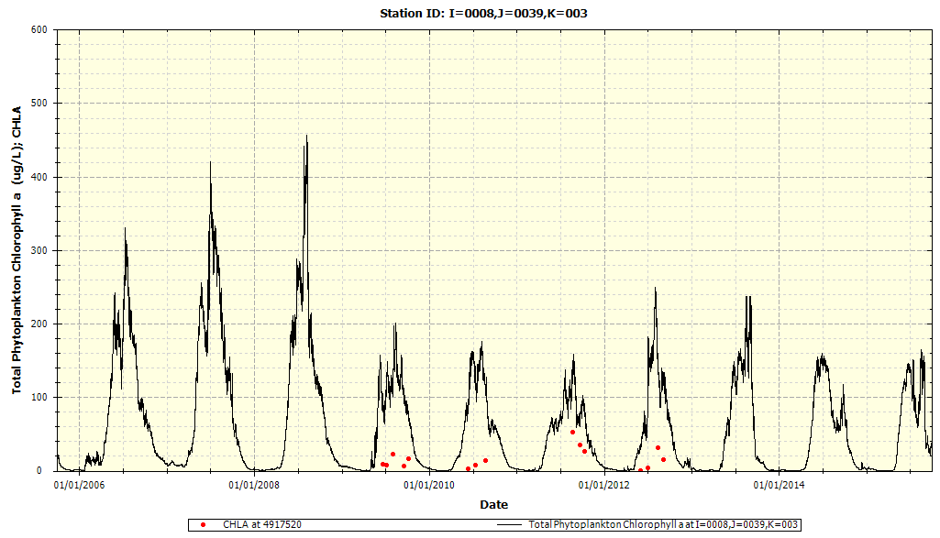

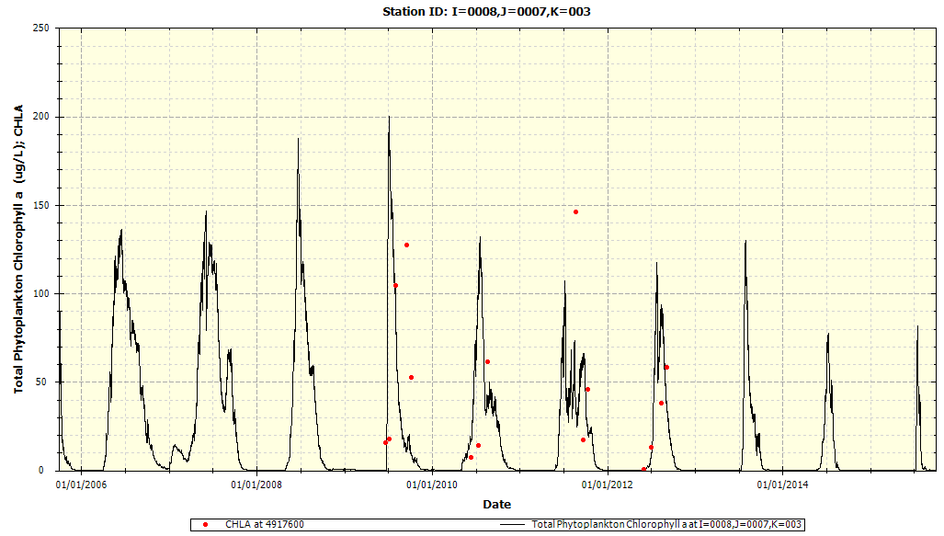

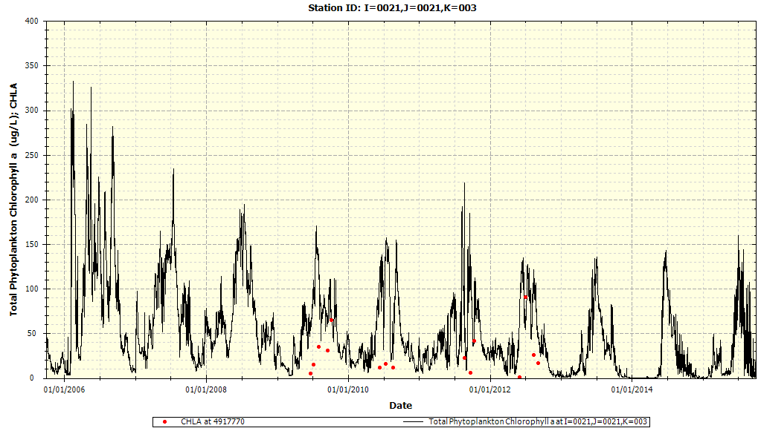

### CBOD

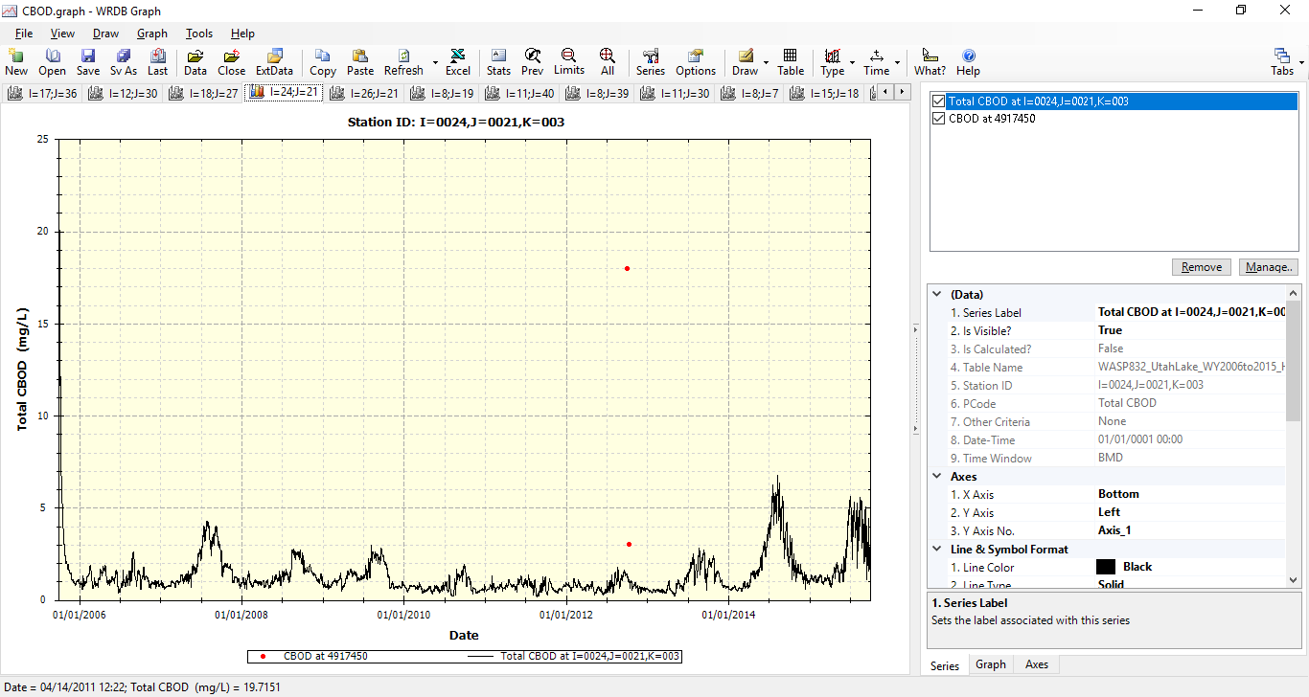

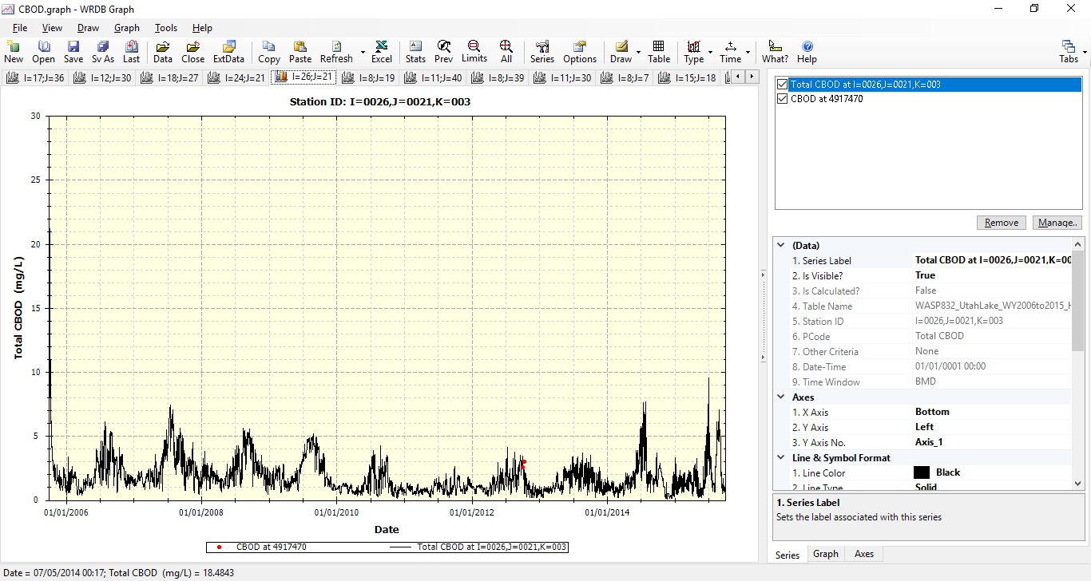

### Total Solids

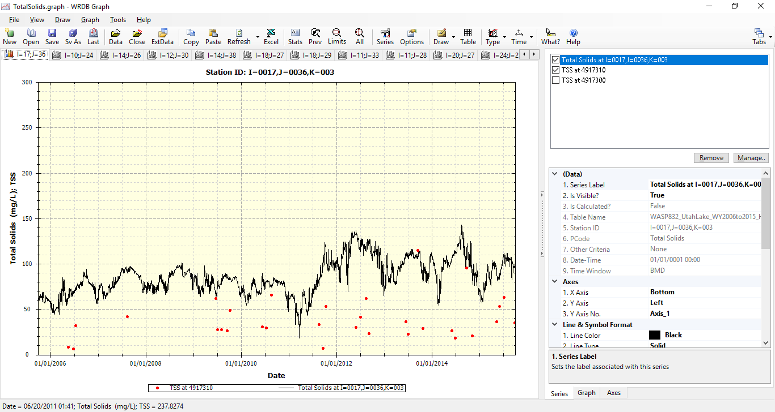

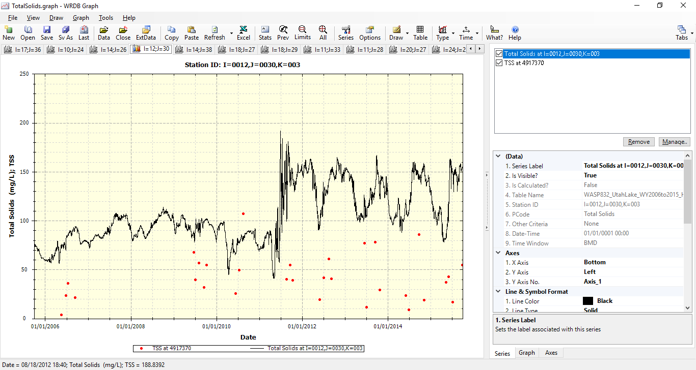

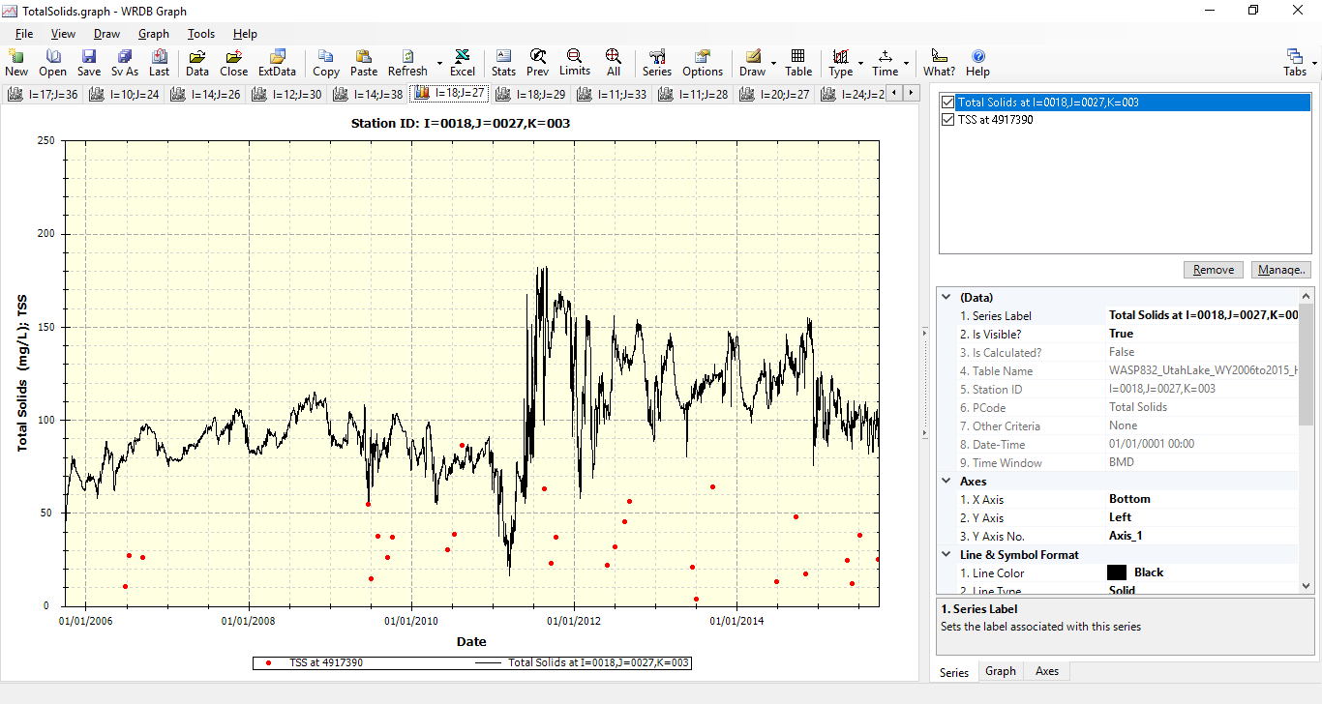

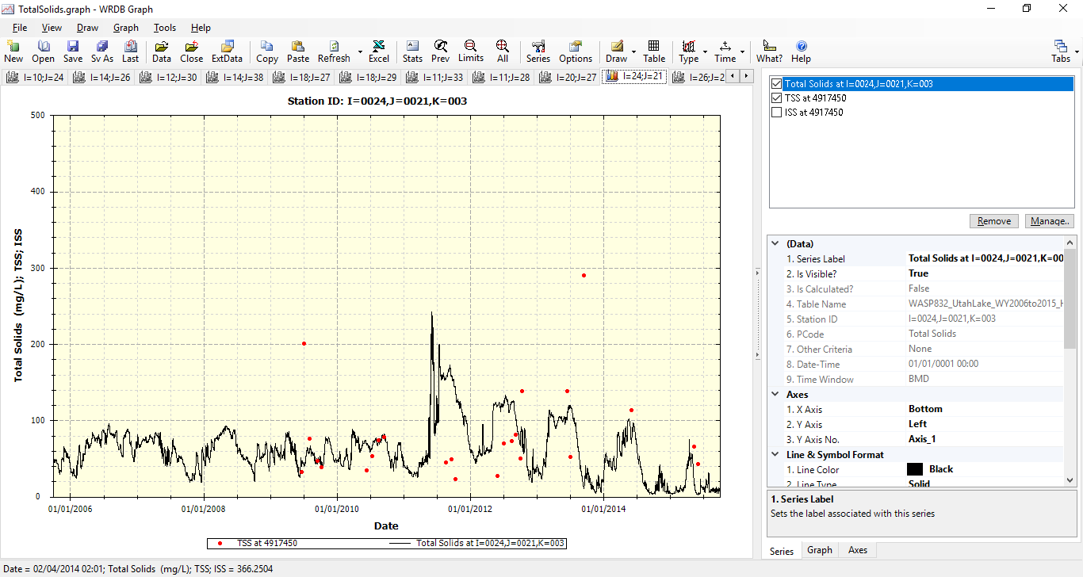

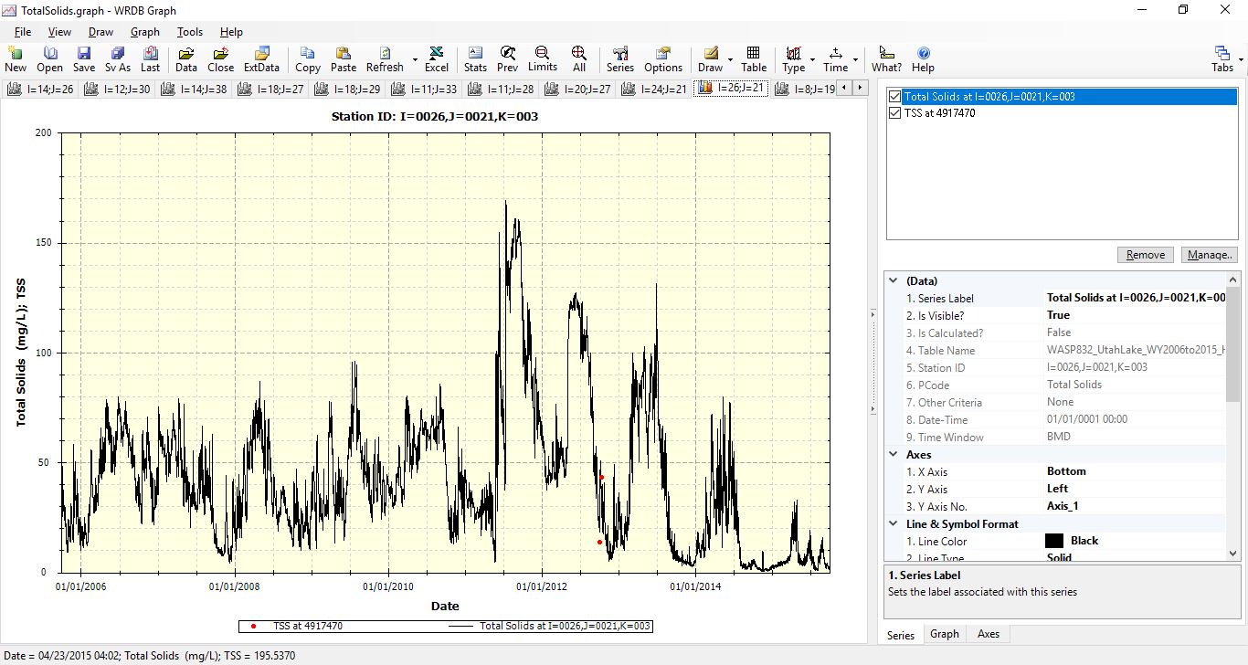

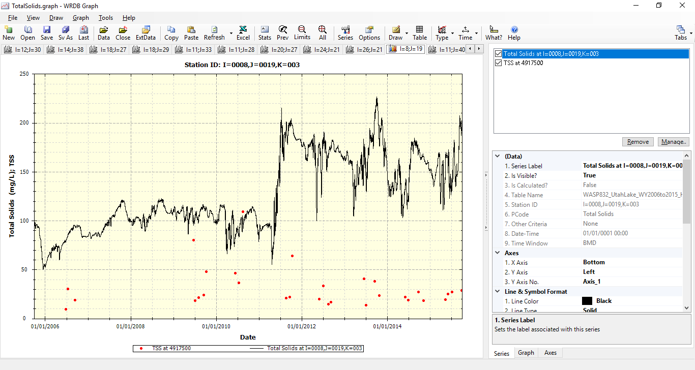

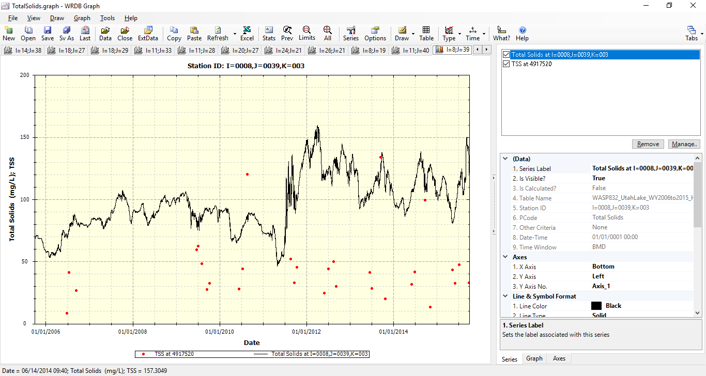

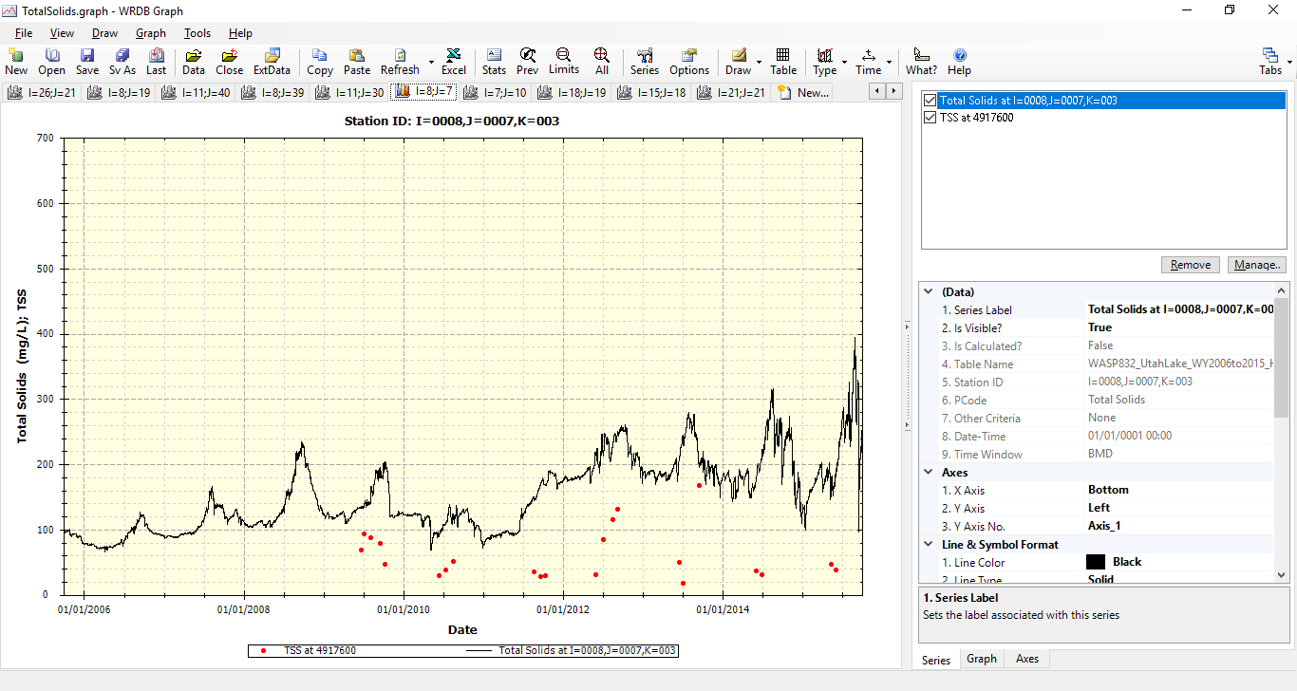

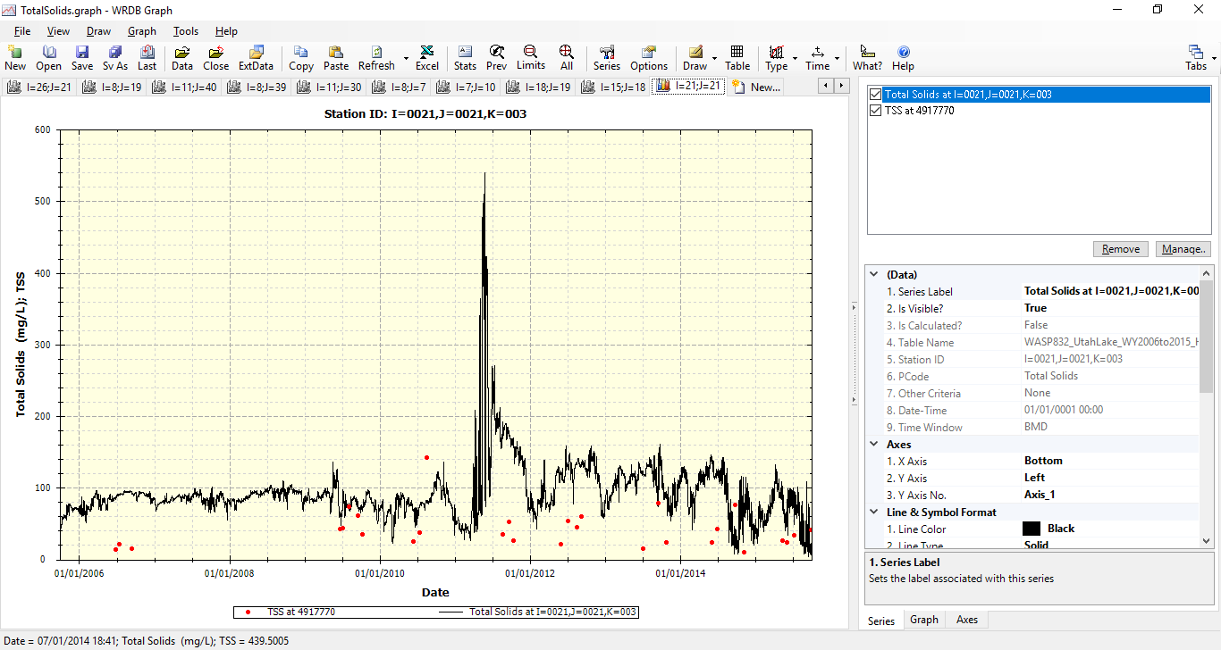

## Graphical Results (Scatter Plot)

This sub-section provides scatter plots of simulated results against the measured data for each segment (segment indicated in chart title per plot) and is organized into separate sub-sections based on water quality constituent. Such scatter plots are included for constituents that follow the following criteria:

1. Time-series plots (Section B.1) generally suggest agreement among the simulated results against the measured data
2. The corresponding AWQMS UDWQ site exhibits at least 5 measured data throughout the model calibration period (October 1, 2005 to September 30, 2015)

Hence, based on the criteria above, the scatter plots are only included for the following water quality constituents for the Utah Lake WASP.

* Dissolved Oxygen (Section B.2.1)
* Ammonia-Nitrogen (Section B.2.2)
* Total Phytoplankton Chlorophyll-a (Section B.2.3)

The corresponding WASP I and J node for which the scatter plot displays is provided in the chart title. Please refer to Table 4.1 for the corresponding UDWQ AWQMS site for the measured data. (Note: Due to the observed high variability (e.g., R2 < 0.5) upon the measured against the simulated results, the scatter plots do not include any linear trends applied.)

### Dissolved Oxygen (DO)

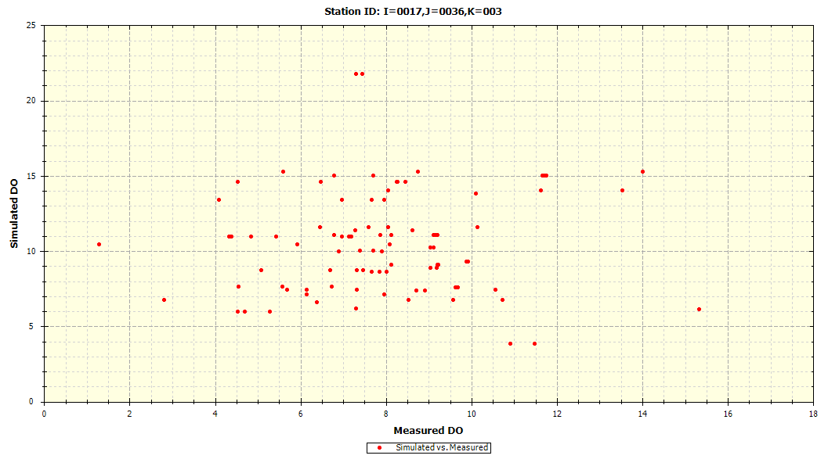

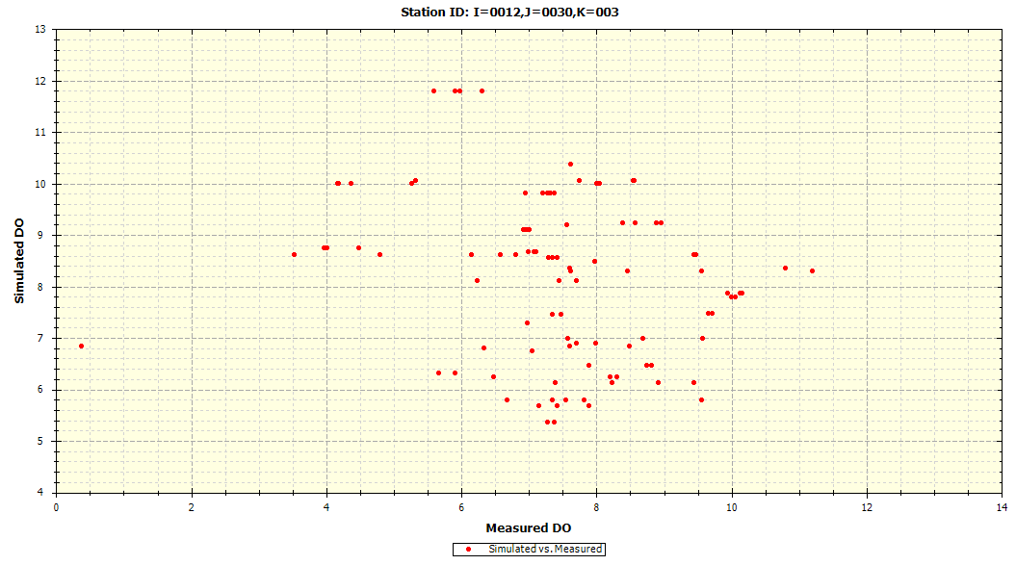

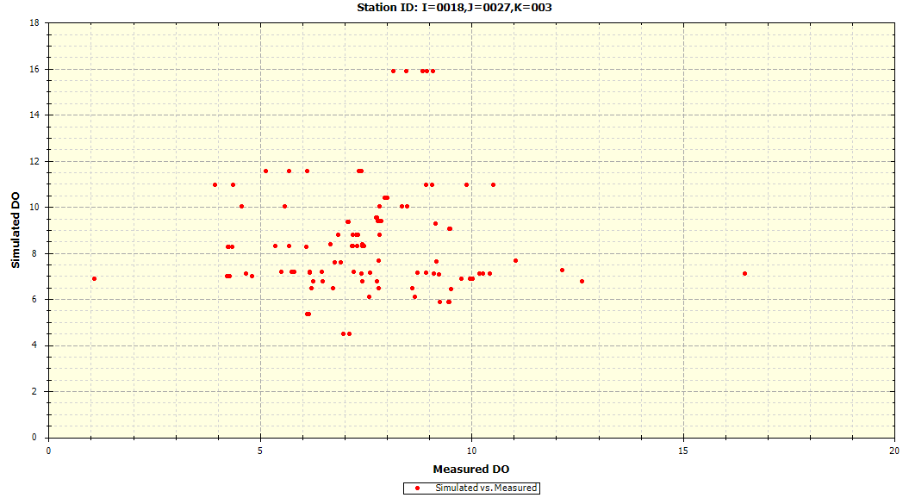

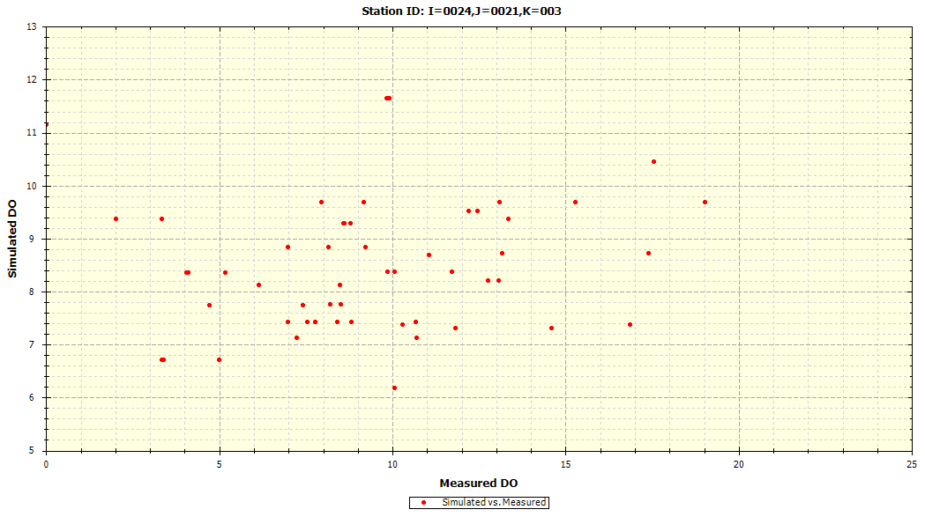

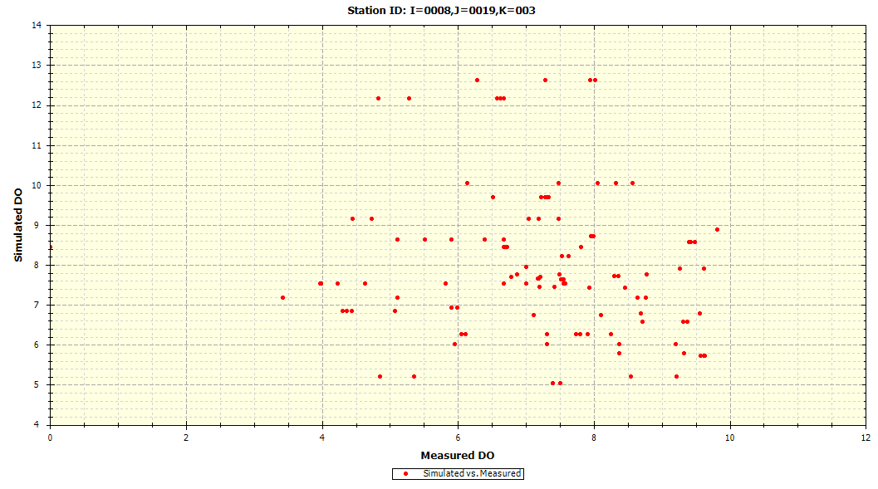

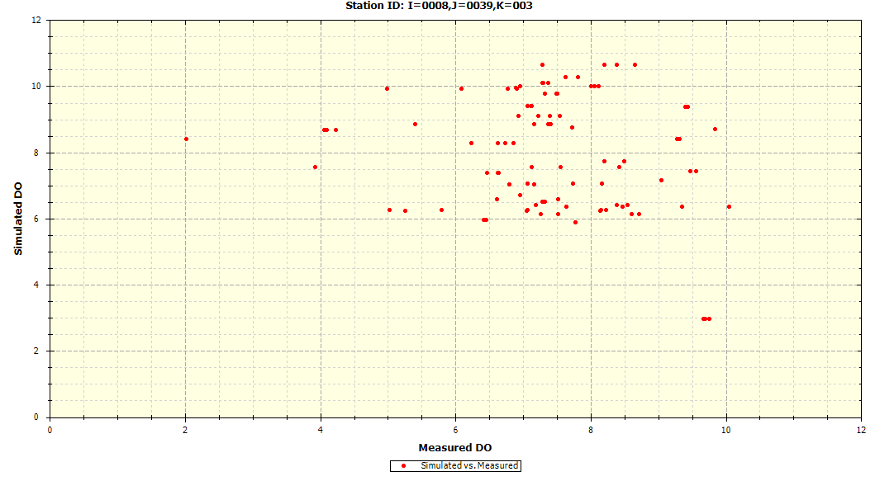

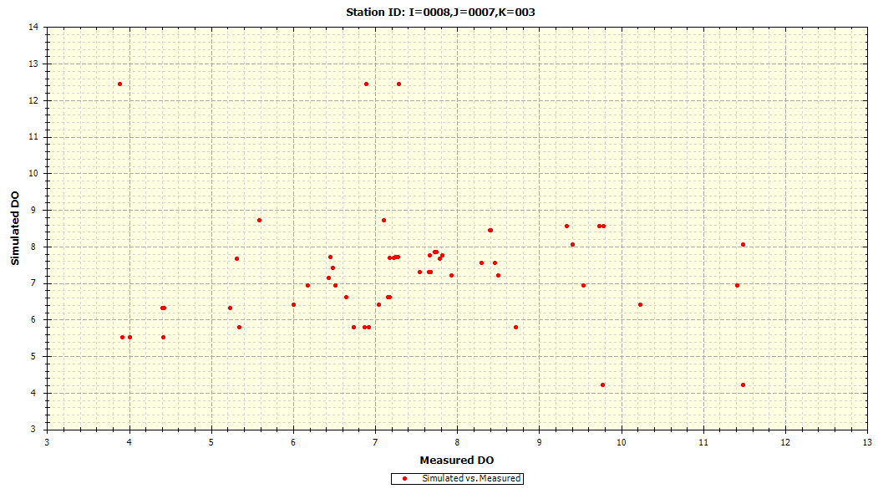

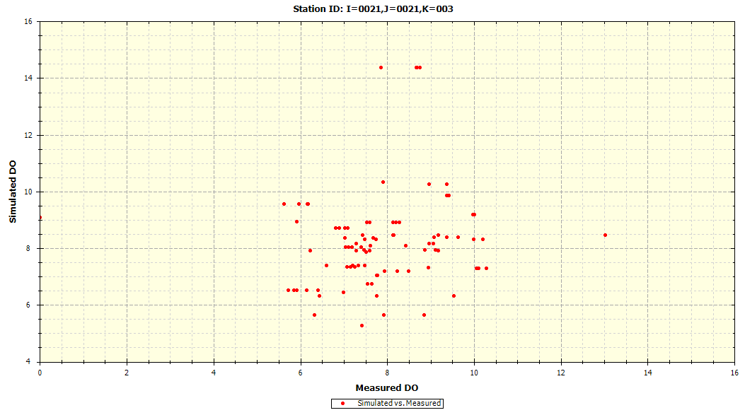

### Ammonia-Nitrogen

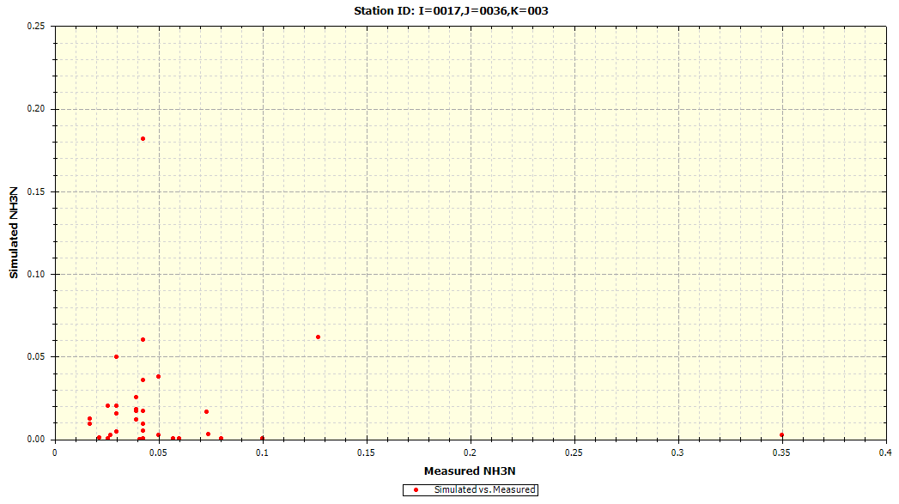

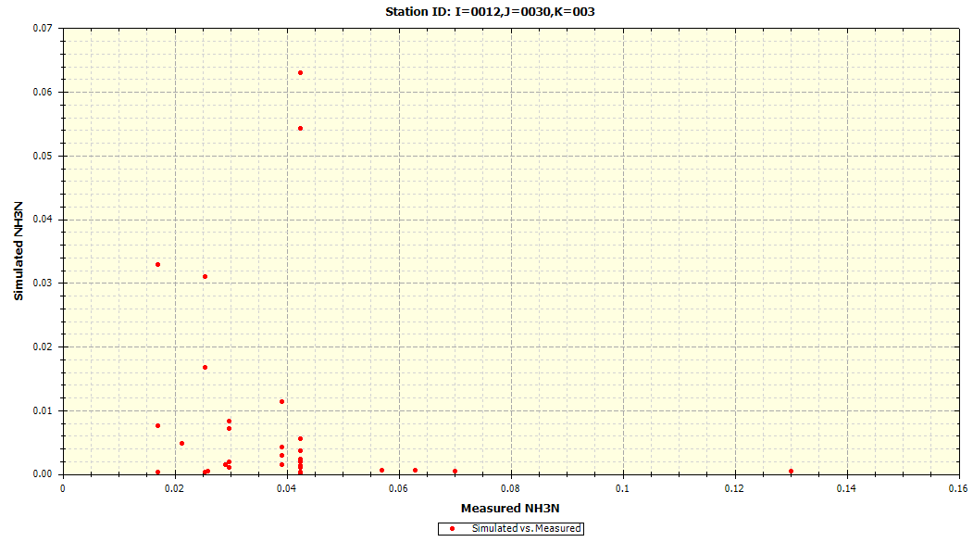

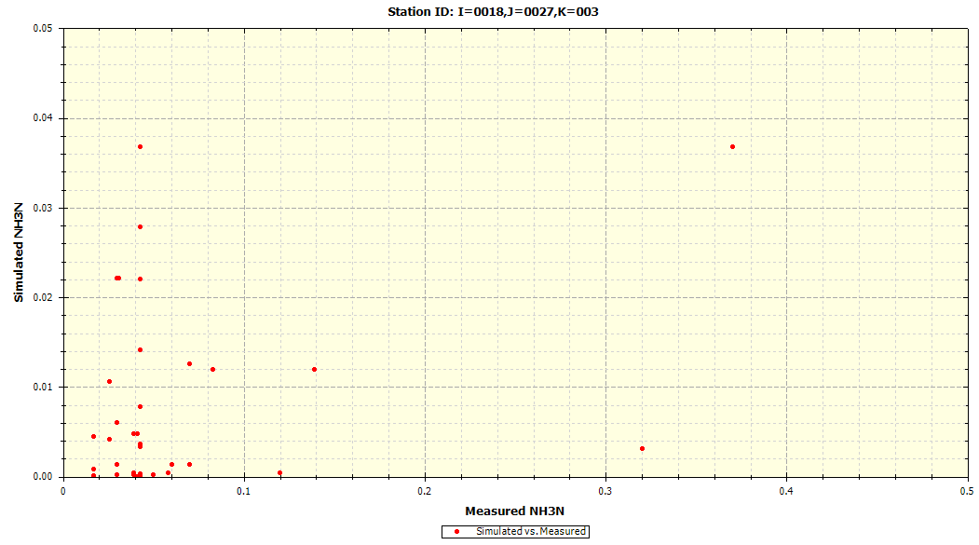

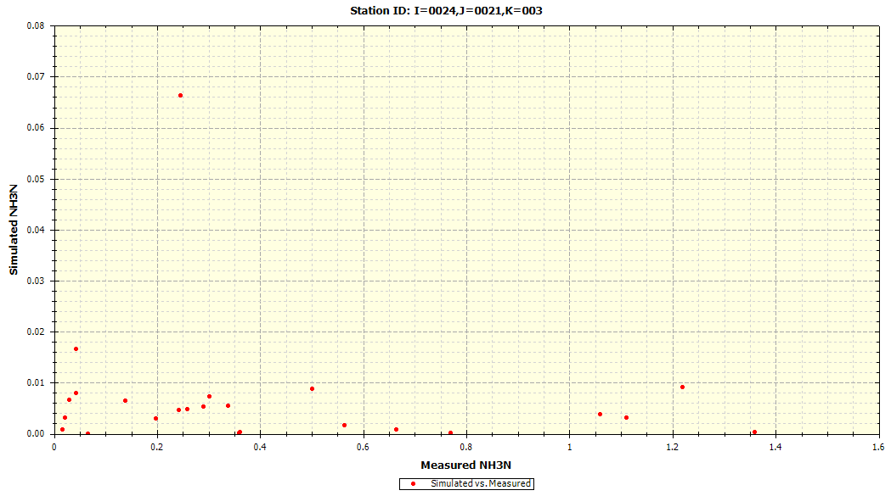

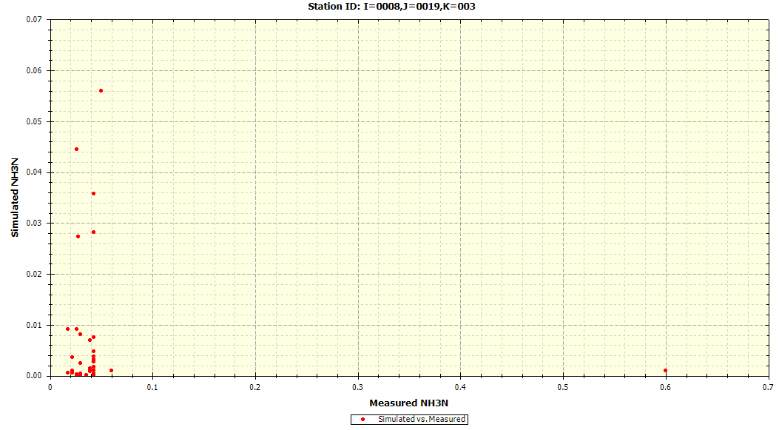

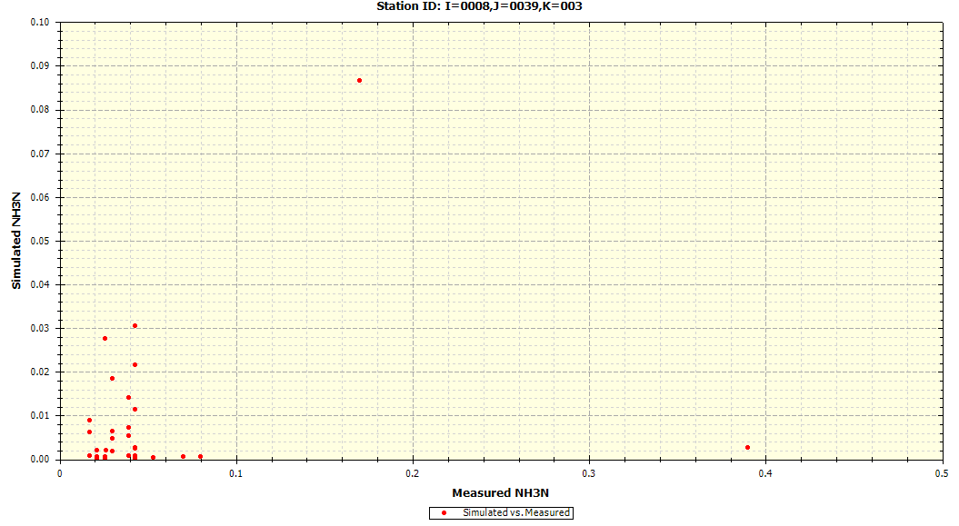

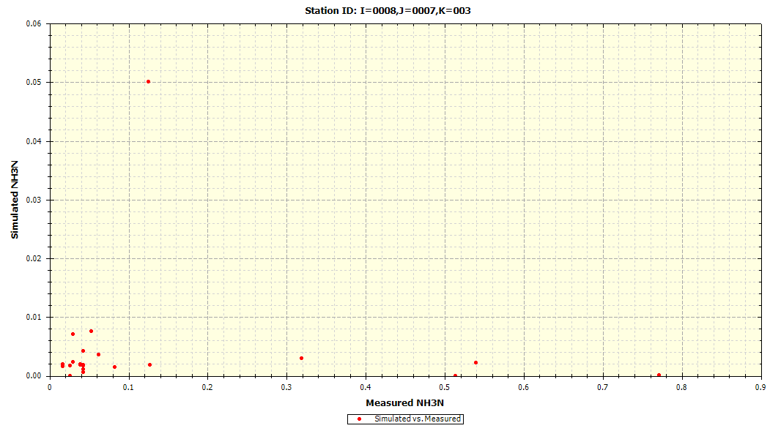

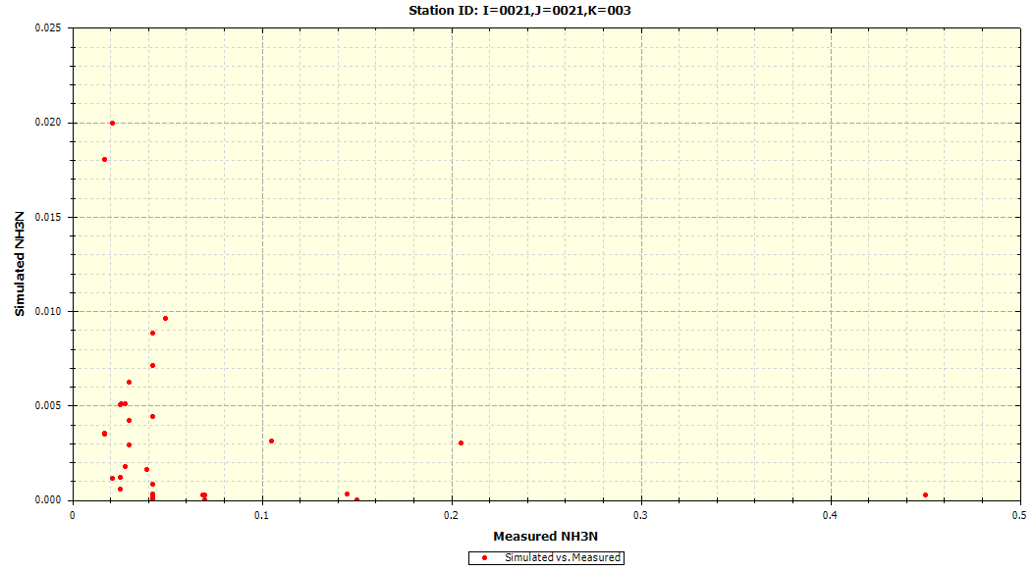

### Total Phytoplankton Chlorophyll-a

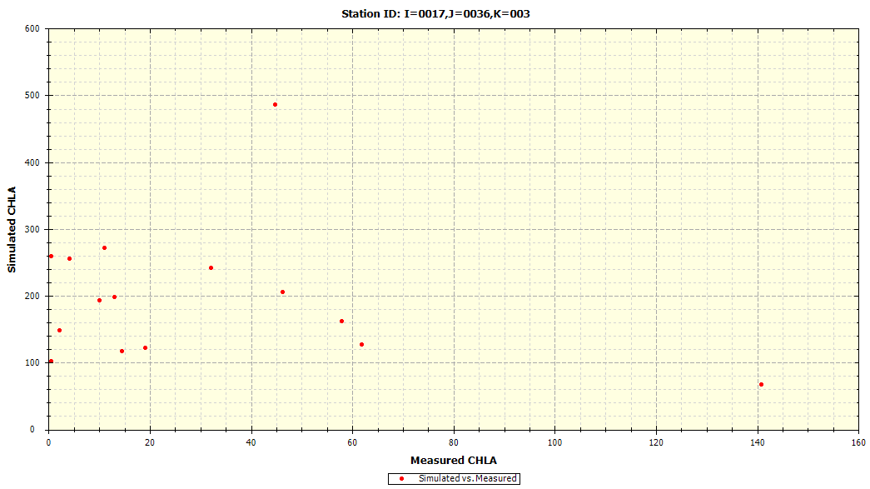

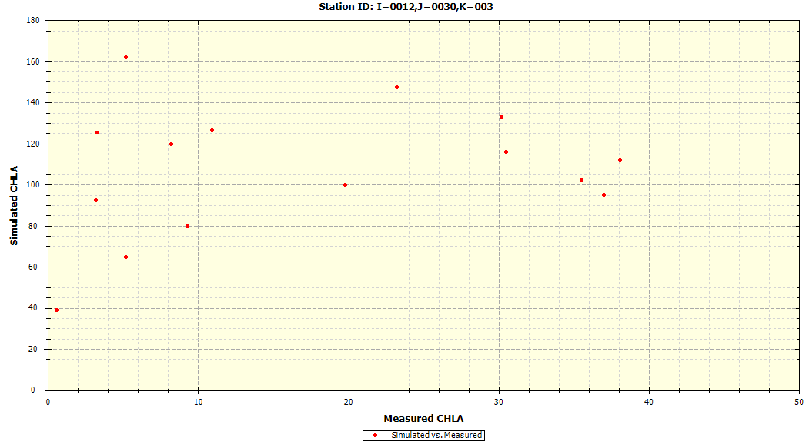

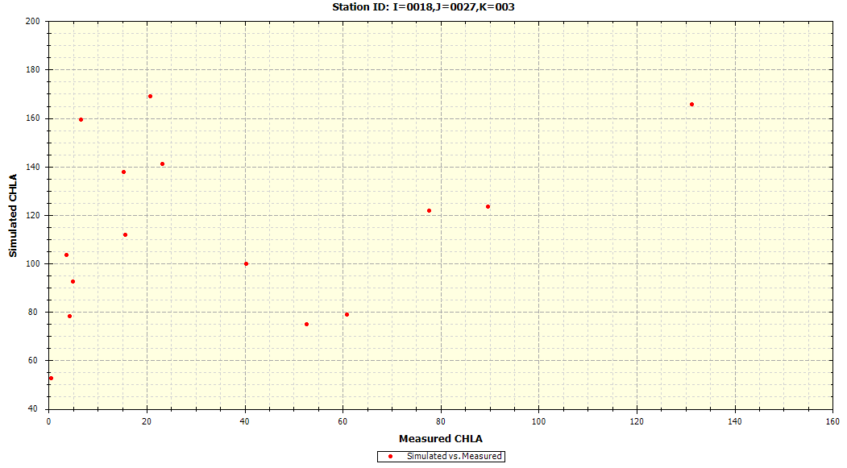

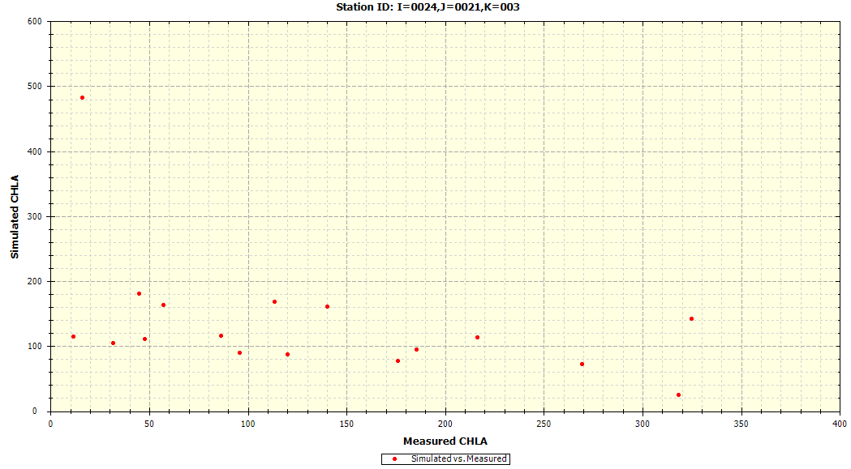

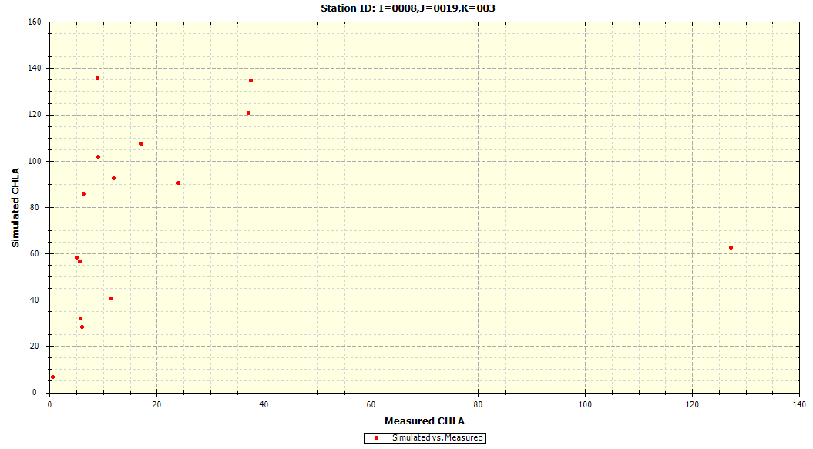

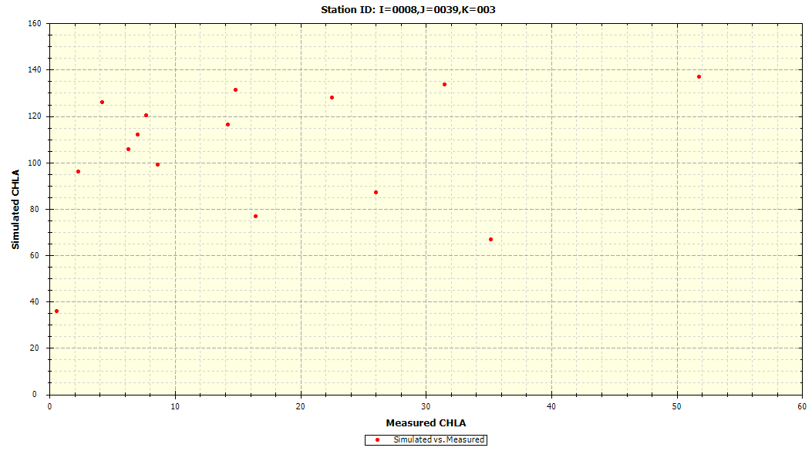

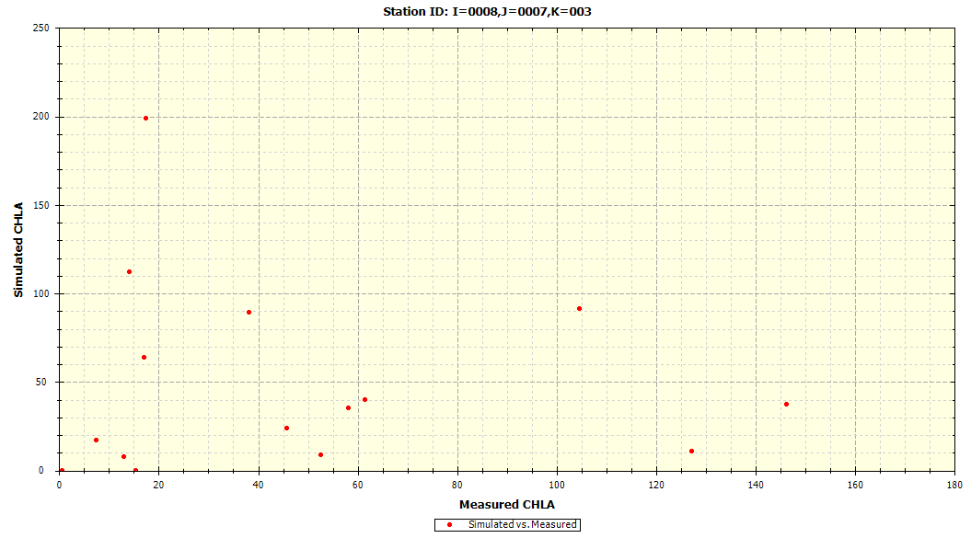

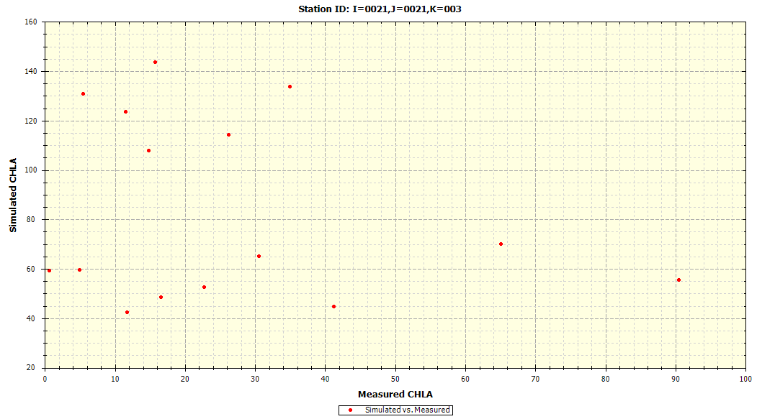

## Graphical Results (Probability Plot)

This sub-section provides probability plots of simulated results against the measured data for each segment (segment indicated in chart title per plot) and is organized into separate sub-sections based on water quality constituent. Such probability plots are included for constituents that follow the following criteria:

1. Time-series plots (Section B.1) generally suggest agreement among the simulated results against the measured data
2. The corresponding AWQMS UDWQ site exhibits at least 5 measured data throughout the model calibration period (October 1, 2005 to September 30, 2015)

Hence, based on the criteria above, the probability plots are only included for the following water quality constituents for the Utah Lake WASP.

* Dissolved Oxygen (Section B.3.1)
* Ammonia-Nitrogen (Section B.3.2)
* Total Phytoplankton Chlorophyll-a (Section B.3.3)

The corresponding WASP I and J node for which the probability plot displays is provided in the chart title while the corresponding AWQMS site is provided in the plot legend per node.

### Dissolved Oxygen (DO)

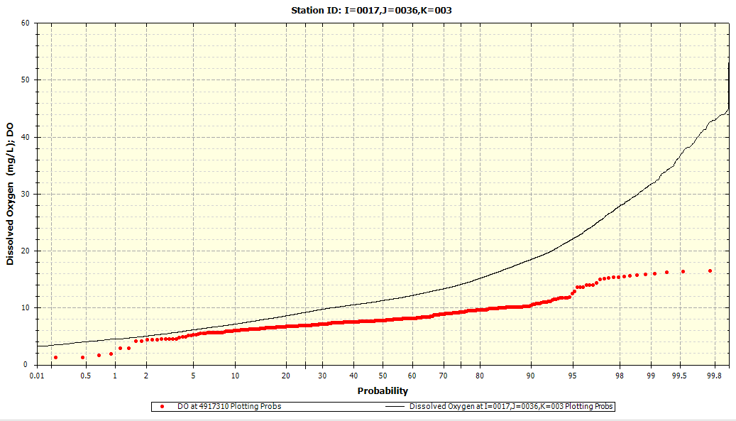

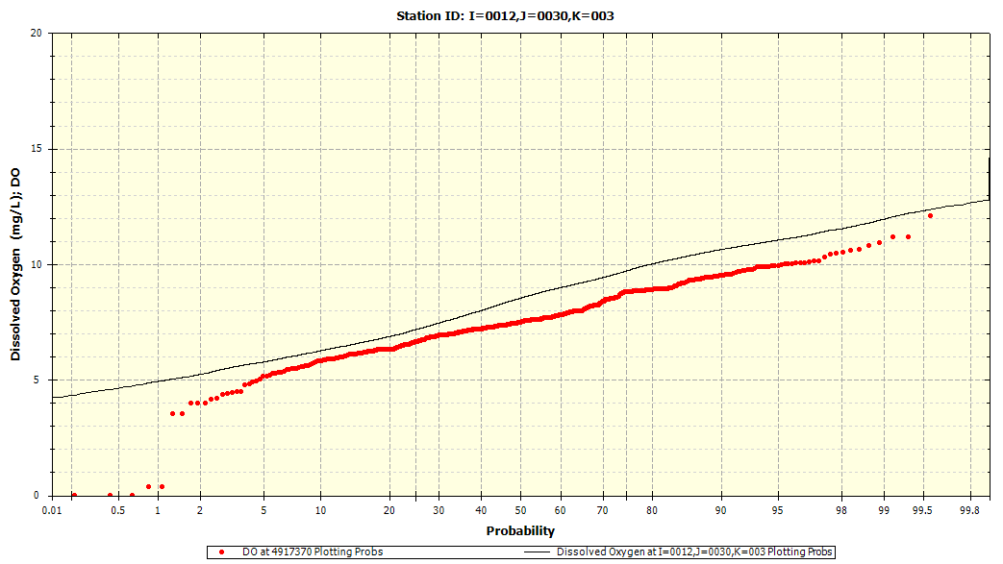

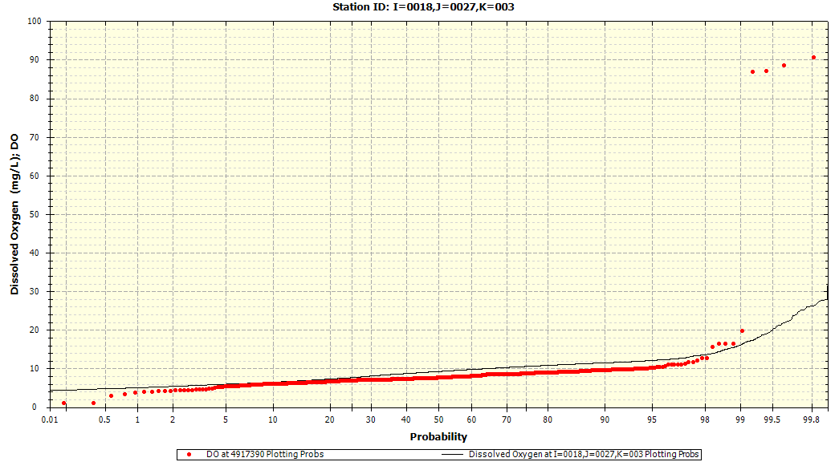

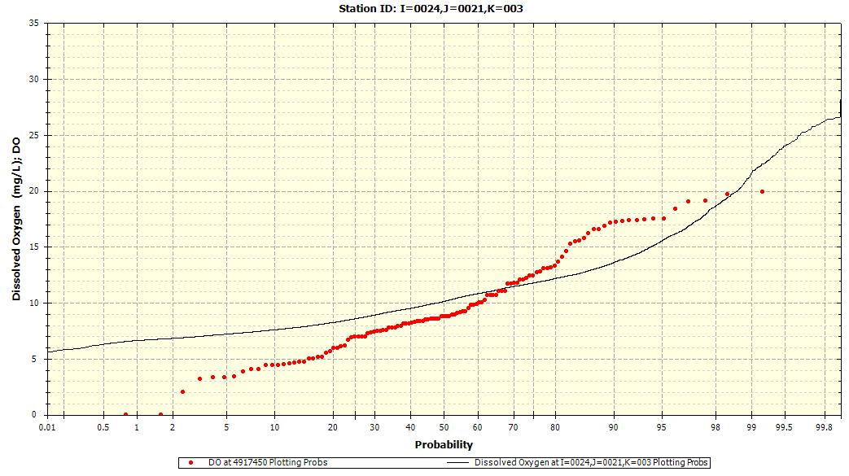

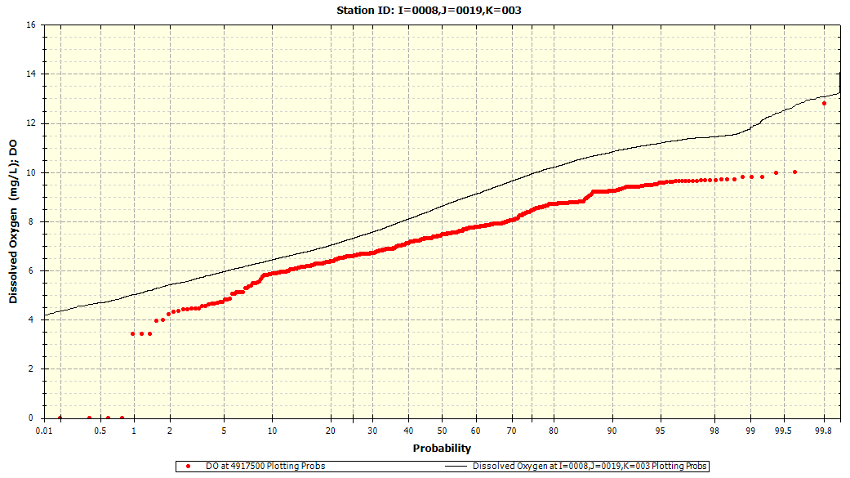

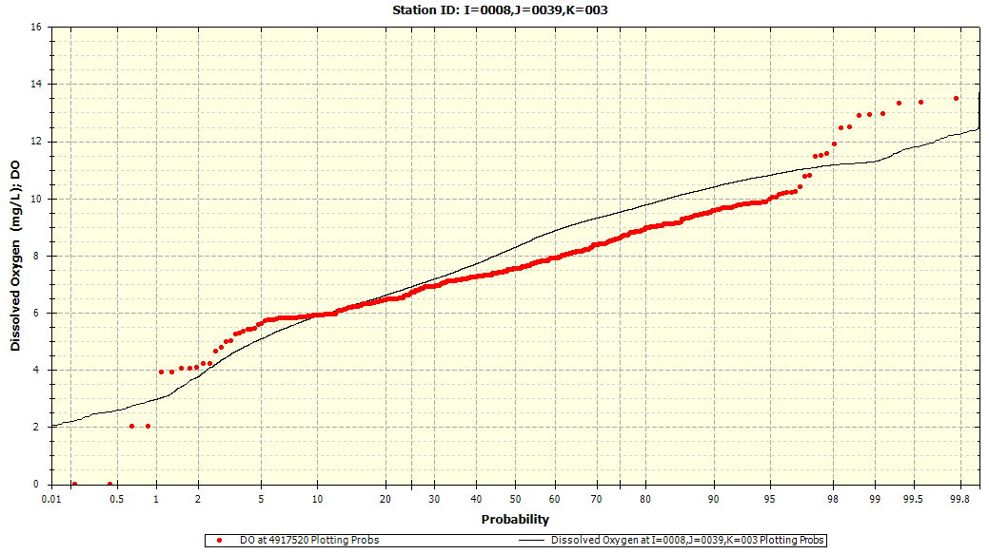

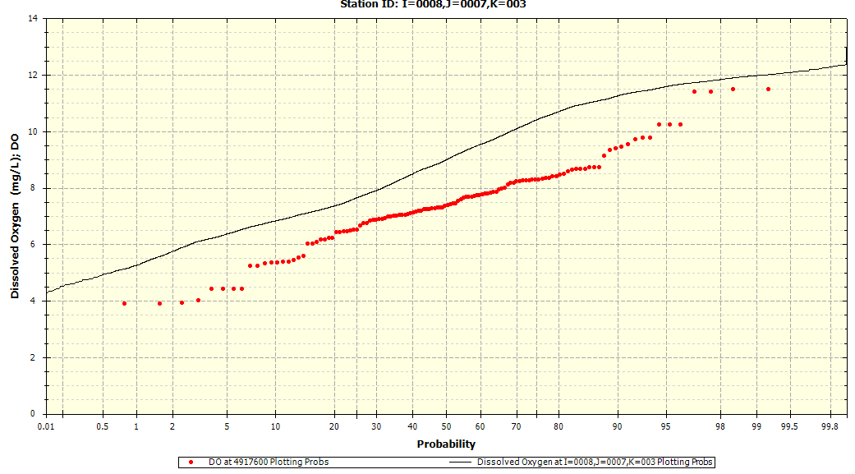

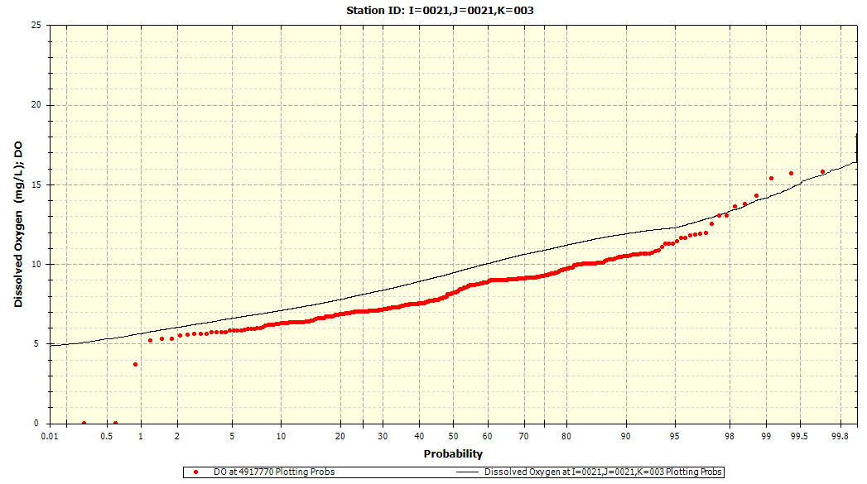

### Ammonia-Nitrogen

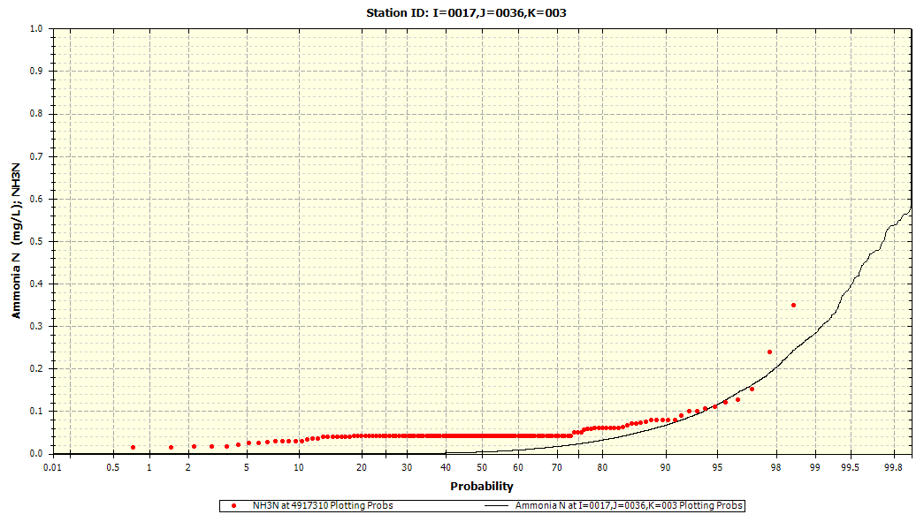

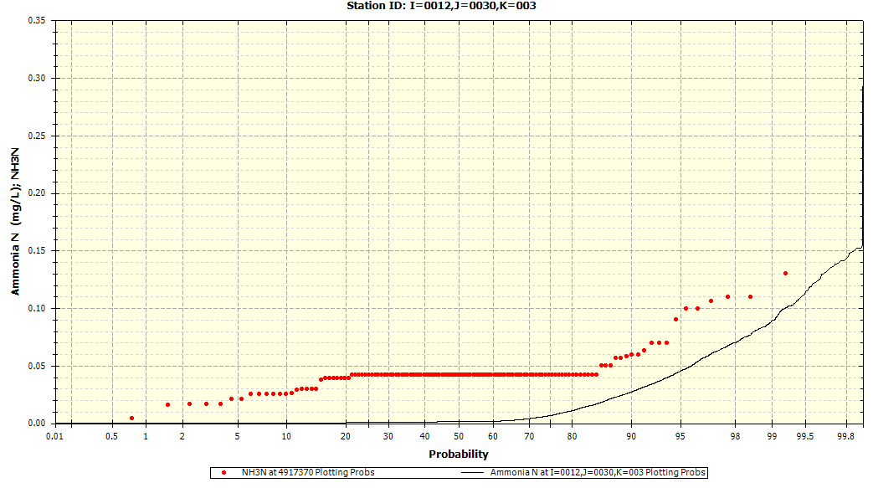

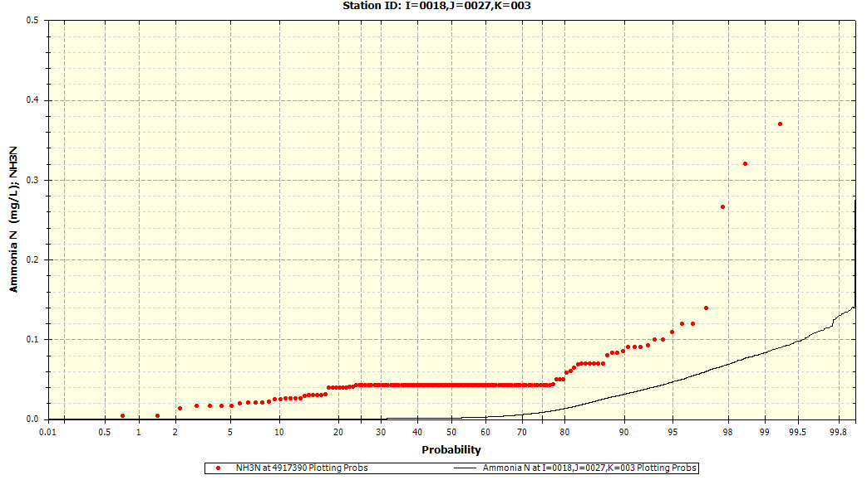

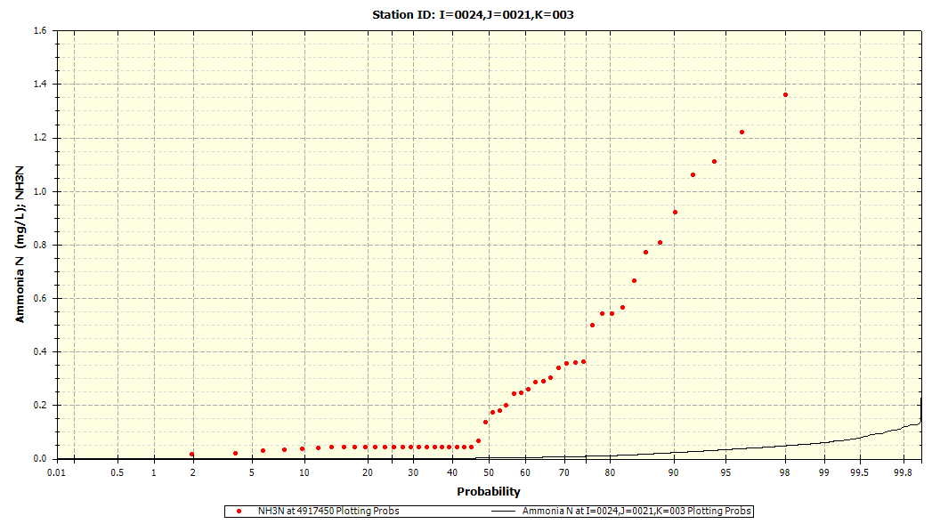

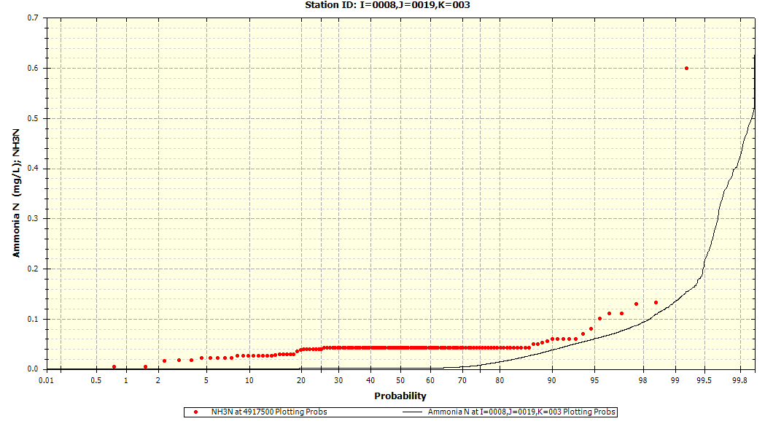

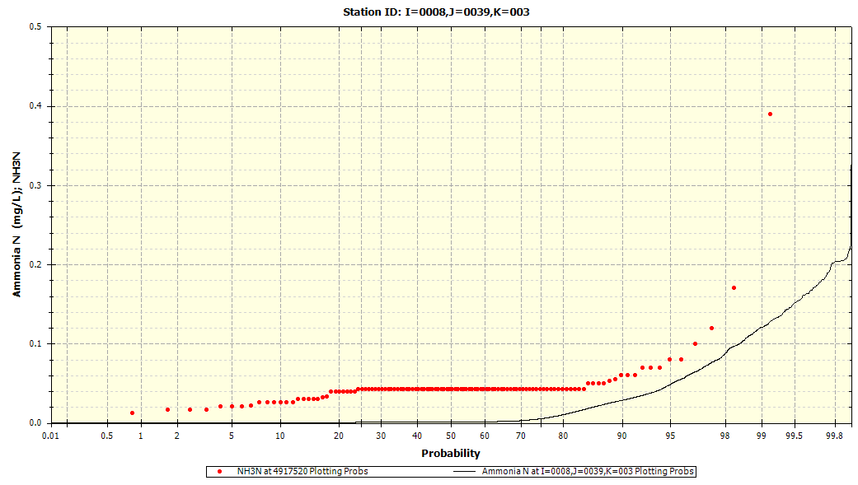

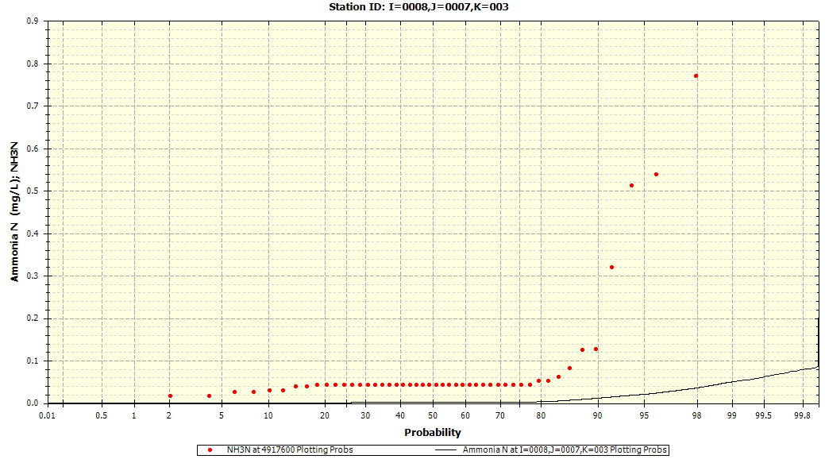

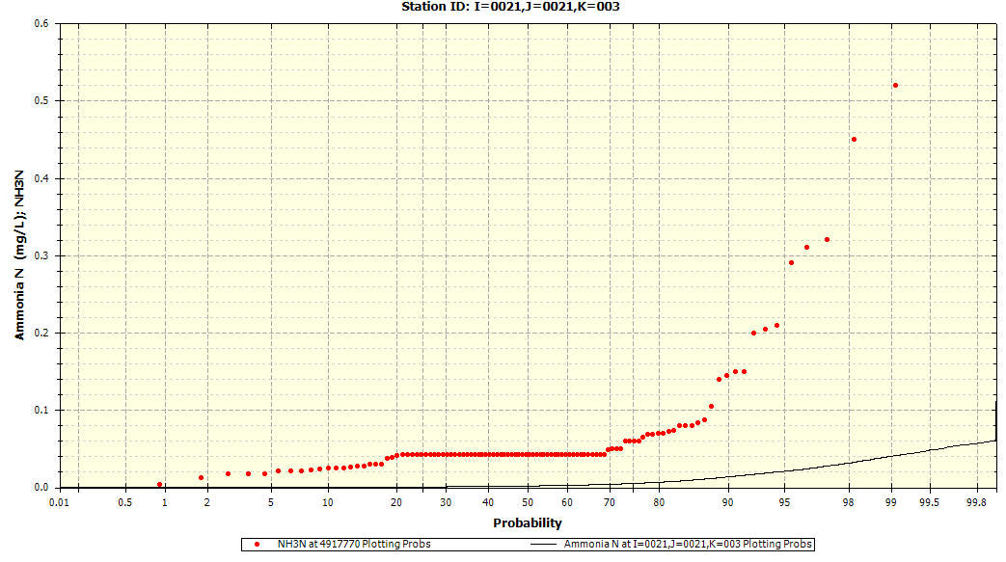

### Total Phytoplankton Chlorophyll-a

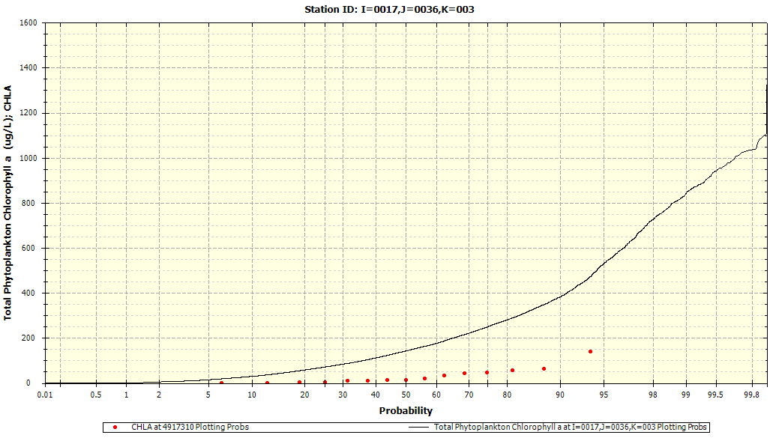

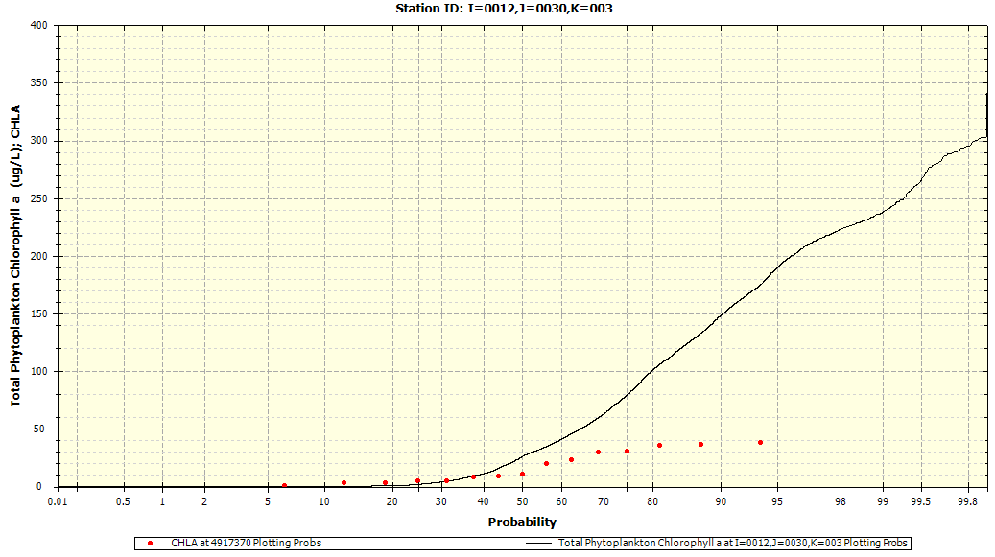

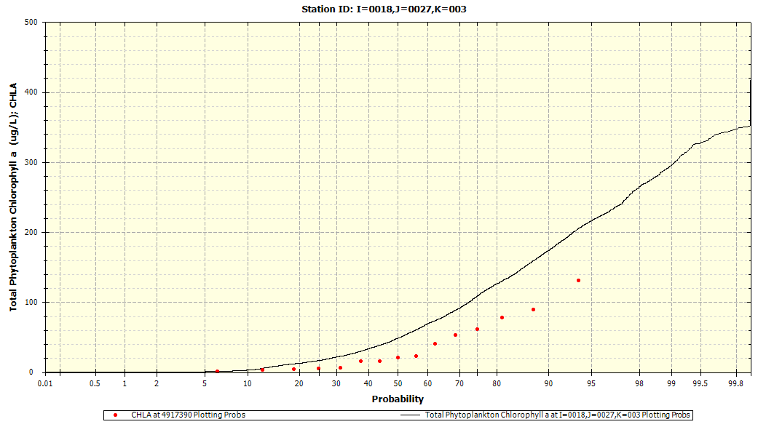

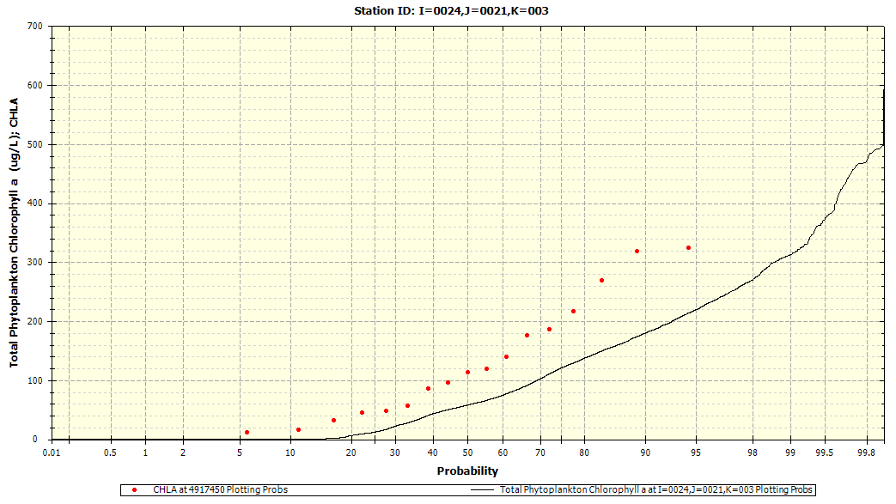

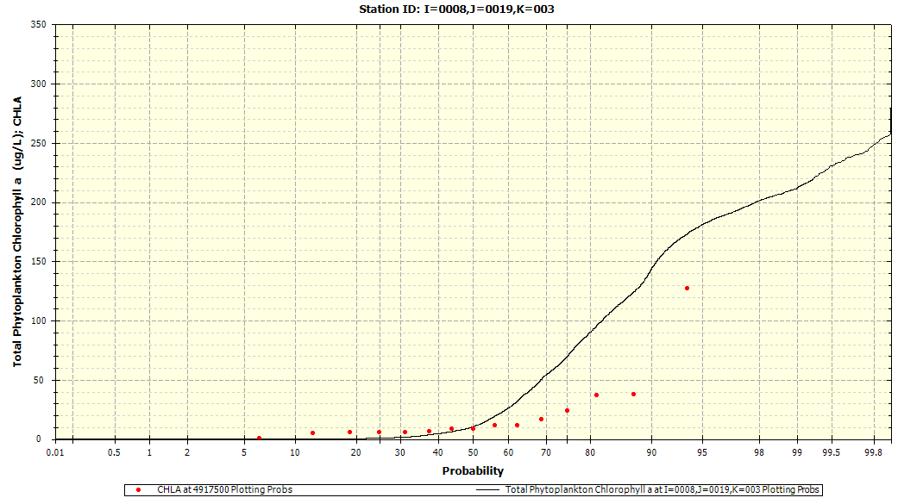

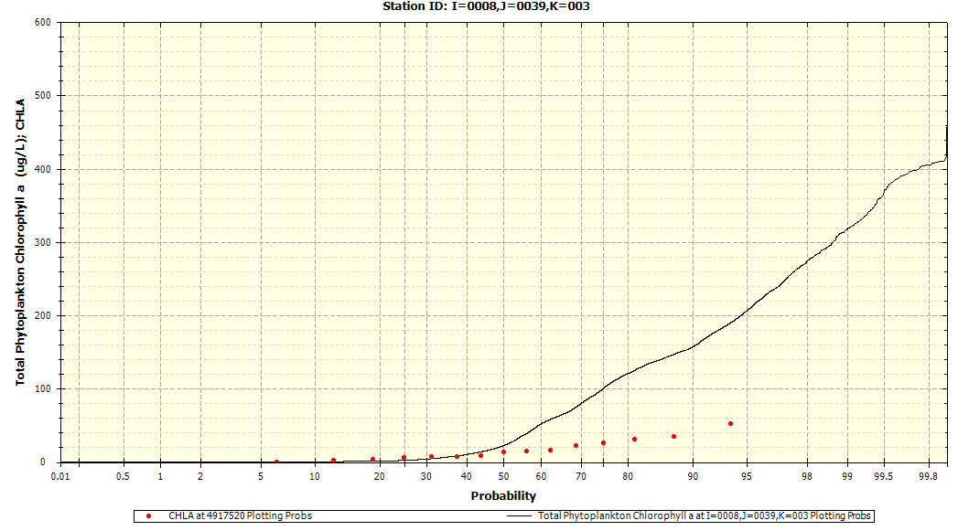

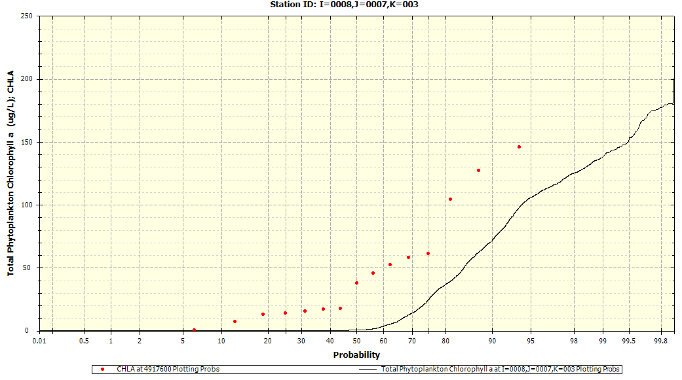

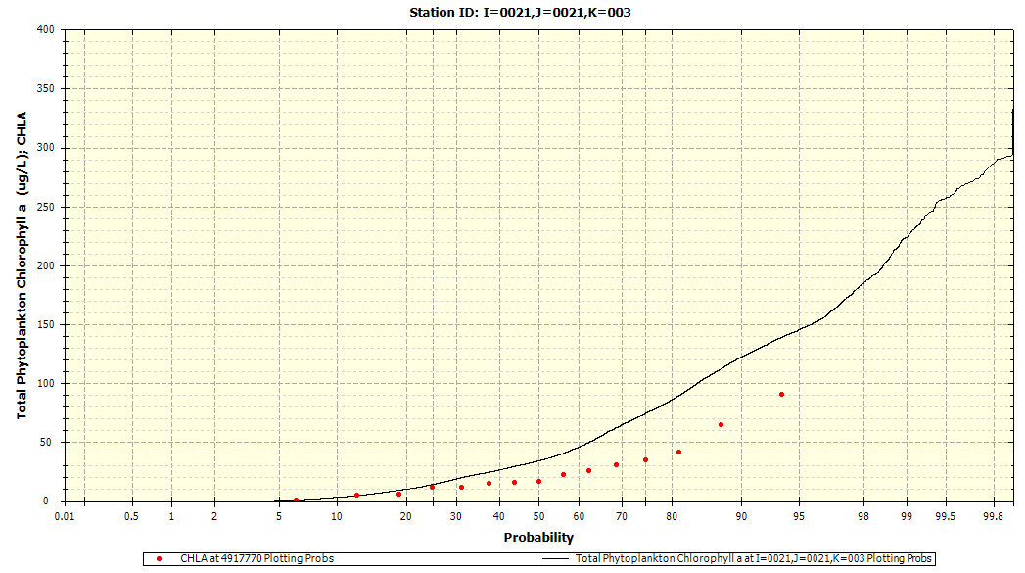

## Statistical Results

The following tables provide the model calibration results among the Utah Lake WASP (e.g., simulated results) against the measured data employed for the exercise, with sub-sections organized based on water quality constituent. Please note the following notations displayed under each table per constituent.

* 25%tile = 25th Percentile
* 75%tile = 75th Percentile
* R2 = Coefficient of Determination
* Mean Abs Err = Mean Absolute Error
* RMS Err = Root-Mean Square Error
* Norm RMS Err = Normalized Root-Mean Square Error
* Index of Agrmt = Index of Argument

### Dissolved Oxygen (DO)

|  |  |  |  |  |  |  |  |  |  |  |  |  |  |  |
| --- | --- | --- | --- | --- | --- | --- | --- | --- | --- | --- | --- | --- | --- | --- |
| **Station** | **Parameter** | **Measured** | | | | **Simulated** | | | | **R2** | **Mean Abs Err** | **RMS Err** | **Norm RMS Err** | **Index of Agrmt** |
| **Mean** | **Median** | **25 %tile** | **75 %tile** | **Mean** | **Median** | **25 %tile** | **75 %tile** |
| I=0008J=0007,K=003 | DO | 7.451 | 7.29 | 6.52 | 8.46 | 7.42 | 7.358 | 6.324 | 7.748 | 0 | 1.776 | 2.605 | 0.351 | 0.34 |
| I=0008,J=0019,K=003 | DO | 7.239 | 7.522 | 6.593 | 8.35 | 7.997 | 7.723 | 6.778 | 8.851 | 0.02 | 2.128 | 2.689 | 0.355 | 0.27 |
| I=0021,J=0021,K=003 | DO | 7.806 | 7.761 | 7.085 | 8.85 | 8.214 | 8.161 | 7.268 | 8.764 | 0.01 | 1.566 | 2.334 | 0.291 | 0.35 |
| I=0024,J=0021,K=003 | DO | 9.071 | 9.184 | 7.24 | 11.05 | 8.432 | 8.368 | 7.422 | 9.282 | 0.01 | 2.967 | 4.014 | 0.458 | 0.31 |
| I=0014,J=0026,K=003 | DO | 7.98 | 7.992 | N/A | N/A | 7.045 | 7.045 | N/A | N/A | 0 | 0 | 0 | 0 | 0 |
| I=0018,J=0027,K=003 | DO | 8.454 | 7.8 | 6.47 | 9.073 | 8.484 | 8.287 | 6.977 | 9.39 | 0 | 3.23 | 7.983 | 0.94 | 0.1 |
| I=0011,J=0028,K=003 | DO | 8.05 | N/A | N/A | N/A | 6.981 | N/A | N/A | N/A | 0 | 0 | 0 | 0 | 0 |
| I=0012,J=0030,K=003 | DO | 7.51 | 7.648 | 6.838 | 8.568 | 8.126 | 8.583 | 6.766 | 9.243 | 0.07 | 2.249 | 2.734 | 0.352 | 0.21 |
| I=0017,J=0036,K=003 | DO | 8.037 | 8.09 | 6.77 | 9.185 | 10.557 | 10.956 | 7.641 | 13.389 | 0.02 | 3.433 | 4.45 | 0.48 | 0.45 |
| I=0008,J=0039,K=003 | DO | 7.507 | 7.56 | 6.91 | 8.42 | 7.916 | 8.343 | 6.418 | 9.364 | 0.04 | 1.976 | 2.433 | 0.317 | 0.24 |

### Ammonia-Nitrogen

|  |  |  |  |  |  |  |  |  |  |  |  |  |  |  |
| --- | --- | --- | --- | --- | --- | --- | --- | --- | --- | --- | --- | --- | --- | --- |
| **Station** | **Parameter** | **Measured** | | | | **Simulated** | | | | **R2** | **Mean Abs Err** | **RMS Err** | **Norm RMS Err** | **Index of Agrmt** |
| **Mean** | **Median** | **25 %tile** | **75 %tile** | **Mean** | **Median** | **25 %tile** | **75 %tile** |
| I=0008,J=0007,K=003 | NH3N | 0.138 | 0.043 | 0.03 | 0.126 | 0.004 | 0.002 | 0.001 | 0.003 | 0 | 0.133 | 0.242 | 11.095 | 0.02 |
| I=0008,J=0019,K=003 | NH3N | 0.049 | 0.043 | 0.026 | 0.043 | 0.007 | 0.001 | 0.001 | 0.007 | 0 | 0.043 | 0.099 | 5.756 | 0.06 |
| I=0018,J=0019,K=003 | NH3N | 0.06 | N/A | N/A | N/A | 0.041 | N/A | N/A | N/A | 0 | 0 | 0 | 0 | 0 |
| I=0021,J=0021,K=003 | NH3N | 0.059 | 0.043 | 0.026 | 0.043 | 0.004 | 0.002 | 0 | 0.005 | 0.05 | 0.056 | 0.094 | 8.392 | 0.02 |
| I=0024,J=0021,K=003 | NH3N | 0.425 | 0.329 | 0.084 | 0.639 | 0.007 | 0.005 | 0.001 | 0.007 | 0.02 | 0.418 | 0.577 | 12.326 | 0.01 |
| I=0026,J=0021,K=003 | NH3N | 0.166 | 0.206 | N/A | N/A | 0.012 | 0.012 | N/A | N/A | 1 | 0.154 | 0.203 | 4.491 | 0 |
| I=0018,J=0027,K=003 | NH3N | 0.061 | 0.043 | 0.033 | 0.048 | 0.008 | 0.004 | 0 | 0.012 | 0.08 | 0.053 | 0.086 | 3.296 | 0.18 |
| I=0012,J=0030,K=003 | NH3N | 0.039 | 0.043 | 0.029 | 0.043 | 0.007 | 0.002 | 0 | 0.005 | 0.02 | 0.035 | 0.041 | 2.713 | 0.22 |
| I=0017,J=0036,K=003 | NH3N | 0.053 | 0.043 | 0.03 | 0.05 | 0.017 | 0.009 | 0.001 | 0.019 | 0 | 0.046 | 0.073 | 2.497 | 0.19 |
| I=0008,J=0039,K=003 | NH3N | 0.049 | 0.043 | 0.026 | 0.043 | 0.007 | 0.002 | 0 | 0.007 | 0.06 | 0.042 | 0.073 | 3.024 | 0.23 |

### 

### Nitrate-Nitrite Nitrogen

|  |  |  |  |  |  |  |  |  |  |  |  |  |  |  |
| --- | --- | --- | --- | --- | --- | --- | --- | --- | --- | --- | --- | --- | --- | --- |
| **Station** | **Parameter** | **Measured** | | | | **Simulated** | | | | **R2** | **Mean Abs Err** | **RMS Err** | **Norm RMS Err** | **Index of Agrmt** |
| **Mean** | **Median** | **25 %tile** | **75 %tile** | **Mean** | **Median** | **25 %tile** | **75 %tile** |
| I=0008,J=0007,K=003 | NO2NO3N | 0.08 | 0.064 | 0.027 | 0.085 | 0.001 | 0 | 0 | 0.001 | 0 | 0.08 | 0.149 | 23.835 | 0 |
| I=0008,J=0019,K=003 | NO2NO3N | 0.082 | 0.085 | 0.049 | 0.119 | 0 | 0 | 0 | 0 | 0.02 | 0.082 | 0.096 | 20.59 | 0.01 |
| I=0018,J=0019,K=003 | NO2NO3N | 0.085 | N/A | N/A | N/A | 0.008 | N/A | N/A | N/A | 0 | 0 | 0 | 0 | 0 |
| I=0021,J=0021,K=003 | NO2NO3N | 0.063 | 0.085 | 0.022 | 0.085 | 0.008 | 0 | 0 | 0 | 0.06 | 0.069 | 0.085 | 9.011 | 0.01 |
| I=0024,J=0021,K=003 | NO2NO3N | 0.173 | 0.083 | 0.019 | 0.085 | 0.012 | 0 | 0 | 0 | 0.02 | 0.167 | 0.319 | 5.064 | 0.12 |
| I=0026,J=0021,K=003 | NO2NO3N | 4.35 | 4.7 | 3.515 | 5.195 | 0 | 0 | 0 | 0 | 0.99 | 4.35 | 4.424 | 203.592 | 0 |
| I=0018,J=0027,K=003 | NO2NO3N | 0.07 | 0.085 | 0.038 | 0.085 | 0 | 0 | 0 | 0.001 | 0.07 | 0.069 | 0.081 | 19.52 | 0.01 |
| I=0012,J=0030,K=003 | NO2NO3N | 0.11 | 0.085 | 0.043 | 0.1 | 0 | 0 | 0 | 0 | 0 | 0.109 | 0.216 | 44.541 | 0 |
| I=0017,J=0036,K=003 | NO2NO3N | 0.091 | 0.085 | 0.048 | 0.085 | 0.004 | 0 | 0 | 0.002 | 0.01 | 0.088 | 0.111 | 5.574 | 0.09 |
| I=0008,J=0039,K=003 | NO2NO3N | 0.08 | 0.085 | 0.055 | 0.114 | 0 | 0 | 0 | 0 | 0 | 0.079 | 0.088 | 18.888 | 0.01 |

### Total Phosphate-Phosphorus

|  |  |  |  |  |  |  |  |  |  |  |  |  |  |  |
| --- | --- | --- | --- | --- | --- | --- | --- | --- | --- | --- | --- | --- | --- | --- |
| **Station** | **Parameter** | **Measured** | | | | **Simulated** | | | | **R2** | **Mean Abs Err** | **RMS Err** | **Norm RMS Err** | **Index of Agrmt** |
| **Mean** | **Median** | **25 %tile** | **75 %tile** | **Mean** | **Median** | **25 %tile** | **75 %tile** |
| I=0008,J=0007,K=003 | TP | 0.073 | 0.059 | 0.044 | 0.098 | 0.199 | 0.202 | 0.175 | 0.223 | 0.14 | 0.13 | 0.139 | 1.172 | 0.2 |
| I=0008,J=0019,K=003 | TP | 0.046 | 0.045 | 0.033 | 0.058 | 0.196 | 0.198 | 0.175 | 0.21 | 0.22 | 0.15 | 0.158 | 1.697 | 0.23 |
| I=0018,J=0019,K=003 | TP | 0.039 | N/A | N/A | N/A | 0.274 | N/A | N/A | N/A | 0 | 0 | 0 | 0 | 0 |
| I=0021,J=0021,K=003 | TP | 0.055 | 0.058 | 0.038 | 0.069 | 0.227 | 0.186 | 0.16 | 0.215 | 0.01 | 0.171 | 0.211 | 1.858 | 0.38 |
| I=0024,J=0021,K=003 | TP | 0.302 | 0.255 | 0.2 | 0.356 | 0.207 | 0.185 | 0.161 | 0.206 | 0.03 | 0.165 | 0.246 | 1.005 | 0.07 |
| I=0026,J=0021,K=003 | TP | 0.371 | 0.406 | N/A | N/A | 0.229 | 0.251 | N/A | N/A | 1 | 0.189 | 0.236 | 0.852 | 0.06 |
| I=0018,J=0027,K=003 | TP | 0.053 | 0.053 | 0.034 | 0.063 | 0.206 | 0.197 | 0.186 | 0.214 | 0.12 | 0.156 | 0.165 | 1.621 | 0.23 |
| I=0012,J=0030,K=003 | TP | 0.054 | 0.05 | 0.033 | 0.061 | 0.194 | 0.194 | 0.161 | 0.211 | 0.17 | 0.142 | 0.155 | 1.555 | 0.25 |
| I=0017,J=0036,K=003 | TP | 0.062 | 0.054 | 0.04 | 0.071 | 0.257 | 0.241 | 0.223 | 0.288 | 0.07 | 0.196 | 0.209 | 1.682 | 0.27 |
| I=0008,J=0039,K=003 | TP | 0.053 | 0.049 | 0.033 | 0.064 | 0.207 | 0.213 | 0.186 | 0.225 | 0.27 | 0.154 | 0.164 | 1.609 | 0.21 |

### Total Phytoplankton Chlorophyll-a

|  |  |  |  |  |  |  |  |  |  |  |  |  |  |  |
| --- | --- | --- | --- | --- | --- | --- | --- | --- | --- | --- | --- | --- | --- | --- |
| **Station** | **Parameter** | **Measured** | | | | **Simulated** | | | | **R2** | **Mean Abs Err** | **RMS Err** | **Norm RMS Err** | **Index of Agrmt** |
| **Mean** | **Median** | **25 %tile** | **75 %tile** | **Mean** | **Median** | **25 %tile** | **75 %tile** |
| I=0008,J=0007,K=003 | CHLA | 47.926 | 44.18 | 14.1 | 61.4 | 49.147 | 36.829 | 8.881 | 89.567 | 0.01 | 50.477 | 71.518 | 1.543 | 0.33 |
| I=0008,J=0019,K=003 | CHLA | 20.933 | 11.02 | 5.8 | 24 | 76.912 | 89.563 | 40.432 | 107.283 | 0.02 | 64.601 | 72.146 | 1.709 | 0.47 |
| I=0021,J=0021,K=003 | CHLA | 26.173 | 21.48 | 11.5 | 35 | 83.526 | 69.164 | 52.7 | 123.646 | 0.05 | 62.001 | 74.237 | 1.662 | 0.4 |
| I=0024,J=0021,K=003 | CHLA | 132.688 | 119.34 | 46.35 | 200.95 | 135.486 | 114.751 | 88.565 | 162.049 | 0.2 | 121.117 | 164.536 | 1.399 | 0.1 |
| I=0026,J=0021,K=003 | CHLA | 5.3 | 5.81 | N/A | N/A | 109.238 | 111.702 | N/A | N/A | 1 | 103.938 | 104.41 | 4.393 | 0.13 |
| I=0018,J=0027,K=003 | CHLA | 36.52 | 22.8 | 5 | 60.9 | 114.035 | 119.678 | 79.042 | 141.198 | 0.08 | 77.515 | 88.636 | 1.316 | 0.41 |
| I=0012,J=0030,K=003 | CHLA | 17.346 | 18.02 | 5.2 | 30.5 | 107.636 | 115.075 | 92.452 | 126.444 | 0.05 | 90.289 | 95.253 | 2.153 | 0.35 |
| I=0017,J=0036,K=003 | CHLA | 30.586 | 18.18 | 4.1 | 46.2 | 197.45 | 197.832 | 122 | 255.674 | 0.05 | 176.608 | 200.883 | 2.768 | 0.34 |
| I=0008,J=0039,K=003 | CHLA | 16.606 | 14.68 | 6.3 | 26 | 104.785 | 115.376 | 87.158 | 127.954 | 0.07 | 88.179 | 92.306 | 2.15 | 0.32 |

### CBOD

|  |  |  |  |  |  |  |  |  |  |  |  |  |  |  |
| --- | --- | --- | --- | --- | --- | --- | --- | --- | --- | --- | --- | --- | --- | --- |
| **Station** | **Parameter** | **Measured** | | | | **Simulated** | | | | **R2** | **Mean Abs Err** | **RMS Err** | **Norm RMS Err** | **Index of Agrmt** |
| **Mean** | **Median** | **25 %tile** | **75 %tile** | **Mean** | **Median** | **25 %tile** | **75 %tile** |
| I=0024,J=0021,K=003 | CBOD | 10.5 | 12.75 | N/A | N/A | 2.034 | 2.075 | N/A | N/A | 1 | 8.466 | 11.22 | 2.371 | 0.03 |
| I=0026,J=0021,K=003 | CBOD | 2.775 | 2.843 | N/A | N/A | 2.355 | 2.715 | N/A | N/A | 1 | 1.422 | 1.483 | 0.592 | 0.17 |

### 

### Total Solids

|  |  |  |  |  |  |  |  |  |  |  |  |  |  |  |
| --- | --- | --- | --- | --- | --- | --- | --- | --- | --- | --- | --- | --- | --- | --- |
| **Station** | **Parameter** | **Measured** | | | | **Simulated** | | | | **R2** | **Mean Abs Err** | **RMS Err** | **Norm RMS Err** | **Index of Agrmt** |
| **Mean** | **Median** | **25 %tile** | **75 %tile** | **Mean** | **Median** | **25 %tile** | **75 %tile** |
| I=0008,J=0007,K=003 | TSS | 60.427 | 48.425 | 30.9 | 85.75 | 179.406 | 184.677 | 151.196 | 213.653 | 0.08 | 118.978 | 128.134 | 1.207 | 0.35 |
| I=0008,J=0019,K=003 | TSS | 31.127 | 24.9 | 18.775 | 36.8 | 151.039 | 157.283 | 113.166 | 184.421 | 0.04 | 119.912 | 128.639 | 1.907 | 0.31 |
| I=0021,J=0021,K=003 | TSS | 41.279 | 39.2 | 23.2 | 52.65 | 105.327 | 101.075 | 77.824 | 134.774 | 0.02 | 71.359 | 82.14 | 1.268 | 0.37 |
| I=0024,J=0021,K=003 | TSS | 78.796 | 69 | 42.975 | 80.25 | 89.764 | 87.039 | 50.976 | 131.048 | 0.1 | 62.024 | 89.478 | 1.142 | 0.25 |
| I=0026,J=0021,K=003 | TSS | 28.4 | 32.84 | N/A | N/A | 34.074 | 35.771 | N/A | N/A | 1 | 9.143 | 10.761 | 0.332 | 0.74 |
| I=0018,J=0027,K=003 | TSS | 33.207 | 31.54 | 20.925 | 43.575 | 118.644 | 123.354 | 98.914 | 138.019 | 0 | 85.437 | 90.611 | 1.444 | 0.29 |
| I=0012,J=0030,K=003 | TSS | 41.716 | 40.24 | 23.2 | 54.8 | 123.486 | 125.168 | 102.739 | 150.635 | 0.02 | 82.511 | 87.991 | 1.217 | 0.32 |
| I=0017,J=0036,K=003 | TSS | 38.884 | 34.44 | 26 | 52.8 | 116.678 | 117.404 | 96.294 | 132.909 | 0.02 | 77.794 | 83.365 | 1.227 | 0.32 |
| I=0008,J=0039,K=003 | TSS | 44.727 | 41.68 | 28.3 | 48.8 | 111.987 | 116.502 | 98.477 | 125.569 | 0.01 | 68.623 | 73.94 | 1.039 | 0.28 |

# Appendix C: Utah Lake Water Balance

This appendix describes the distinct components for applying the Utah Lake water balance and inflows applied for evaluating the water quantity performance simulated through the Utah Lake EFDC model. Section C.1 presents the distinct components of the water balance model applied toward the Utah Lake EFDC, describing the data sources and methodologies implemented for populating each outflow parameter. Meanwhile, Section C.2 provides the distinct components contributing to the total inflow into Utah Lake, discussing the data sources and methodologies applied for populating each inflow parameter. Section C.3 presents the results for describing the mean annual water balance (inflows and outflows) into Utah Lake for the EFDC model.

## Water Balance: Components, Data Sources, and Methodology

A monthly water balance for Utah Lake was calculated for water year 2006-2018. based on the following equation:

$$Q_{I}= ∆S+Q_{O}+ET-P \left(C.1\right)$$

As indicated in Equation C.1, $Q_{I}$, the total inflow (m3), equates to the change in storage (m3), , added by the outflow (m3), , and the evapotranspiration volume (m3), , subtracted by precipitation volume (m3), . In other words, Equation C.1 can be rewritten as the water balance for which the summation of the outflows equates to those yielded by inflows (e.g., $Q_{I}+P=∆S+Q_{O}+ET$). For this exercise, the following data sources, methodologies, etc. are applied for calculating each component demonstrated in Equation C.1.

* Change in Storage Volume ($∆S$): The stage-storage-surface area table for the EFDC grid was developed using the Storage Capacity Tool in ArcGIS ArcMap 10.5 Spatial Analyst extension. Lake elevation data was obtained from UDWR under the “Utah Lake Storage Content (Gage Reading)” station name. The monthly change in storage (*ΔS*) was then calculated by using the lake elevation data to determine the storage content based on the stage-storage table for the EFDC grid.
* Precipitation and Evapotranspiration ($P$, $ET$): The precipitation volume, $P$, and evapotranspiration volume, $ET$, were calculated by multiplying the *P* and *ET* depth by the lake surface area obtained from the stage-surface area table. The precipitation depth measured at the Provo BYU station was reduced to reflect that less rain falls on the lake relative to the east bench along the Wasatch Mountains. Using ArcGIS, the mean annual precipitation over Utah Lake was calculated using the Utah Lake boundary and PRISM 30-year normal (1981-2010) raster data. The precipitation measured at the Provo BYU station was then adjusted by the ratio of the mean annual precipitation over Utah Lake to the mean annual precipitation at Provo BYU station (0.705). The Priestley-Taylor method was used to estimate evapotranspiration depth from Utah Lake.
* Outflow ($Q_{O}$): Utah Lake has only one outflow location to the Jordan River. The Utah Division of Water Rights publishes outflow records for Utah Lake which were used to determine outflow, $Q_{O}$.
  + For 9/1/2005-12/31/2008, monthly flow records for “Utah Lake Outflow” were used.
  + For 1/1/2009-9/30/2018, daily flow records for “05 Jordan Narrows (Total)” were used.

## Utah Lake Inflow: Components, Data Sources, and Methodology

With all of the terms on the right hand side of the water balance equation, the total inflow to the lake was calculated, $Q_{I}$*.* The total inflow can be further subdivided into the following components:

$$Q_{I}= Q_{GW}+Q_{WW}+Q_{GS}+Q_{US} \left(C.2\right)$$

As indicated in Equation C.2, the total inflow volume (m3), , into Utah Lake is calculated through the summation of the groundwater inflow volume (m3), , the treated wastewater inflow volume (m3), , the gaged surface inflow volume (m3), , and the ungaged surface inflow volume (m3), . For this exercise, the following data sources, methodologies, etc. are applied for calculating each inflow component (e.g., groundwater, wastewater, etc.) as described in Equation C.2.

* Gaged Surface Inflow ($Q_{GS}$): Only two of the surface inflows were actively gaged during the period- Provo River and Hobble Creek.
* Treated Wastewater Inflow ($Q_{WW}$): The flows from the wastewater treatment plants (WWTP) were based on monthly Discharge Monitoring Reports (DMR) submitted to Utah Division of Water Quality (UDWQ).
* Groundwater Inflow ($Q_{GW}$): Constant mean annual rates were used for the groundwater inputs, based on estimates published by the USGS.
* Ungaged Surface Inflow ($Q_{US}$): All other surface water, stormwater, and irrigation return flows were ungaged and unknown during the period.

## Results over Utah Lake Annual Water Balance and Inflows

The following table documents the annual flow volumes in acre-feet for Utah Lake per water year, providing the distribution of distinct components described in Equations C.1 for the outflow parameters (primarily the Jordan River outflow and losses due to evapotranspiration) and C.2. The average flow volumes per component described in Equations C.1 for the outflow parameters followed by C.2 for the inflow components throughout the entire Utah Lake EFDC model calibration period (October 1, 2005 to September 30, 2018) are also provided in the following table.

|  |  |  |  |  |  |  |  |  |  |
| --- | --- | --- | --- | --- | --- | --- | --- | --- | --- |
| **Water Year** | **Inflows (ac-ft)** | | | | | | **Outflows (ac-ft)** | | |
| **WWTP** | **Ground-water** | **Gaged Surface** | **Ungaged Surface** | **Precip** | **Inflow Total** | **Jordan River** | **Evap** | **Total Outflow** |
| 2006 | 51,023 | 38,682 | 199,825 | 346,141 | 104,688 | *740,358* | 303,760 | 335,193 | *638,953* |
| 2007 | 51,416 | 38,682 | 136,990 | 151,791 | 74,998 | *453,877* | 235,100 | 320,490 | *555,590* |
| 2008 | 54,884 | 38,788 | 125,067 | 192,191 | 74,067 | *484,998* | 172,200 | 298,180 | *470,380* |
| 2009 | 59,694 | 38,682 | 186,898 | 274,645 | 109,107 | *669,026* | 267,298 | 299,927 | *567,225* |
| 2010 | 58,463 | 38,682 | 119,003 | 207,948 | 83,297 | *507,394* | 280,623 | 314,165 | *594,788* |
| 2011 | 63,665 | 38,682 | 425,952 | 468,173 | 148,767 | *1,145,239* | 589,183 | 333,138 | *922,321* |
| 2012 | 57,291 | 38,788 | 157,922 | 148,410 | 59,316 | *461,726* | 423,397 | 329,905 | *753,301* |
| 2013 | 57,053 | 38,682 | 71,998 | 151,346 | 69,980 | *389,060* | 159,943 | 300,383 | *460,326* |
| 2014 | 57,461 | 38,682 | 71,986 | 136,355 | 88,049 | *392,534* | 164,238 | 289,574 | *453,812* |
| 2015 | 54,967 | 38,682 | 64,875 | 116,905 | 79,065 | *354,494* | 142,605 | 286,916 | *429,521* |
| 2016 | 54,838 | 38,788 | 64,505 | 105,238 | 70,172 | *333,542* | 129,295 | 277,539 | *406,834* |
| 2017 | 54,556 | 38,682 | 262,324 | 205,972 | 88,715 | *650,249* | 126,110 | 331,444 | *457,554* |
| 2018 | 52,494 | 38,682 | 103,336 | 87,255 | 45,803 | *327,571* | 145,961 | 256,751 | *402,712* |
| Mean | 56,432 | 38,711 | 147,729 | 209,013 | 87,410 | *539,295* | 260,695 | 307,764 | *568,459* |

Meanwhile, the following figure documents the mean contribution of distinct components of the inflows (as described by Equation C.2 in Section C.2) and the outflows (as described by Equation C.1 in Section C.1) for Utah Lake over the EFDC model calibration period (October 1, 2005 to September 30, 2018).

